Manual

LOGIQC QMS v5 Administrator Manual

This manual describes the functions that can be performed under the System Administrator user account.

The LOGIQC System Administrator 3
LOGIQC menus 3
Core menus 3
Non-core menus 4
LOGIQC Menu types 5
Editing a single level menu 5
Editing a double level menu 6
Removing or disabling menu options 7
Add system users 8
Add a system user 9
Site information 11
User login history 12
Calendar Integration 12
Register Settings 12
Hide items/tasks in the system 12
Risk register settings 13
Creating risk treatment options 14
Accreditation register settings 14
LOGIQC workflows 16
Workflow 2: Contracts, Risks and Accreditation Standards 16
Workflow 3: Audit, Compliance, Training and Licensing 16
Workflow 4: Incidents, Feedback, Repairs and Improvements 16
LOGIQC User Permissions 17

The LOGIQC System Administrator
Your LOGIQC system comes with a free administrator user account. This account should be used when you need to undertake system administrator functions.
The LOGIQC system administrator can perform the following functions:
- Edit menu options
- Create system users
- Re-set user passwords
- Hide register items (the equivalent of deleting an item in LOGIQC)
- Adjust system settings

LOGIQC menus
There are a variety of drop-down menus that appear in LOGIQC to assist the user to complete tasks and actions quickly and consistently. LOGIQC comprises core menus and non-core menus. Core menus are common to all LOGIQC systems and non-core menus relate to the specific registers and features that are activated in your system.

Core menus
These menus must be populated before using your LOGIQC system.
Menu name | Description
Contact type | This list appears when adding a contact to the Contacts Register. It provides options for the user to select the type of contact being added. The Contacts Register allows for sorting, filtering and report printing based on the items in this list.
Document category | This list appears when uploading a document to the Document Register. It provides options for the user to select the type of document being uploaded. The Document Register allows for sorting, filtering and report printing based on the items in this list.
Meetings | A selection from this list must be made when adding an item to any register. This list also appears when scheduling a meeting in the Meetings Register.
Positions | This list appears when setting up staff contacts in the Contacts Register. A single unique position title should be created for every user of the system. If there are multiple positions with the same title, each position should be numbered to remain unique e.g. Receptionist 1, Receptionist 2 etc. Tasks in the system are assigned to positions.
Records Category | This list appears when uploading a document to the Quality Records Register. It provides options for the user to select the type of document being uploaded. The Quality Records allows for sorting, filtering and report printing based on the items in this list.
Work area | It is the list of functional work areas in the organisation (e.g. HR Administration, Clinic, Programs, etc.) that tasks and issues can be assigned to. A selection from this list must be made when adding an item to any register. All Registers allows for sorting, filtering and report printing based on the items in this list.

Non-core menus
Accreditation assessment | This list appears in the Accreditation Register when assigning a self-assessment rating
Compliance source | This list appears when creating a new item in the Compliance Register. It provides options for the user to select the source of the compliance requirement. The Compliance Register allows for sorting, filtering and report printing based on the items in this list.
Contract category | This list appears when uploading a contract to the Contracts Register. It provides options for the user to select the type of contract being uploaded. The Contracts Register allows for sorting, filtering and report printing based on the items in this list.
Feedback category | This list appears when recording customer/client feedback in the Feedback Register and is used to describe the nature of the feedback received. The Feedback Register allows for sorting, filtering and report printing based on the items in this list.
Feedback source | This list appears when recording customer/client feedback in the Feedback Register and is used to describe the type of customer/client/stakeholder providing the feedback.
Feedback type | This list appears when recording customer/client feedback in the Feedback Register and is used to describe the type the feedback received. The Feedback Register allows for sorting, filtering and report printing based on the items in this list.
Improvement source | This list appears when recording a new continual improvement suggestion in the Continual Improvement Register and is used to identify the driver for the improvement suggestion. The Continual improvement Register allows for sorting, filtering and report printing based on the items in this list.
Incident type | This list appears when reporting an OHS incident or hazard in the OHS Incidents Register and is used to describe the nature of the incident being reported.
License type | This list appears when creating a licensing requirement in the Licensing Register and is used to describe the type of license that needs to be monitored. The Licensing Register allows for sorting, filtering and report printing based on the items in this list.
Notifiable incident provider type | This list appears in the form used to submit an incident report to an external body.
Risk dimension | This list appears in the Risk Register when categorising a risk.
Risk name | This list appears in the Risk Register when adding a risk to the register. It also appears in the incidents, feedback, repairs and improvement registers when linking an issue to a risk.
Risk treatment | This list appears in the Risk Register when adding a risk mitigation task.
Supplier assessment criteria | This list appears when adding a new supplier to the Suppliers Register and is used as a checklist for the attributes of a potential approved supplier.
Training type | This list appears when creating a licensing requirement in the Training Register and is used to describe the type of training that needs to be undertaken. The Training Register allows for sorting, filtering and report printing based on the items in this list.

LOGIQC Menu types
There are two types of menus in LOGIQC: single level, double level, and editable.
Single level menu example:
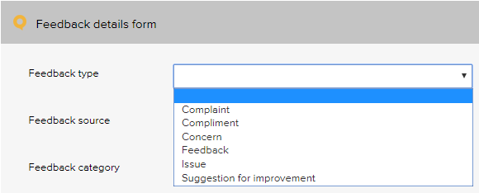
Double level menu example:
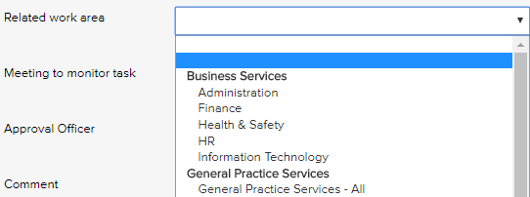

Editing a single level menu
- Log-in as administrator and select system setup in the system settings menu.
- From the system setup menu, select the menu to edit.
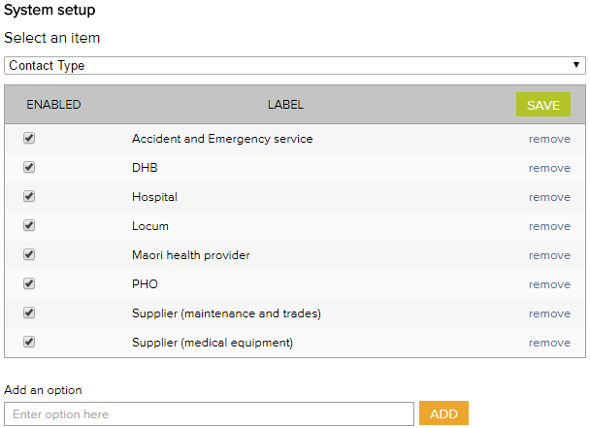
- To add new menu options, type the new option into the option field.
- Click add and click save.
- To remove contact types, click remove and click save. (Note: Once an option has been used in a register item in the system the option can only be disabled and cannot be removed. See section ‘Removing or disabling menu options’)

Editing a double level menu
Create primary category
- Log-in with the Administrator password and select system setup in the system settings menu.
- From the system setup menu, select primary work area from the menu. From this screen, you can customise the menu to your organisation by adding and removing menu options.
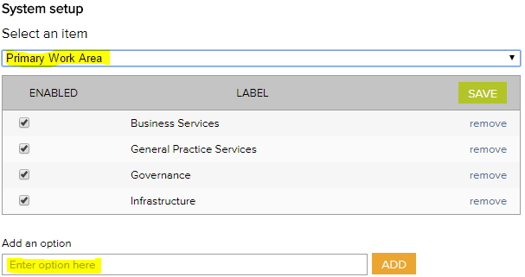
- To add new primary work area categories and type into the option field.
- Click add and click save.
- To remove primary work area categories that you don’t want, click remove and click save. (Note: Once an option has been used in a register item in the system the option can only be disabled and cannot be removed)
Create secondary category
- Select secondary work area from the system setup menu.
If a new primary category is created LOGIQC will automatically create a duplicate secondary menu label with the word ‘all’ appended. This option can be removed after other secondary options are added to the category. LOGIQC requires a minimum of one secondary menu option for each primary option.
- To add new secondary work areas, select the related primary work area and type into the option field.
- Click add and click save.
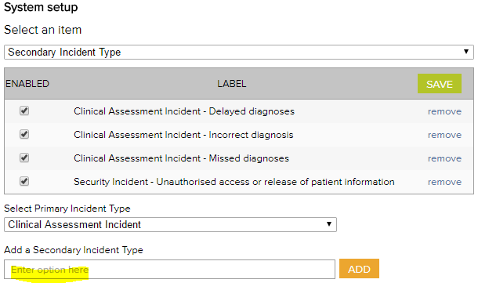
- To remove secondary work area categories that you don’t want, click remove and click save. (Note: Once an option has been used in a register item in the system the option can only be disabled and cannot be removed)

Removing or disabling menu options
If a menu option has been used in a register item LOGIQC will not allow it to be removed entirely from the system. It can, however, be 'disabled' (hidden) so that the option is no longer displayed.

To disable a menu option, un-check the enabled checkbox and click save. To remove a menu option, click remove and click save.
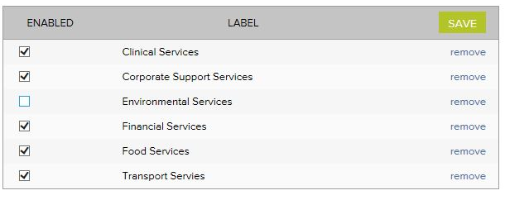

Add system users
User profiles are required so that users can log into LOGIQC. The staff contacts tab displays all system users who can access the system. Note: people must be entered as staff contacts to be able to log into the system.
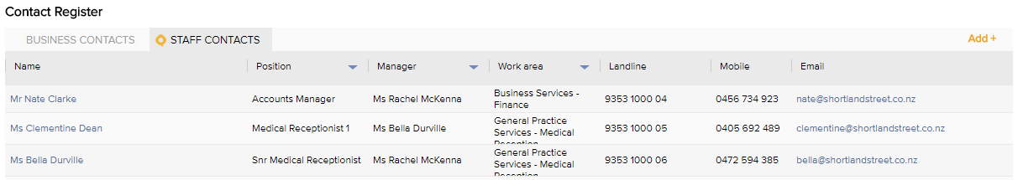
A system user is always displayed by their name and position. Position titles must be unique even if there are multiple positions with the same title. This is because tasks in LOGIQC are assigned to the position, not the person. When creating multiple positions of the same name, make them unique e.g. Nurse 1, Nurse 2 etc.
Setup the positions menu
- Log-in with the Administrator password and select system setup in the system settings menu.
- From the system setup menu, select positions.
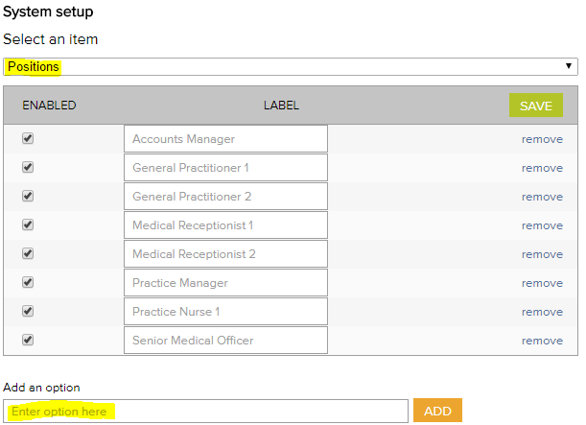
- To remove example positions, click remove and click save. (Note: Once an option has been used in a register item in the system the option can only be disabled and cannot be removed)
- To add new position titles, type the position title into the option field.
- Click add and click save.

Password re-set
To re-set a user's password:
- Log in as System Administrator
- Go to Contacts and open the user's profile
- Type a new password in the Password field and click save.
- Advise the user of their new log-in details and to update/personalise their password by selecting 'My profile' after logging in and editing their password field.

Add a system user
- Log in as administrator
- Click on contacts and click add
- Select the staff option in the contact type menu
- Complete the contacts details form referring to the instructions for each field below:

 | Select active to enable the user to log in. When a user leaves the organisation, their status should be set to inactive.
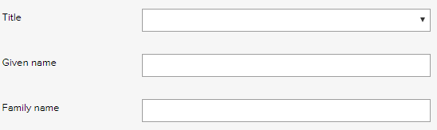 | Select the person’s preferred title and enter their family and given name.
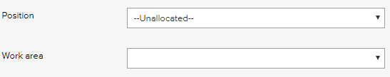 | Select the position title of the staff member. A user must have a position to receive tasks.  Select the work area and position relevant to the person.
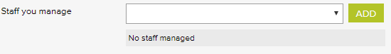 | Select the name of each staff member who reports to this position and click add.
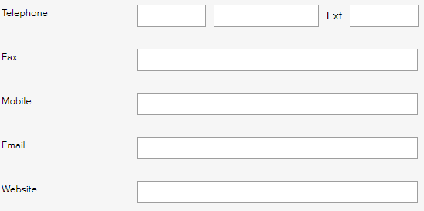 | Enter the contact details for the staff member. All users can see these details. Required fields are:  Telephone OR mobile number  Email
 | Specify the user’s system permissions. (see appendix or search on permissions in helpdesk)
 | Enter a username for logging on to the system e.g. firstname.lastname. It may be useful to use the same naming convention as the user network login account.
 | Enter the user password for logging in. Each user can reset their own password by clicking My profile after logging in. Tip: Passwords are case sensitive.

Site information
The site information settings controls certain automatic behaviours such as the number of days allowed to respond to a task and the frequency of sending automatic reminders.

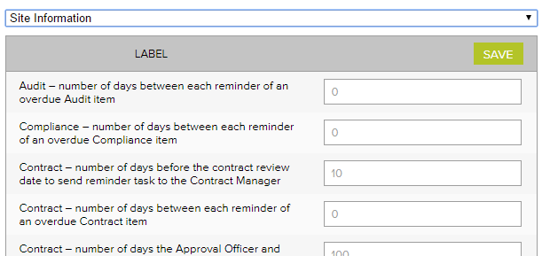

Site information setting | Purpose
Number of days between each reminder of an overdue item | LOGIQC can send email reminders to users with overdue tasks. This setting is available for each register and will determine the frequency of the reminder emails.
Number of days before the <xx> review date to send reminder task | LOGIQC scans the system regularly for documents and other items that have due dates for review. This setting determines the number of days prior to a review deadline to send a reminder to the relevant user.
Number of days the Approval Officer has to complete the Approval task | When an issue is reported, such as an incident, an approval officer will be assigned a task to respond. This setting determines the number of days the task should sit with the approval officer before LOGIQC marks it as overdue.

User login history
LOGIQC allows the system administrator to export a report of the log-on history for all users. This is an excel document that lists: username; date and time; IP of workstation; Success/failure of logon; and Web browser type for every user log-on attempt.
- Go to System setup and click the Excel file icon to export the report to Excel
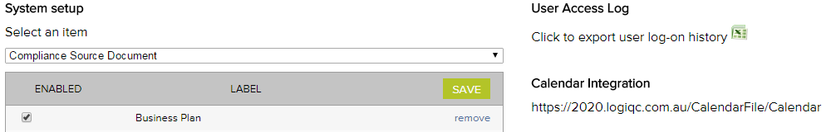

Calendar Integration
Each LOGIQC QMS has an individual internet calendar and the link is stored on the system setup page. Adding this Internet calendar to your email client (e.g. Outlook) will create a new calendar that will display and update with the users scheduled LOGIQC QMS meetings.
There are different instructions to do this depending on your version of MS Outlook and windows. You can access these instructions on the LOGIQC Helpdesk at https://support.logiqc.com.au

Register Settings
LOGIQC can be set to automatically close recurring tasks, e.g. audits and compliance tasks, that have not been completed by the time the next occurrence of the task is due. The tasks will be assigned a status of ‘not completed’. This feature can be activated by un-checking the ‘Do not auto-close overdue scheduled items’ checkbox.
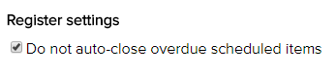

Hide items/tasks in the system
Register items in the system can be hidden by checking the 'hide' box next to the item. This terminates the task and removes the item from the view of all users. This will also automatically hide any related records or attachments on the Records register. The System Administrator will always be able to see the item and the item can be returned at any time by un-checking the box.
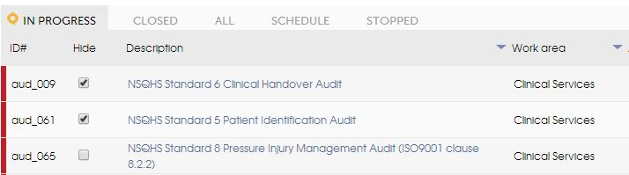

Risk register settings
Risk Settings
- Go to Risk Settings
- Complete the risk matrix fields to suit your organisation
- Save
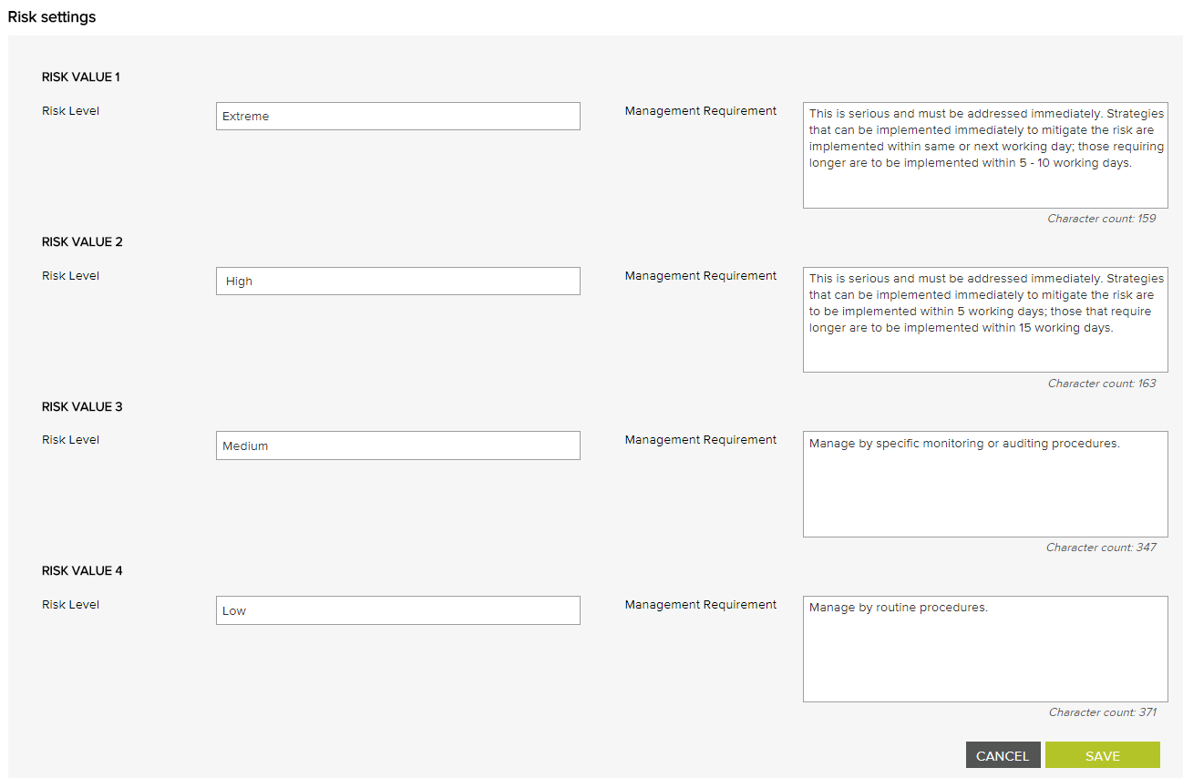
All risks will be assessed against the risk matrix
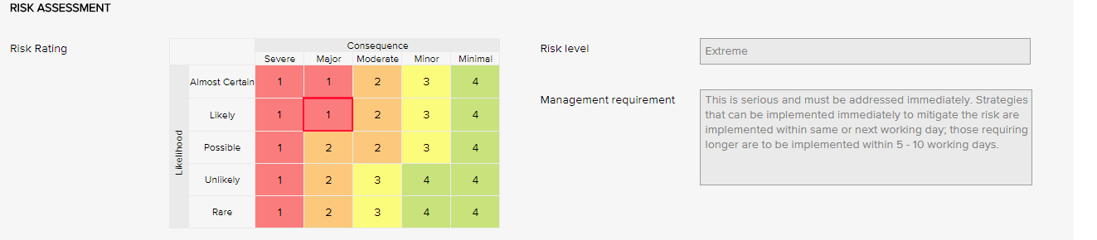

Creating risk treatment options
- Go to System setup and select Risk Treatment Option from the drop-down menu.
- Enter an option and click Add
- Save
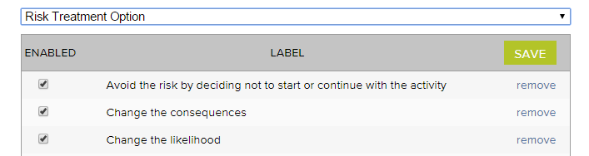

Accreditation register settings
Standard Settings
- Go to Standard Settings
- Select the Title of the standard
- Click + Add clause to add a new clause. Complete the Reference and Name field then click Save.
- Click + Add Sub clause to add a sub clause under an existing clause of the standard. Complete the Reference and Name field then click Save.
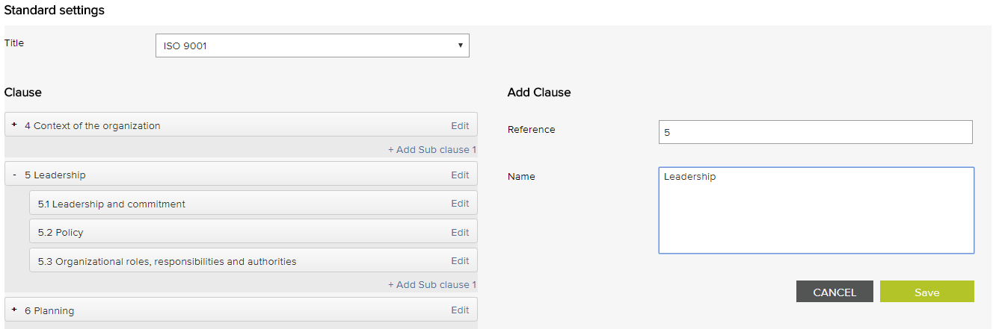
These settings will display in the corresponding drop-down menus on the Accreditation Details Form.
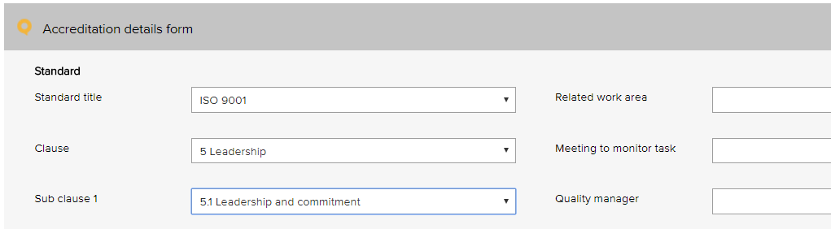

LOGIQC workflows
LOGIQC comprises four workflows that act as built-in business rules about how to manage the business processes:
Workflow 1: Documents and Suppliers

Workflow 2: Contracts, Risks and Accreditation Standards
Workflow 3: Audit, Compliance, Training and Licensing
Workflow 4: Incidents, Feedback, Repairs and Improvements

LOGIQC User Permissions
 | User permission level
Permissions | External Auditor | Read/Report only | Staff | Creator | Approving Officer | Manager  (level 1-2) | Manager  (level 3) | Manager  (level 4) | Quality Manager | CEO | System administrator
See all registers
Add items to Improvement, Feedback, Incidents, Repairs registers
Carry out tasks
Add items to Documents, Contracts, and Records registers
Add items to Audit, Compliance, Meetings, Training, Licensing and Contacts registers
Re-assign tasks to other users and change the due date of tasks
Access to archived documents and records
Approve and delegate tasks
Un-publish a document and see unpublished documents
Un-approve a supplier
See register items with CEO, Managers and Approval Officers access permissions |  | Only when user is the review officer | Only when user is the review officer | Only when user is the review officer
See register items with CEO and Level 3 and 4 Managers access permissions |  | Only if user is the action or approval officer | Only if user is the action or approval officer | Only if user is the action or approval officer | Only if user is the action or approval officer | Only if user is the action or approval officer
See register items with CEO and Level 4 Managers access permissions |  | Only if user is the review officer | Only if user is the review officer | Only if user is the review officer | Only if user is the action or approval officer | Only if user is the action or approval officer | Only if user is the action or approval officer
See register items with CEO and assigned Approval Officer access permissions |  | Only if user is the review officer | Only if user is the review officer | Only if user is the review officer | Only if user is the action or approval officer | Only if user is the action or approval officer | Only if user is the action or approval officer | Only if user is the action or approval officer
Access system setup and user password re-set
NOTE: These access restrictions are over-ridden if a user is specifically given access by entering their name in the “users” field or by being the set as the approval or action officer.



PO Box 483, Paddington, Qld, Australia 4064 | 37 Kennigo Street, Fortitude Valley Qld 4006
AU +617 3216 0335 NZ 0800 002 280 E: info@logiqc.com.au W: logiqc.com.au

