Organisation Name:
Organisation Contact:
Planned Migration date:
Return this document to LOGIQC by:

Congratulations for choosing to upgrade to the new LOGIQC v6 QMS platform
Migrating to the new platform is easy. We will take your existing system offline for a few hours, transfer all the data, and then return the new platform online ready for use. All data, documents and tasks will be transferred and returned exactly as they were in your v5 system.
Apart from preparing your organisation for the change, the only thing you need to do is to review the new menus included in the v6 platform and recommended default menu label options and advise us if you want changes. If the default options look right for your organisation, you can always run with them and make changes later as people start to use the system.
The new menus in the v6 platform are designed to make the platform easier to use and to provide better reporting capability. This form describes each of these new menus and lists the default menu label options that will be created. The new menus are:
- Repair type (Repairs register)
- Repair location (Repairs register)
- Asset (Repairs register and Incidents register)
- Incident location (Incidents register)
- System failure type (Improvement register)
- Risk criteria (Risk register)
- SAC criteria (Reporting registers)
- SAC rating action (Reporting registers)
- Risk Criterion
- Assessment results for SAC

What you need to do
Review each of the menus in this document and the recommended default menu label options and let us know if you would like any changes made before we build your new v6 platform.
Instructions
For each menu shown in this document, review and revise the default options to reflect your organisation’s operating environment.

Is there a deadline?
Yes. If you want changes made to these menus before your new v6 platform is released, you must advise us by 00/00/0000.
1. Repair type menu
Repair Type is completed on the Repairs Register details form. This drop-down menu allows for repairs to be categorised. The categories chosen are important as they will drive the basis of analytical reports.

Default menu label options (Review and revise as required)
Maintenance
Repair
Service
Calibration
Other

2. Repair location menu
Repair location is completed on the Repairs Register details form. Allows for a specific location of the repair/maintenance issue to be selected. The categories chosen are important as they will be used as the basis for analytical reports.

Default menu label options (Review and revise as required)
Board room
Building
Car park
Consult room 1
Consult room 2
Entrance
Grounds
Internal stairwell
Lift
Reception
Staff room
Training room
3. Asset
Allows for a specific asset relating to the issue to be selected. The categories chosen are important as they will be used as the basis for analytical reports. Completed on:
- the Repair Register details form in the ‘Item/s needing repair or maintenance’ field
- the Incident Register details form (if the ‘damage to asset’ checkbox is selected)

Default menu label options (Review and revise as required)
Air conditioning unit
Clinical equipment
Humidifier
Intercom system
Medical gas system
Nurse call system
Patient monitoring equipment
Sterilizer
Vehicle (rego number)

4. Incident location menu
Incident location is completed on the Incident Register details form. Allows for a specific location of the incident to be selected. The categories chosen are important as they will be used as the basis for analytical reports.

Default menu label options (Review and revise as required)
Board room
Building
Car park
Consult room 1
Consult room 2
Entrance
Grounds
Internal stairwell
Lift
Reception
Staff room
Training room

5. System failure type
System failure type is completed on the Improvement Register when the improvement type is a ‘Non-conformance’. The menu allows for a general type of system or process to be selected as the area impacted by the non-conformance.

Default menu label options (Review and revise as required)
Financial system and processes
HR systems and processes
Information management systems and processes
Management systems and processes
Service delivery systems and processes
Communication systems and processes
Decision making processes

6. Risk criteria
In the Risk details form there is a ‘help’ button that displays text to help a user rate a risk. Four pieces of text are required that relate to low, medium, high, and extreme risk levels.
Default text (Review and revise as required)
Low | Medium | High | Extreme
No measurable operational delay or interruption  Clinical issue reported but no action required  No measurable operational delay or interruption to information technology  No or minimal financial loss of income  Minor adverse publicity, no impact on clients or stakeholders  Issue reported - no injury sustained  Incident reported- no action required | Short term disruption to essential services <5 days  Disruption to operating and clinic services <5 days  Significant incident requiring investigation and review of clinical processes and procedures  Disruption to information technology <1 day  Financial loss of income <$5k  Significant adverse publicity  Funding body request organisation to 'explain'  Short term loss of time <5 days due to injury / incident in the workplace (work related) | Disruption to essential services >5 days  Disruption to operating and clinic services >5 days  Serious incident resulting in hospitalisation or further treatment  Disruption to information technology >1day  Financial loss of income >$5k  Major adverse publicity  Serious injury / incident in the workplace (work related) requiring hospitalisation | Disruption to essential services >14 days  Disruption to operating and clinic services >14 days  Serious breach of clinical standards requiring notification to external authority  Permanent loss of data  Financial loss of income >$25k  Sustained adverse publicity  Permanent damage to stakeholder relations  Death in the workplace (work related)  Serious breach of Workplace Health and safety  Serious breach of legal, regulatory or policy requirement  Serious financial or statutory breach  Notification of external authority or civil case  Significant impact on organisation' viability
Revised help text:

7. SAC criteria
In the Incident details form and the Manage forms of the Incident, Improvement, Repairs and Feedback Registers there is a ‘help’ button that displays text to help a user rate the severity of the event/issue. Four pieces of text are required that relate to SAC levels 1-4
Default text (Review and revise as required)
SAC 1 | SAC 2 | SAC3 | SAC4
Sentinel Event, or death that is unrelated to the natural course of the illness/injury and differing from the expected outcome of the consumer’s health care management | Major permanent loss of bodily functioning (sensory, motor, physiologic or intellectual) that is unrelated to the natural course of the illness/injury and differing from the expected outcome of consumer’s health care management | Permanent lessening of bodily functioning (sensory, motor, physiologic, or intellectual) that is unrelated to the natural course of the illness/injury and differing from the expected outcome of consumer’s health care management | Increased in level of care required, including;  • review and evaluation  • additional investigations  • referral to another clinician
revised help text:

8. SAC assessment result
When a SAC rating is selected, a message appears that provides information about the company’s response protocols e.g. response times and which positions are to be notified. Four pieces of text are required that relate to SAC levels 1-4
Default text (Review and revise as required)
SAC 1 | SAC 2 | SAC3 | SAC4
This is serious and must be addressed immediately. Notify CEO, SMO and Practice Manager. | This is serious and must be addressed immediately. Notify SMO and Practice Manager. | Manage by specific monitoring. Notify Practice Manager. | Manage by routine procedures.
Revised text:

Post – migration
- Incident area
To make it easy for users to navigate long menus, the new Incident Area menu acts as a master control that limits the list of menu options by providing only the incident types related to one of the three main areas* below:
- Clinical
- Workplace Health and Safety
- Operational
To enable this functionality, your system administrator will need to link each of your incident types to one or more of the Incident Areas. This will need to be done as soon as possible after the migration
Example:
Incident area | Incident type
Clinical | Incorrect patient handover
Clinical | Acute VR Surgery
Clinical | Patient collapse
Clinical | Controlled drug register - count error
Workplace Health and Safety | Blood and body fluid exposure
Workplace Health and Safety | Needle stick injury
Workplace Health and Safety | Electrical safety issue
Operational | Damage
Operational | Lift failure
Operational | Loss of network connectivity

*Note: The titles of the Incident areas above can be modified by LOGIQC specifically for your organisation. For example, a non-clinical organisation in WA, the following options might be more appropriate:
- Service delivery
- Occupational Health and Safety
- Operational

- Items in Approve for action stage
Items which were in the ‘Approve for action’ in the Reporting registers (Incidents, Feedback, Improvement, Repairs) stage prior to migration, will appear in the Close stage when your system is released in v6.
The task options that the user will have in v6 are the same as they were in v5. That is, they can close the issue or assign the issue to someone for action. However, the issue to be aware of is that users may close items off prematurely thinking that they have been fully reviewed and managed. This issue only relates to open items at the time of migration and will cease to be an issue once these existing items are closed.
For items in this state, the workflow navigation bar will appear as follows:
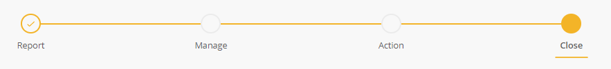
And the task options for the user will be:
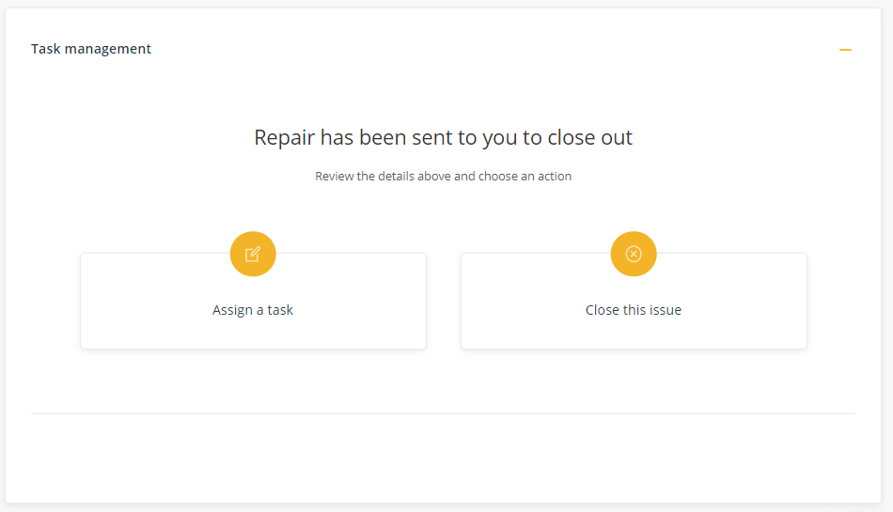

- Review and assign Document Managers and Document Owners
A new role called Document Manager has been introduced in the Documents register. A Document Manager is assigned to each document and is responsible for managing the review and update of the document and for sending the document to the Document Owner (Approval Officer) when it’s ready for approval.
This means that senior staff including the CEO can be assigned as the Document Owner for approval at ‘the end of the chain’ and they won’t have to manage the ‘day-to-day’ review processes.
You can assign the same person to both roles if that is appropriate for your business. In this case, there are new features that will make it fast for the same person to perform both roles.
The Document Manager:
- Will receive notifications when a document is due for review
- Can assign the document to a user (including themselves) to review
- Can escalate the document to the Document Owner for approval
- Can approve documents when they are also assigned as the Document Owner

- Review and assign Supplier Managers and Supplier Owners
A new role called Supplier Manager has been introduced in the Suppliers register. A Supplier Manager is assigned to each supplier and is responsible for managing the review of the supplier and for sending the supplier to the Approval Officer when it’s ready for approval.
This means that senior staff including the CEO can be assigned as the Approval Officer for approval at ‘the end of the chain’ and they won’t have to manage the ‘day-to-day’ review processes.
You can assign the same person to both roles if that is appropriate for your business. In this case, there are new features that will make it fast for the same person to perform both roles.
The Supplier Manager:
- Will receive notifications when a supplier is due for review
- Can assign the supplier to a user (including themselves) to review
- Can escalate the supplier to the Approval Officer for approval
- Can approve suppliers when they are also assigned as the Approval Officer

- Target Risk Rating
In rating a risk on the Risk Register, there are now 3 ratings:
- Uncontrolled risk rating
- Controlled risk rating
- Target risk rating – this is a new rating
Post migration, each risk on the Risk Register, needs to be reviewed and assigned a ‘target risk rating’. The ‘target risk rating’, is the level in which the organisation will accept the risk. Where the ‘controlled risk rating’ is higher than the ‘target risk rating’ further risk mitigation action is required.

