LOGIQC v6 QUICK START GUIDE

Logging in
Open your Internet browser (e.g. Google Chrome, Microsoft Edge) and go to https://organisation_name.logiqc.com.au (Note: using ‘www’ in the address will take you to the wrong page)
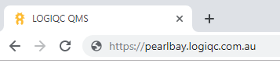
Enter your username and password, and click log in
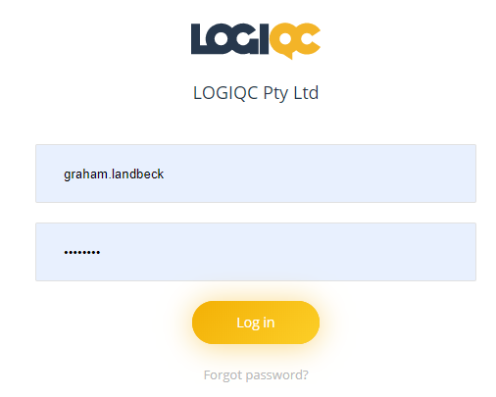
Forgot password
If you’ve forgotten your password, click on the Forgot password? link
Enter your username, tick the 'I'm not a robot' box and then click on 'Submit’ and a reset password will be sent to your email address.
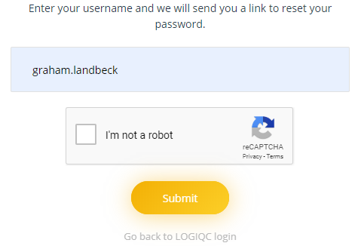
If you can't remember your username, or need further assistance, click on the link and a Help Desk request form will open. Fill out your details, submit the form and the LOGIQC Help Desk team will respond.
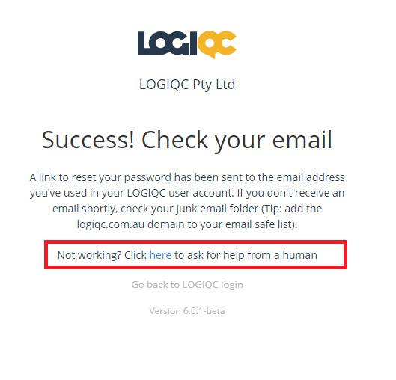

The LOGIQC QMS Home Screen
This is your where you access your account details
When you log into LOGIQC QMS, you will open at the dashboard.
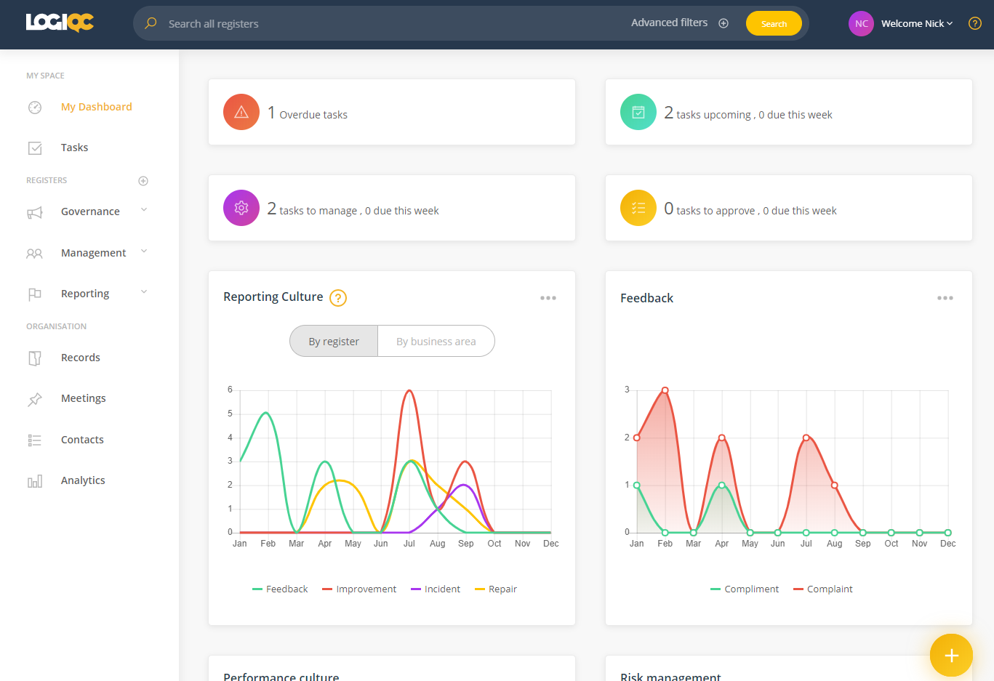
This is the FAB where you add items
These are the register menus

This is the link to the Help Centre

Updating your password and account details
- After logging in, go to your account details, located at the top right of the screen identified by your name
- Click on your name and select ‘My Account’
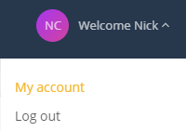
User account details form
This is where you update your account details e.g.: phone numbers
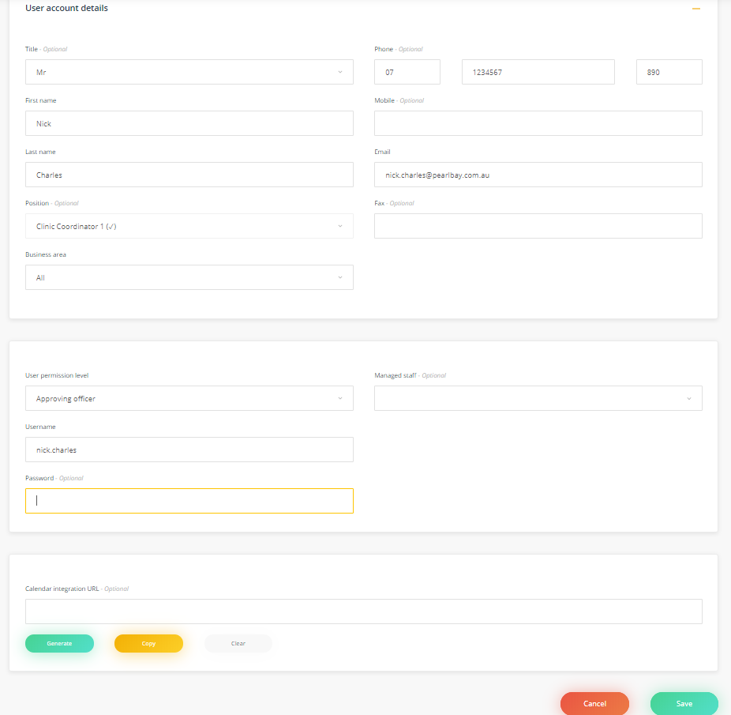
This is where you change your password
This is where you save your account changes
To change your password, you simply enter a new password in the Password field and click on ‘Save’.

LOGIQC Help Desk
Click Help? (top-right of screen) to access the LOGIQC Help Centre

The LOGIQC Help Centre is a public facing web site. To access the Help Centre from outside of the LOGIQC QMS platform, go to https://helpcentre.logiqc.com.au/hc/en-us We recommend you save this address as a bookmark.
LOGIQC Help Centre
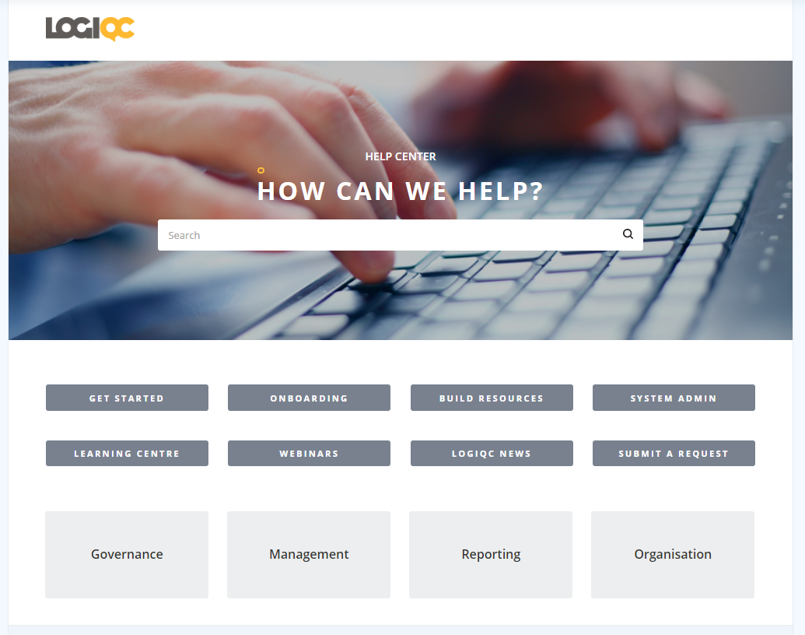
These sections contain Help articles about these registers
This is where you log a Help Desk request
This is where you search for articles using keywords
This is where you access courses and workshops

Report an event (e.g. incident, repair, feedback, improvement)
The FAB (Floating Action Button) is how items are added into the LOGIQC QMS.

To report an event:
- Navigate to the FAB located at the bottom right of the LOGIQC QMS screen. As you hover your mouse over the FAB, it will expand to ‘Add item’. Click on this
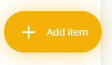
- The Reporting registers will open. Select a register by clicking on the ‘+’ button beside the register name.
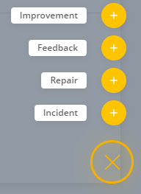
- You will open to the chosen register’s details form. Fill out the details and select ‘Submit’

View a document
- Select Documents from the Governance menu, located on the left-hand side of the LOGIQC QMS screen
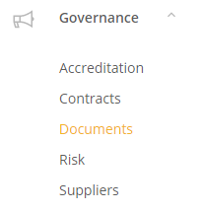
- To search for a document, use the filter located at the top right of the Documents register. Type the name of the document or a key word in the filter and hit enter on your keyboard.

Note: This filtering functionality exists across all registers in LOGIQC QMS.
- When you have found the document, click on the file icon in the View column to open a preview of the document
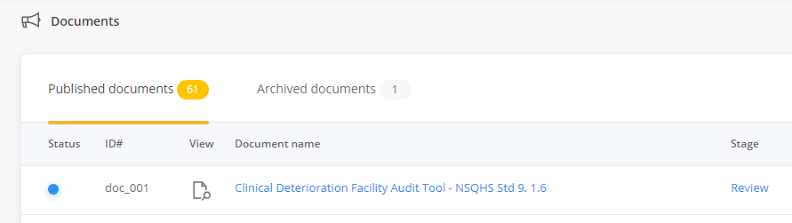
You can download the document to your computer by clicking on the Download button 

Complete a Task
If you have been assigned a task you will receive an email and a task will be listed in My tasks when you log in.
- Click on the name in the Description column to open your task and review your options and instructions.
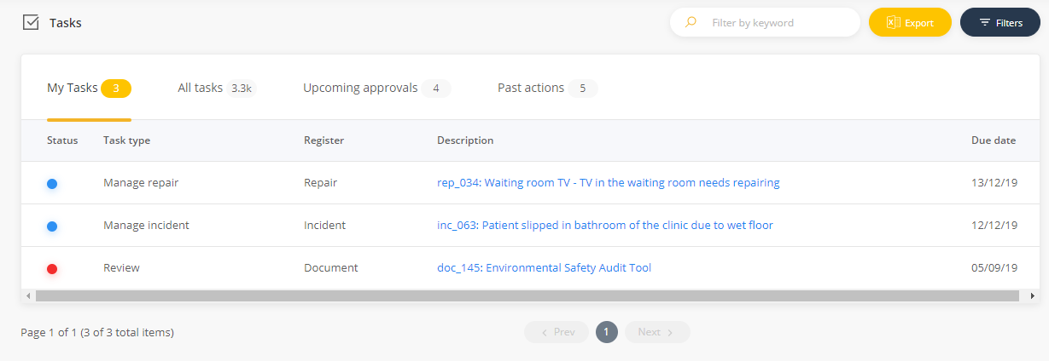
Attach a record to the task (Optional).
- When you open your task, scroll down the page to Attach records. Click on Attach.
- Name the record in the Record name field
- Select Choose file and select the file from your computer
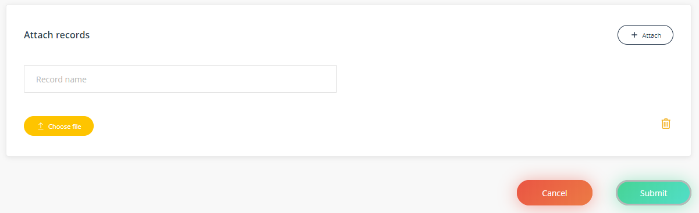
- Click on Submit and the record will be uploaded into LOGIQC.

LOGIQC workflows
Workflow: Incidents, Feedback, Repairs and Improvements
When reported, item goes to a user who can review the issue, assign tasks if necessary, and escalate for closure when ready. If the user managing the item is the same use who will close the item, the new ‘quick approve’ feature will allow for the quick closure of the item.
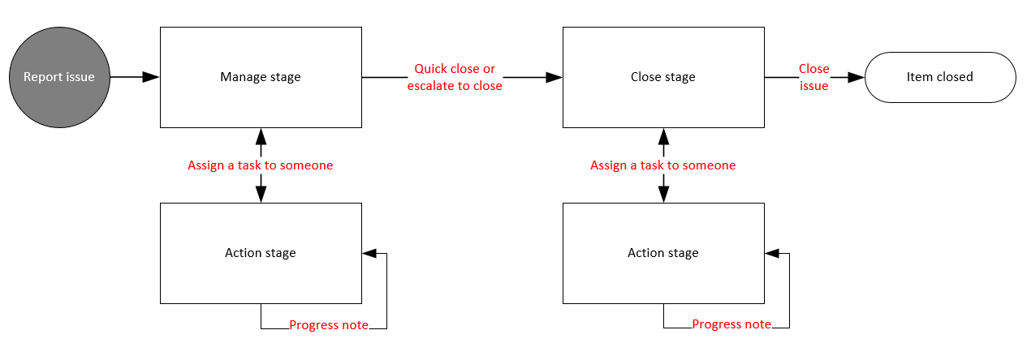

Workflow: Documents and Suppliers
When added, item goes to a user who can review the document/supplier, assign review tasks if necessary, and escalate for closure when ready. If the user managing the document is the same user who will approve the document, the new ‘quick publish’ feature will allow for the quick approval and publishing of the document.
