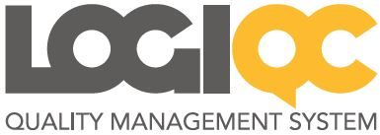

LOGIQC QMS v6 – new features

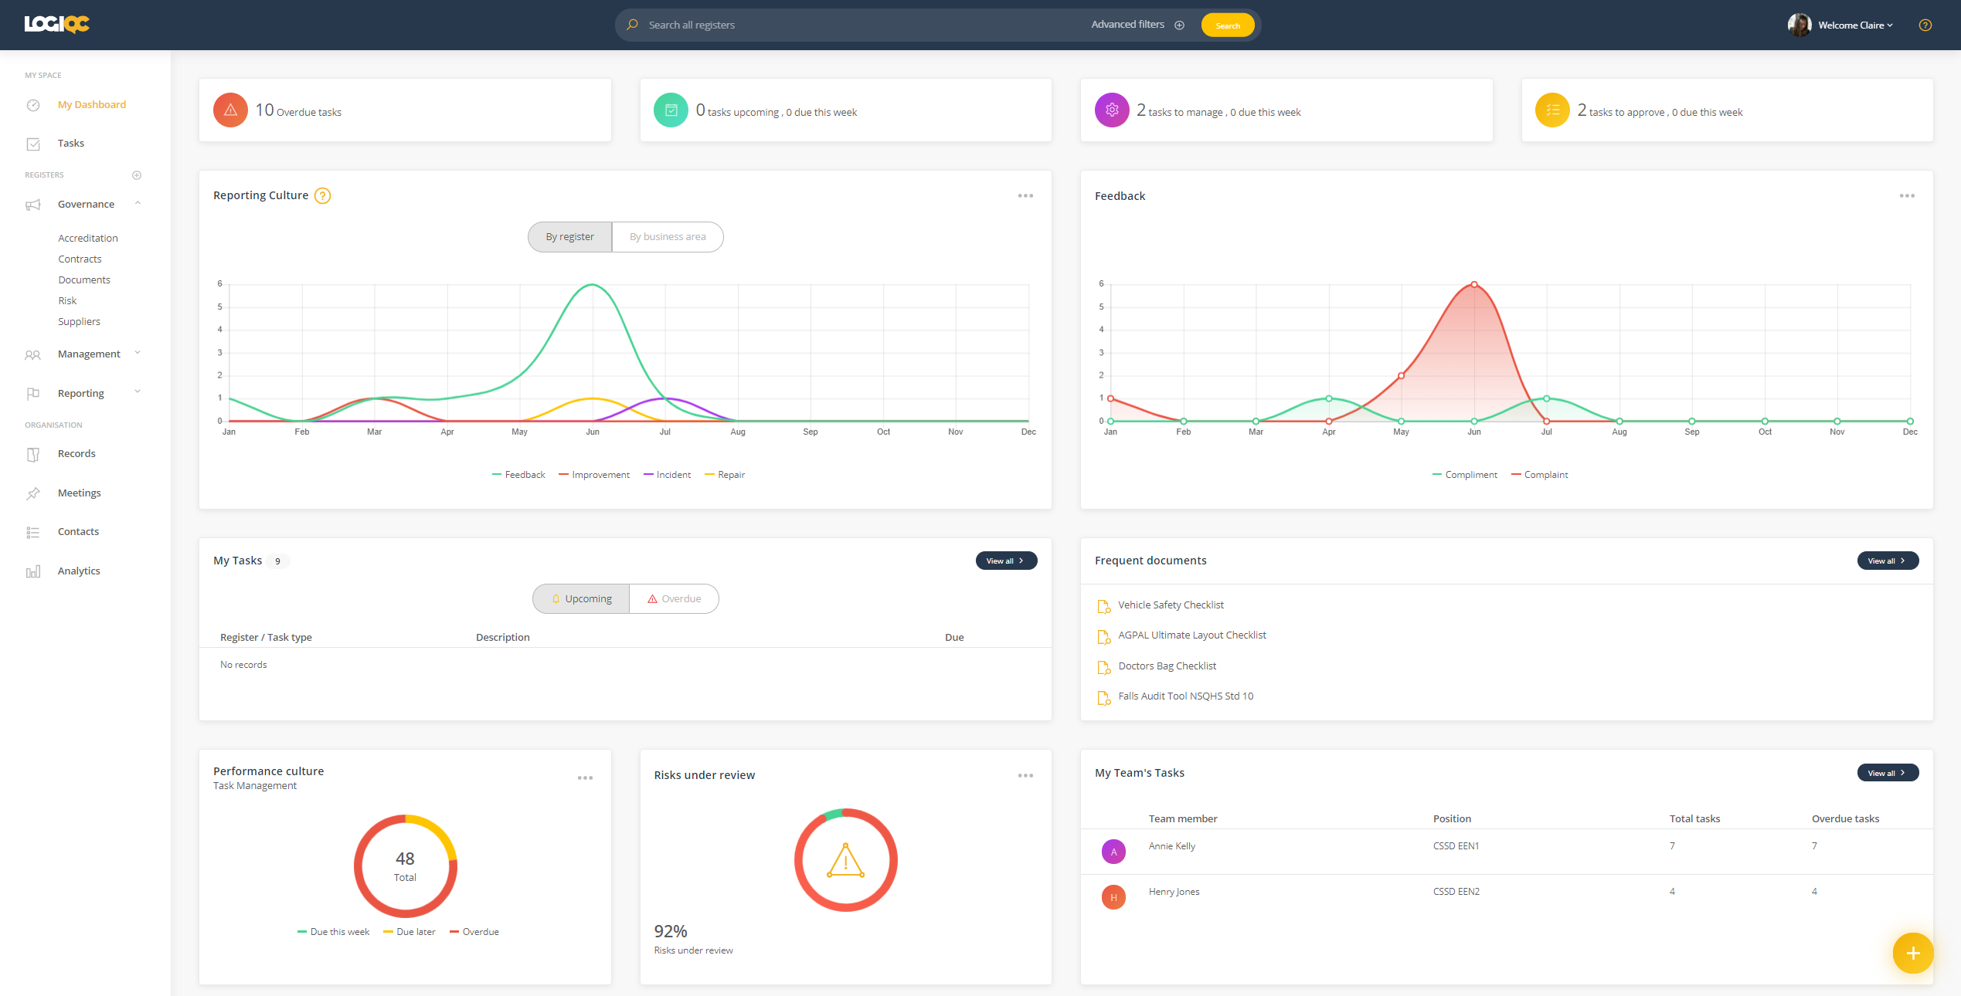
Screenshot of the new LOGIQC platform dashboard
We are excited to announce the ‘new generation’ LOGIQC QMS platform. LOGIQC v6 is the result of a two-year design and development process to improve usability, add new features and respond to feedback from users.
Main new features in the platform:
- Dashboard
- Global search
- Simpler forms and more intuitive workflows
- Enhanced incident management
- Improved analytics
- Document preview
- Optimised to work like an app on your mobile and tablet
- Simpler scheduling
- ‘Quick-publish’ and ‘Quick-approve’ features to publish documents and close items in a single session
This proposal provides information about the new pricing model, special incentives to migrate, and the process involved to move to the new platform.

FAQ’s

What’s different about the new platform?
While the new platform ‘look and feel’ is very different to the current system, all the registers and tasks that users carry out remain unchanged. The new ‘look and feel’ is designed to be far more intuitive and easier to use.
The key differences with the new platform can be considered at three main levels:
- Appearance and controls (UI)
The user interface of the new system includes a new design, a dashboard, easier forms, and enhanced ways to search across the entire platform in just one click.

- Navigation and workflow (UX)
Navigation is done via a panel on the left-hand side of the screen and tasks now come with added information for the user to see what’s happened, what they are supposed to do, and what’s next. An additional workflow step called ‘Manage’ in Documents, Incidents, Feedback, Improvements, Repairs and Suppliers has been added allowing for the item to be assigned to a separate user to ‘manage’ prior to being escalated for approval. The platform has also been optimised for mobile and tablet use.

- Simplified forms
Forms have been made quicker and easier to complete allowing the user to choose when additional information needs to be added.
Do we have to migrate to the new version?
You don’t have to migrate to the new platform. Although the current v5 platform is no longer offered to new customers, you can choose to remain on the platform and we will continue to provide support through bug fixes and Helpdesk for users for the foreseeable future.
Is there support to migrate to the new version?
Yes. LOGIQC QMS v6 comes with a dedicated Help Centre with webinars, animated instructional articles and a learning centre with courses for individual users and trainers. Onsite training and support are also available.
Is there support to migrate to the new version?
Yes. A member of our Customer Success team will be assigned to your organisation who will be your touchstone throughout the migration process. And, an online portal will be created with a migration project plan, resources and templates you can use for communication to staff about the changes in the new platform.
In addition, LOGIQC QMS v6 comes with a dedicated Help Centre with webinars, instructional articles and a learning centre with courses for individual users and trainers.
Training packages are also available to support your migration or general refresher training for staff.

New features

LOGIQC QMS v6 is the result of a two-year design and development process to improve usability and add new features. The process involved user consultation and review of user feedback and suggestions.

Here is a ‘top line’ list of the new features.
- User dashboard configured separately for different user permission levels
- Global search and results page allowing one query to search across all registers
- Additional workflow step in Documents, Incidents, Feedback, Improvements, Repairs and Suppliers allowing for the item to be assigned to a separate person to ‘manage’ prior to being escalated for approval
- ‘Quick-publish’ feature for a single user to upload, approve and publish documents in a single session
- ‘Quick-approve’ feature for a single user to report and close items, such as incidents and improvements, in a single session
- Optimised to work like an app on your mobile and tablet
- Improved UX (user experience) through clear task options and a new ‘Action history’ displaying all past user actions and comments on a single item
- Improved navigation logic and more intuitive workflow/task options
- New user interface
- More search filters
- Simpler forms with a more logical design
- Simpler scheduling
- Improved reports and analytics
- Enhanced incident management
- Business ‘intelligence’ for quicker and easier completion of forms
- New asset list menu to link incidents and repairs to a specified asset
These are some the major new features. There are many other changes that make the new platform easier and more intuitive to use.
Bookings for online demos of the new platform can be made by emailing info@logiqc.com.au

New workflows
New ‘Manage’ stage in Incidents, Feedback, Improvements and Repairs registers
When reported, item goes to a user who can review the issue, assign tasks if necessary, and escalate for closure when ready. If the user managing the item is the same use who will close the item, the new ‘quick approve’ feature will allow for the quick closure of the item.
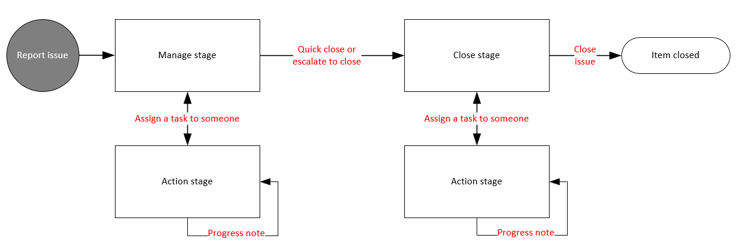

New ‘Manage’ stage in Documents, Records, and Suppliers registers.
When added, item goes to a user who can review the document/supplier, assign review tasks if necessary, and escalate for closure when ready. If the user managing the document is the same user who will approve the document, the new ‘quick publish’ feature will allow for the quick approval and publishing of the document.
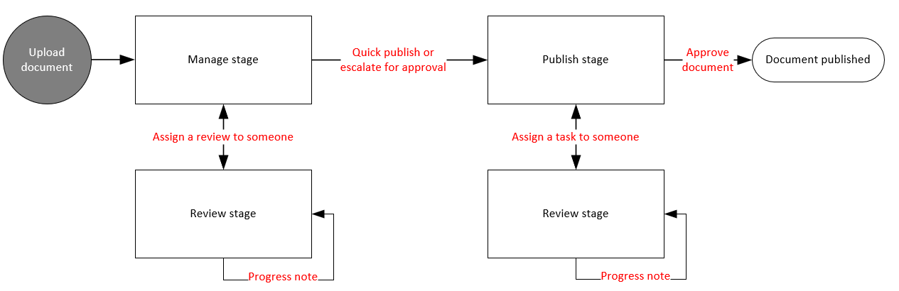

Next steps/implementation overview

What are the next steps?
- If you haven’t already seen the new platform, book a demo by emailing info@logiqc.com.au or view webinars at https://helpcentre.logiqc.com.au/hc/en-us/sections/360000231795-Get-started-videos-click-here-
- Confirm your acceptance of quote for the upgrade to LOGIQC QMS v6 + once-off migration costs
- You nominate your preferred date for migration to the new platform (typically a Monday)
- We create a migration plan and start working with you to support the process
- Your system is taken offline (typically a Friday) and updated by the following Monday

Recommended process:
Week 1 | Week 2 |  | Week 3 |  | Week 4
- Primary Contact contacted to discuss migration to v6  - Session 1: Onboarding the Transformation Team – overview of process and training resources  - Session 2: How to add and modify the System Setup to enable new functionality of v6 (for System Administrator/s) |  | - Release 1st comms to users (template provided)  - System champions view pre-recorded webinar ‘Intro to LOGIQC v6 – a new generation’  - Management determines changes and additions for the v6 System Setup (example and template provided) |  | - Release 2nd comms to users (template provided)  - Session 3: Navigating v6 (for Managers and LOGIQC champions) (recorded and provided to service for future training purposes)  - Suspend system access (Typically on the Friday)  - System migration and testing (completed by LOGIQC)  - LOGIQC updates System Setup as per the specifications provided by the Service or with default settings applicable to service type |  | - System go-live (Monday)  - LOGIQC sends email to all users advising of upgrade to v6 (Monday)  - Session 4: Intro to v6 Workflows (for Managers)  (recorded and provided to service for future training purposes)  - Session 5: ‘Get started with v6’ (for all Users)  (recorded and provided to service for future training purposes)

