LOGIQC QMS SETUP GUIDE - DAY HOSPITAL CONSULTING
This guide supports the set-up of the LOGIQC Quality Management System menus for Day Hospital Consulting clients in accordance with the requirements of the National Safety and Quality Health Service Standards (September 2011) and the ISO 9001:2015 Quality management systems - Requirements.

Customising menus

System menu types
There are two main types of menus in LOGIQC: single level menus and double level menus. Most menus are single level. The double level menus are work area, incident type and identified risk.

Single level menu example | Double level menu example
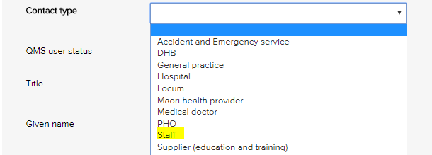 | 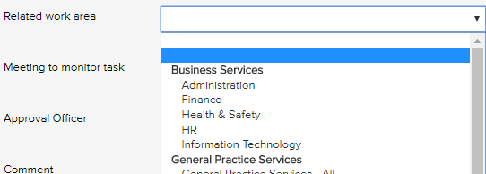
Single level menus  Accreditation assessment  Compliance source document  Contact type  Contract category  Document category  Feedback category  Feedback source  Feedback type  Improvement source  Licensing type  Meetings *  Positions *  Records category  Risk dimension  Risk treatment information  Supplier assessment criteria  Training type  * The content in these menus can be edited. | Double level menus  Primary + secondary incident type  Primary + secondary work area  Risk category + risk name

Editing single level menu options
These instructions use the contact type menu as an example.
- Log-in as administrator and select system setup in the system settings menu.
- From the system setup menu, select the menu to edit.
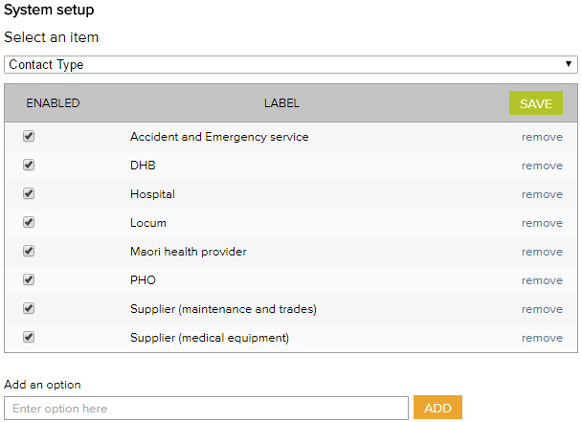
- Enter the new menu option into the add an option field.
- Click add and click save.
- To remove menu options, click remove and click save. (Note: Once an option has been used in a register item in the system the option can only be disabled and cannot be removed)

Editing double level menu options
These instructions use the work area menu as an example.
- Log-in with the Administrator password and select system setup in the system settings menu.
- From the system setup menu, select primary work area from the menu. From this screen, you can customise the menu to your organisation by adding and removing menu options.
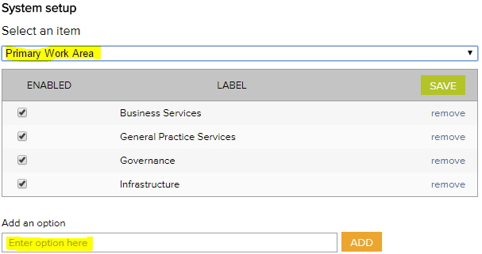
- To add new primary work area categories and type into the option field.
- Click add and click save.
- To remove primary work area categories that you don’t want, click remove and click save. (Note: Once an option has been used in a register item in the system the option can only be disabled and cannot be removed)
- Select secondary work area from the system setup menu.
If a new primary category is created LOGIQC will automatically create a duplicate secondary menu label with the word ‘all’ appended. This option can be removed after other secondary options are added to the category. LOGIQC requires a minimum of one secondary menu option for each primary option.
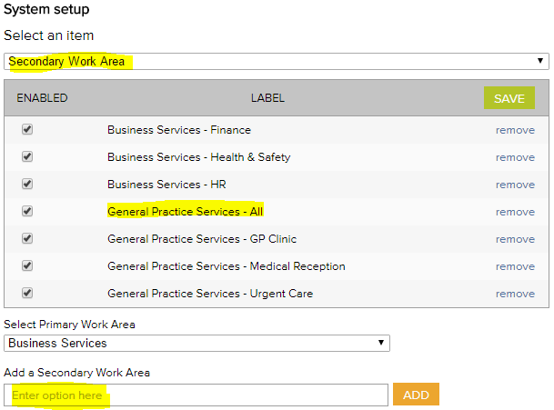
- To add new secondary work areas, select the related primary work area and type into the option field.
- Click add and click save.
- To remove secondary work area categories that you don’t want, click remove and click save. (Note: Once an option has been used in a register item in the system the option can only be disabled and cannot be removed)

System menu examples

Accreditation Register
The accreditation business system is used to group ‘accreditation actions required’ into higher order categories in the accreditation action plan and excel export. This way the individual tasks added can be categories.
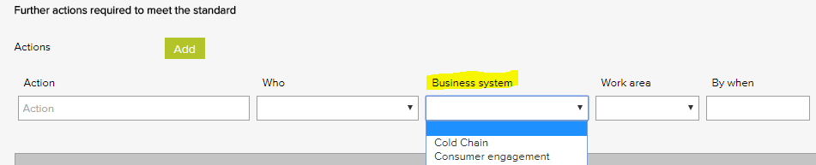

Accreditation business system - Examples
Accountability and reporting
Cold chain
Consumer engagement
Equipment - medical
Equipment - non-medical
Governance - clinical
Governance - corporate
Infection control
Internal communication
Management - clinical
Management - corporate
Training - induction
Training - mandatory

Compliance Register
The Source of requirement menu is used when scheduling a compliance task. It allows for the task to be coded to the entity or regulation that stipulates that the task should be carried out. Reports can be generated based on the selections in this menu.
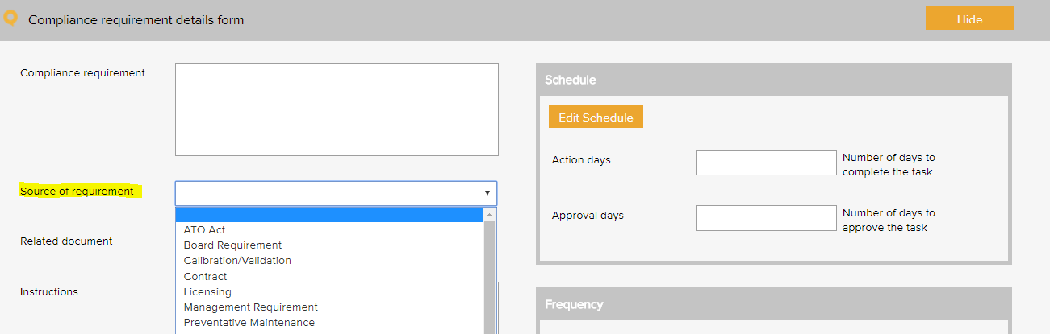

Compliance source document category - Examples
Antibiotic guidelines
AS 31000 Risk management: principles and guidelines
AS 4485:1997 Security for healthcare facilities
AS / NZS 4187:2014 Reprocessing of reusable medical devices
AS4260-1997 HEPA filters-classification
Australian commission on safety and quality in health care
Australian standards
Australian tax law
Australian guidelines for infection control
Board requirement
Calibration / validation
Compliance - national blood authority
Management requirement
Manufacturer's instructions
National hand hygiene initiative
Regulation
Superannuation policy and legislation
Therapeutic goods administration (TGA)
Work health and safety act

Contact Register
The contact type menu is used when adding a business contact to the contacts register. It allows for the contact to be coded to a category. Reports can be generated based on the selections in this menu.
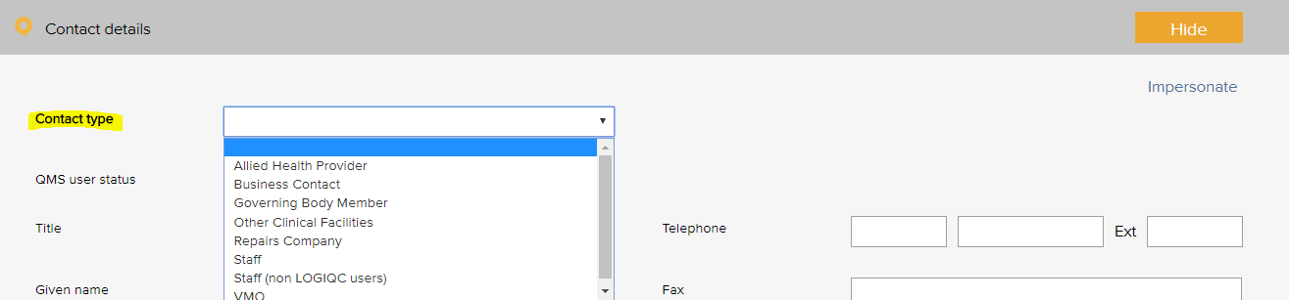

Contact type - Examples
Advocacy and support services | Supplier - education and training
Agency staff | Supplier - hospital environment and cleaning
Business contact | Supplier - IT and support
General practitioner | Supplier - maintenance
Government agency | Supplier - medical equipment
Industry body | Supplier - medical gases
Medical practitioner - anaesthetist | Supplier - medical supplies
Medical practitioner - surgeon | Supplier - office
Staff | Supplier - waste management
Standards agency | Visiting medical officer - surgical assistant

Contract Register
The contract category menu is used when adding a contract to the contracts register. It allows for the contract to be coded to a category. Reports can be generated based on the selections in this menu.
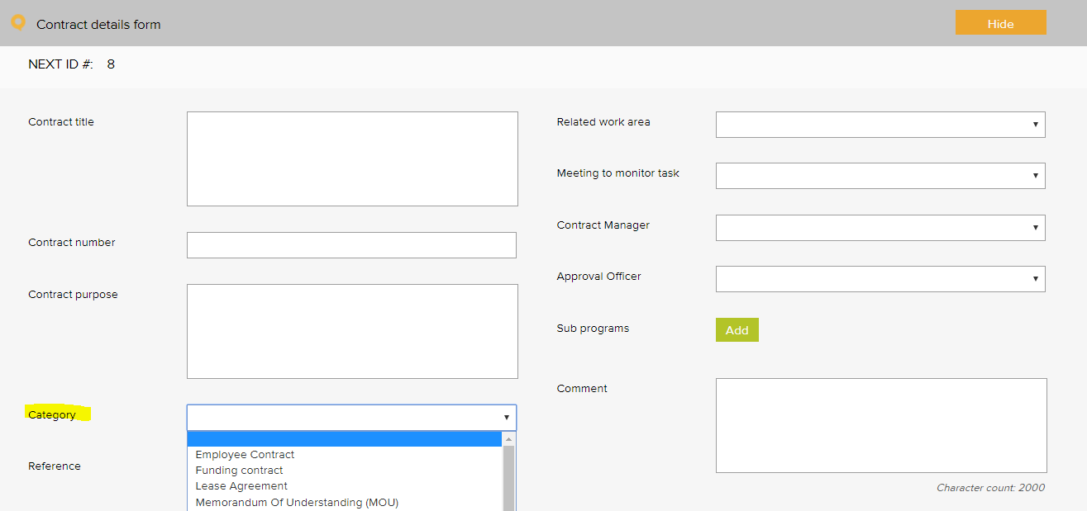

Contract category - Examples
Confidentiality agreement | Memorandum of understanding (MOU)
Contractor agreement | Non-disclosure agreement
Employee agreement | Partnership agreement
External provider agreement | Position description
Funding agreement | Rental agreement
Health insurance agreement - 2nd tier default benefits | Service level agreement (SLA)
Health insurance contract | Supplier agreement
Insurance policy | Warranty agreement
Lease agreement | Workforce contract

Document Register
The document category menu is used when adding a document to the documents register. It allows for the document to be coded to a category. Reports can be generated based on the selections in this menu.
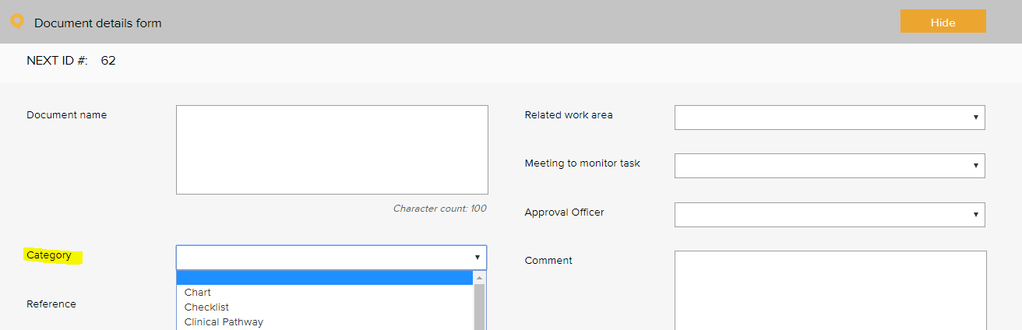

Document category - Examples
Audit report template | Logo
Audit report tool | Manufacturer instruction manual
Brochure, information sheet | Material safety data sheet
Bylaws | Patient / carer information
Charter | Plan
Checklist | Position description
Clinical pathway | Policies, procedures, protocols
Clinical preference sheet | Procedure manual
Communication material | Reference text
Competency assessment tool | Resource material
Diagram | Sign sheet
Education material | Signage
Flowchart | Standard
Form | Template
Guideline | Terms of reference
Information resource | Tool
List | Work instruction

Feedback Register

Feedback Type
The feedback type menu is used when reporting feedback in the feedback register. It allows for the feedback or complaint to be coded to a category. Reports can be generated based on the selections in this menu.
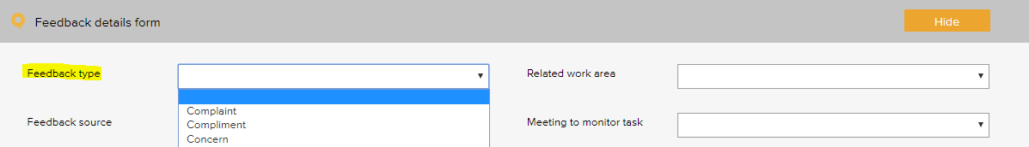

Feedback type - Examples
Complaint
Compliment
Issue of concern
Staff praise
Suggestion for improvement

Feedback Source
The feedback source menu is used when reporting feedback in the feedback register. It allows for the source of the feedback or complaint to be selected. Reports can be generated based on the selections in this menu.
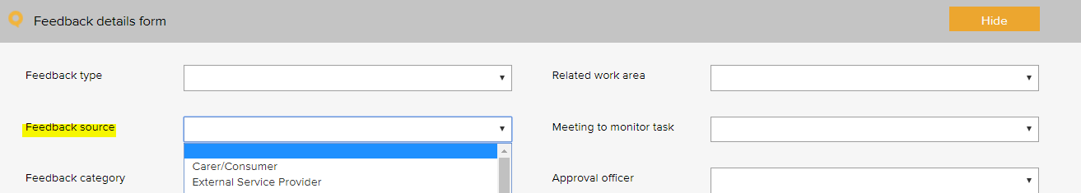

Feedback source - Examples
Community focus group | Patient - scheduled appointment
Community member | Patient - walk in
External service provider | Patient carer or family member
Government agency | Staff member
Medical practitioner

Feedback Category
The feedback category menu is used when reporting feedback in the feedback register. It allows for the feedback or complaint to be coded to a category. Reports can be generated based on the selections in this menu.
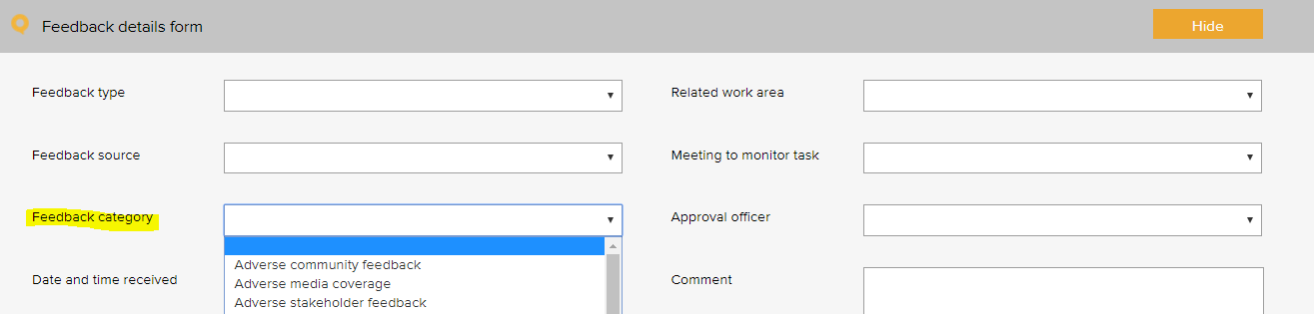

Feedback category - Examples
Adverse community feedback | Issue with referral pathways
Adverse media coverage | Issue with referral practices
Adverse stakeholder feedback | Issue with service facilities
Issue with access to services | Issue with service performance
Issue with clinical care | Issue with service responsiveness
Issue with clinical handover | Issue with staff courtesy
Issue with confidentiality / privacy | Issue with waiting time
Issue with consent - financial | Pleased with access
Issue with consent - materials used to obtain informed consent | Pleased with anaesthetist
Issue with consent - process | Pleased with confidentiality / privacy
Issue with cost of service | Pleased with cultural sensitivity
Issue with cultural sensitivity | Pleased with customer service
Issue with governance | Pleased with facilities and amenities
Issue with information - clinical | Pleased with medical practitioner
Issue with information - nonclinical | Pleased with performance
Issue with information material | Pleased with service responsiveness
Issue with internal temperature | Pleased with services provided
Issue with medication | Pleased with surgeon
Issue with poor care and communication | Staff praise
Issue with processes of engagement and support provided

Improvement Register
The source of issue menu is used when recording an improvement or non-conformance in the improvement register. It allows for the source of the issue to be recorded. Reports can be generated based on the selections in this menu.
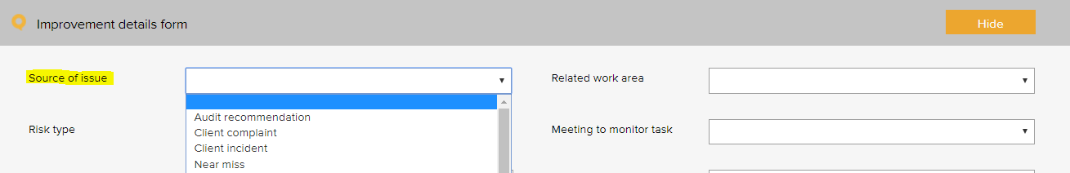

Improvement source - Examples
Arising from - audit | Arising from - WHS incident
Arising from - breakdown in service | Suggestion - manager
Arising from - complaint | Suggestion - other service provider
Arising from - emergency | Suggestion - staff
Arising from - feedback | Suggestion - staff member
Arising from - near miss | Suggestion - stakeholder
Arising from - non-patient incident | Suggestion - team meeting
Arising from - patient incident | Suggestion - visiting practitioner

Incident Register
The incident type menu is used when reporting an incident in the incident register. It allows for the incident to be coded to a category. Reports can be generated based on the selections in this menu.
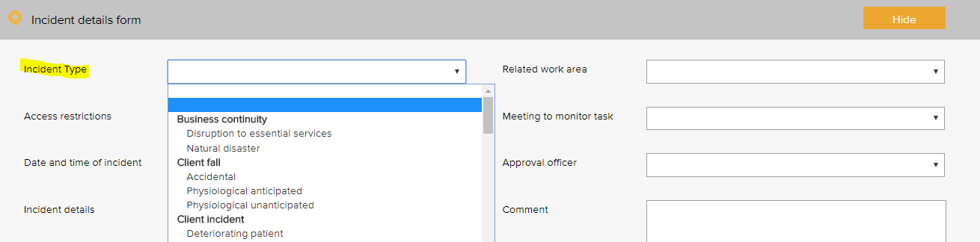
The following example is based on the WHO Conceptual Framework for the International Classification for Patient Safety which provides a categorization of patient safety information using standardized sets of concepts with agreed definitions, preferred terms, and the relationships between them based on an explicit domain ontology. It is designed to facilitate the description, comparison, measurement, monitoring, analysis and interpretation of information to improve patient care, and for epidemiological and health policy planning purposes.

Primary and secondary incident Type - Examples
Primary incident type | Secondary incident type
Clinic administration incident | Advanced health directive
 | Allocation of Medical Record Number
 | Appointment
 | Consent - financial
 | Consent - non-financial
 | Discharge
 | Handover
 | Patient identification
 | Referral / consultation
 | Response to emergency
 | Task allocation
 | Transfer of care
 | Waiting time
Clinical process / procedure incident | Adverse event
 | Cancellation after admission
 | Deviation from protocol / procedure / guideline
 | Diagnosis / assessment
 | General care / management
 | Infectious status
 | Lack of protocols / policy / procedure / guideline
 | Misidentification
 | Near miss
 | Patient / procedure mismatching
 | Preadmission screening
 | Procedure / treatment / intervention
 | Referral
 | Sentinel event
 | Specimens / results
 | Tests / investigations
 | Transfer
 | Wrong site
Pressure injury | Anaphylaxis
 | Inadequate skin assessment
 | Inadequate use of equipment
 | Prolonged length of time in theatre
Documentation incident | Clinical pathway
 | Discharge summary
 | Double up of Medical Record Number
 | Loss of medical information
 | Loss of medical record
 | Medical certificates
 | Medical records / assessments
 | Medical records / consultation notes
 | Orders / requests
 | Poor record management
 | Referrals
 | Reports / results / images
Healthcare associated infection incident | Antibiotic related issue
 | Infection incident
Medication incident | Administering
 | Adverse drug reaction
 | Breach of authorisation system
 | Breach of policies, procedures and protocols
 | Disposal
 | Information provided to patients and carers
 | Monitoring
 | Prescribing
 | Reporting system
 | Storage
 | Supply and distribution
 | Supply / ordering
 | Temperature sensitivity
 | Un-reconciled controlled drug register
Blood management | Adverse event
 | Inadequate blood handling
 | Mismanagement of blood
 | Transfusion issue
IV fluid incident | Administering
 | Setup
Oxygen incident | Administering
 | Fault
 | Storage
Medical device equipment incident | Failure / breakdown
 | Fault
Staff behaviour incident | Bullying
 | Discrimination / prejudice
 | Disrespectful
 | Harassment
 | Intended self-harm / suicide
 | Noncompliant
 | Physical assault
 | Sexual assault
 | Substance use / abuse
 | Threat to personal safety
 | Verbal aggression
Patient behaviour incident | Bullying
 | Discrimination / prejudice
 | Disrespectful
 | Harassment
 | Intended self-harm / suicide
 | Noncompliant
 | Physical assault
 | Sexual assault
 | Substance use / abuse
 | Threat to personal safety
 | Verbal aggression
Patient accident | Exposure to electricity
 | Poisoning by chemical or other substance
Patient fall | Collapse
 | Loss of balance
 | Slip / trip / stumble
Building incident | Damage
 | Lift failure
Fixture incident | Damaged
 | Faulty

Additional incidents type examples, beyond patient safety:
Primary incident type | Secondary incident type
Business continuity issue | Fire
 | Flooding
 | Loss of connectivity
 | Loss of service power
 | Loss of service telecommunications
 | Loss of service water
 | Natural disaster
Cold chain incident | Cold chain breach
 | Cold chain excursion
 | Cold chain failure
Contract incident | Breach of contract
Finance incident | Bad debt
 | Fraud / theft
 | Inaccurate accounting and / or reporting
 | Inadequate insurance
 | Inadequate liability insurance (directors and public liability)
 | Loss of funding
 | Missed billing
 | Missed payment obligation
Hazard | Biological
 | Chemical
 | Environmental hazard
 | Ergonomic
 | Falls hazard
 | Physical
 | Psychological
 | Safety
Infection prevention and control | Compromised packaging
 | Contamination of a sterile field
 | Contamination of instruments
 | Endophthalmitis
 | Hand hygiene
 | HepB
 | MRSA
Staff training incident | Inadequate supervision
 | Inadequate training
 | Incompetent
ICT incident | Backup systems failure
 | Computer / systems breakdown
 | Inappropriate use of technology / internet
 | Intrusion / virus
 | Loss of IT data
 | Unauthorised file deletion
Legal incident | Cease and desist notice
 | Legal penalty
 | Litigation claim - non-staff
Inventory incident | Critical item out of stock
 | Expired medical product
 | Inadequate stock
Privacy incident | Privacy breach
 | Unauthorised access or release of patient information
Reputation incident | Adverse publicity
Security incident
 | Security breach
 | Trespassing
 | Unauthorised access or release of corporate information
Health and safety | Electrical safety
 | Fire and emergency
 | Manual handling
 | Near miss
Vehicle incident | Accident
 | Damage
 | Theft
Environment | Status
 | Un-cleanliness

License Register
The pre-set licence options menu is used when scheduling a licensing task in the licensing register. It allows for the task to be coded to a category. Reports can be generated based on the selections in this menu.
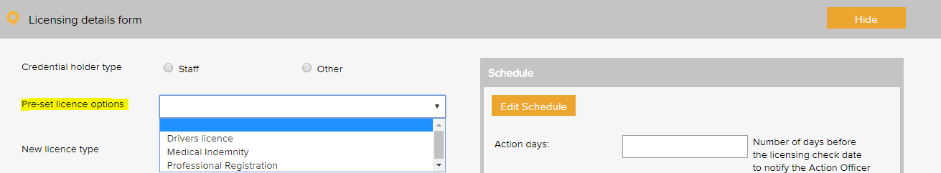

License type - Examples
AHPRA registrations
Credentialing requirements
Driver’s licence – C
Healthcare provider identifier
Immunisation requirements
Medical indemnity
Medicare provider number
National criminal check
Vaccination requirements
Working with children check

Meeting Register
The select a meeting menu is used when scheduling a meeting in the meeting register. It controls the meetings that users can add to the system. A selection from this list must be made when adding an item to any register.
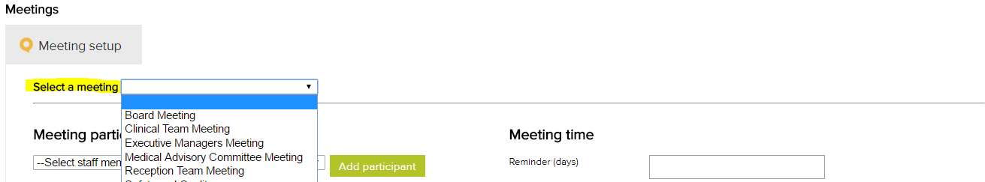

Meeting type - examples
Clinical and Corporate Governance
Clinical Staff Meeting
Consumer Focus Group Committee
Executive Management Committee
Management Review Committee
Medical Advisory Committee
Quality and Safety Committee
Staff Meeting - All

Positions
The position menu appears when setting up staff contacts in the contacts register. A single unique position title should be created for every user of the system. If there are multiple positions with the same title, each position should be numbered to remain unique e.g. Receptionist 1, Receptionist 2 etc. Tasks in the system are assigned to positions.
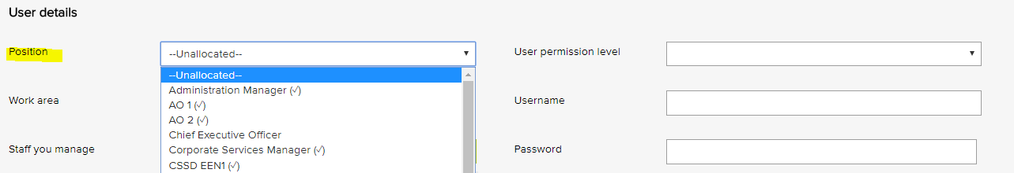

Position titles - Examples
Chief Executive Officer
Quality Manager
Registered Nurse 1
Registered Nurse 2
Health and Safety Officer
Clinical Manager

Records Register
The category menu is used when adding a record to the records register. It allows for the record to be coded to a category. The menu must also be used when adding a record to a task in the system. Reports can be generated based on the selections in this menu.
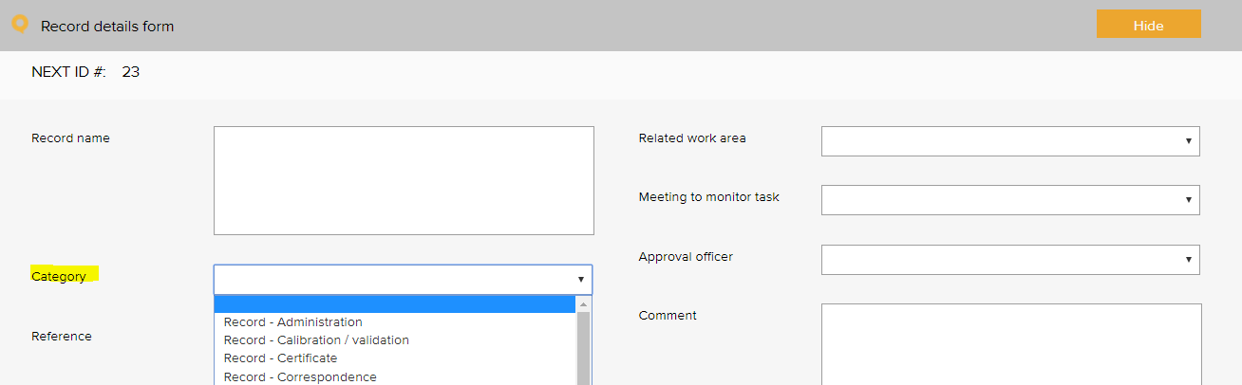

Quality records category - Examples
Certificate - AHPRA | Record - discard rates of blood products
Certificate - education and training | Record - email
Certificate - indemnity insurance | Record - ethics approval
Certificate - laser use licence | Record - feedback to consumers and carers
Certificate - orientation | Record - finance
Certificate - other | Record - focus group
Record - administration | Record - Human resource
Record - antimicrobial consumption | Record - incident
Record - antimicrobial stewardship | Record - legislation update
Record - audit information requirements / request | Record - meeting agenda
Record - blood and blood products | Record - meeting member contact details
Record - calibration / validation | Record - meeting minutes
Record - committee papers | Record - meetings task sheet
Record - communication to workforce | Record - memo
Record - community meeting | Record - newsletters
Record - consumer engagement | Record - newspaper articles
Record - consumer involvement | Record - observers registration
Record - consumer involvement in governance activity | Record - open disclosure
Record - consumer representation | Record - patient feedback
Record - consumer training | Record - photograph
Record - correspondence - external | Record - planning
Record - correspondence - internal | Record - quote
Record - credentialing | Record - related / supporting documentation
Record - credentialing - insurance authority | Record - safety and quality performance
Record - credentialing - renewal declaration | Record - staff confidentiality
Record - staff recruitment | Report - legal advice
Record - task sheet | Report - maintenance
Record - training | Report - management
Record - thermostat mixing valve | Report - microbiology
Register - assets | Report - medication safety alerts
Register - education and training attendance | Report - mortality review
Register - orientation attendance | Report - progress
Report - annual report | Report - referee
Report - audit | Report - review of deaths and cardiac arrests
Report - benchmarking report | Report - risk assessment
Report - board | Report - safety and quality indicators and data
Report - clinical indicator report | Report - serious transfusion incident report (stir)
Report - clinician key performance indicators | Report - service notification
Report - clinician's scope of practice | Report - staff performance review
Report - consumer focus groups | Report - supervision
Report - data | Report - transfusion (QiiT)
Report - data systems and surveillance | Report - trend
Report - education and training evaluation | Sign Sheet - emergency trolley
Report - equipment maintenance | Sign Sheet - fridge temperatures
Report - evaluation | Sign Sheet - key register
Report - external report | Sign Sheet - miscellaneous
Report - falls prevention | Sign Sheet - oxygen and suction
Report - financial | Sign Sheet - pathology collection
Report - haemovigilance | Sign Sheet - visitors log
Report - hospital licensing / reporting

Risk Register

Risk Assessment
The risk level and management requirement settings are displayed when rating a risk in the system. Reports can be generated based on the selections in this menu. There are four possible levels of risk in the LOGIQC assessment matrix. Each of these levels can be given a name such as Extreme, High, Medium and Low. Each risk level can also be given a related ‘management requirement’, eg. rules for how that level of risk should be managed.
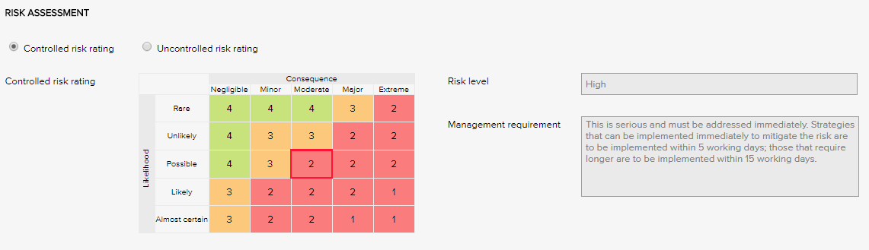

Risk Levels and related Management Requirements - Examples
Extreme | This is serious and must be addressed immediately. Strategies that can be implemented immediately to mitigate the risk are to be implemented within same or next working day; those requiring longer are to be implemented within 5 - 10 working days.
High | This is serious and must be addressed immediately. Strategies that can be implemented immediately to mitigate the risk are to be implemented within 5 working days; those that require longer are to be implemented within 15 working days.
Medium | Manage by specific monitoring or auditing procedures
Low | Manage by routine procedures.

Risk Treatment Options
The risk treatment option menu is used when adding a mitigation action to the risk register. It allows for the action to be categorised against a risk treatment strategy.
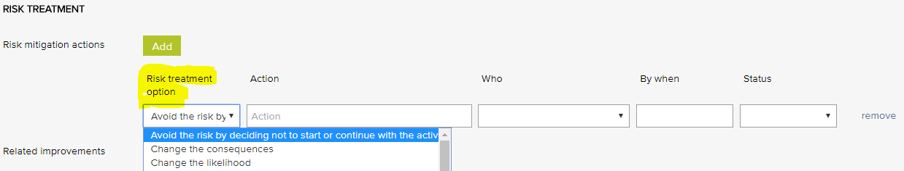

Risk treatment options - Examples
Avoid the risk by deciding not to start or continue with the activity | Make a change or improvement
Take or increase the risk in order to pursue an opportunity | Minimise the hazard
Change the consequences | Remove the risk source
Change the likelihood | Retain the risk by informed decision
Eliminate the hazard | Share the risk with another party or parties
Isolate the hazard

Risk Dimensions
The risk dimension menu is used when adding a risk to the risk register. It allows for the identified risk to be coded to a high level dimension. Reports can be generated based on the selections in this menu.
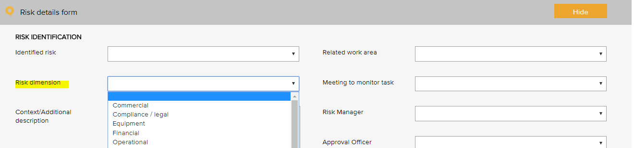

Risk dimensions - Examples
Risk dimensions | Definition
Commercial | This category includes the risks associated with market placement, business growth, diversification and commercial success. This relates to the commercial viability of a product or service, and extends through establishment to retention and then growth of a customer base.
Compliance / legal | This category includes compliance with legal requirements such as legislation, regulations, standards, codes of practice and contractual requirements. This category also extends to compliance with additional ‘rules’ such as policies, procedures or expectations, which may be set by contracts, customers or the social environment.
Equipment | This extends to the equipment utilised for the operations and conduct of the business. It includes the general operations of the equipment, maintenance, appropriateness, depreciation, safety and upgrade.
Financial | This category includes cash flow, budgetary requirements, tax obligations, creditor and debtor management, remuneration and other general account management concerns.
Organisational | This relates to the internal requirements of a business, extending to the cultural, structural and people issues associated with the effective operation of the business.
Operational | This covers the planning, operational activities, resources (including people) and support required within the operations of a business that result in the successful development and delivery of a product or service.
Project | This includes the management of equipment, finances, resources, technology, timeframes and people associated with the management projects. It extends to internal operational projects, projects relating to business development, and external projects such as those undertaken for clients/patients.
Reputation | This entails the threat to the reputation of the business due to the conduct of the entity as a whole, the viability of product or service, or the conduct of employees or other individuals associated with the business.
Safety | This category includes the safety of everyone associated with the business. This extends from individual safety, to workplace safety, public safety and to the safety and appropriateness of products or services delivered by the business.
Security | This includes the overall security of the business premises, assets and people, and extends to security of information, intellectual property, and technology.
Service delivery | This relates to the delivery of services, including the quality and appropriateness of service provided, or the manner in which a product is delivered, including customer interaction and after-sales service.
Stakeholder management | This category relates to the management of stakeholders, and includes identifying, establishing and maintaining an appropriate relationship. This includes both internal and external stakeholders.
Strategic | This includes the planning, scoping and resourcing requirements for the establishment, sustaining and/or growth of the business.
Technology | This includes the implementation, management, maintenance and upgrades associated with technology. This extends to recognising the need for and the cost benefit associated with technology as part of a business development strategy.

Risk category and risk name
The identified risk menu is used when adding a risk to the risk register. It presents a list of risks that can be added to the risk register. Reports can be generated based on the selections in this menu.
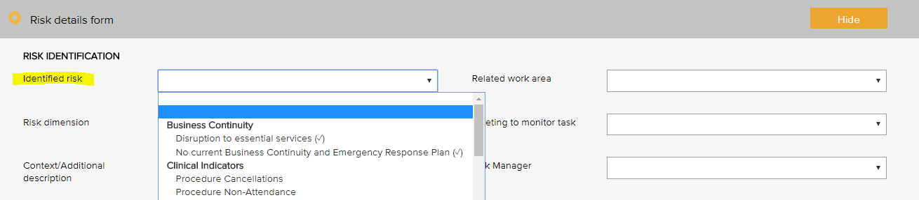

Risk category and risk name - Examples
Risk category | Risk name
Business continuity | Disruption to essential services
Collaborative partnerships | Breakdown in relationship with suppliers / stakeholders
Patient safety - clinical | Administration of Blood or Blood Products
 | Clinical incident
 | Clinical recognition and response system
 | Clinical risk
 | Currency of professional registration / credentialing
 | Currency of staff immunisation
 | Falls prevention and harm minimisation
 | Harm to patients
 | Healthcare associated infection
 | High-risk medicines
 | Infection control management
 | Medication safety
 | Non-conformance with clinical procedures / standards
 | Patient clinical record documentation
 | Patient complaint
 | Patient identification and procedure mismatching
 | Patient placement
 | Patient quality
 | Patient safety
 | Pressure injury prevalence
 | Reusable medical devices
 | Vulnerable patients
Financial | Cash / fund management shortfall
 | Competitors
 | Non-conformance with financial management procedures
 | Over-reliance on a small number of customers / suppliers
Human resource / personnel | Cross cultural conflict
 | Industrial action
 | Lack / insufficient skills, training to complete job duties
 | Non-conformance with hr procedures
 | Over-reliance on a small number of staff or key staff
 | Problems with outside contractors
Inventory | Inventory mismanagement
Legal | Legislative / regulatory / contractual breaches
Management | Assets mismanagement
 | Patient transport mismanagement
 | Equipment mismanagement
 | Hazard mismanagement
 | Information management
 | Project goals and objectives not met
 | Property mismanagement
 | Vehicle mismanagement
 | WHS mismanagement
Operations & assets | Non-conformance with operational procedures
 | Planning and scheduling conflicts
Policy & political | Changes in government
 | Organisational culture not aligned to organisational values
Reputation and image | Adverse media coverage
 | Loss or injury to reputation
 | Reduced or loss of community connectedness
Security | Security breach
Student / registrar placement | Non-conformance with student / registrar placement procedures
Technological | Breach of data security and backup
 | Failure of IT hardware and network management
 | Loss of productivity due to staff IT competencies
 | Not maximising the potential benefits of digital technologies
Environmental | Environmental issue

Linkages between the Risk Module and the Feedback and Incident Registers
When the Risk Module is activated in the LOGIQC QMS, incident types and feedback categories can be linked to one or more identified risks. When an incident or feedback that is linked to a risk is reported, it will inherit the risk rating assigned to the risk that it is linked to. Where an incident type or feedback category has been linked to multiple risks, it will be assigned the risk that has the highest risk rating amongst those risks that it has been linked to. In the event that there is more than one risk at the highest risk rating, LOGIQC will assign the risk in alphabetical order from those at the highest level.

Site Information
The site information settings controls certain automatic behaviours such as the number of days allowed to respond to a task and the frequency of sending automatic reminders.

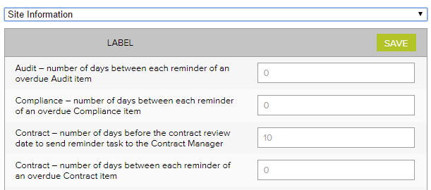

Site information - Examples
Label | No of days
Accreditation – number of days between each reminder of an open accreditation plan action | 14
Accreditation – number of days between each reminder of an overdue Accreditation item | 14
Accreditation – number of days the Approval Officer and the Quality Manager has to complete their tasks | 60
Audit – number of days between each reminder of an overdue audit item | 7
Compliance – number of days between each reminder of an overdue Compliance item | 7
Contract – number of days before the contract review date to send reminder task to the Contract manager | 14
Contract - number of days between each reminder of an overdue Contract item | 7
Contract – number of days the Approval Officer and the Contracts manager has to complete their tasks | 14
Document – number of days before the document review date to send reminder task to the Approval officer | 14
Document – number of days between each reminder of an overdue document item | 7
Document – number of days the Approval Officer has to complete the Approval task | 14
Feedback – number of days between each reminder of an overdue Feedback item | 3
Feedback – number of days the Approval Officer has to complete the Approve for Action task | 3
Improvement - number of days between each reminder of an overdue Improvement item | 14
Improvement – number of days the Approval Officer has to complete the Approve for Action task | 30
Incident - number of days between each reminder of an overdue Incident item | 3
Incident - number of days the Approval Officer has to complete the Approve for Action task | 3
Licensing - number of days between each reminder of an overdue licensing item | 3
Record - number of days between each reminder of an overdue Record item | 14
Repair - number of days between each reminder of an overdue Repair item | 7
Repair - number of days the Approval Officer has to complete the Approve for Action task | 3
Risk - number of days between each reminder of an open mitigation item | 14
Risk - number of days between each reminder of an overdue Risk item | 7
Risk – number of days the Approval Officer and the Risk Manager has to complete their tasks | 60
Supplier – number of days before the supplier review date to send reminder task to the Approval officer | 14
Supplier - number of days between each reminder of an overdue Supplier item | 7
Supplier – number of days the Approval Officer has to complete the Approval task | 14
Training – number of days between each reminder of an overdue Training item | 7

Suppliers Register
The Assessment criteria menu is displayed as checkboxes when adding and reviewing a supplier in the supplier register. It controls the criteria used for assessing suppliers.
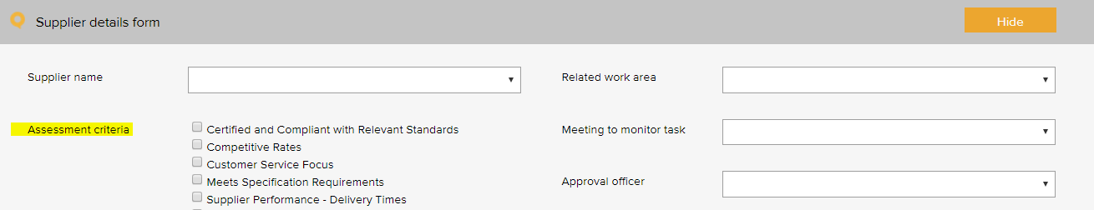

Supplier assessment criteria - Examples
ABN verified
Certified and compliant with relevant standards
Competitive rates
Customer service focus
Meets specification requirements
Supplier performance - delivery times
Supplier performance - engagement
Supplier performance - processing of orders
Supplier performance - returns and back orders
Supplier performance - value adding

System Settings

System Default Settings
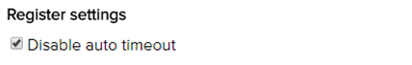

Disable auto timeout
The default settings in your LOGIQC QMS are set to disable auto timeout. This means that once logged in, your session will remain open for 12 hours before ‘timing out’ and requiring you to log in again. If you want to decrease this time to 70 minutes, simply un-check the setting.

Training Register
The pre-set training options menu is used when scheduling a training task in the training register. It allows for the task to be coded to a category. Reports can be generated based on the selections in this menu.
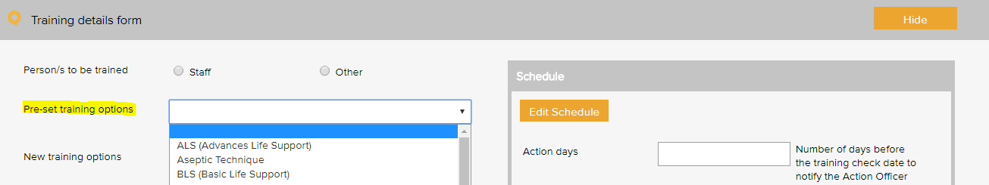

Training type - Examples
ALS (Advanced Life Support) | Human resource management
BLS (Basic Life Support) | Manual handling
Budget management | Open disclosure
Bullying and harassment | Patient privacy and confidentiality
Code of conduct | Quality management system training
Competency assessment | Recruitment and selection
Cultural awareness | Security and access
Emergency procedures | Use of email and information technology
Fire safety | WHS
Hazard reporting

Additional occupation specific training
ACSQHC / NPS antibiotic prescribing modules | Medication authorisation system
Advanced care directives | Medication management system
Adverse drug reaction documentation and reporting | Medication safety on-line training modules
Antimicrobial stewardship | Patient identification and management protocols
Aseptic technique | Personal protective equipment
Blood and blood products - adverse reactions | Prescription & clinical administration of blood and risk assessment
Clinical services, procedures, and technologies | Pressure injury prevention and management
Complaints management system | Pressure injury reporting systems
Decontamination of reusable instruments and devices | Protocols for clinical handover
Disposal of unused, unwanted, or expired medications | Receipt, storage, collection and transport of blood & blood products
Escalating care | Requirements of the NSQHS Standards
Falls prevention and management | Safety and quality - general
Hand hygiene | Safety and quality - patient care
Identification of at-risk patients | Standard precautions
Individual performance review | Transmission-based precautions
Investigating clinical incidents | Use of invasive devices
Infection prevention and control | Workforce orientation

Work Areas
This list appears when adding an item to any register. It is the list of functional work areas in the organisation (eg HR Administration, Clinic, Programs, etc) that tasks and issues can be assigned to. All Registers allow for sorting, filtering and printing of reports based on “work areas”.

Work area - Examples
Primary work area | Secondary work area
Corporate services | Administration
 | Finance
 | Human resources
 | Infection control
 | Information Communication Technology
 | Marketing and promotion
 | Quality and risk
 | Work health and safety
Governance | Board
 | Clinical governance
 | Corporate governance
 | Management
Infrastructure and facilities | Building
 | Car park
 | Equipment
 | Grounds
 | Lifts
 | Property
 | Security
Patient services | Admission
 | CSSD
 | Discharge
 | Operative
 | Pre-admission
 | Pre-operative
 | Recovery
Environmental services | Cleaning
 | Laundry
 | Medical gases
 | Medical plumbing
 | Water management
 | Waste

WHO Conceptual Framework for the International Classification for Patient Safety Version 1.1 Final Technical Report January 2009
International Classification for Patient Safety Statement of Purpose - http://www.who.int/patientsafety/taxonomy/ICPS_Statement_of_Purpose.pdf
There are 3 types of events that need separate reports: Cold chain breach: an event which has led to the vaccines being stored or transported in temperatures outside the required +2˚C to +8˚C range, but the potency/stability of the vaccines has not been compromised. Cold chain excursion: an event which has led to the vaccines being stored or transported in temperatures outside the required +2⁰C to +8⁰C range and as a result, vaccines are compromised and need to be returned for destruction. Cold chain failure: an event in which vaccines involved in a cold chain excursion are administered to patients
Risk management guide for small business, NSW Department of State and Regional Development, www.smallbiz.nsw.gov.au

