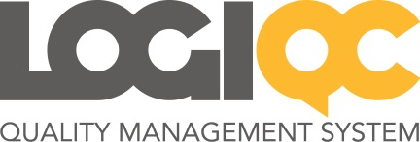

LOGIQC QMS v5 – Overview of Workflows

1. Control and Review
a. Document and Suppliers Register
b. Contracts Register, Risk and Accreditation Module

2. Schedule and Approve
a. Organisational tasks: Audit and Compliance Register
b. HR tasks: Training and Licensing Register

3. Report and Manage

1.a Control and Review
Documents and Suppliers Register
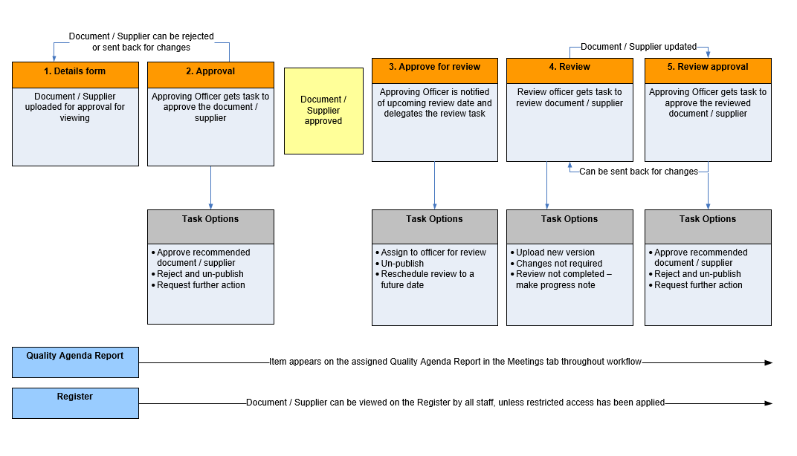

1.b Control and Review
Contracts Register, Risk and Accreditation Module
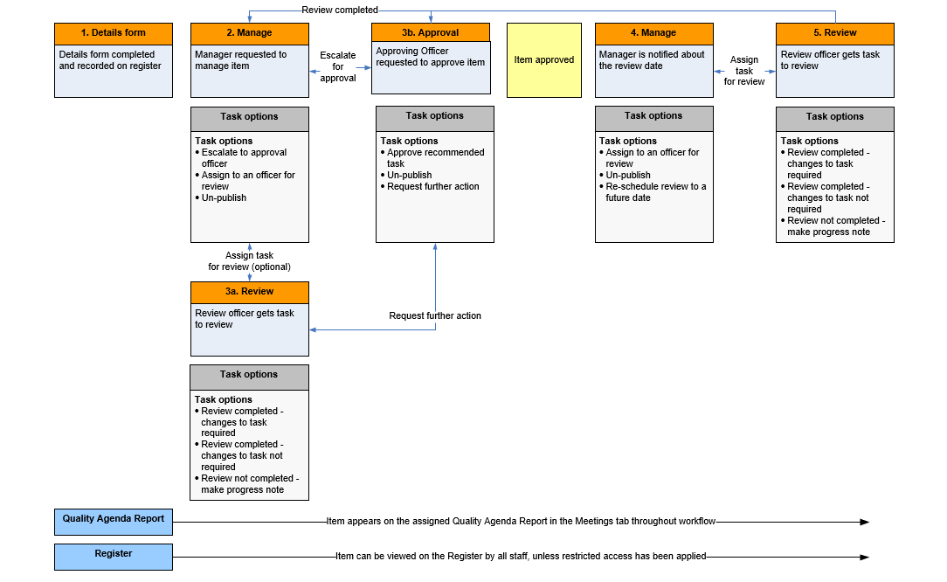
2.a Scheduling: Organisational tasks
Audit and Compliance Register
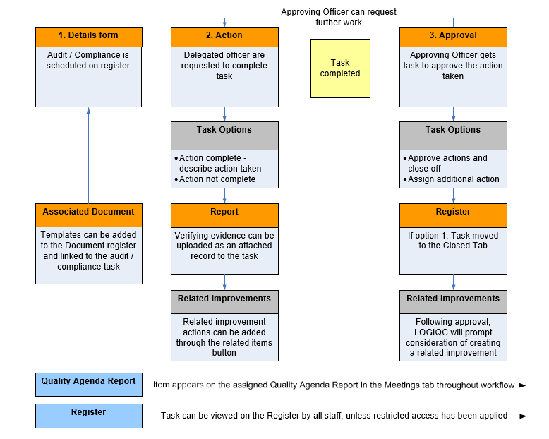
2.b Scheduling: HR tasks
Training and Licensing Register
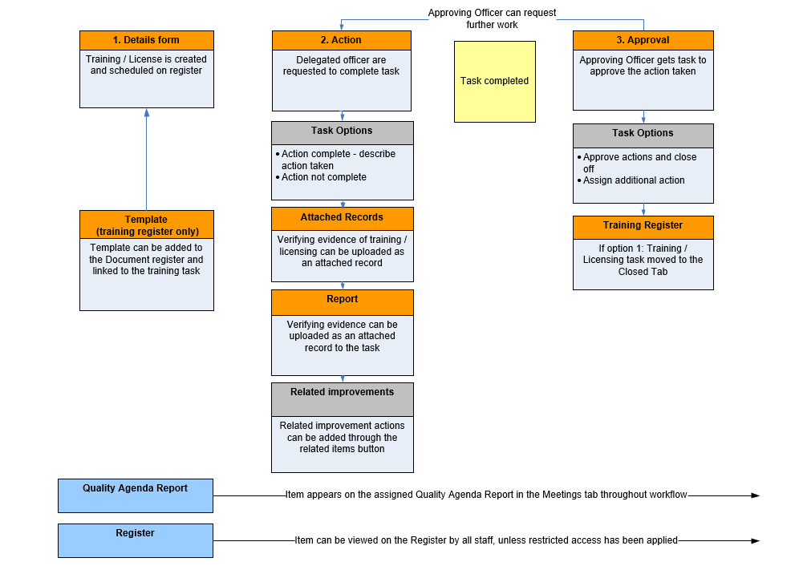
3. Report and Manage
Improvement, Incidents, Feedback and Repairs Register
