LOGIQC ACCREDITATION MODULE WORKBOOK

This workbook supports the onboarding and training of the LOGIQC Quality Management System Accreditation Module.

Contents page

1. Introduction 3
2. The purpose and scope of the Accreditation Module 3
3. LOGIQC Accreditation Module – Workflow 5
5. How to navigate within the Accreditation Module 6
6. How to complete the Accreditation Details Form 7
7. Accreditation Action Plan 11
8. Evidence Report 13
9. How to review an accreditation requirement 14
10. How to manage the review of an accreditation requirement 14

Introduction
This training workshop has been designed to provide support in the onboarding and training in the use of the LOGIQC Quality Management System Accreditation Module.
Learning outcomes:
Completion of Accreditation Details Forms for relevant Standard requirements
- Understanding of purpose and scope of the Accreditation Module
- How to describe existing evidence to meet the requirements
- How to link relevant items in the QMS as evidence of meeting the requirements
- How to identify further Accreditation Action Plan tasks

Managing and maintaining compliance with the Standard requirements
- How to complete the self-assessment of the Standard requirements
- How to manage and approve the Accreditation Details Form
- How to review the Evidence Report for the Standards to assess compliance with the Standard requirements
- How to bring the requirements of a Standard under review
- How to utilise the Accreditation Action Plan and complete the action tasks

Related Documents and Resources
- Copy of the relevant Standard for full details of the requirements of the Standards

The purpose and scope of the Accreditation Module
The Accreditation Module significantly reduces the time and effort required to manage and maintain accreditation requirements. The Accreditation Module is an online tool integrated within the LOGIQC QMS to allow the organisation to:
- Conduct a self-assessment of how the requirements of specific Standards are being met
- Add and manage individual action tasks to further comply with the Standards and automatically generate an action plan
- Link your documents, audits and other activities to the requirements of Standards and automatically generate an Evidence Report
- Set automatic reminders to prepare for external audits detailing what needs to be done
- Give your auditor online or on-site access to view your Evidence Report with direct links to the relevant evidence for each assessment option
- Benefit from LOGIQC’s ‘knowledge bank’ of examples and pre-loaded requirements for compliance with Standards

The Accreditation Module has been developed in line with international quality and clinical Standards including:

- ACHS EQuIP Day Procedure Centres Standards
- ACHS EQuIP National Day Procedure Centres Standards
- ACHS EQuIP6
- Aged Care Quality Standards
- AS/NZS 4187:2014 Reprocessing of reusable medical devices in health service organizations
- AS/NZS ISO 9001:2015 Quality management system - Requirements
- Department of Human Services Standards 2011
- Human Services Quality Standards 2013
- Licensing Standards for the Arrangements for Management, Staffing and Equipment. Day Hospital – Class A 2017
- National Quality Standards 2017
- National Quality Standards 2018
- National Regulatory System for Community Housing
- National Safety and Quality Health Service Standards First Edition
- National Safety and Quality Health Service Standards Second Edition
- National Standards for Disability Services Version 1
- National Standards for Mental Health Services 2010
- NSW Child safe Standards for Permanent Care 2015
- NSW Disability Service Standards 3rd Edition 2016
- NT Quality and Safeguarding Framework 2016
- NZS 8134:2008 Health and Disability Services (Core) Standards
- NZS 8164:2005 Day-stay Surgery and Procedures
- NZS 8171:2005 Allied Health Services Sector Standards
- QIC Health and Community Services Standards 6th Edition
- QIC Health and Community Services Standards 7th Edition
- RACGP Standards for general practices 4th edition
- RACGP Standards for general practices 5th edition
- RNZCUC Urgent Care Standard 2015
- RNZCGP Standard for New Zealand general practice Version 1.0 - June 2016
- RTAC Code of Practice 2017
- Specialist Homelessness Service Standards 2016
- Standard on Culturally Secure Practice (Alcohol and other Drug Sector) WANADA 1st Edition
- Victorian Early Childhood Intervention Standards 2016
- White Ribbon Australia Workplace Accreditation Program Standards and Criteria

LOGIQC Accreditation Module – Workflow
The diagram bellow outlines the workflow of the LOGIQC QMS Accreditation Module, which involves the following processes:
Process 1 The Accreditation Details Form (ADF) will be drafted based on the Standard requirements purchased. The form will need to be reviewed and completed in full to describe how the requirements are met, link evidence and examples of meeting the requirement, allocate the responsibility for managing the ADF and assess the status of compliance in meeting the Standard requirement.
Process 2 ADF is sent to the Quality Manager to check that the Standard requirement has been met with evidence and examples of meeting the requirements linked to the ADF.
Process 3 If approved by the Quality Manager, the ADF is sent to the Approving Office for sign off
Process 4 Based on the review date set for the individual Standard requirements, the Quality Manager will be sent a task to review the ADF.
Process 5 If required, the Quality Manager will push the Standard requirement into the “review” phase of the workflow. As part of the review the following processes will be undertaken:
- Review the status of the Standard requirement (met, part met, not met, NA)
- Review to what extent the linked evidence is compliant with the requirements based on the status
- Review the individual Assessment Details Forms to ensure they are accurate and revise, if required. Specifically, reviewing the “How the requirements are met” field and the linked evidence. Link additional evidence if required and update the assessment status.
- Review the status of the Accreditation Action Plan tasks
- Add additional accreditation action tasks to better comply with and meet the assessment requirements
- Review the linkages with incident types and feedback categories and revise, if required
Process 6 Workflow returns to step 2

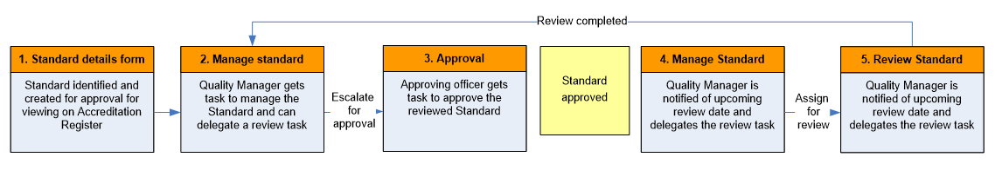

How to navigate within the Accreditation Module
  - Accreditation Module Tabs
To access the Accreditation Module, you will need to select “accreditation” from the registers heading.
There are 7 ‘tabs’ along the top of the Accreditation Module:
- The Requirements tab displays the Standard requirements currently published in the LOGIQC QMS.
- The Assessment tab displays individual assessment forms that are assessed as part of meeting the requirements.
- The Accreditation Action Plan tab displays a current list of actions that are in place to further meet the requirements of the Standards.
- The Evidence Report tab displays a report for each assessment indicator displaying the evidence and examples linked from other registers within the LOGIQC QMS to the Standard requirements at the assessment level. This report displays the status of the evidence and a direct link open and view the full details of each example of evidence.
- The Workflow tab displays the list of Accreditation Details Forms at the requirements level with information as to where in the workflow the Standard requirement is currently in and the allocation of responsibility of that task.
- The Draft tab displays the drafted Accreditation Details Forms at the requirements level. These details forms will not generate tasks and are not part of the workflow until they are saved and published to the requirements tab.
- The Unpublished tab displays requirements that have been unpublished and are no longer required to be managed or maintained within the Accreditation Module.
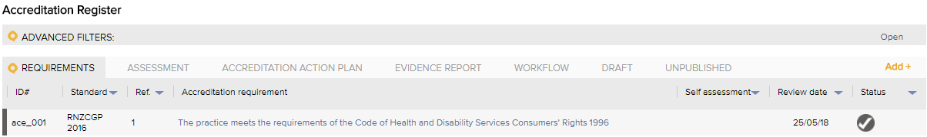

  - Navigating through the Accreditation Module
- The search bar allows the user to search for Standard requirements based on the requirement description or the ID# of the ADF.
- The Standard requirements in the register view are displayed in order based on the reference number of the Standard requirement by default. The column titles allow the user to click on the title of the column to sort the content in alphabetical or numerical order based on that column. E.g. Click on the “Accreditation requirement” title in the third column to sort the Standard requirements in alphabetical order. Clicking again will reverse the sort order.
- The column filters are displayed as small blue triangles on the left hand-side of some of the register columns and enable the user to select options from that column to be filtered. E.g. Click on the blue triangle in the “Self-assessment” column to select one or more options from the list, then click apply.
- The advanced filters option sits above the Accreditation Module tabs and can be used to apply a range of filters to enable different views or ad-hoc reports based on data within the details forms of the Standard requirements. E.g. Click on the word “Advanced filters” to display the advanced filter options. Use the drop-down menus to select one or more filters then click apply.
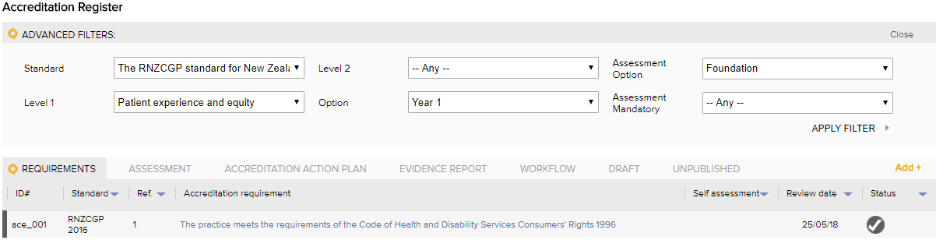

How to complete the Accreditation Details Form
To assist organisations with the build of their Accreditation Module, LOGIQC will pre-populate the Accreditation Details Forms with content based on the Standards you purchase. You will still need to refer to your copy of the specific Standards for full details of the Standard requirements, appendices and any other information provided as part of the Standard requirements.
The content provided in these drafted details forms can be modified to suit your organisations specific operating environment.

  - Opening the ‘Accreditation Details Form’.
- Click on registers and select accreditation
- Click on the draft tab
- Click on the title of one of the Standard requirement draft details form
- Complete the form as follows:
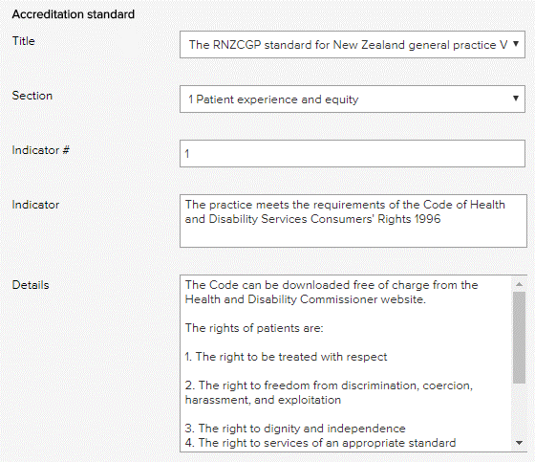 | The details of the Standard will be pre-populated in the Accreditation Details Form.  Note: The titles of these fields will vary to suit the specific Standard you are managing.

  - Completing the ‘Assessment details form’ within the Accreditation Details Form.
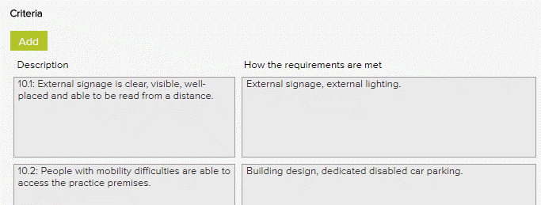 | The specific assessment requirements for the Standard will be displayed below with a reference ID and description. In some cases, the “How the requirements are met” field will be prepopulated based on an example of how to meet this requirement. This field is editable, and the information we have provided is an example only. You will need to modify this information in order to reflect the specific ways in which your organisation meets these requirements.
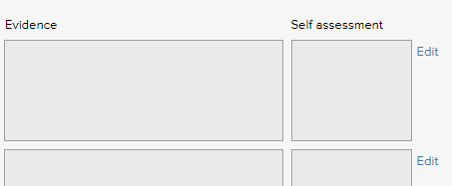 | To complete the Assessment details form, click the “Edit” button on the right-hand side of assessment item.  This will open the specific “Assessment details form”.
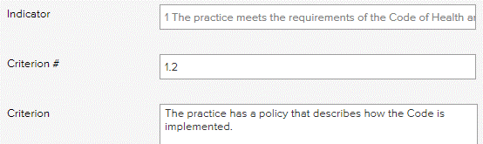 | The relevant details of the Standards will be pre-populated in the Assessment details form.  Note: The titles of these fields will vary to suit the specific Standard you are managing.
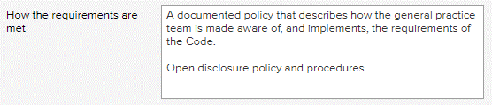 | In ‘How the requirements are met’ field you need to describe how your organisation meets the requirements of this assessment item. This field may be pre-populated with an example of how the requirements could be met. This information is an example only and needs to be modified to reflect how your organisation specifically meets the Standards.
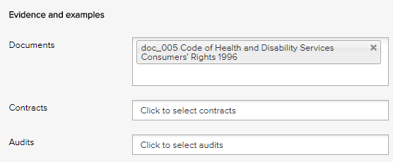 | Items in the other LOGIQC registers that have been activated in your system can be linked to the Standard as evidence of compliance with the Standard.  Click into each field and LOGIQC will list the items from the respective register. For example, when you click on the field titled “Documents”, you will be provided with a list of all approved documents on the Document Register.  To select the evidence, you want to link to the Standard, simply click the item and it will be added as a link.
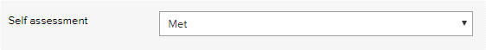 | Assess the extent your organisation complies with the Standard: met, part met, not met and not applicable.
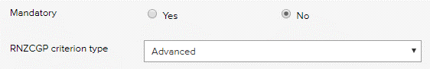 | Depending on the specific requirements of the Standard there may be additional fields to complete.  Note: You will be able to filter on these parameters, through the advanced filters. For example, you will be able to find all mandatory items.
 | To save the Assessment Details Form, click ‘Save’. This will take you back to the Accreditation Details Form.
NOTE: Complete each of the Assessment Details Forms for the Standard and then complete the Accreditation Details Form.

  - Completing the ‘Accreditation Details Form’
 | Based on the self-assessment of each of the Assessment Details Forms, select the overall score for the Standard requirement.
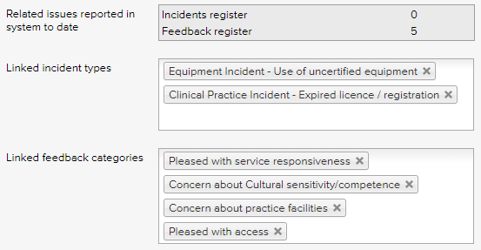 | If there are incident types and feedback categories that relate to meeting this Standard, they can be linked to the Standard via this field.  When incidents or feedback are reported, and these incident types / feedback categories are selected, details of these reports will appear as part of the Evidence Report of your organisation meets the Standard. This is useful when you want to demonstrate that you receive positive feedback, for example, in relation to access to care. Or when you need to demonstrate that how you respond to and manage types of incidents.
 | Select the person who is responsible for managing compliance with this Standard.
 | Select the person who has the authority to approve the Standard to be published ton the Accreditation Module.
 | Select the meeting responsible for oversight of compliance with this Standard.
 | Select the meeting responsible for monitoring the organisation’s compliance with this Standard.
 | Enter the date when the Standard is to be reviewed in the future.

  - Add actions to further comply with the requirements of the Standard
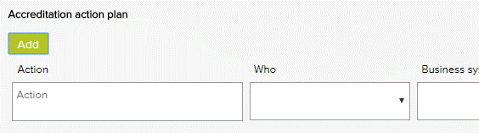 | If your organisation needs to take further action in order to meet the requirements of the Standard, details of the action can be added here, which will be collated into a single Accreditation Action Plan, with all actions across all of the Standards.  Note: The “Accreditation Action Plan” which will provide details of action to be taken to meet the Standards, appears on a separate tab in the Accreditation Module.

  - Saving the Accreditation Details Form
- The Delete Draft option will delete the draft Accreditation Details Form including the assessment forms.

- The Save Draft option will allow you to save your progress in completing the Accreditation Details Form. The Accreditation Details Form will remain in the draft tab.
Note: The user fields within the form cannot be completed when saving the form as draft. This includes: Quality Manager, Approval Officer, Review Officer, or the action office and due date for an added action task.

- The Cancel option will not save any changes you may have made. The Accreditation Details Form will remain in the draft tab.

- The Save option will allow you to publish the Accreditation Details Form. The Accreditation Details Form will move to the Requirements tab. The Assessment Details Form/s within the Accreditation Details Forms will display in the Assessment tab. A task to manage the Accreditation Details Form will be generated and allocated to the Quality Manager.

- The Save and Approve option will allow you to publish the Accreditation Details Form and approve the item. The Accreditation Details Form will move to the Requirements tab. The Assessment Details Form/s within the Accreditation Details Forms will display in the Assessment tab. This form will be identified as completed and will come up for review based on the review date.

Accreditation Action Plan
The Accreditation Action Plan section of the Accreditation Details Form allows a user to identify actions that could be completed to further comply with the requirements of the Standard. Where applicable, the accreditation action tasks are added to the respective Assessment Details Form.
Examples of further action that could be taken to improve compliance with a standard are:
- Draft a procedure for responding to needle stick injuries
- Provide training to staff on the management of the exposure to blood and other body fluids and the requirement to report all instances on the Incident Register
- Conduct an internal audit of compliance with infection prevention and control procedures

When an accreditation action task has been added to an Accreditation Details Form, LOGIQC will advise via email the staff member assigned to complete the action. If the accreditation action task has not been signed off as completed by the due date, LOGIQC will send a reminder email, at a frequency set by the Administrator in system setup.

  - How to view accreditation action tasks
The accreditation action tasks are documented on the respective Accreditation Details Form. All accreditation action tasks will also be automatically listed on the Accreditation Action Plan tab within the Accreditation Module. The Accreditation Action Plan will display all action tasks relating to each Standard as well as information about the status, due date and the staff member who is required to complete the action (Action Officer).
To view an accreditation action task, click on the description of the task in the column titled “Actions”. This will take you to the respective Accreditation Details Form that the action relates to, and will provide a full context as to why this action is required.

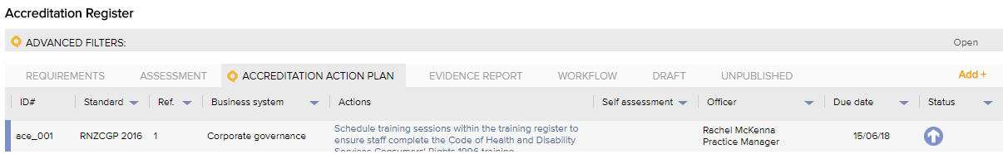

  - How to complete an accreditation action task
Click on the title of the action task. The action tasks will display at the bottom of the details form.
Click on the description of the task in the column titled “Action” from the Accreditation Action Plan tab. The Accreditation action plan appears on the bottom of the Accreditation Details Form. If you have been assigned this action you can also access this form from the link in the email that has been sent to you advising that you have been assigned this task.
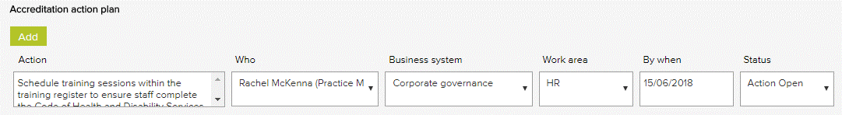

When the action has been completed, change the status of the task to “Action Completed”, if applicable.
In completing the task, if evidence has been added to a LOGIQC Register, eg. a procedure for responding to needle stick injuries has been added to the Document Register and it has been approved, you can link the relevant evidence to the Standard by clicking on the filed titled “Documents” and selecting the respective document from the list of documents.
      - Click edit on the relevant Assessment Details Form.

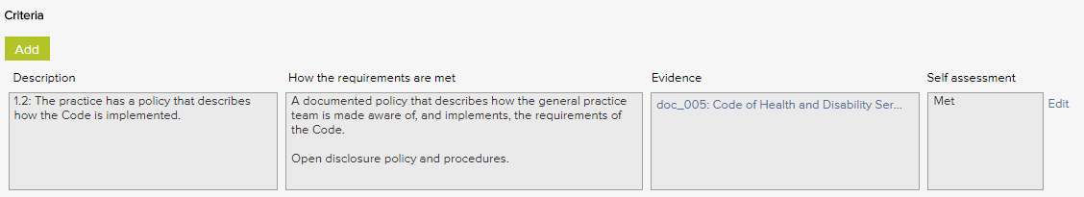
      - Then select the document in the “Document” field under the Evidence and examples section. Click Save.
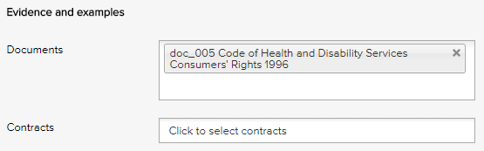

  - How to approve or close accreditation action tasks
The Quality Manager who has been assigned to manage the Standard is responsible for ensuring all accreditation action tasks associated with the Accreditation Details Forms have been completed to the satisfaction of the organisation and within required timeframes.
Following the completion of accreditation actions, they are also responsible for ensuring the description of “How the requirements are met” field and the linked evidence are accurately reflected on the Accreditation Details Form. While this is also a part of their responsibilities when reviewing the Standard requirements, the Accreditation Details Form, can be updated by the respective Quality Manager at any time.

Evidence Report
The Evidence Report tab will provide an interactive “Evidence Report” for each assessment item for the respective Standard in the Accreditation Module.
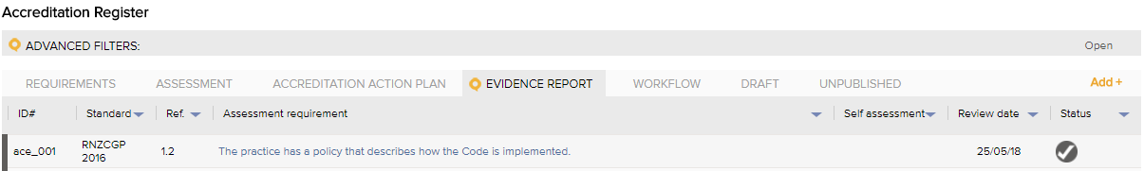

  - How to view the accreditation Evidence Report
To support the assessment of meeting the Standard, the Evidence Report commences with a description of “How the requirements are met” then details the status of the evidence and examples that have been linked to the respective Assessment Details Form.
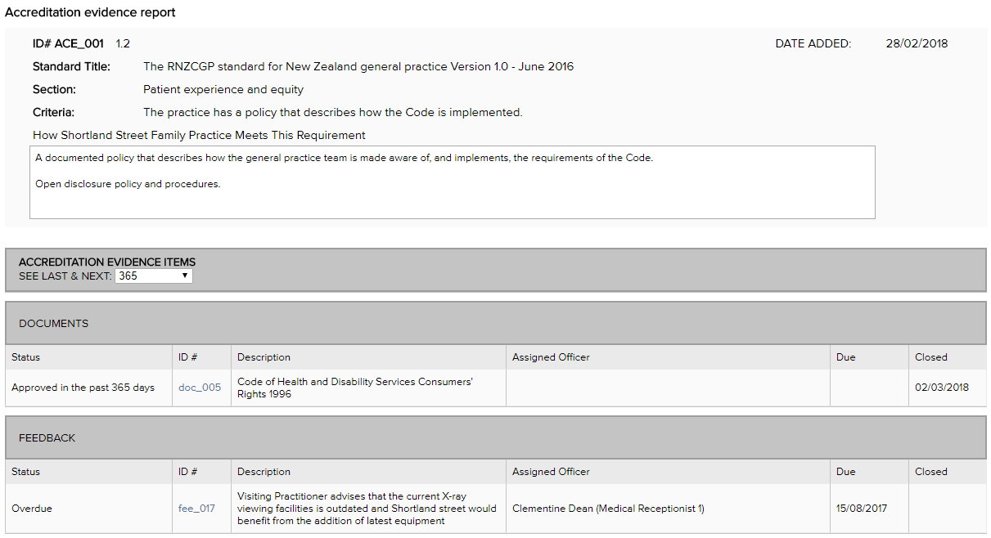

Note: In reviewing the Evidence Report, you have the option to modify the number of days the review relates to, from 30 days to Four years by adjusting the “See last & next” drop down field.
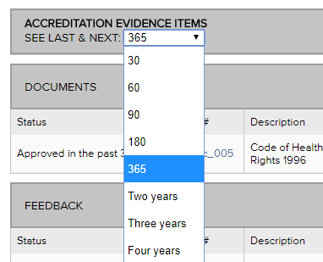

This Evidence Report provides details of the status of all items in the QMS that have been linked on the Assessment Details Form. In the following example, information is provided on a task relating to calibrating the equipment and indicates that the latest task was completed, while 3 times the task was missed. It also indicates that the task is scheduled to occur again in the following 365 day period.

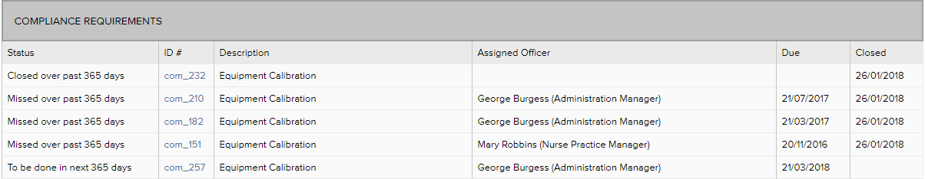

  - How to drill through the accreditation Evidence Report
To view a particular item on the Accreditation Evidence Report, click on the ID# hyperlink to go directly to the task. You can then use the “back” button to return to the Evidence Report. This allows you to view the full details of the evidence, such as the details of actions taken, the attached records or documentation and the history of the task of when the task was completed.

How to review an accreditation requirement
In reviewing an accreditation requirement, the following steps are recommended:
Refer to the Evidence Report for each of the assessment items within the Accreditation Details Form.
- Assess to what extent the evidence is compliant based on the status
- Where reported items are linked (incidents, feedback, non-conformances, repairs), open the item to gain an understanding of the organisation’s response and management of the item
- Review the status of the Accreditation Action Plan tasks
Based on the information gained through the review of the Evidence Report
- Review the individual Assessment Details Forms to ensure they are accurate and revise, if required. Specifically, review the “How the requirements are met” field and the linked evidence. Link additional evidence if required and update the assessment status.
- Review the linkages with incident types and feedback categories and revise, if required
- Review the overall status of meeting the requirements and update, if required
- Add additional accreditation action tasks to better comply with and meet the assessment requirements, if required

How to manage the review of an accreditation requirement
The Quality Manager has responsibility for the overall management of the Standard requirement that has been assigned to them. As part of this role the Quality Manager has the responsibility to ensure:
- the organisation has an accurate understanding of the requirements to comply with the Standards
- relevant and current evidence and examples of meeting the requirements are linked to the Assessment Details Forms
- where the status of the accreditation requirement is “not met” or “part met”, further accreditation action tasks are scheduled, delegated and have clear timeframes for completion
- the organisation’s compliance with the Standards are being monitored and maintained

