LOGIQC QMS SETUP GUIDE – General Practice AU
This guide supports the set-up of the LOGIQC Quality Management System menus in accordance with the requirements of the RACGP Standards for general practices (5th edition).

Contents

Customising menus 3
System menu types 3
Editing single level menu options 4
Editing double level menu options 5
System menu examples 6
Accreditation Register 6
Compliance Register 7
Contact Register 8
Contract Register 9
Document Register 10
Feedback Register 11
Feedback Type 11
Feedback Source 11
Feedback Category 12
Improvement Register 13
Incident Register 14
License Register 19
Meeting Register 20
Positions 20
Records Register 21
Risk Register 22
Risk Assessment 22
Risk Treatment Options 22
Risk Dimensions 23
Risk Category and Risk Name 24
Site Information 26
Suppliers Register 27
System Settings 27
Training Register 28
Work Areas 29

Customising menus

System menu types
There are two main types of menus in LOGIQC: single level menus and double level menus. Most menus are single level. The double level menus are work area, incident type and identified risk.

Single level menu example | Double level menu example
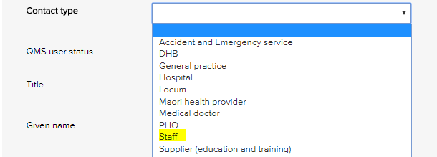 | 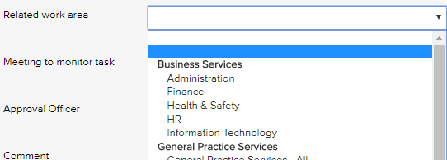
Single level menus  Accreditation assessment  Compliance source document  Contact type  Contract category  Document category  Feedback category  Feedback source  Feedback type  Improvement source  Licensing type  Meetings *  Positions *  Records category  Risk dimension  Risk treatment information  Supplier assessment criteria  Training type  * The content in these menus can be edited. | Double level menus  Primary + secondary incident type  Primary + secondary work area  Risk category + risk name

Editing single level menu options
These instructions use the contact type menu as an example.
- Log-in as administrator and select system setup in the system settings menu.
- From the system setup menu, select the menu to edit.
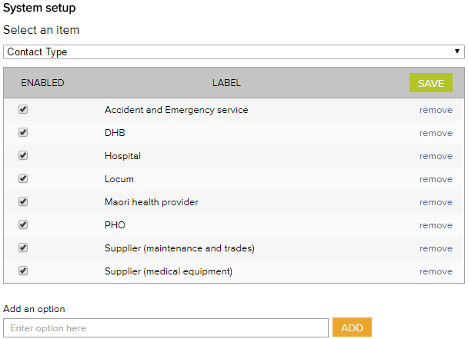
- Enter the new menu option into the add an option field.
- Click add and click save.
- To remove menu options, click remove and click save. (Note: Once an option has been used in a register item in the system the option can only be disabled and cannot be removed)

Editing double level menu options
These instructions use the work area menu as an example.
- Log - in with the Administrator password and select system setup in the system settings menu.
- From the system setup menu, select primary work area from the menu. From this screen, you can customise the menu to your organisation by adding and removing menu options.
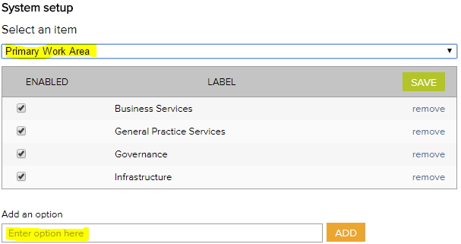
- To add new primary work area categories and type into the option field.
- Click add and click save.
- To remove primary work area categories that you don’t want, click remove and click save. (Note: Once an option has been used in a register item in the system the option can only be disabled and cannot be removed)
- Select secondary work area from the system setup menu.
If a new primary category is created LOGIQC will automatically create a duplicate secondary menu label with the word ‘all’ appended. This option can be removed after other secondary options are added to the category. LOGIQC requires a minimum of one secondary menu option for each primary option.
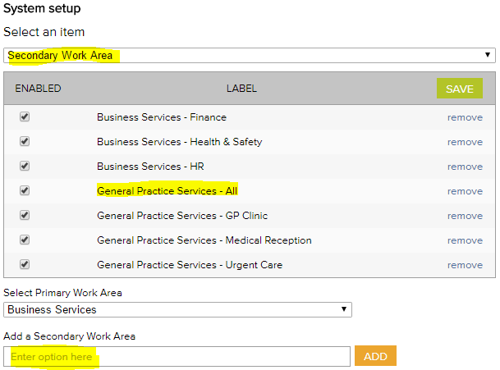
- To add new secondary work areas, select the related primary work area and type into the option field.
- Click add and click save.
- To remove secondary work area categories that you don’t want, click remove and click save. (Note: Once an option has been used in a register item in the system the option can only be disabled and cannot be removed)

System menu examples

Accreditation Register
The accreditation business system is used to group ‘accreditation actions required’ into higher order categories in the accreditation action plan and excel export. This way the individual tasks added can be categories.
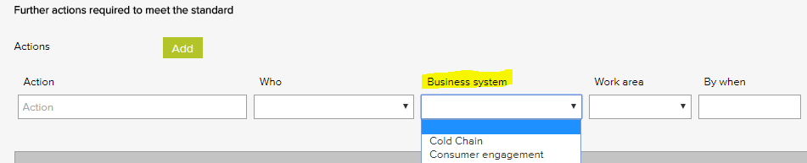

Accreditation business system – General Examples
Accountability and reporting
Cold chain
Consumer engagement
Equipment - medical
Equipment - non-medical
Governance - clinical
Governance - corporate
Infection prevention and control
Internal communication
Management - clinical
Management - corporate
Training - induction
Training - mandatory

Compliance Register
The Source of requirement menu is used when scheduling a compliance task. It allows for the task to be coded to the entity or regulation that stipulates that the task should be carried out. Reports can be generated based on the selections in this menu.
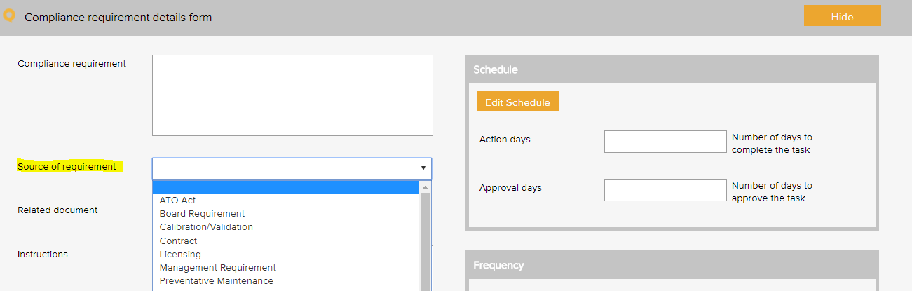

Compliance source document category – General Examples based on the RACGP Standards 5th Ed.
Australian standards
Australian tax law
Constitution
Contract requirement
Funding agreement
Management requirement
Practice requirement
Regulation
Superannuation policy and legislation
Work health and safety act

Contact Register
The contact type menu is used when adding a business contact to the contacts register. It allows for the contact to be coded to a category. Reports can be generated based on the selections in this menu.
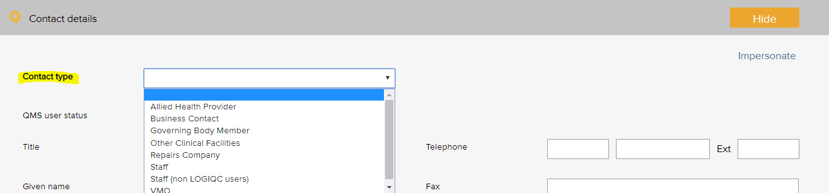

Contact type – General Examples based on the RACGP Standards 5th Ed.
Advocacy and support services
Agency staff
Allied health provider
Business contact
General practitioner
Government agency
Health care provider - other
Industry body
LOGIQC user
Standards agency
Supplier - education and training
Supplier - IT and support
Supplier - maintenance
Supplier - medical equipment
Supplier - medical gases
Supplier - medical supplies
Supplier - office
Supplier - waste management

Contract Register
The contract category menu is used when adding a contract to the contracts register. It allows for the contract to be coded to a category. Reports can be generated based on the selections in this menu.
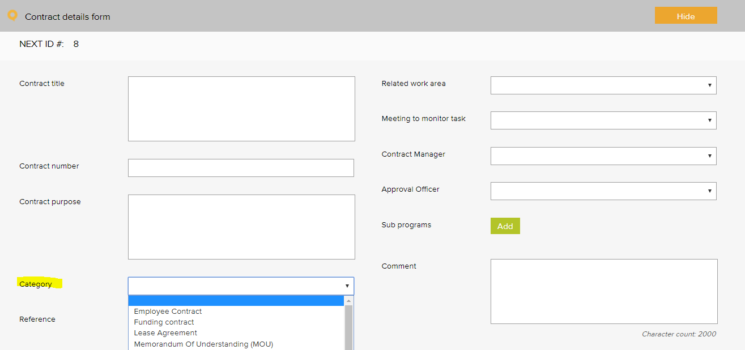

Contract category - General Examples based on RACGP Standards 5th Ed.
Contractor agreement
Employee agreement
External provider agreement
Funding agreement
Insurance policy
Lease agreement
Memorandum of understanding (MOU)
Partnership agreement
Position description (signed)
Rental agreement
Service level agreement (SLA)
Supplier agreement
Warranty agreement

Document Register
The document category menu is used when adding a document to the documents register. It allows for the document to be coded to a category. Reports can be generated based on the selections in this menu.
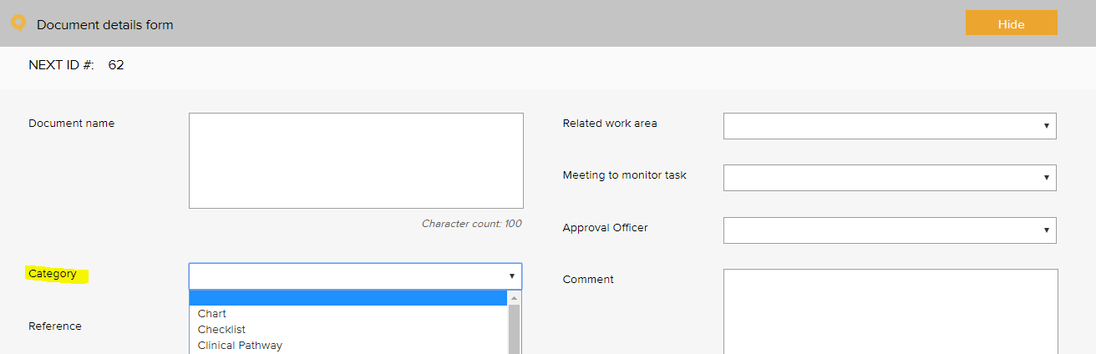

Document category – General Examples based on the RACGP Standards 5th Ed.
Audit tool | Manufacturer instruction manual
Brochure, information sheet | Patient / carer information
Charter | Plan
Checklist | Policies, procedures, protocols
Clinical pathway | Position description
Communication material | Reference text
Competency assessment tool | Resource material
Diagram | Safety data sheet
Education material | Sign sheet
Flowchart | Signage
Framework | Standard
Form | Template
Guideline | Terms of reference
Information resource | Tool
List | Work instruction
Logo

Feedback Register

Feedback Type
The feedback type menu is used when reporting feedback in the feedback register. It allows for the feedback or complaint to be coded to a category. Reports can be generated based on the selections in this menu.
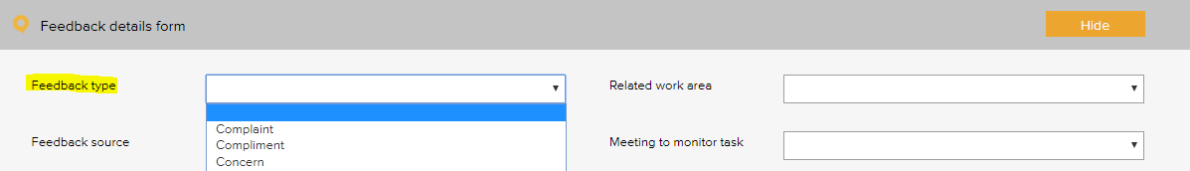

Feedback type - General Examples based on the RACGP Standards 5th Ed.
Complaint
Compliment
Issue of concern
Praise of staff
Suggestion for improvement

Feedback Source
The feedback source menu is used when reporting feedback in the feedback register. It allows for the source of the feedback or complaint to be selected. Reports can be generated based on the selections in this menu.
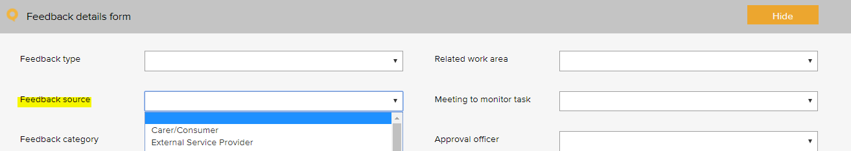

Feedback source - General Examples based on the RACGP Standards 5th Ed.
Community member
External service provider
Government agency
Patient - scheduled appointment
Patient - walk in
Patient carer or family member
Practice partner
Supplier
Visiting practitioner

Feedback Category
The feedback category menu is used when reporting feedback in the feedback register. It allows for the feedback or complaint to be coded to a category. Reports can be generated based on the selections in this menu.
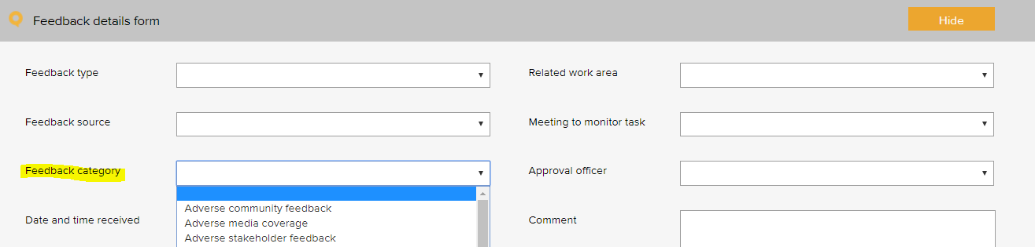

Feedback Category - General Examples based on the RACGP Standards 5th Ed.
Adverse community feedback | Issue with Practice performance
Adverse media coverage | Issue with Practice responsiveness
Adverse stakeholder feedback | Issue with processes of engagement and support provided
Issue with access to services | Issue with referral practices
Issue with clinical care | Issue with staff courtesy
Issue with clinical handover | Issue with waiting time
Issue with confidentiality / privacy | Pleased with access
Issue with consent | Pleased with confidentiality / privacy
Issue with cost of service | Pleased with cultural sensitivity
Issue with cultural sensitivity | Pleased with customer service
Issue with governance | Pleased with facilities and amenities
Issue with information - clinical | Pleased with healthcare provided
Issue with information - non-clinical | Pleased with medical practitioner
Issue with information - quality of information | Pleased with performance
Issue with medication | Pleased with Practice responsiveness
Issue with poor care and communication | Pleased with staff courtesy
Issue with Practice facilities

Improvement Register
The source of issue menu is used when recording an improvement or non - conformance in the improvement register. It allows for the source of the issue to be recorded. Reports can be generated based on the selections in this menu.
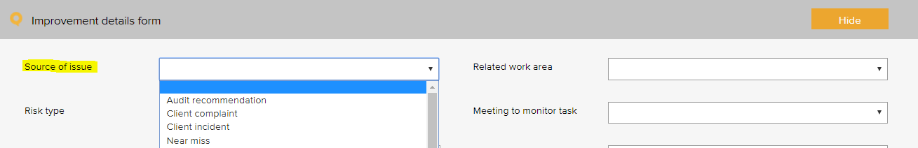

Improvement source – General Examples
Arising from - audit | Arising from - WHS incident
Arising from - clinical incident | Suggestion - manager
Arising from - complaint | Suggestion - other service provider
Arising from - feedback | Suggestion - staff
Arising from - near miss | Suggestion - stakeholder
Arising from - non-clinical incident | Suggestion - team meeting
Arising from - patient incident | Suggestion - visiting practitioner

Incident Register
The incident type menu is used when reporting an incident in the incident register. It allows for the incident to be coded to a category. Reports can be generated based on the selections in this menu.
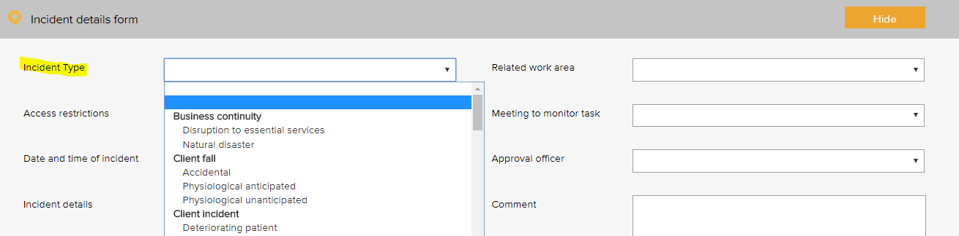
The following example is based on the WHO Conceptual Framework for the International Classification for Patient Safety which provides a categorization of patient safety information using standardized sets of concepts with agreed definitions, preferred terms, and the relationships between them based on an explicit domain ontology. It is designed to facilitate the description, comparison, measurement, monitoring, analysis and interpretation of information to improve patient care, and for epidemiological and health policy planning purposes.

Incident type – General Examples
Primary incident type | Secondary incident type
Clinic administration incident | Appointment
Clinic administration incident | Consent
Clinic administration incident | Discharge
Clinic administration incident | Handover
Clinic administration incident | Patient identification
Clinic administration incident | Referral / consultation
Clinic administration incident | Response to emergency
Clinic administration incident | Task allocation
Clinic administration incident | Transfer of care
Clinic administration incident | Waiting time
Clinical process / procedure incident | Adverse event
Clinical process / procedure incident | Deviation from protocol / procedure / guideline
Clinical process / procedure incident | Diagnosis / assessment
Clinical process / procedure incident | General care / management
Clinical process / procedure incident | Infectious status
Clinical process / procedure incident | Lack of protocols / policy / procedure / guideline
Clinical process / procedure incident | Misidentification
Clinical process / procedure incident | Near miss
Clinical process / procedure incident | Procedure / treatment / intervention
Clinical process / procedure incident | Referral
 | Sentinel event
 | Specimens / results
 | Tests / investigations
 | Transfer
Documentation incident | Clinical pathway
Documentation incident | Loss of patient / medical data
Documentation incident | Loss of patient / medical information
Documentation incident | Medical certificates
Documentation incident | Orders / requests
Documentation incident | Patient records / assessments
Documentation incident | Patient records / consultation notes
Documentation incident | Poor record management
Documentation incident | Referrals
Documentation incident | Reports / results / images
Healthcare associated infection incident | Antibiotic related issue
Healthcare associated infection incident | Infection incident
Medication incident | Administering
Medication incident | Adverse drug reaction
Medication incident | Breach of policies, procedures and protocols
Medication incident | Disposal
Medication incident | Information provided to patients and carers
Medication incident | Monitoring
Medication incident | Prescribing
Medication incident | Reporting system
Medication incident | Storage
Medication incident | Supply / ordering
Medication incident | Supply and distribution
Medication incident | Temperature sensitivity
 | Un-reconciled controlled drug register
IV fluid incident | Administering
IV fluid incident | Setup
Oxygen incident | Administering
Oxygen incident | Storage
Medical device equipment incident | Failure / breakdown
Medical device equipment incident | Fault
Staff behaviour incident | Bullying
Staff behaviour incident | Discrimination / prejudice
Staff behaviour incident | Disrespectful
Staff behaviour incident | Harassment
Staff behaviour incident | Intended self-harm / suicide
Staff behaviour incident | Noncompliant
Staff behaviour incident | Physical assault
Staff behaviour incident | Sexual assault
Staff behaviour incident | Substance use / abuse
Staff behaviour incident | Threat to personal safety
Staff behaviour incident | Verbal aggression
Patient behaviour incident | Bullying
Patient behaviour incident | Discrimination / prejudice
Patient behaviour incident | Disrespectful
Patient behaviour incident | Harassment
Patient behaviour incident | Intended self-harm / suicide
Patient behaviour incident | Noncompliant
Patient behaviour incident | Physical assault
Patient behaviour incident | Sexual assault
Patient behaviour incident | Substance use / abuse
Patient behaviour incident | Threat to personal safety
Patient behaviour incident | Verbal aggression
Patient accident | Exposure to electricity
Patient accident | Poisoning by chemical or other substance
Patient fall | Collapse
Patient fall | Loss of balance
Patient fall | Slip / trip / stumble
Building incident | Damaged
 | Lift failure
Fixture incident | Damaged
 | Faulty

Additional incidents types, beyond WHO Conceptual Framework for the International Classification for Patient Safety:
Primary incident type | Secondary incident type
Business continuity issue | Loss of connectivity
 | Loss of service power
 | Loss of service telecommunications
 | Loss of service water
 | Natural disaster
Contract incident | Breach of contract
Cold chain incident | Cold chain breach
Cold chain incident | Cold chain excursion
Cold chain incident | Cold chain failure
Finance incident | Bad debt
 | Fraud / theft
 | Inaccurate accounting and / or reporting
 | Inadequate insurance
 | Inadequate liability insurance (directors and public liability)
 | Loss of funding
 | Missed billing
 | Missed payment obligation
Hazard | Biological
 | Chemical
 | Environmental hazard
 | Ergonomic
 | Falls hazard
 | Physical
 | Psychological
 | Safety
Infection prevention and control | Compromised packaging
 | Contamination of a sterile field
 | Contamination of instruments
 | Endophthalmitis
 | Hand hygiene
 | HepB
 | MRSA
Staff training incident | Inadequate skills
Staff training incident | Inadequate supervision
Staff training incident | Inadequate training
ICT incident | Backup systems failure
 | Computer / systems breakdown
 | Inappropriate use of technology / internet
 | Intrusion / virus
 | Loss of IT data
 | Unauthorised file deletion
Legal incident | Cease and desist notice
 | Legal penalty
 | Litigation claim - non-staff
Inventory incident | Critical item out of stock
 | Expired medical product
 | Inadequate stock
Privacy incident | Privacy breach
 | Unauthorised access or release of patient information
Reputation incident | Adverse publicity
Security incident | Security breach
 | Trespassing
 | Unauthorised access or release of corporate information
Health and safety | Electrical safety
 | Fire and emergency
 | Manual handling
 | Near miss
Vehicle incident | Accident
 | Damage
 | Theft
Environment | Status
 | Un-cleanliness

License Register
The pre-set licence options menu is used when scheduling a licensing task in the licensing register. It allows for the task to be coded to a category. Reports can be generated based on the selections in this menu.
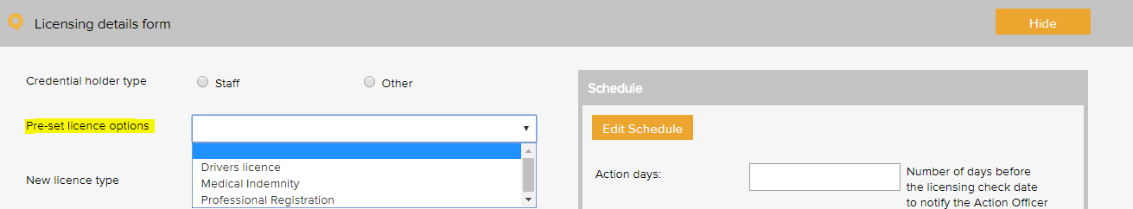

License type - General Examples
Practice Staff
AHPRA registration | Medical indemnity
Credentialing requirements | Medicare Prescriber Number
Criminal record check | Medicare provider number
Driver’s licence - C | National criminal check
Healthcare provider identifier | Vaccination requirement
Immunisation requirement | Working with children check
External service providers
Professional registrations
Medicare Provider Number
Medical Indemnity

Meeting Register
The select a meeting menu is used when scheduling a meeting in the meeting register. It controls the meetings that users can add to the system. A selection from this list must be made when adding an item to any register.
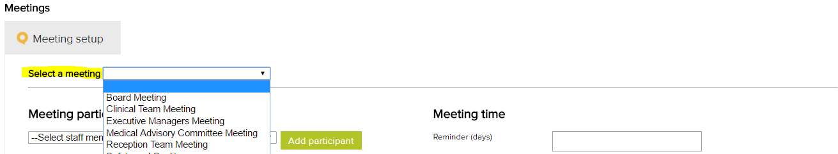

Meeting types – General Examples
Clinical Staff Meeting
Corporate Services Meeting
Executive Management Meeting
Quality and Safety Committee
Staff Meeting - All

Positions
The position menu appears when setting up staff contacts in the contacts register. A single unique position title should be created for every user of the system. If there are multiple positions with the same title, each position should be numbered to remain unique e.g. Receptionist 1, Receptionist 2 etc. Tasks in the system are assigned to positions.
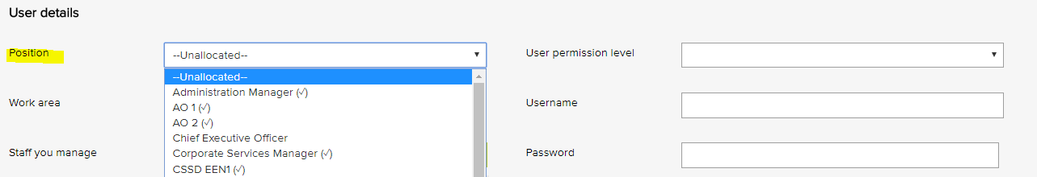

Position titles - General Examples
Health and Safety Officer
Medical Receptionist 1
Medical Receptionist 2
Nurse Practitioner
Practice Manager
Registered Nurse 1
Registered Nurse 2

Records Register
The category menu is used when adding a record to the records register. It allows for the record to be coded to a category. The menu must also be used when adding a record to a task in the system. Reports can be generated based on the selections in this menu.
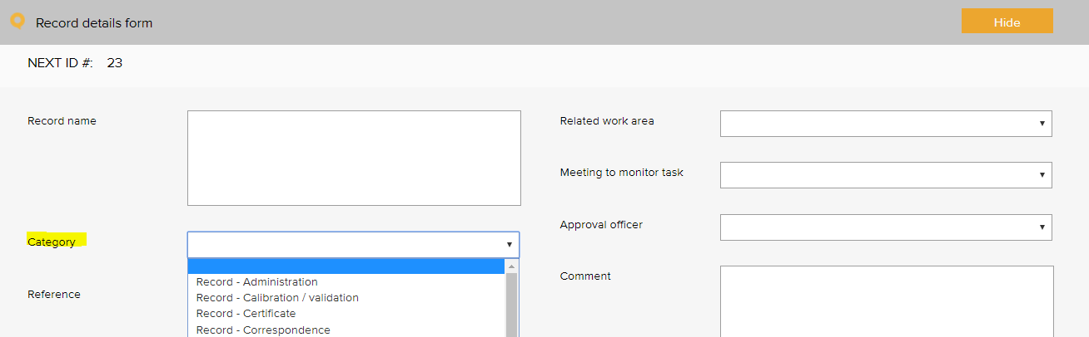
Quality records category – General Examples based on the RACGP Standards 5th Ed.
Certificate - AHPRA | Record - staff recruitment
Certificate - education and training | Record - task sheet
Certificate - indemnity insurance | Record - training
Certificate - other | Register - orientation attendance
Record - administration | Register - training attendance
Record - calibration / validation | Report - audit
Record - patient feedback | Report - benchmarking report
Record - communication to workforce | Report - data
Record - correspondence | Report - equipment maintenance
Record - credentialing | Report - evaluation
Record - email | Report - financial
Record - finance | Report - legal advice
Record - HR | Report - management
Record - incident | Report - other
Record - legislation update | Report - progress
Record - meeting agenda | Report - referee
Record - meeting minutes | Report - service notification
Record - memo | Report - staff performance review
Record - newsletter | Report - supervision
Record - photograph | Sign sheet - emergency trolley
Record - planning | Sign sheet - fridge temperatures
Record - quote | Sign sheet - key register
Record - safety and quality performance | Sign sheet - miscellaneous
Record - staff confidentiality | Sign sheet - oxygen and suction
Record - job advertisement | Sign sheet - pathology collection
Sign sheet - visitors log

Risk Register

Risk Assessment
The risk level and management requirement settings are displayed when rating a risk in the system. Reports can be generated based on the selections in this menu. There are four possible levels of risk in the LOGIQC assessment matrix. Each of these levels can be given a name such as Extreme, High, Medium and Low. Each risk level can also be given a related ‘management requirement’, eg. rules for how that level of risk should be managed.
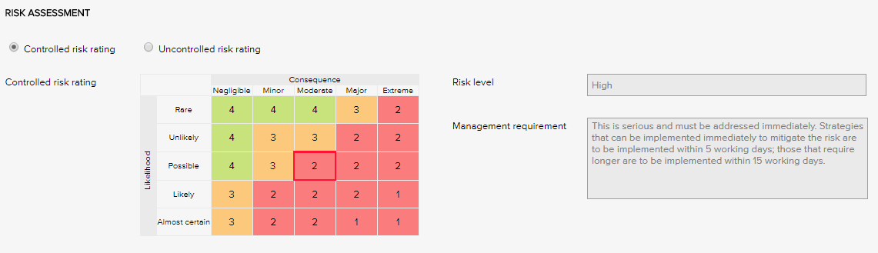

Risk Levels and related Management Requirements - Examples
Extreme | This is serious and must be addressed immediately. Strategies that can be implemented immediately to mitigate the risk are to be implemented within same or next working day; those requiring longer are to be implemented within 5 - 10 working days.
High | This is serious and must be addressed immediately. Strategies that can be implemented immediately to mitigate the risk are to be implemented within 5 working days; those that require longer are to be implemented within 15 working days.
Medium | Manage by specific monitoring or auditing procedures
Low | Manage by routine procedures.

Risk Treatment Options
The risk treatment option menu is used when adding a mitigation action to the risk register. It allows for the action to be categorised against a risk treatment strategy.
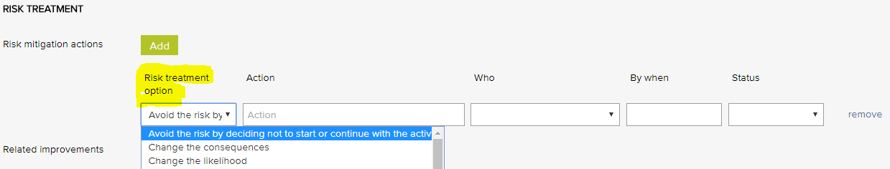
Risk treatment options - General Examples
Avoid the risk by deciding not to start or continue with the activity | Isolate the hazard
Take or increase the risk in order to pursue an opportunity | Minimise the hazard
Change the consequences | Remove the risk source
Change the likelihood | Retain the risk by informed decision
Eliminate the hazard | Share the risk with another party or parties

Risk Dimensions
The risk dimension menu is used when adding a risk to the risk register. It allows for the identified risk to be coded to a high level dimension. Reports can be generated based on the selections in this menu.
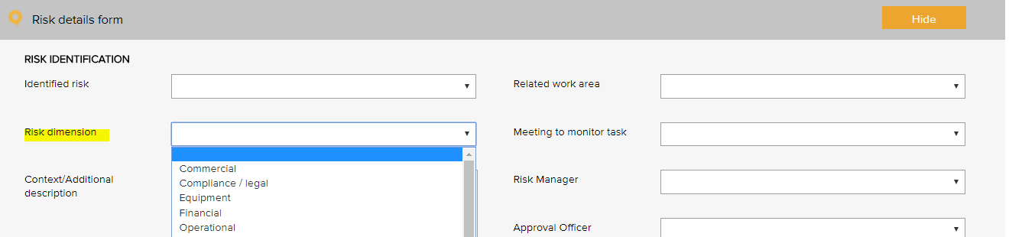

Risk Dimensions | Definition
Commercial | This category includes the risks associated with market placement, business growth, diversification and commercial success. This relates to the commercial viability of a product or service, and extends through establishment to retention and then growth of a customer base.
Compliance / legal | This category includes compliance with legal requirements such as legislation, regulations, standards, codes of practice and contractual requirements. This category also extends to compliance with additional ‘rules’ such as policies, procedures or expectations, which may be set by contracts, customers or the social environment.
Equipment | This extends to the equipment utilised for the operations and conduct of the business. It includes the general operations of the equipment, maintenance, appropriateness, depreciation, safety and upgrade.
Financial | This category includes cash flow, budgetary requirements, tax obligations, creditor and debtor management, remuneration and other general account management concerns.
Organisational | This relates to the internal requirements of a business, extending to the cultural, structural and people issues associated with the effective operation of the business.
Operational | This covers the planning, operational activities, resources (including people) and support required within the operations of a business that result in the successful development and delivery of a product or service.
Project | This includes the management of equipment, finances, resources, technology, timeframes and people associated with the management projects. It extends to internal operational projects, projects relating to business development, and external projects such as those undertaken for patients.
Reputation | This entails the threat to the reputation of the business due to the conduct of the entity as a whole, the viability of product or service, or the conduct of employees or other individuals associated with the business.
Safety | This category includes the safety of everyone associated with the business. This extends from individual safety, to workplace safety, public safety and to the safety and appropriateness of products or services delivered by the business.
Security | This includes the overall security of the business premises, assets and people, and extends to security of information, intellectual property, and technology.
Service delivery | This relates to the delivery of services, including the quality and appropriateness of service provided, or the manner in which a product is delivered, including customer interaction and after-sales service.
Stakeholder management | This category relates to the management of stakeholders, and includes identifying, establishing and maintaining an appropriate relationship. This includes both internal and external stakeholders.
Strategic | This includes the planning, scoping and resourcing requirements for the establishment, sustaining and/or growth of the business.
Technology | This includes the implementation, management, maintenance and upgrades associated with technology. This extends to recognising the need for and the cost benefit associated with technology as part of a business development strategy.

Risk Category and Risk Name
The identified risk menu is used when adding a risk to the risk register. It presents a list of risks that can be added to the risk register. Reports can be generated based on the selections in this menu.
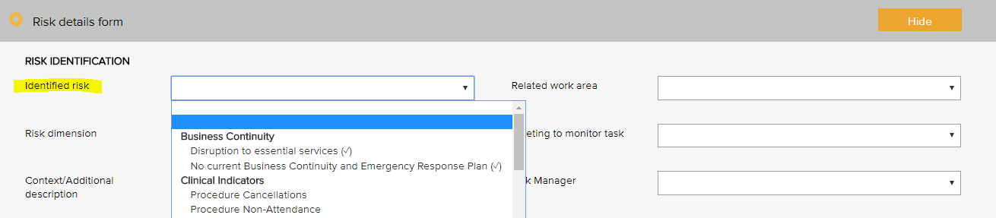

Risk category | Risk name
Business continuity | Disruption to essential services
 | Workforce sustainability
Collaborative partnerships | Breakdown in relationship with suppliers / stakeholders
Patient safety | Patient complaint
Patient safety | Falls prevention and harm minimisation
Patient safety | Clinical incident
Patient safety | Cold chain breach
Patient safety | Patient safety
Patient safety | Currency of professional registration / credentialing
Patient safety | Currency of staff immunisation
Patient safety | Infection control breach
Patient safety | Medication safety
Patient safety | Non-conformance with clinical procedures / standards
Financial | Cash / fund management shortfall
Financial | Competitors
Financial | Financial literacy
Financial | Non-conformance with financial management procedures
Financial | Over-reliance on a small number of customers / suppliers
Human resource / personnel | Cross cultural conflict
Human resource / personnel | Industrial action
Human resource / personnel | Lack / insufficient skills, training to complete job duties
Human resource / personnel | Non-conformance with HR procedures
Human resource / personnel | Over-reliance on a small number of staff or key staff
Human resource / personnel | Problems with outside contractors
Inventory | Inventory mismanagement
Legal | Legislative / regulatory / contractual breaches
Legal | Legislative risk
Management | Assets mismanagement
Management | Patient transport mismanagement
Management | Equipment mismanagement
Management | Hazard mismanagement
Management | Information mismanagement
Management | Project goals and objectives not met
Management | Property mismanagement
Management | Vehicle mismanagement
Management | WHS mismanagement
Operations and assets | Non-conformance with operational procedures
Operations and assets | Planning and scheduling conflicts
Policy and political | Changes in government
Policy and political | Organisational culture not aligned to organisational values
Reputation and image | Adverse media coverage
Reputation and image | Loss or injury to reputation
Reputation and image | Reduced or loss of community connectedness
Security | Security breach
Student / registrar placement | Non-conformance with student / registrar placement procedures
Technological | Breach of data security and backup
Technological | Failure of IT hardware and network management
Technological | Loss of productivity due to staff IT competencies
Technological | Not maximising the potential benefits of digital technologies

Linkages between the Risk Module and the Feedback and Incident Registers
When the Risk Module is activated in the LOGIQC QMS, incident types and feedback categories can be linked to one or more identified risks. When an incident or feedback that is linked to a risk is reported, it will inherit the risk rating assigned to the risk that it is linked to. Where an incident type or feedback category has been linked to multiple risks, it will be assigned the risk that has the highest risk rating amongst those risks that it has been linked to. In the event that there is more than one risk at the highest risk rating, LOGIQC will assign the risk in alphabetical order from those at the highest level.

Site Information
The site information settings controls certain automatic behaviours such as the number of days allowed to respond to a task and the frequency of sending automatic reminders.

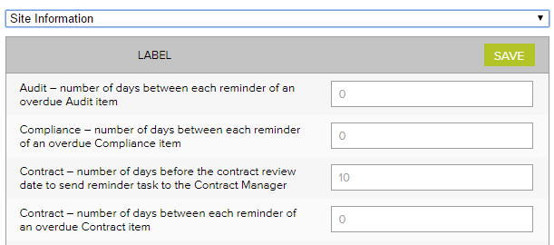
Site information - Examples
Label | No of days
Accreditation – number of days between each reminder of an open accreditation plan action | 14
Accreditation – number of days between each reminder of an overdue Accreditation item | 14
Accreditation – number of days the Approval Officer and the Quality Manager has to complete their tasks | 60
Audit – number of days between each reminder of an overdue audit item | 7
Compliance – number of days between each reminder of an overdue Compliance item | 7
Contract – number of days before the contract review date to send reminder task to the Contract manager | 14
Contract - number of days between each reminder of an overdue Contract item | 7
Contract – number of days the Approval Officer and the Contracts manager has to complete their tasks | 14
Document – number of days before the document review date to send reminder task to the Approval officer | 14
Document – number of days between each reminder of an overdue document item | 7
Document – number of days the Approval Officer has to complete the Approval task | 14
Feedback – number of days between each reminder of an overdue Feedback item | 3
Feedback – number of days the Approval Officer has to complete the Approve for Action task | 3
Improvement - number of days between each reminder of an overdue Improvement item | 14
Improvement – number of days the Approval Officer has to complete the Approve for Action task | 30
Incident - number of days between each reminder of an overdue Incident item | 3
Incident - number of days the Approval Officer has to complete the Approve for Action task | 3
Licensing - number of days between each reminder of an overdue licensing item | 3
Record - number of days between each reminder of an overdue Record item | 14
Repair - number of days between each reminder of an overdue Repair item | 7
Repair - number of days the Approval Officer has to complete the Approve for Action task | 3
Risk - number of days between each reminder of an open mitigation item | 14
Risk - number of days between each reminder of an overdue Risk item | 7
Risk – number of days the Approval Officer and the Risk Manager has to complete their tasks | 60
Supplier – number of days before the supplier review date to send reminder task to the Approval officer | 14
Supplier - number of days between each reminder of an overdue Supplier item | 7
Supplier – number of days the Approval Officer has to complete the Approval task | 14
Training – number of days between each reminder of an overdue Training item | 7

Suppliers Register
The Assessment criteria menu is displayed as checkboxes when adding and reviewing a supplier in the supplier register. It controls the criteria used for assessing suppliers.
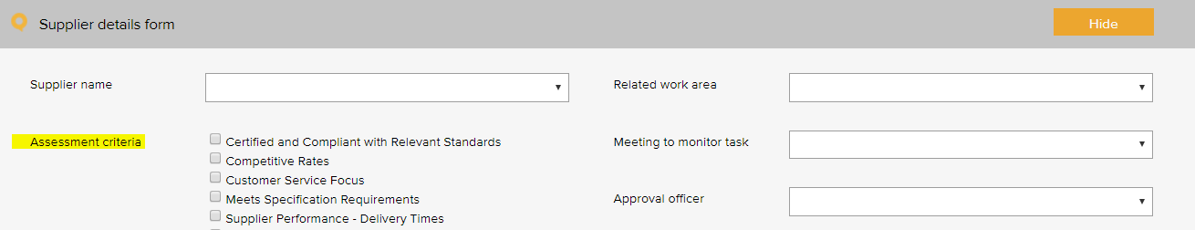

Supplier assessment criteria – General Examples based on the RACGP Standards 5th Ed.
ABN verified
Certified and compliant with relevant standards
Competitive rates
Customer service focus
Meets specification requirements
Supplier performance - delivery times
Supplier performance - processing of orders
Supplier performance - returns and back orders

System Settings

Disable auto timeout
The default settings in your LOGIQC QMS are set to disable auto timeout. This means that once logged in, your session will remain open for 12 hours before ‘timing out’ and requiring you to log in again. If you want to decrease this time to 70 minutes, simply un-check the setting.

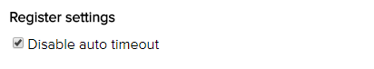

Training Register
The pre - set training options menu is used when scheduling a training task in the training register. It allows for the task to be coded to a category. Reports can be generated based on the selections in this menu.
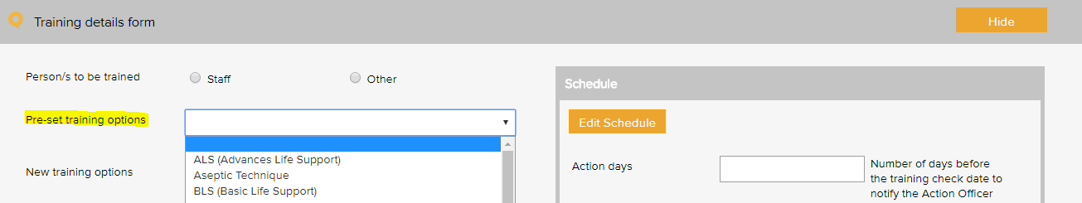

Training type – General Examples based on the RACGP Standards 5th Ed.
Corporate Orientation and Mandatory Training (for all staff)
Basic CPR
Complaints management
Culturally appropriate care
Fire safety training / fire drill
Induction
Manual handling
Privacy legislation and confidentiality (including protocols when patients request access to medical records)
Quality improvement including incident / near miss reporting
Triage and prioritisation of patients

Occupation Specific Training (for specified roles/positions)
Infection control processes and systems
Information to assist with advising out of pocket costs to patients
Medical Practice Reception, appointments and systems
Medical software use and data entry
Medicare item requirements
Nursing registration CPD requirements
RACGP QA and CPD program requirements
Reminder and recall systems
Use of new and existing medical equipment
Vaccine storage / cold chain

Work Areas
This list appears when adding an item to any register. It is the list of functional work areas in the organisation (eg HR Administration, Clinic, Programs, etc) that tasks and issues can be assigned to. All Registers allow for sorting, filtering and printing of reports based on “work areas”.
Work areas - Examples
Primary work area | Secondary work area examples
Corporate services | Administration
Corporate services | Cold chain
Corporate services | Finance
Corporate services | HR
Corporate services | Infection prevention and control
Corporate services | IT
Corporate services | Marketing and promotion
Corporate services | Quality and risk
Corporate services | Work health and safety
Governance | Clinical governance
Governance | Corporate governance
Governance | Management
Infrastructure and facilities | Building
Infrastructure and facilities | Car park
Infrastructure and facilities | Equipment
Infrastructure and facilities | Grounds
Infrastructure and facilities | Lifts
Infrastructure and facilities | Property
Infrastructure and facilities | Security
Health care services | After hours care
Health care services | All
Health care services | Chronic disease management
Health care services | GP care
Health care services | Immunisation
Health care services | Medical reception
Health care services | Nursing care

WHO Conceptual Framework for the International Classification for Patient Safety Version 1.1 Final Technical Report January 2009
International Classification for Patient Safety Statement of Purpose - http: / / www.who.int / patient safety / taxonomy / ICPS_Statement_of_Purpose.pdf
There are 3 types of events that need separate reports: Cold chain breach: an event which has led to the vaccines being stored or transported in temperatures outside the required +2˚C to +8˚C range, but the potency/stability of the vaccines has not been compromised. Cold chain excursion: an event which has led to the vaccines being stored or transported in temperatures outside the required +2⁰C to +8⁰C range and as a result, vaccines are compromised and need to be returned for destruction. Cold chain failure: an event in which vaccines involved in a cold chain excursion are administered to patients
Risk management guide for small business, NSW Department of State and Regional Development, www.smallbiz.nsw.gov.au

