LOGIQC QMS SETUP GUIDE – TRANSPORT SERVICES
This guide supports the set-up of the LOGIQC Quality Management System menus for Transport services in accordance with Bus Operator Accreditaiton Scheme (BOAS) NSW (August 2011) and Aged Care Quality Standards.
Contents

Customising menus 3
System menu types 3
Editing single level menu options 4
Editing double level menu options 5
System menu examples 6
Accreditation Register 6
Compliance Register 7
Contact Register 8
Contract Register 9
Document Register 10
Feedback Register 11
Feedback type 11
Feedback source 11
Feedback category 12
Improvement Register 13
Incident Register 14
Licensing Register 16
Meeting Register 17
Positions 17
Records Register 18
Risk Register 19
Risk Assessment 19
Risk Treatment Options 19
Risk Dimensions 20
Risk category and risk name 21
Site Information 23
Suppliers register 24
System Settings 24
Training Register 25
Work Areas 27

Customising menus

System menu types
There are two main types of menus in LOGIQC: single level menus and double level menus. Most menus are single level. The double level menus are work area, incident type and identified risk.

Single level menu example | Double level menu example
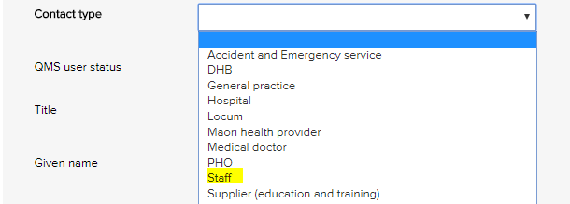 | 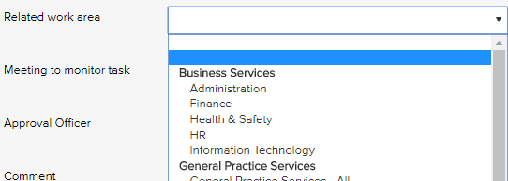
Single level menus  Accreditation assessment  Compliance source document  Contact type  Contract category  Document category  Feedback category  Feedback source  Feedback type  Improvement source  Licensing type  Meetings *  Positions *  Records category  Risk dimension  Risk treatment information  Supplier assessment criteria  Training type  * The content in these menus can be edited. | Double level menus  Primary + secondary incident type  Primary + secondary work area  Risk category + risk name

Editing single level menu options
These instructions use the contact type menu as an example.
- Log - in as administrator and select system setup in the system settings menu.
- From the system setup menu, select the menu to edit.
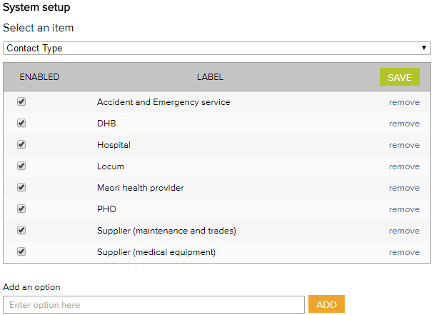
- Enter the new menu option into the add an option field.
- Click add and click save.
- To remove menu options, click remove and click save. (Note: Once an option has been used in a register item in the system the option can only be disabled and cannot be removed)

Editing double level menu options
These instructions use the work area menu as an example.
- Log - in with the Administrator password and select system setup in the system settings menu.
- From the system setup menu, select primary work area from the menu. From this screen, you can customise the menu to your organisation by adding and removing menu options.
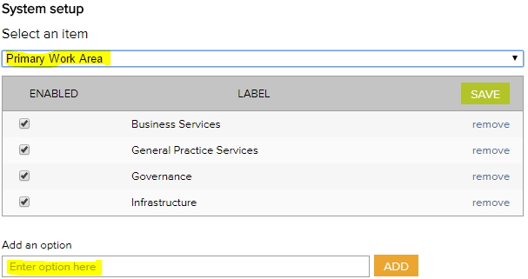
- To add new primary work area categories and type into the option field.
- Click add and click save.
- To remove primary work area categories that you don’t want, click remove and click save. (Note: Once an option has been used in a register item in the system the option can only be disabled and cannot be removed)
- Select secondary work area from the system setup menu.
If a new primary category is created LOGIQC will automatically create a duplicate secondary menu label with the word ‘all’ appended. This option can be removed after other secondary options are added to the category. LOGIQC requires a minimum of one secondary menu option for each primary option.
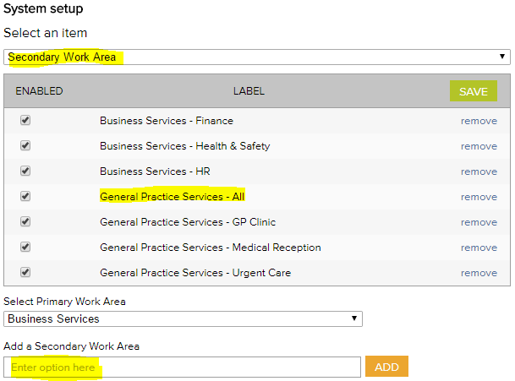
- To add new secondary work areas, select the related primary work area and type into the option field.
- Click add and click save.
- To remove secondary work area categories that you don’t want, click remove and click save. (Note: Once an option has been used in a register item in the system the option can only be disabled and cannot be removed)

System menu examples

Accreditation Register
The accreditation business system is used to group ‘accreditation actions required’ into higher order categories in the accreditation action plan and excel export. This way the individual tasks added can be categories.
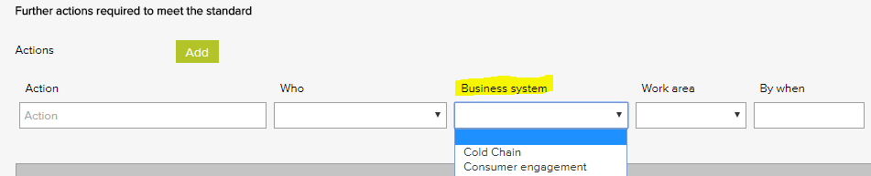
Accreditation business system - Examples
Accountability and reporting
Consumer engagement
Equipment - vehicle
Equipment – non - vehicle
Governance - corporate
Internal communication
Management
Training - induction
Training - mandatory

Compliance Register
The Source of requirement menu is used when scheduling a compliance task. It allows for the task to be coded to the entity or regulation that stipulates that the task should be carried out. Reports can be generated based on the selections in this menu.
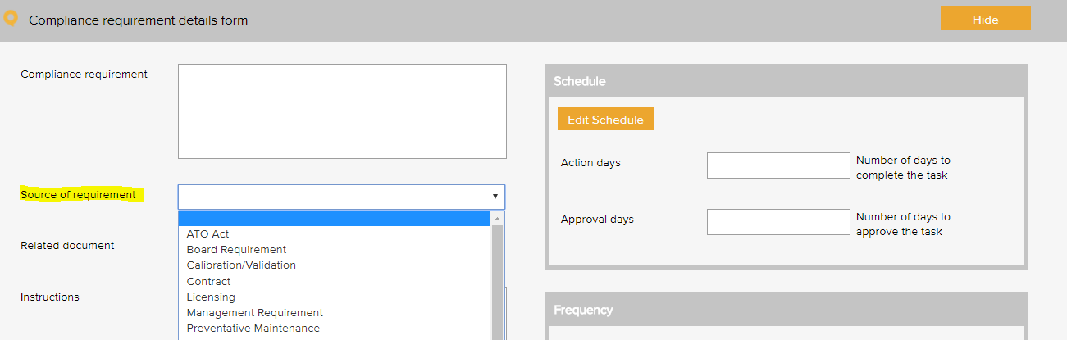

Compliance source document category – Examples
Australian standards
Australian tax law
Board requirement
Company name board requirement
Company name constitution
Contract requirement - non-funding
Funding agreement
Management requirement
Manufacturer's instructions
NSW Transport Act 2013
Passenger Transport Act 2014
Regulation
Superannuation policy and legislation
Work Health and Safety Act 2011

Contact Register
The contact type menu is used when adding a business contact to the contacts register. It allows for the contact to be coded to a category. Reports can be generated based on the selections in this menu.
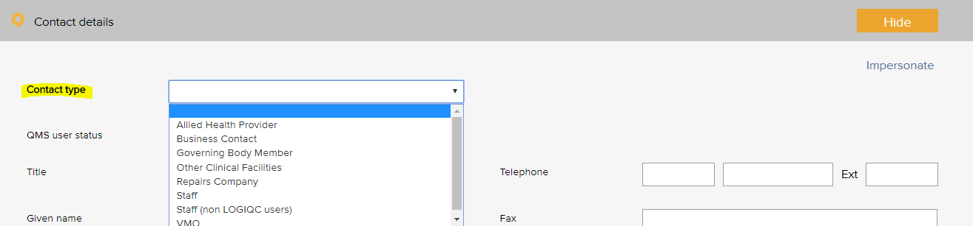

Contact Type - Examples
Business contact
Community service
Government agency
Industry body
Staff
Supplier - IT and support
Supplier - vehicle maintenance
Supplier - trade
Supplier - office
Supplier - vehicle

Contract Register
The contract category menu is used when adding a contract to the contracts register. It allows for the contract to be coded to a category. Reports can be generated based on the selections in this menu.
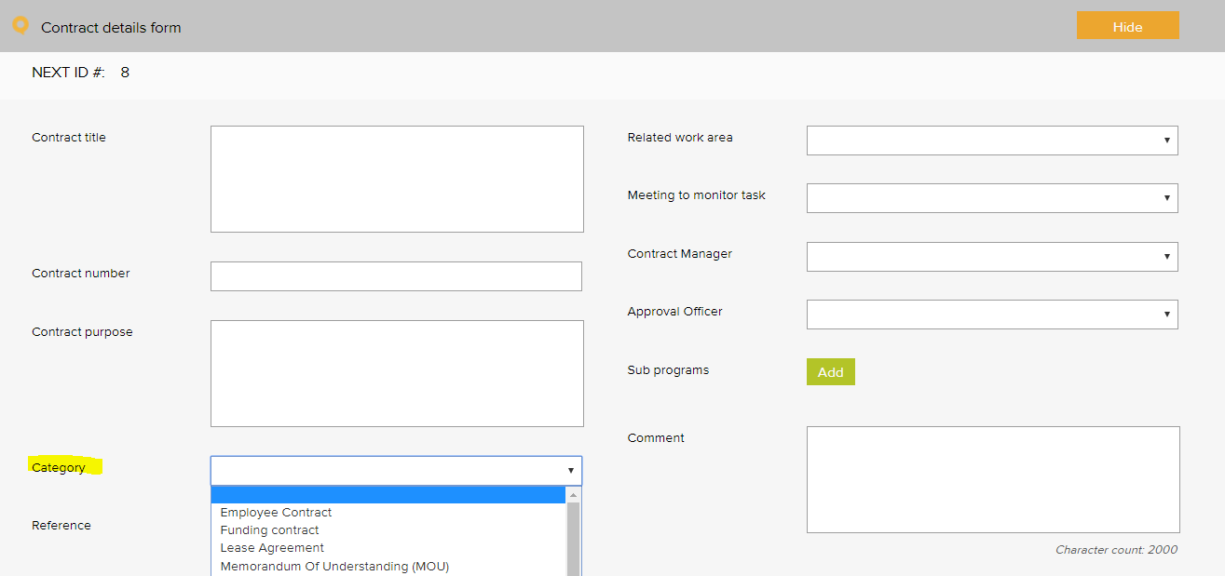

Contract Category - Examples
Contractor agreement
Employee agreement
External provider agreement
Funding agreement
Insurance policy
Lease agreement
Memorandum of understanding (MOU)
Partnership agreement
Position description (signed)
Rental agreement
Service level agreement (SLA)
Supplier agreement
Warranty agreement

Document Register
The document category menu is used when adding a document to the documents register. It allows for the document to be coded to a category. Reports can be generated based on the selections in this menu.
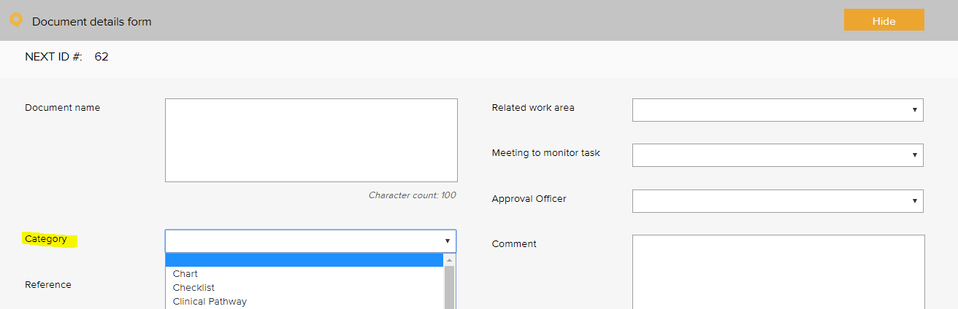

Document Category - Examples
Audit report template | Logo
Audit report tool | Manufacturer instruction manual
Brochure, information sheet | Plan
Bylaws | Policies, procedures, protocols
Charter | Position description
Checklist | Procedure manual
Communication material | Reference text
Competency assessment tool | Resource material
Diagram | Safety Data Sheet
Education material | Signage
Flowchart | Standard
Form | Template
Guideline | Terms of reference
Information resource | Tool
List | Work instruction

Feedback Register

Feedback type
The feedback type menu is used when reporting feedback in the feedback register. It allows for the feedback or complaint to be coded to a category. Reports can be generated based on the selections in this menu.
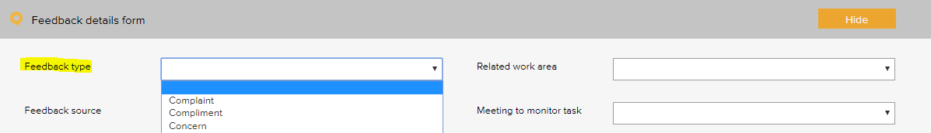
Feedback type - Examples
Complaint
Compliment
Issue of concern
Praise of staff

Feedback source
The feedback source menu is used when reporting feedback in the feedback register. It allows for the source of the feedback or complaint to be selected. Reports can be generated based on the selections in this menu.
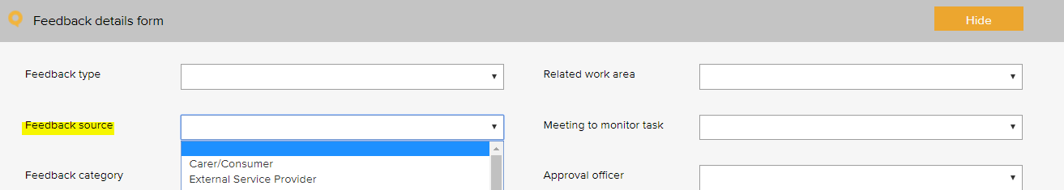

Feedback source- Examples
Board member
Client
Carer or family member
Community member
External service provider
Government agency
Supplier
Staff member

Feedback source – ACQS Examples
Family, friends and carers

Feedback category
The feedback category menu is used when reporting feedback in the feedback register. It allows for the feedback or complaint to be coded to a category. Reports can be generated based on the selections in this menu.
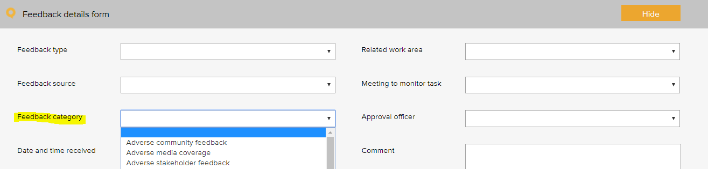

Feedback category - Examples
Adverse community feedback | Issue with service responsiveness
Adverse media coverage | Issue with staff courtesy
Adverse stakeholder feedback | Issue with transport service
Issue with access to services | Issue with waiting time
Issue with confidentiality / privacy | Pleased with access
Issue with consent | Pleased with confidentiality / privacy
Issue with cost of service | Pleased with cultural sensitivity
Issue with cultural sensitivity | Pleased with driver
Issue with driver | Pleased with facilities and amenities
Issue with governance | Pleased with performance
Issue with information | Pleased with services provided
Issue with service facilities | Pleased with staff courtesy
Issue with service performance | Pleased with transport service

Feedback category – ACQS Examples
Issue with respect and dignity | Issue with respect of cultural diversity
Issue with support in decision making | Issue with communication
Issue with connectivity/inclusion | Issue with information provided
Issue with privacy | Issue with assessment and planning
Issue with collaboration with other providers | Issue with personal / clinical care
Issue with end of life needs/preferences | Issue with service and support
Issue with emotional, spiritual and psychological well-being | Issue with meal service
Issue with welcoming of environment | Issue with facilities
Issue with furniture, fittings and equipment | Issue with feedback and complaints process
Issue with info/access to advocacy and/or language services | Issue with staff
Issue with service delivery | Issue with responding to abuse and neglect of consumers

Improvement Register
The source of issue menu is used when recording an improvement or non - conformance in the improvement register. It allows for the source of the issue to be recorded. Reports can be generated based on the selections in this menu.
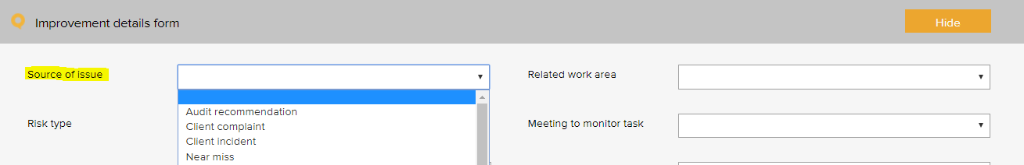

Improvement Source - Examples
Arising from - audit
Arising from - client incident
Arising from - complaint
Arising from - feedback
Arising from - incident - WHS
Arising from - incident - vehicle
Arising from - near miss
Suggestion - manager
Suggestion - other service provider
Suggestion - staff
Suggestion - staff member
Suggestion - stakeholder
Suggestion - team meeting

Incident Register
The incident type menu is used when reporting an incident in the incident register. It allows for the incident to be coded to a category. Reports can be generated based on the selections in this menu.
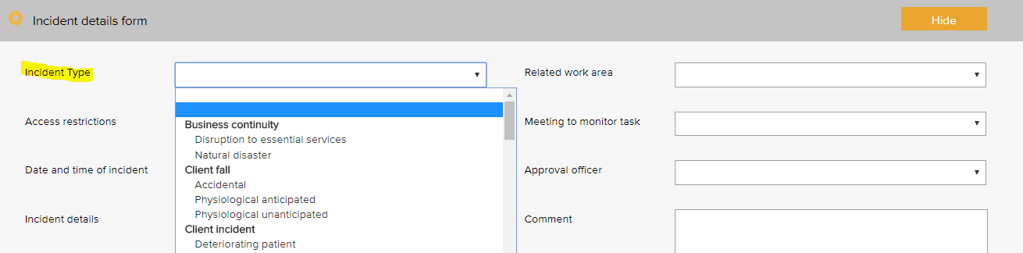
Primary Incident Type Example | Secondary Incident Type Example
Business continuity issue | Loss of service power
 | Loss of service telecommunications
 | Loss of service water
 | Natural disaster
Contract incident | Breach of contract
Finance incident | Bad debt
 | Fraud / Theft
 | Inaccurate accounting and / or reporting
 | Inadequate insurance
 | Inadequate liability insurance (directors and public liability)
 | Loss of funding
 | Missed billing
 | Missed payment obligation
Hazard | Biological
 | Chemical
 | Environmental hazard
 | Ergonomic
 | Falls hazard
 | Physical
 | Psychological
 | Safety
Staff training incident | Inadequate skills
Staff training incident | Inadequate supervision
Staff training incident | Inadequate training
ICT incident | Backup systems failure
 | Computer / systems breakdown
 | Inappropriate use of technology / internet
 | Intrusion / virus
 | Loss of IT data
 | Unauthorised file deletion
Legal incident | Cease and desist notice
 | Legal penalty
 | Litigation claim – non- staff
Reputation incident | Adverse publicity
Security incident | Privacy breach
Security incident | Security breach
Security incident | Trespassing
Security incident | Unauthorised access or release of client information
Security incident | Unauthorised access or release of corporate information
Health and safety | Electrical safety
 | Fire and emergency
 | Manual handling
 | Near miss
Vehicle incident | Accident - multiple vehicle
 | Accident - single vehicle
 | Damage
 | Theft
Environment | Status
 | Un-cleanliness

Licensing Register
The pre - set licence options menu is used when scheduling a licensing task in the licensing register. It allows for the task to be coded to a category. Reports can be generated based on the selections in this menu.
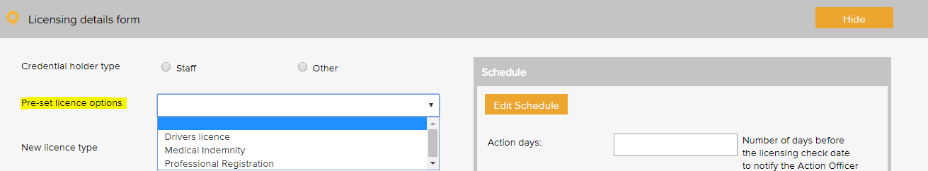

License type - Examples
Driver Authorisation
Driver’s licence - C
Driver’s licence - HR
Driver’s licence - LR
National criminal check
Vehicle safety
Working with children check

Meeting Register
The select a meeting menu is used when scheduling a meeting in the meeting register. It controls the meetings that users can add to the system. A selection from this list must be made when adding an item to any register.
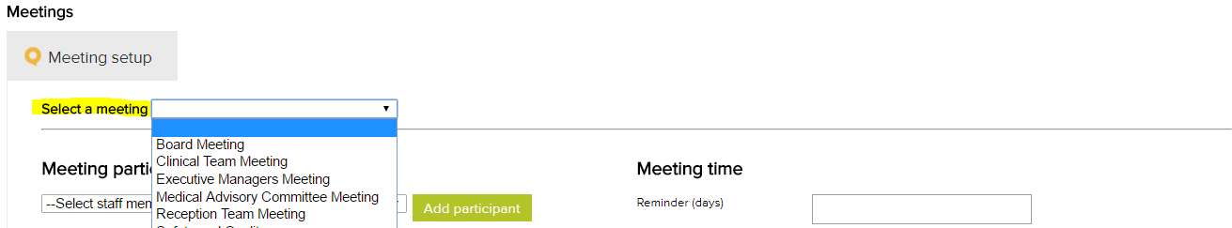

Meeting types - Examples
Corporate Services Meeting
Executive Management Committee
Quality and Safety Committee
Staff Meeting - All

Positions
The position menu appears when setting up staff contacts in the contacts register. A single unique position title should be created for every user of the system. If there are multiple positions with the same title, each position should be numbered to remain unique e.g. Receptionist 1, Receptionist 2 etc. Tasks in the system are assigned to positions.
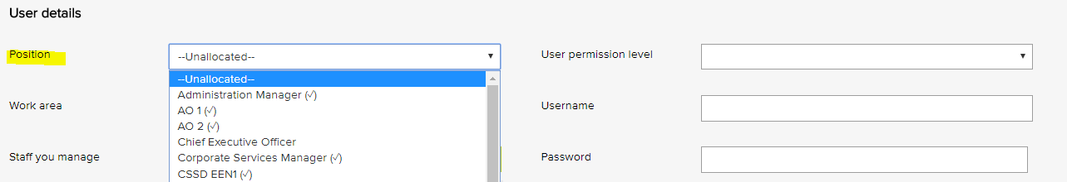

Position titles - Examples
Chief Executive Officer
Driver 1
Driver 2
Health and Safety Officer
Quality Manager
Reception 1
Reception 2

Records Register
The category menu is used when adding a record to the records register. It allows for the record to be coded to a category. The menu must also be used when adding a record to a task in the system. Reports can be generated based on the selections in this menu.
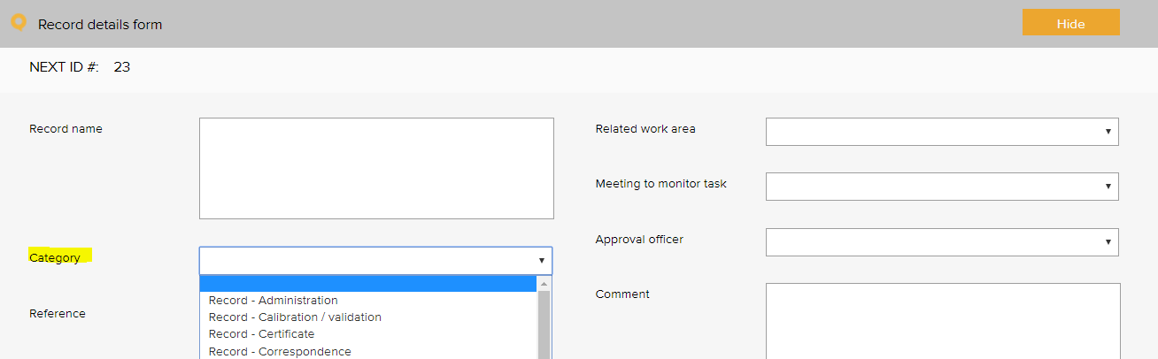

Quality records category - Examples
Certificate - education and training | Record - task sheet
Certificate - other | Record - training
Record - administration | Record - vehicle checks
Record - client feedback | Register - orientation attendance
Record - communication to workforce | Register - training attendance
Record - community meeting | Report
Record - correspondence | Report - audit
Record - email | Report - benchmarking report
Record - finance | Report - board
Record - HR | Report - data
Record - incident | Report - equipment maintenance
Record - legislation update | Report - evaluation
Record - meeting agenda | Report - financial
Record - meeting minutes | Report - legal advice
Record - memo | Report - management
Record - newsletters | Report - progress
Record - photograph | Report - referee
Record - planning | Report - service notification
Record - quote | Report - staff performance review
Record - safety and quality performance | Report - supervision
Record - staff confidentiality | Sign Sheet - key register
Record - staff recruitment | Sign Sheet - miscellaneous

Risk Register

Risk Assessment
The risk level and management requirement settings are displayed when rating a risk in the system. Reports can be generated based on the selections in this menu. There are four possible levels of risk in the LOGIQC assessment matrix. Each of these levels can be given a name such as Extreme, High, Medium and Low. Each risk level can also be given a related ‘management requirement’, eg. rules for how that level of risk should be managed.
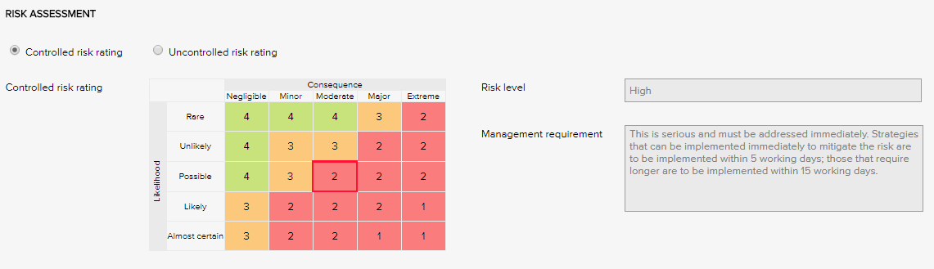
Risk Levels and related Management Requirements – Examples
Extreme | This is serious and must be addressed immediately. Strategies that can be implemented immediately to mitigate the risk are to be implemented within same or next working day; those requiring longer are to be implemented within 5 - 10 working days.
High | This is serious and must be addressed immediately. Strategies that can be implemented immediately to mitigate the risk are to be implemented within 5 working days; those that require longer are to be implemented within 15 working days.
Medium | Manage by specific monitoring or auditing procedures
Low | Manage by routine procedures.

Risk Treatment Options
The risk treatment option menu is used when adding a mitigation action to the risk register. It allows for the action to be categorised against a risk treatment strategy.
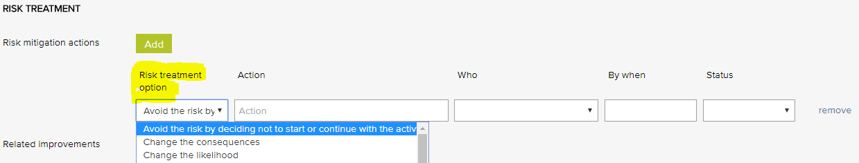
Risk Treatment Options - Examples
Avoid the risk by deciding not to start or continue with the activity | Isolate the hazard
Take or increase the risk in order to pursue an opportunity | Minimise the hazard
Change the consequences | Remove the risk source
Change the likelihood | Retain the risk by informed decision
Eliminate the hazard | Share the risk with another party or parties

Risk Dimensions
The risk dimension menu is used when adding a risk to the risk register. It allows for the identified risk to be coded to a high level dimension. Reports can be generated based on the selections in this menu.
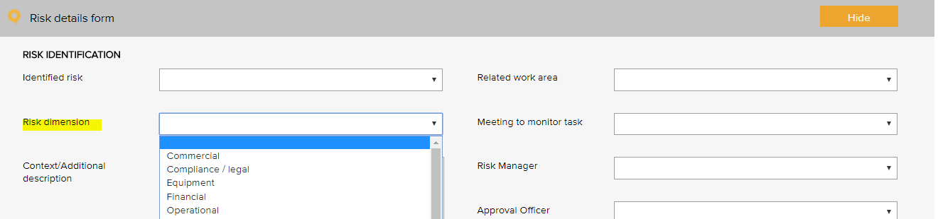
Risk Dimensions | Definition
Commercial | This category includes the risks associated with market placement, business growth, diversification and commercial success. This relates to the commercial viability of a product or service, and extends through establishment to retention and then growth of a customer base.
Compliance / legal | This category includes compliance with legal requirements such as legislation, regulations, standards, codes of practice and contractual requirements. This category also extends to compliance with additional ‘rules’ such as policies, procedures or expectations, which may be set by contracts, customers or the social environment.
Equipment | This extends to the equipment utilised for the operations and conduct of the business. It includes the general operations of the equipment, maintenance, appropriateness, depreciation, safety and upgrade.
Financial | This category includes cash flow, budgetary requirements, tax obligations, creditor and debtor management, remuneration and other general account management concerns.
Organisational | This relates to the internal requirements of a business, extending to the cultural, structural and people issues associated with the effective operation of the business.
Operational | This covers the planning, operational activities, resources (including people) and support required within the operations of a business that result in the successful development and delivery of a product or service.
Project | This includes the management of equipment, finances, resources, technology, timeframes and people associated with the management projects. It extends to internal operational projects, projects relating to business development, and external projects such as those undertaken for clients/patients.
Reputation | This entails the threat to the reputation of the business due to the conduct of the entity as a whole, the viability of product or service, or the conduct of employees or other individuals associated with the business.
Safety | This category includes the safety of everyone associated with the business. This extends from individual safety, to workplace safety, public safety and to the safety and appropriateness of products or services delivered by the business.
Security | This includes the overall security of the business premises, assets and people, and extends to security of information, intellectual property, and technology.
Service delivery | This relates to the delivery of services, including the quality and appropriateness of service provided, or the manner in which a product is delivered, including customer interaction and after-sales service.
Stakeholder management | This category relates to the management of stakeholders, and includes identifying, establishing and maintaining an appropriate relationship. This includes both internal and external stakeholders.
Strategic | This includes the planning, scoping and resourcing requirements for the establishment, sustaining and/or growth of the business.
Technology | This includes the implementation, management, maintenance and upgrades associated with technology. This extends to recognising the need for and the cost benefit associated with technology as part of a business development strategy.

Risk category and risk name
The identified risk menu is used when adding a risk to the risk register. It presents a list of risks that can be added to the risk register. Reports can be generated based on the selections in this menu.
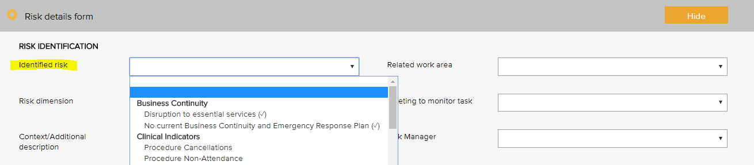
Risk category | Risk name
Business continuity | Disruption to essential services
 | Workforce sustainability
Collaborative partnerships | Breakdown in relationship with suppliers / stakeholders
Client safety | Client complaint
Client safety | Client safety
Client safety | Currency of driver licenses
Client safety | Falls prevention and harm minimisation
 | Non-conformance with procedures / standards
Financial | Cash / fund management shortfall
 | Competitors
 | Financial literacy
 | Non-conformance with financial management procedures
 | Over-reliance on a small number of customers / suppliers
Human resource / personnel | Cross cultural conflict
 | Industrial action
 | Lack / insufficient skills, training to complete job duties
 | Non-conformance with HR procedures
 | Over-reliance on a small number of staff or key staff
 | Problems with outside contractors
Inventory | Inventory mismanagement
Legal | Legislative / regulatory / contractual breaches
Legal | Legislative risk
Management | Assets mismanagement
 | Equipment mismanagement
 | Hazard mismanagement
 | Information mismanagement
 | Project goals and objectives not met
 | Property mismanagement
 | WHS mismanagement
Operations and assets | Non-conformance with operational procedures
 | Planning and scheduling conflicts
Policy and political | Changes in government
 | Organisational culture not aligned to organisational values
Reputation and image | Adverse media coverage
Reputation and image | Loss or injury to reputation
Reputation and image | Reduced or loss of community connectedness
Student placement | Non-conformance with student placement procedures
Security | Security breach
Technological | Breach of data security and backup
 | Failure of IT hardware and network management
 | Loss of productivity due to staff IT competencies
 | Not maximising the potential benefits of digital technologies
Vehicle management | Client transport mismanagement
 | Driver safety
 | Vehicle mismanagement
 | Vehicle safety

Linkages between the Risk Module and the Feedback and Incident Registers
Feedback and Incident Register
When the Risk Module is activated in the LOGIQC QMS, incident types and feedback categories can be linked to one or more identified risks. When an incident or feedback that is linked to a risk is reported, it will inherit the risk rating assigned to the risk that it is linked to. Where an incident type or feedback category has been linked to multiple risks, it will be assigned the risk that has the highest risk rating amongst those risks that it has been linked to. In the event that there is more than one risk at the highest risk rating, LOGIQC will assign the risk in alphabetical order from those at the highest level.

Site Information
The site information settings controls certain automatic behaviours such as the number of days allowed to respond to a task and the frequency of sending automatic reminders.

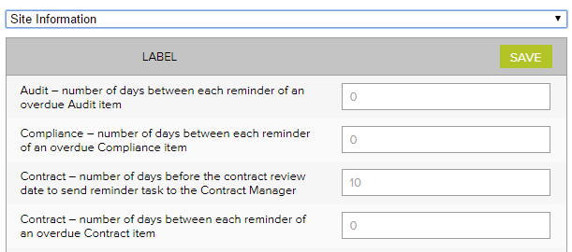
Label | No of days
Accreditation – number of days between each reminder of an open accreditation plan action | 14
Accreditation – number of days between each reminder of an overdue Accreditation item | 14
Accreditation – number of days the Approval Officer and the Quality Manager has to complete their tasks | 60
Audit – number of days between each reminder of an overdue audit item | 7
Compliance – number of days between each reminder of an overdue Compliance item | 7
Contract – number of days before the contract review date to send reminder task to the Contract manager | 14
Contract - number of days between each reminder of an overdue Contract item | 7
Contract – number of days the Approval Officer and the Contracts manager has to complete their tasks | 14
Document – number of days before the document review date to send reminder task to the Approval officer | 14
Document – number of days between each reminder of an overdue document item | 7
Document – number of days the Approval Officer has to complete the Approval task | 14
Feedback – number of days between each reminder of an overdue Feedback item | 3
Feedback – number of days the Approval Officer has to complete the Approve for Action task | 3
Improvement - number of days between each reminder of an overdue Improvement item | 14
Improvement – number of days the Approval Officer has to complete the Approve for Action task | 30
Incident - number of days between each reminder of an overdue Incident item | 3
Incident - number of days the Approval Officer has to complete the Approve for Action task | 3
Licensing - number of days between each reminder of an overdue licensing item | 3
Record - number of days between each reminder of an overdue Record item | 14
Repair - number of days between each reminder of an overdue Repair item | 7
Repair - number of days the Approval Officer has to complete the Approve for Action task | 3
Risk - number of days between each reminder of an open mitigation item | 14
Risk - number of days between each reminder of an overdue Risk item | 7
Risk – number of days the Approval Officer and the Risk Manager has to complete their tasks | 60
Supplier – number of days before the supplier review date to send reminder task to the Approval officer | 14
Supplier - number of days between each reminder of an overdue Supplier item | 7
Supplier – number of days the Approval Officer has to complete the Approval task | 14
Training – number of days between each reminder of an overdue Training item | 7

Suppliers register
The Assessment criteria menu is displayed as checkboxes when adding and reviewing a supplier in the supplier register. It controls the criteria used for assessing suppliers.
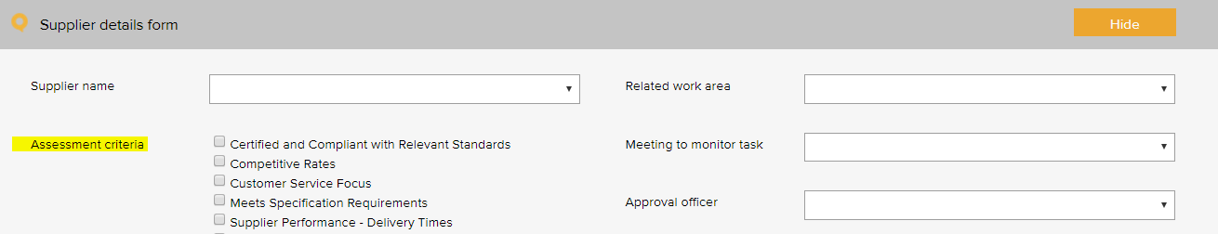
Supplier assessment criteria - Examples
ABN verified
Certified and compliant with relevant standards
Competitive rates
Customer service focus
Meets specification requirements
Supplier performance - delivery times
Supplier performance - processing of orders
Supplier performance - returns and back orders

System Settings

Disable auto timeout
The default settings in your LOGIQC QMS are set to disable auto timeout. This means that once logged in, your session will remain open for 12 hours before ‘timing out’ and requiring you to log in again. If you want to decrease this time to 70 minutes, simply un-check the setting.

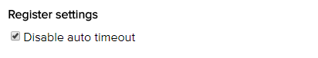

Training Register
The pre - set training options menu is used when scheduling a training task in the training register. It allows for the task to be coded to a category. Reports can be generated based on the selections in this menu.
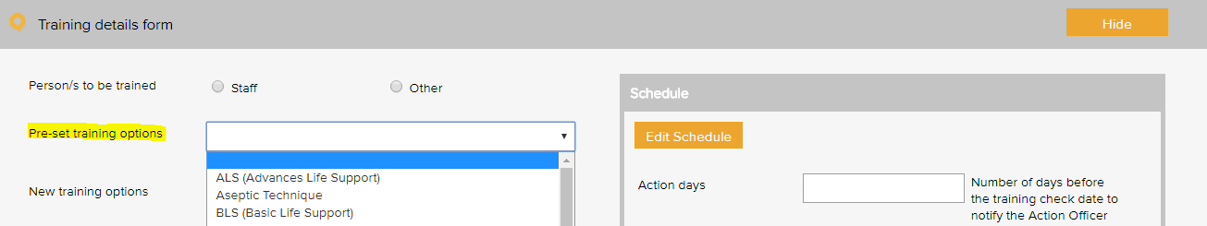
Training type – Examples
Basic life support (BLS)
Budget management
Bullying and harassment
Code of conduct
Competency assessment
Complaints management system
Cultural awareness
Driver safety
Emergency procedures
Falls prevention and management
Fire safety
Hazard reporting
Human resource management
Manual handling
Personal protective equipment
Quality management system training
Recruitment and selection
Safety and quality - general
Security and access
Use of email and information technology
WHS

Training type – ACQS Examples
Treating individuals with dignity and respect | Referral protocols
Protocols to support informed decision making | Protocols for maintaining confidential and privacy
Protocols to support consumer planning and assessment | Protocols to working in collaboration with other providers
End of life protocols | Quality management
Infection prevention and control | Protocols to engagement of consumers
Complaint management protocols | Staff code of conduct
Protocols for determining change or deterioration in a consumer's condition | Protocols relating to supporting consumers to exercise choice and independence
Protocols to support consumers, consumers, their family, friends, carers and others are to provide feedback and make complaints

Work Areas
This list appears when adding an item to any register. It is the list of functional work areas in the organisation (eg HR Administration, Clinic, Programs, etc) that tasks and issues can be assigned to. All Registers allow for sorting, filtering and printing of reports based on “work areas”.
Primary work area | Secondary work area
Corporate services | Administration
Corporate services | Finance
Corporate services | HR
Corporate services | ICT
Corporate services | Marketing and promotion
Corporate services | Quality and risk
Corporate services | Work health and safety
Governance | Board
Governance | Corporate governance
Governance | Management
Infrastructure and facilities | Buildings
Infrastructure and facilities | Car park
Infrastructure and facilities | Depo
Infrastructure and facilities | Equipment
Infrastructure and facilities | Grounds
Infrastructure and facilities | Motor vehicles
Infrastructure and facilities | Property
Infrastructure and facilities | Security
Programs | Aged Care - social support
Programs | Aged Care - transport
Programs | Disability transport
Programs | Health transport
Programs | Transport disadvantage
Programs | Vehicle hire

Primary work area - ACQS Examples | Secondary work area – ACQS Examples
Consumer Support Services | Food Service
 | Domestic Assistance
 | Transport Assistance
 | Recreational and Social Activities

Risk management guide for small business, NSW Department of State and Regional Development, www.smallbiz.nsw.gov.au

