LOGIQC QMS SETUP GUIDE – ACCHO PHC
This guide supports the set-up of the LOGIQC Quality Management System menus in accordance with the requirements of the RACGP Standards for general practices (5th edition), ISO 9001:2015 Quality management systems – Requirements, QIC Health and Community Services Standards (7th edition), Department of Human Service Standards 2011, Human Services Quality Standards 2013, National Standards for Disability Services (DSS 1504.02.15 — Version 0.1. December 2013), White Ribbon Australia Workplace Accreditation Program Standards and Criteria, Aged Care Quality Standards and Specialist Homelessness Services Standards 2016.

Contents

Customising menus 3
System menu types 3
Editing single level menu options 4
Editing double level menu options 5
System menu examples 6
Accreditation Register 6
Compliance Register 7
Contact Register 9
Contract Register 11
Document Register 12
Feedback Register 14
Feedback Type 14
Feedback Source 14
Feedback Category 15
Improvement Register 18
Incident Register 19
Licensing Register 25
Meeting Register 26
Positions 27
Records Register 28
Risk Register 29
Risk Assessment 29
Risk Treatment Options 29
Risk Dimensions 30
Risk Category and Risk Name 31
Site Information 33
Suppliers Register 34
System Settings 34
Training Register 35
Work Areas 36

Customising menus

System menu types
There are two main types of menus in LOGIQC: single level menus and double level menus. Most menus are single level. The double level menus are work area, incident type and identified risk.

Single level menu example | Double level menu example
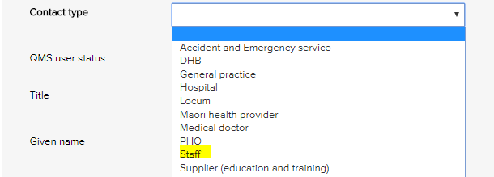 | 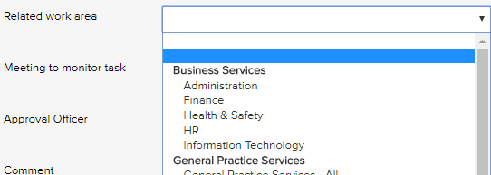
Single level menus  Accreditation assessment  Compliance source document  Contact type  Contract category  Document category  Feedback category  Feedback source  Feedback type  Improvement source  Licensing type  Meetings *  Positions *  Records category  Risk dimension  Risk treatment information  Supplier assessment criteria  Training type  * The content in these menus can be edited. | Double level menus  Primary + secondary incident type  Primary + secondary work area  Risk category + risk name

Editing single level menu options
These instructions use the contact type menu as an example.
- Log-in as administrator and select system setup in the system settings menu.
- From the system setup menu, select the menu to edit.
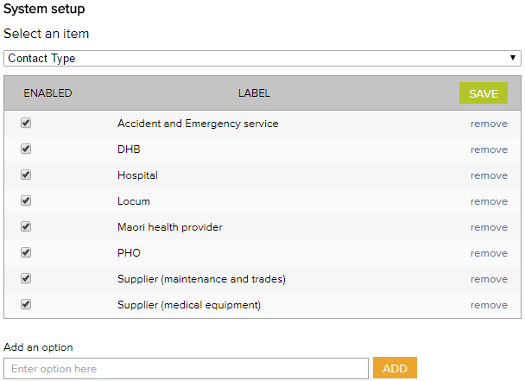
- Enter the new menu option into the add an option field.
- Click add and click save.
- To remove menu options, click remove and click save. (Note: Once an option has been used in a register item in the system the option can only be disabled and cannot be removed)

Editing double level menu options
These instructions use the work area menu as an example.
- Log - in with the Administrator password and select system setup in the system settings menu.
- From the system setup menu, select primary work area from the menu. From this screen, you can customise the menu to your organisation by adding and removing menu options.
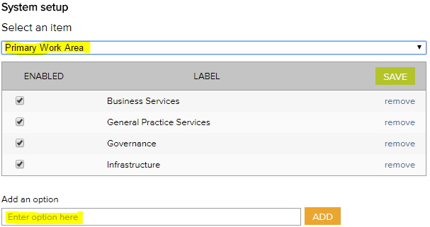
- To add new primary work area categories and type into the option field.
- Click add and click save.
- To remove primary work area categories that you don’t want, click remove and click save. (Note: Once an option has been used in a register item in the system the option can only be disabled and cannot be removed)
- Select secondary work area from the system setup menu.
If a new primary category is created LOGIQC will automatically create a duplicate secondary menu label with the word ‘all’ appended. This option can be removed after other secondary options are added to the category. LOGIQC requires a minimum of one secondary menu option for each primary option.
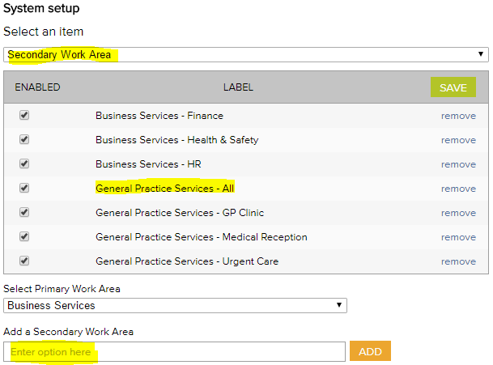
- To add new secondary work areas, select the related primary work area and type into the option field.
- Click add and click save.
- To remove secondary work area categories that you don’t want, click remove and click save. (Note: Once an option has been used in a register item in the system the option can only be disabled and cannot be removed)

System menu examples

Accreditation Register
The accreditation business system is used to group ‘accreditation actions required’ into higher order categories in the accreditation action plan and excel export. This way the individual tasks added can be categories.
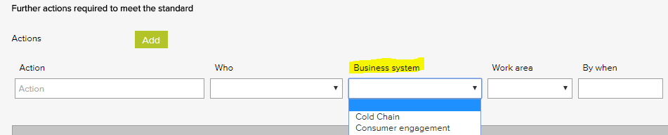
Accreditation business system – General Examples
Accountability and reporting
Cold chain
Consumer engagement
Equipment - medical
Equipment - non-medical
Governance - clinical
Governance - corporate
Infection prevention and control
Internal communication
Management - clinical
Management - corporate
Training - induction
Training - mandatory

Compliance Register
The Source of requirement menu is used when scheduling a compliance task. It allows for the task to be coded to the entity or regulation that stipulates that the task should be carried out. Reports can be generated based on the selections in this menu.
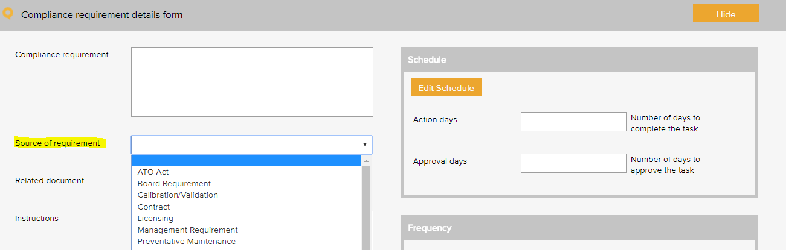

Compliance source document category – General Examples based on the RACGP Standards 5th Ed
Australian standards
Australian tax law
Board requirement
CATSI Act
Constitution
Contract requirement - non-funding
Funding agreement
Management requirement
Regulation
Superannuation policy and legislation
Work health and safety act

Compliance category – HSQS Examples
Information Privacy Act 2009 | Right to Information Act 2009
Queensland Language Services Policy | Children (Risk Management and Screening) Act 2000
Multicultural Queensland Charter | Working with Children (Risk Management and Screening) Regulation 2011.

Compliance category – National SDS Examples
Disability Discrimination Act 1992

Compliance category – WRA Examples
White Ribbon Australia Workplace Accreditation
Workplace Gender Equality Act 2012a

Compliance category – SHSS Examples
Department for Child Protection and Family Support
Professional standards
Incorporation regulations
Operational Plan
Action Plan

Contact Register
The contact type menu is used when adding a business contact to the contacts register. It allows for the contact to be coded to a category. Reports can be generated based on the selections in this menu.
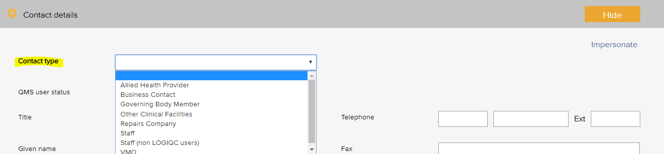

Contact type – General Examples based on the RACGP Standards 5th Ed
Advocacy and support services
Agency staff
Allied health provider
Business contact
Education agency
General practitioner
Government agency
Health care provider - ACCHO
Health care provider - other
Housing agency
Industry body
Justice agency
Legal agency
LOGIQC user
Standards agency
Supplier - education and training
Supplier - IT and support
Supplier - maintenance
Supplier - medical equipment
Supplier - medical gases
Supplier - medical supplies
Supplier - office
Supplier - waste management

Contact type – HSQS Examples
Preferred supplier agreement

Contact type – WRA Examples
Family relationship counselling services
Family support services
Legal advice services
Crisis intervention services.
Woman’s shelters
Domestic violence services and networks

Contact type – SHSS Examples
Community service

Contract Register
The contract category menu is used when adding a contract to the contracts register. It allows for the contract to be coded to a category. Reports can be generated based on the selections in this menu.
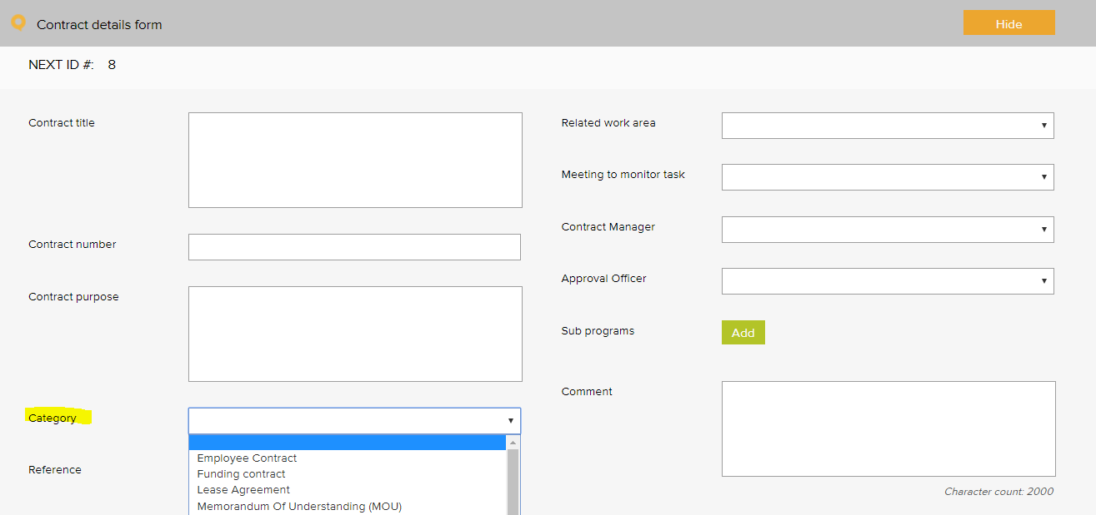

Contract category - General Examples based on RACGP Standards 5th Ed
Contractor agreement | Partnership agreement
Employee agreement | Position description (signed)
External provider agreement | Rental agreement
Funding agreement | Service level agreement (SLA)
Insurance policy | Supplier agreement
Lease agreement | Warranty agreement
Memorandum of understanding (MOU)

Contract category – QIC 7 Examples
Funding agreement | Partnership agreement
Insurance policy | Research agreement
Interagency agreement | Staff confidential agreement
Membership | Staff contract
Memorandum of understanding (MOU) | Subscription

Contract category – SHSS Examples
Service Agreement

Document Register
The document category menu is used when adding a document to the documents register. It allows for the document to be coded to a category. Reports can be generated based on the selections in this menu.
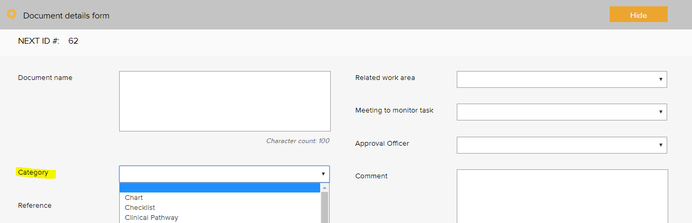

Document category – General Examples based on the RACGP Standards 5th Ed
Audit tool | Logo
Brochure, information sheet | Manufacturer instruction manual
Charter | Safety data sheet
Checklist | Plan
Client / carer information | Policies, procedures, protocols
Clinical pathway | Position description
Communication material | Reference text
Competency assessment tool | Resource material
Diagram | Sign sheet
Education material | Signage
Flowchart | Standard
Form | Template
Framework | Terms of reference
Guideline | Tool
Information resource | Work instruction
List

Document category – DHSS Examples
Poster | Resource

Document category – QIC 7 Examples
Chart | Position description
Legislation | Protocol
Plan | Standard
Policy and procedure | Terms of reference

Document category – National SDS Examples
Written policies and procedures that safeguard individuals’ SERVICE PROVIS rights and freedom from harm, neglect, abuse and violence are upheld in place and applied.

Document category – WRA Examples
Video

Document category – SHSS Examples
Assessment tool
Code
Assessment guideline

Feedback Register

Feedback Type
The feedback type menu is used when reporting feedback in the feedback register. It allows for the feedback or complaint to be coded to a category. Reports can be generated based on the selections in this menu.
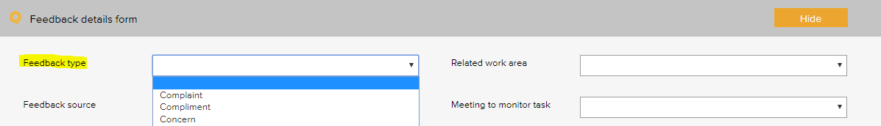

Feedback type - General Examples based on the RACGP Standards 5th Ed
Complaint
Compliment
Issue of concern
Suggestion for improvement

Feedback type – HSQS Examples
Issue with other service provider performance
Pleased with other service provider performance

Feedback Source
The feedback source menu is used when reporting feedback in the feedback register. It allows for the source of the feedback or complaint to be selected. Reports can be generated based on the selections in this menu.
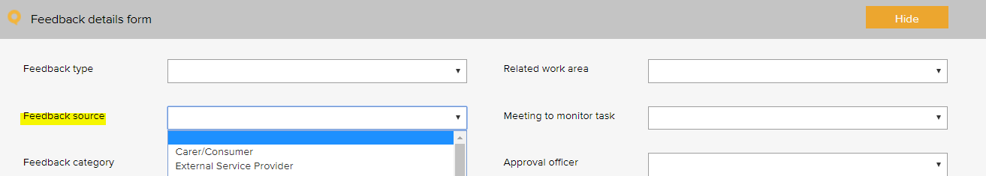

Feedback source - General Examples based on the RACGP Standards 5th Ed
Board member
Client - scheduled appointment
Client - walk in
Client carer or family member
Community member
External service provider
Government agency
Supplier
Visiting practitioner

Feedback source – HSQS Examples
Child Protection
Community visitors
Guardian
Family member
Carer
Advocate

Feedback source – WRA Examples
Union

Feedback source – ACQS Examples
Family, friends and carers

Feedback source – SHSS Examples
Department for Child Protection and Family Support
CaLD
Client under 18 years

Feedback Category
The feedback category menu is used when reporting feedback in the feedback register. It allows for the feedback or complaint to be coded to a category. Reports can be generated based on the selections in this menu.
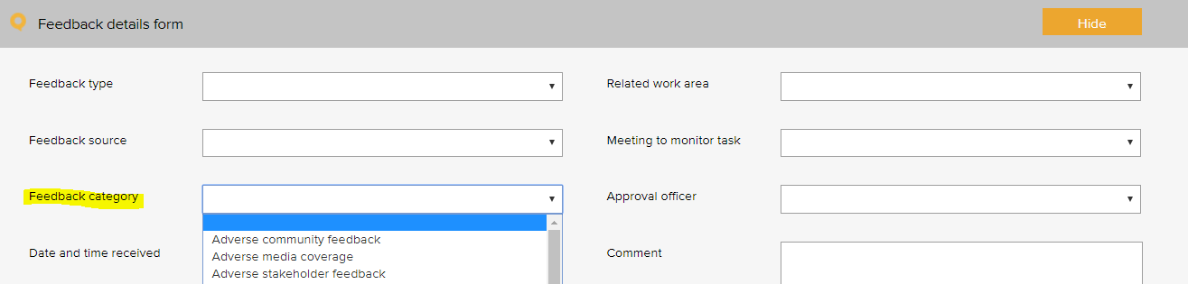

Feedback Category - General Examples based on the RACGP Standards 5th Ed
Adverse community feedback | Issue with referral practices
Adverse media coverage | Issue with service facilities
Adverse stakeholder feedback | Issue with service performance
Issue with access to services | Issue with service responsiveness
Issue with clinical care | Issue with staff courtesy
Issue with clinical handover | Issue with waiting time
Issue with confidentiality / privacy | Pleased with access
Issue with consent | Pleased with confidentiality / privacy
Issue with cost of service | Pleased with cultural sensitivity
Issue with cultural sensitivity | Pleased with customer service
Issue with governance | Pleased with facilities and amenities
Issue with information - clinical | Pleased with medical practitioner
Issue with information - non-clinical | Pleased with performance
Issue with information - quality of information | Pleased with service responsiveness
Issue with medication | Pleased with services provided
Issue with poor care and communication | Pleased with staff courtesy
Issue with processes of engagement and support provided | Praise of staff

Feedback category – DHSS Examples
Issue with access
Pleased with access

Feedback category – National SDS Examples
Issue with respect and dignity | Issue with information regarding advocacy services
Issue with individual freedom of expression | Issue with range of supports available
Issue with information provided in suitable formats | Issue with handling of personal information
Issue with restrictiveness of options | Issue with connections to family/communities
Issue with information provided in suitable formats | Issue with accessing preferred activities
Issue with breach of rights | Issue with family/friends involvement in reviews/planning
Issue with cultural needs of ATSI people | Issue with support with needs/life goals
Issue with service planning for individual needs | Issue with participation in service reviews
Issue with response to diversity | Issue with non-collaboration with other service providers
Issue with feedback & complaints process | Issue with staff member
Issue with participation in feedback reviews | Issue with access and potential barriers
Issue with accessibility of service, physical environment | Issue with consumer engagement in review of service provision protocols

Feedback category – ACQS Examples
Issue with respect and dignity | Issue with respect of cultural diversity
Issue with support in decision making | Issue with communication
Issue with connectivity/inclusion | Issue with information provided
Issue with privacy | Issue with assessment and planning
Issue with collaboration with other providers | Issue with personal / clinical care
Issue with end of life needs/preferences | Issue with service and support
Issue with emotional, spiritual and psychological well-being | Issue with meal service
Issue with welcoming of environment | Issue with facilities
Issue with furniture, fittings and equipment | Issue with feedback and complaints process
Issue with info/access to advocacy and/or language services | Issue with staff
Issue with service delivery | Issue with responding to abuse and neglect of consumers

Feedback category – SHSS Examples
Issue with waiting time | Issue with referral pathway
Issue with eligibility assessment outcome | Issue with interpreter service
Issue with support plan | Issue with consent
Issue with case coordination | Issue with case management
Issue with case closure process | Issue with disability access
Issue with restriction of rights | Issue with release or use of client data

Improvement Register
The source of issue menu is used when recording an improvement or non - conformance in the improvement register. It allows for the source of the issue to be recorded. Reports can be generated based on the selections in this menu.
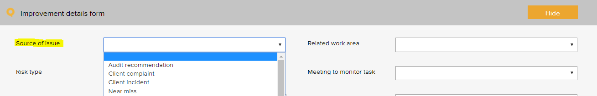

Improvement source – General Examples
Arising from - audit | Arising from - WHS incident
Arising from - client incident | Suggestion - manager
Arising from - clinical incident | Suggestion - other service provider
Arising from - complaint | Suggestion - staff
Arising from - feedback | Suggestion - stakeholder
Arising from - near miss | Suggestion - team meeting
Arising from - non-clinical incident | Suggestion - visiting practitioner

Improvement source – National SDS
Individual
Family member
Friend
Carer

Incident Register
The incident type menu is used when reporting an incident in the incident register. It allows for the incident to be coded to a category. Reports can be generated based on the selections in this menu.
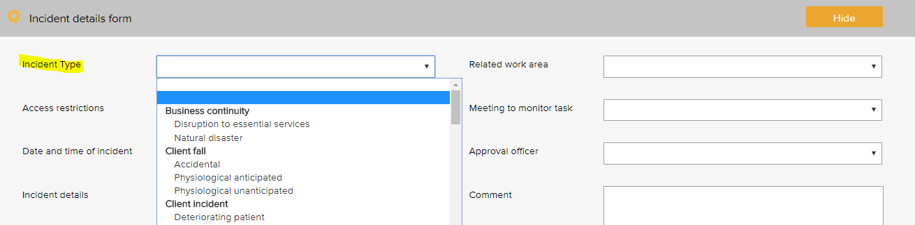
The following example is based on the WHO Conceptual Framework for the International Classification for Client Safety which provides a categorization of client safety information using standardized sets of concepts with agreed definitions, preferred terms, and the relationships between them based on an explicit domain ontology. It is designed to facilitate the description, comparison, measurement, monitoring, analysis and interpretation of information to improve client care, and for epidemiological and health policy planning purposes.

Incident type – General Examples
Primary incident type example | Secondary incident type example
Clinic administration incident | Appointment
 | Client identification
 | Consent
 | Discharge
 | Handover
 | Referral / consultation
 | Response to emergency
 | Task allocation
 | Transfer of care
 | Waiting time
Clinical process / procedure incident | Adverse event
 | Deviation from protocol / procedure / guideline
 | Diagnosis / assessment
 | General care / management
 | Infectious status
 | Lack of protocols / policy / procedure / guideline
 | Misidentification
 | Near miss
 | Procedure / treatment / intervention
 | Referral
 | Sentinel event
 | Specimens / results
 | Tests / investigations
 | Transfer
 | Wrong site
Documentation incident | Clinical pathway
 | Loss of client / medical data
 | Loss of client / medical information
 | Medical certificates
 | Client records / assessments
 | Client records / consultation notes
 | Orders / requests
 | Poor record management
 | Referrals
 | Reports / results / images
Healthcare associated-infection incident | Antibiotic related issue
 | Infection incident
Medication incident | Administering
 | Adverse drug reaction
 | Breach of policies, procedures and protocols
 | Disposal
 | Information provided to clients and carers
 | Monitoring
 | Prescribing
 | Reporting system
 | Storage
 | Supply / ordering
 | Supply and distribution
 | Temperature sensitivity
 | Un-reconciled controlled drug register
IV fluid incident | Administering
 | Setup
Oxygen incident | Administering
 | Storage
Medical device equipment incident | Failure / breakdown
 | Fault
Staff behaviour incident | Bullying
Staff behaviour incident | Discrimination / prejudice
Staff behaviour incident | Disrespectful
Staff behaviour incident | Harassment
Staff behaviour incident | Intended self-harm / suicide
 | Noncompliant
 | Physical assault
 | Sexual assault
 | Substance use / abuse
 | Threat to personal safety
 | Verbal aggression
Client behaviour incident | Bullying
 | Discrimination / prejudice
 | Disrespectful
 | Harassment
 | Intended self-harm / suicide
 | Noncompliant
 | Physical assault
 | Sexual assault
 | Substance use / abuse
 | Threat to personal safety
 | Verbal aggression
Client accident | Exposure to electricity
 | Poisoning by chemical or other substance
Client fall | Collapse
 | Loss of balance
 | Slip / trip / stumble
Building incident | Damaged
 | Lift failure
Fixture incident | Damaged
 | Faulty

Additional incidents type examples, beyond WHO Conceptual Framework for the International Classification for Client Safety
Primary incident type | Secondary incident type
Business continuity issue | Loss of connectivity
 | Loss of service power
 | Loss of service telecommunications
 | Loss of service water
 | Natural disaster
Cold chain incident | Cold chain breach
Cold chain incident | Cold chain excursion
Cold chain incident | Cold chain failure
Contract incident | Breach of contract
Finance incident | Bad debt
 | Fraud / theft
 | Inaccurate accounting and / or reporting
 | Inadequate insurance
 | Inadequate liability insurance (directors and public liability)
 | Loss of funding
 | Missed billing
 | Missed payment obligation
Hazard | Biological
 | Chemical
 | Environmental hazard
 | Ergonomic
 | Falls hazard
 | Physical
 | Psychological
 | Safety
Infection prevention and control | Compromised packaging
 | Contamination of a sterile field
 | Contamination of instruments
 | Endophthalmitis
 | Hand hygiene
 | HepB
 | MRSA
Staff training incident | Inadequate skills
Staff training incident | Inadequate supervision
Staff training incident | Inadequate training
ICT incident | Backup systems failure
 | Computer / systems breakdown
 | Inappropriate use of technology / internet
 | Intrusion / virus
 | Loss of IT data
 | Unauthorised file deletion
Legal incident | Cease and desist notice
 | Legal penalty
 | Litigation claim - non staff
Inventory incident | Critical item out of stock
 | Expired medical product
 | Inadequate stock
Privacy incident | Privacy breach
 | Unauthorised access or release of client information
Reputation incident | Adverse publicity
Security incident | Security breach
 | Trespassing
 | Unauthorised access or release of corporate information
Health and safety | Electrical safety
 | Fire and emergency
 | Manual handling
 | Near miss
Vehicle incident | Accident
 | Damage
 | Theft
Environment | Status
 | Un-cleanliness

Incident type – HSQS Examples
Primary incident type example | Secondary incident type example
Legal | Breach of legislation and regulation

Incident type – WRA Examples
Primary incident type example | Secondary incident type example
Violence against women | Sexist language within the workplace
 | Sexually explicit jokes within the workplace
 | Bullying behaviour against women
 | Sexist behaviour within the workplace
 | Harassment against women
 | Disrespectful behaviour against women
 | Disrespectful attitudes towards women
 | Derogatory behaviour against women
 | Sexual assault
 | Physical assault
 | Breach of the Code of Conduct
Privacy breach | Disrespectful of people’s privacy in the workplace

Licensing Register
The pre-set licence options menu is used when scheduling a licensing task in the licensing register. It allows for the task to be coded to a category. Reports can be generated based on the selections in this menu.
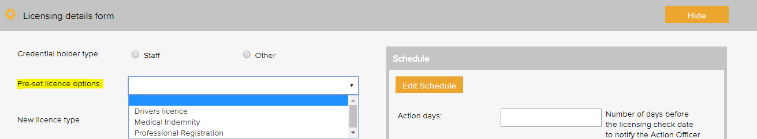

License type - General Examples
AHPRA registration | Medical indemnity
Credentialing requirements | Medicare provider number
Driver’s licence - C | National criminal check
Healthcare provider identifier | Vaccination requirement
Immunisation requirement | Working with children check

License type – HSQS Examples
Yellow Card | Child Safety and Personal History Check

Meeting Register
The select a meeting menu is used when scheduling a meeting in the meeting register. It controls the meetings that users can add to the system. A selection from this list must be made when adding an item to any register.
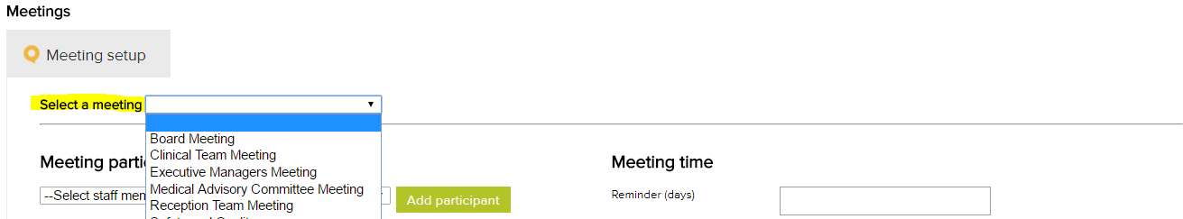

Meeting types - General Examples
Clinical Staff Meeting
Corporate Services Meeting
Executive Management Meeting
Quality and Safety Committee
Staff Meeting - All

Meeting types – SHSS Examples
Case management

Positions
The position menu appears when setting up staff contacts in the contacts register. A single unique position title should be created for every user of the system. If there are multiple positions with the same title, each position should be numbered to remain unique e.g. Receptionist 1, Receptionist 2 etc. Tasks in the system are assigned to positions.
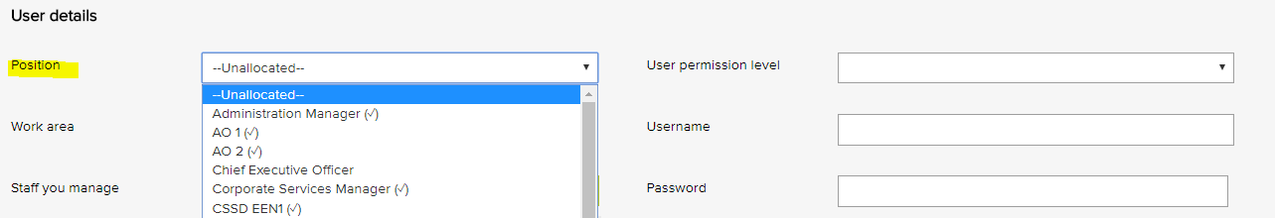

Position titles - General Examples
Aboriginal Health Worker 1
Aboriginal Health Worker 2
Chief Executive Officer
Health and Safety Officer
Practice Manager
Quality Manager
Registered Nurse 1
Registered Nurse 2

Records Register
The category menu is used when adding a record to the records register. It allows for the record to be coded to a category. The menu must also be used when adding a record to a task in the system. Reports can be generated based on the selections in this menu.
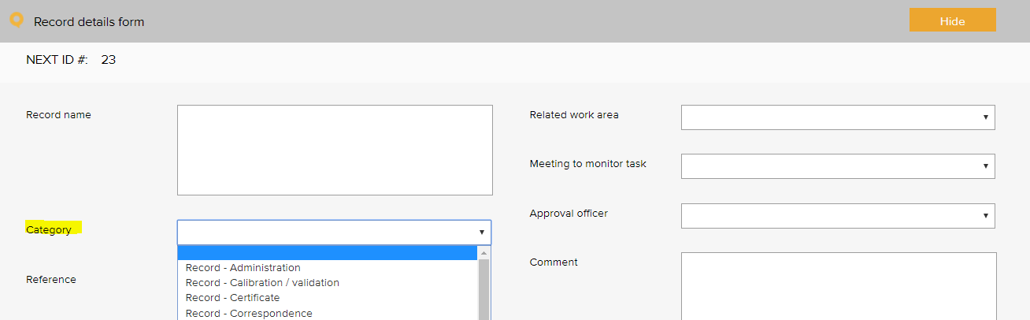
Quality records category - General Examples based on the RACGP Standards 5th Ed
Certificate - AHPRA | Record - task sheet
Certificate - education and training | Record - training
Certificate - indemnity insurance | Register - orientation attendance
Certificate - other | Register - training attendance
Record - administration | Report - other
Record - calibration / validation | Report - audit
Record - client feedback | Report - benchmarking report
Record - communication to workforce | Report - board
Record - community meeting | Report - data
Record - correspondence | Report - equipment maintenance
Record - credentialing | Report - evaluation
Record - email | Report - financial
Record - finance | Report - legal advice
Record - HR | Report - management
Record - incident | Report - progress
Record - legislation update | Report - referee
Record - meeting agenda | Report - service notification
Record - meeting minutes | Report - staff performance review
Record - memo | Report - supervision
Record - newsletter | Sign sheet - emergency trolley
Record - photograph | Sign sheet - fridge temperatures
Record - planning | Sign sheet - key register
Record - quote | Sign sheet - miscellaneous
Record - safety and quality performance | Sign sheet - oxygen and suction
Record - staff confidentiality | Sign sheet - pathology collection
Record - job advertisement | Sign sheet - visitors log
Record - staff recruitment

Risk Register

Risk Assessment
The risk level and management requirement settings are displayed when rating a risk in the system. Reports can be generated based on the selections in this menu. There are four possible levels of risk in the LOGIQC assessment matrix. Each of these levels can be given a name such as Extreme, High, Medium and Low. Each risk level can also be given a related ‘management requirement’, eg. rules for how that level of risk should be managed.
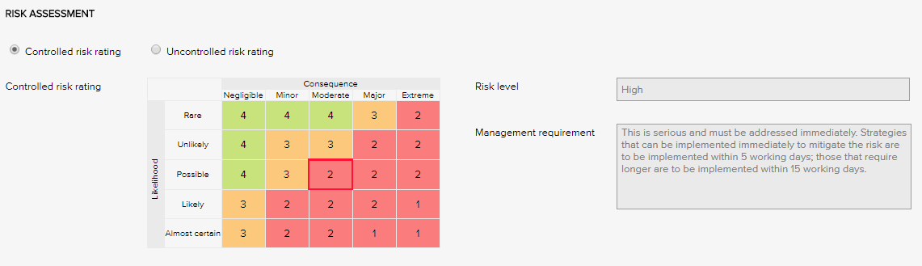

Risk Levels and related Management Requirements - Examples
Extreme | This is serious and must be addressed immediately. Strategies that can be implemented immediately to mitigate the risk are to be implemented within same or next working day; those requiring longer are to be implemented within 5 - 10 working days.
High | This is serious and must be addressed immediately. Strategies that can be implemented immediately to mitigate the risk are to be implemented within 5 working days; those that require longer are to be implemented within 15 working days.
Medium | Manage by specific monitoring or auditing procedures
Low | Manage by routine procedures.

Risk Treatment Options
The risk treatment option menu is used when adding a mitigation action to the risk register. It allows for the action to be categorised against a risk treatment strategy.
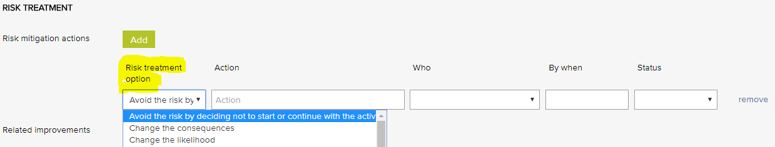
Risk treatment options - General Examples
Avoid the risk by deciding not to start or continue with the activity | Isolate the hazard
Take or increase the risk in order to pursue an opportunity | Minimise the hazard
Change the consequences | Remove the risk source
Change the likelihood | Retain the risk by informed decision
Eliminate the hazard | Share the risk with another party or parties

Risk Dimensions
The risk dimension menu is used when adding a risk to the risk register. It allows for the identified risk to be coded to a high level dimension. Reports can be generated based on the selections in this menu.
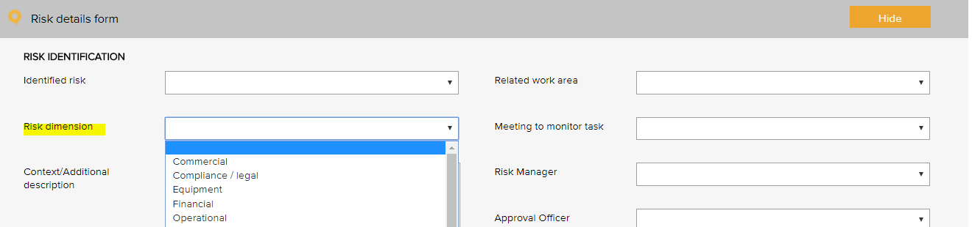
Risk Dimensions | Definition
Commercial | This category includes the risks associated with market placement, business growth, diversification and commercial success. This relates to the commercial viability of a product or service, and extends through establishment to retention and then growth of a customer base.
Compliance / legal | This category includes compliance with legal requirements such as legislation, regulations, standards, codes of practice and contractual requirements. This category also extends to compliance with additional ‘rules’ such as policies, procedures or expectations, which may be set by contracts, customers or the social environment.
Equipment | This extends to the equipment utilised for the operations and conduct of the business. It includes the general operations of the equipment, maintenance, appropriateness, depreciation, safety and upgrade.
Financial | This category includes cash flow, budgetary requirements, tax obligations, creditor and debtor management, remuneration and other general account management concerns.
Organisational | This relates to the internal requirements of a business, extending to the cultural, structural and people issues associated with the effective operation of the business.
Operational | This covers the planning, operational activities, resources (including people) and support required within the operations of a business that result in the successful development and delivery of a product or service.
Project | This includes the management of equipment, finances, resources, technology, timeframes and people associated with the management projects. It extends to internal operational projects, projects relating to business development, and external projects such as those undertaken for clients.
Reputation | This entails the threat to the reputation of the business due to the conduct of the entity as a whole, the viability of product or service, or the conduct of employees or other individuals associated with the business.
Safety | This category includes the safety of everyone associated with the business. This extends from individual safety, to workplace safety, public safety and to the safety and appropriateness of products or services delivered by the business.
Security | This includes the overall security of the business premises, assets and people, and extends to security of information, intellectual property, and technology.
Service delivery | This relates to the delivery of services, including the quality and appropriateness of service provided, or the manner in which a product is delivered, including customer interaction and after-sales service.
Stakeholder management | This category relates to the management of stakeholders, and includes identifying, establishing and maintaining an appropriate relationship. This includes both internal and external stakeholders.
Strategic | This includes the planning, scoping and resourcing requirements for the establishment, sustaining and/or growth of the business.
Technology | This includes the implementation, management, maintenance and upgrades associated with technology. This extends to recognising the need for and the cost benefit associated with technology as part of a business development strategy.

Risk Category and Risk Name
The identified risk menu is used when adding a risk to the risk register. It presents a list of risks that can be added to the risk register. Reports can be generated based on the selections in this menu.
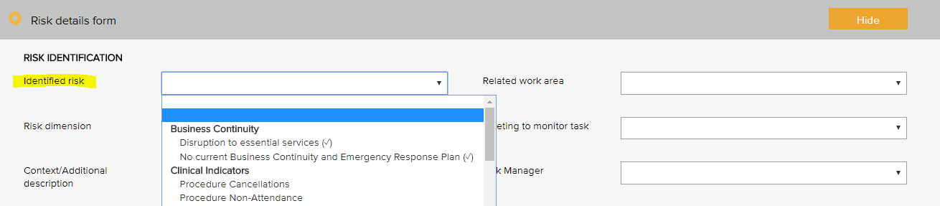

Risk category | Risk name
Business continuity | Disruption to essential services
Business continuity | Workforce sustainability
Collaborative partnerships | Breakdown in relationship with suppliers / stakeholders
Client safety | Client complaint
Client safety | Falls prevention and harm minimisation
Client safety | Clinical incident
Client safety | Client safety
Client safety | Cold chain breach
Client safety | Currency of professional registration / credentialing
Client safety | Currency of staff immunisation
Client safety | Infection control breach
Client safety | Medication safety
Client safety | Non-conformance with clinical procedures / standards
Financial | Cash / fund management shortfall
Financial | Competitors
Financial | Non-conformance with financial management procedures
Financial | Financial literacy
Financial | Over-reliance on a small number of customers / suppliers
Human resource / personnel | Cross cultural conflict
Human resource / personnel | Industrial action
Human resource / personnel | Lack / insufficient skills, training to complete job duties
Human resource / personnel | Non-conformance with HR procedures
Human resource / personnel | Over-reliance on a small number of staff or key staff
Human resource / personnel | Problems with outside contractors
Inventory | Inventory mismanagement
Legal | Legislative / regulatory / contractual breaches
Legal | Legislative risk
Management | Assets mismanagement
Management | Client transport mismanagement
Management | Equipment mismanagement
Management | Hazard mismanagement
Management | Information mismanagement
Management | Project goals and objectives not met
Management | Property mismanagement
Management | Vehicle mismanagement
Management | WHS mismanagement
Operations and assets | Non-conformance with operational procedures
Operations and assets | Planning and scheduling conflicts
Policy and political | Changes in government
Policy and political | Organisational culture not aligned to organisational values
Reputation and image | Adverse media coverage
Reputation and image | Loss or injury to reputation
Reputation and image | Reduced or loss of community connectedness
Security | Security breach
Student / registrar placement | Non-conformance with student / registrar placement procedures
Technological | Breach of data security and backup
Technological | Failure of IT hardware and network management
Technological | Loss of productivity due to staff IT competencies
Technological | Not maximising the potential benefits of digital technologies

Linkages between the Risk Module and the Feedback and Incident Registers
When the Risk Module is activated in the LOGIQC QMS, incident types and feedback categories can be linked to one or more identified risks. When an incident or feedback that is linked to a risk is reported, it will inherit the risk rating assigned to the risk that it is linked to. Where an incident type or feedback category has been linked to multiple risks, it will be assigned the risk that has the highest risk rating amongst those risks that it has been linked to. In the event that there is more than one risk at the highest risk rating, LOGIQC will assign the risk in alphabetical order from those at the highest level.

Site Information
The site information settings controls certain automatic behaviours such as the number of days allowed to respond to a task and the frequency of sending automatic reminders.

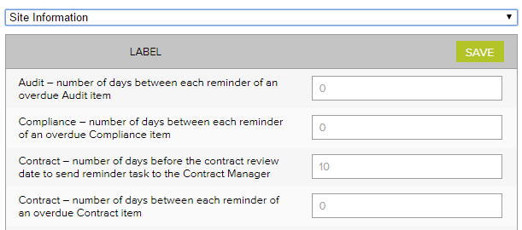
Site information - Examples
Label | No of days
Accreditation – number of days between each reminder of an open accreditation plan action | 14
Accreditation – number of days between each reminder of an overdue Accreditation item | 14
Accreditation – number of days the Approval Officer and the Quality Manager has to complete their tasks | 60
Audit – number of days between each reminder of an overdue audit item | 7
Compliance – number of days between each reminder of an overdue Compliance item | 7
Contract – number of days before the contract review date to send reminder task to the Contract manager | 14
Contract - number of days between each reminder of an overdue Contract item | 7
Contract – number of days the Approval Officer and the Contracts manager has to complete their tasks | 14
Document – number of days before the document review date to send reminder task to the Approval officer | 14
Document – number of days between each reminder of an overdue document item | 7
Document – number of days the Approval Officer has to complete the Approval task | 14
Feedback – number of days between each reminder of an overdue Feedback item | 3
Feedback – number of days the Approval Officer has to complete the Approve for Action task | 3
Improvement - number of days between each reminder of an overdue Improvement item | 14
Improvement – number of days the Approval Officer has to complete the Approve for Action task | 30
Incident - number of days between each reminder of an overdue Incident item | 3
Incident - number of days the Approval Officer has to complete the Approve for Action task | 3
Licensing - number of days between each reminder of an overdue licensing item | 3
Record - number of days between each reminder of an overdue Record item | 14
Repair - number of days between each reminder of an overdue Repair item | 7
Repair - number of days the Approval Officer has to complete the Approve for Action task | 3
Risk - number of days between each reminder of an open mitigation item | 14
Risk - number of days between each reminder of an overdue Risk item | 7
Risk – number of days the Approval Officer and the Risk Manager has to complete their tasks | 60
Supplier – number of days before the supplier review date to send reminder task to the Approval officer | 14
Supplier - number of days between each reminder of an overdue Supplier item | 7
Supplier – number of days the Approval Officer has to complete the Approval task | 14
Training – number of days between each reminder of an overdue Training item | 7

Suppliers Register
The Assessment criteria menu is displayed as checkboxes when adding and reviewing a supplier in the supplier register. It controls the criteria used for assessing suppliers.
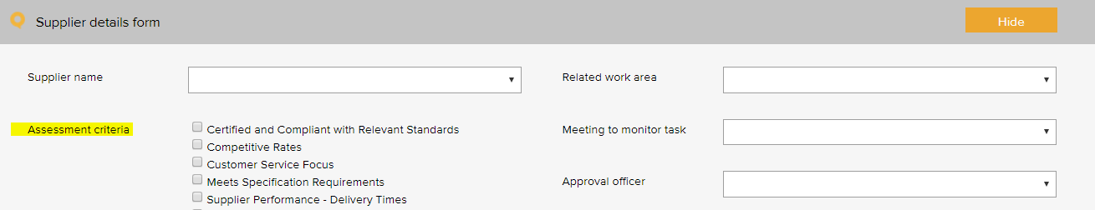

Supplier assessment criteria – General Examples based on the RACGP Standards 5th Ed
ABN verified
Certified and compliant with relevant standards
Competitive rates
Customer service focus
Meets specification requirements
Supplier performance - delivery times
Supplier performance - processing of orders
Supplier performance - returns and back orders

Supplier assessment criteria – WRA Examples
CERT IV in Training and Assessment or equivalent expertise in adult learning
Agreement to uphold zero tolerance for violence against women

System Settings

Disable auto timeout
The default settings in your LOGIQC QMS are set to disable auto timeout. This means that once logged in, your session will remain open for 12 hours before ‘timing out’ and requiring you to log in again. If you want to decrease this time to 70 minutes, simply un-check the setting.

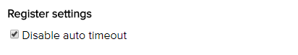

Training Register
The pre - set training options menu is used when scheduling a training task in the training register. It allows for the task to be coded to a category. Reports can be generated based on the selections in this menu.
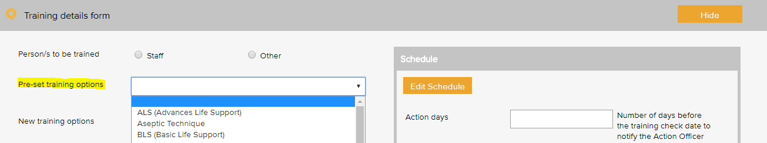
Training type – General Examples based on the RACGP Standards 5th Ed
Advanced life support (ALS) | Human resource management
Aseptic technique | Identification of at-risk clients
Basic life support (BLS) | Induction
Budget management | Infection prevention and control
Bullying and harassment | Investigating clinical incidents
Client privacy and confidentiality | Manual handling
Clinical services, procedures and technologies | Medication management system
Code of conduct | Open disclosure
Competency assessment | Personal protective equipment
Complaints management system | Quality management system training
Cultural awareness | Recruitment and selection
Disposal of unused, unwanted or expired medications | Safety and quality - client care
Emergency procedures | Safety and quality - general
Escalating care | Security and access
Falls prevention and management | Standard precautions
Fire safety | Transmission - based precautions
Hand hygiene | Use of email and information technology
Hazard reporting | WHS

Training type – ACQS Examples
Treating individuals with dignity and respect | Referral protocols
Protocols to support informed decision making | Protocols for maintaining confidential and privacy
Protocols to support consumer planning and assessment | Protocols to working in collaboration with other providers
End of life protocols | Quality management
Infection prevention and control | Protocols to engagement of consumers
Complaint management protocols | Staff code of conduct
Protocols for determining change or deterioration in a consumer's condition | Protocols relating to supporting consumers to exercise choice and independence
Protocols to support consumers, consumers, their family, friends, carers and others are to provide feedback and make complaints

Work Areas
This list appears when adding an item to any register. It is the list of functional work areas in the organisation (eg HR Administration, Clinic, Programs, etc) that tasks and issues can be assigned to. All Registers allow for sorting, filtering and printing of reports based on “work areas”.
Primary work area examples | Secondary work area examples
Corporate services | Administration
 | Cold chain
 | Finance
 | HR
 | Infection prevention and control
 | IT
 | Marketing and promotion
 | Quality and risk
 | Work health and safety
Governance | Board
 | Clinical governance
 | Corporate governance
 | Management
Infrastructure and facilities | Building
 | Car park
 | Equipment
 | Grounds
 | Lifts
 | Property
 | Security
Primary health care services | Chronic disease
 | Clinic
 | Maternal and child health
 | All
 | Reception
 | SEWB
 | Transport service

Primary work area - ACQS Examples | Secondary work area – ACQS Examples
Consumer Support Services | Food Service
 | Domestic Assistance
 | Transport Assistance
 | Recreational and Social Activities

WHO Conceptual Framework for the International Classification for Client Safety Version 1.1 Final Technical Report January 2009
International Classification for Client Safety Statement of Purpose - http: / / www.who.int / patientsafety / taxonomy / ICPS_Statement_of_Purpose.pdf
There are 3 types of events that need separate reports: Cold chain breach: an event which has led to the vaccines being stored or transported in temperatures outside the required +2˚C to +8˚C range, but the potency/stability of the vaccines has not been compromised. Cold chain excursion: an event which has led to the vaccines being stored or transported in temperatures outside the required +2⁰C to +8⁰C range and as a result, vaccines are compromised and need to be returned for destruction. Cold chain failure: an event in which vaccines involved in a cold chain excursion are administered to clients
Risk management guide for small business, NSW Department of State and Regional Development, www.smallbiz.nsw.gov.au

