LOGIQC QMS SETUP GUIDE - PROCARE PRACTICES
This guide supports the set-up of the LOGIQC Quality Management System menus for ProCare GP Practices in accordance with the requirements of the Aiming for Excellence, the RNZCGP standard for New Zealand general practice for Foundation and CORNERSTONE practices (Version 1.0 – July 2016).

Contents

Customising menus 3
System menu types 3
Editing single level menu options 5
Editing double level menu options 6
System menu examples 7
Contact Register 7
Document Register 8
Feedback Register 9
Feedback Type …………………………………………………………………………………………………………………………………………………………….9
Feedback Source ………………………………………………………………………………………………………………………………………………………… 9
Feedback Category ……………………………………………………………………………………………………………………………………………………10
Improvement Register 11
Incident Register 12
Meeting Register 17
Positions 17
Records Register 18
Risk Register 19
Risk Assessment ………………………………………………………………………………………………………………………………………………………..19
Risk Levels and related Management Requirement – Examples …………………………………………………………………………………19
Risk Treatment Options ……………………………………………………………………………………………………………………………………………..19
Risk Dimensions …………………………………………………………………………………………………………………………………………………………20
Risk category and risk name ………………………………………………………………………………………………………………………………………21
Risk category and risk name ………………………………………………………………………………………………………………………………………21
Site Information 23
System Settings 24
Work Areas 24
Accreditation Register 25
Compliance Register 26
Contract Register 27
Suppliers Register 28
License Register 28
Training Register 30

Customising menus

System menu types
There are two main types of menus in LOGIQC: single level menus and double level menus. Most menus are single level. The double level menus are work area, incident type and identified risk.

Single level menu example | Double level menu example
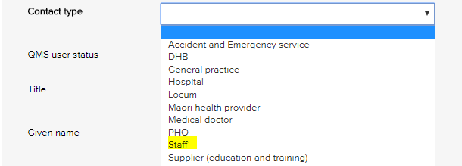 | 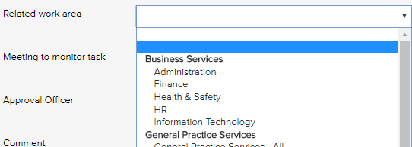
Single level menus  Accreditation assessment  Compliance source document  Contact type  Contract category  Document category  Feedback category  Feedback source  Feedback type  Improvement source  Licensing type  Meetings *  Positions *  Records category  Risk dimension  Risk treatment information  Supplier assessment criteria  Training type  * The content in these menus can be edited. | Double level menus  Primary + secondary incident type  Primary + secondary work area  Risk category + risk name

Editing single level menu options
These instructions use the contact type menu as an example.
- Log-in as administrator and select system setup in the system settings menu.
- From the system setup menu, select the menu to edit.
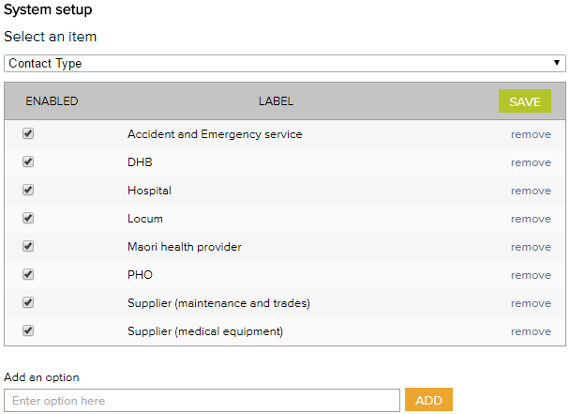
- Enter the new menu option into the add an option field.
- Click add and click save.
- To remove menu options, click remove and click save. (Note: Once an option has been used in a register item in the system the option can only be disabled and cannot be removed)

Editing double level menu options
These instructions use the work area menu as an example.
- Log-in with the Administrator password and select system setup in the system settings menu.
- From the system setup menu, select primary work area from the menu. From this screen, you can customise the menu to your organisation by adding and removing menu options.
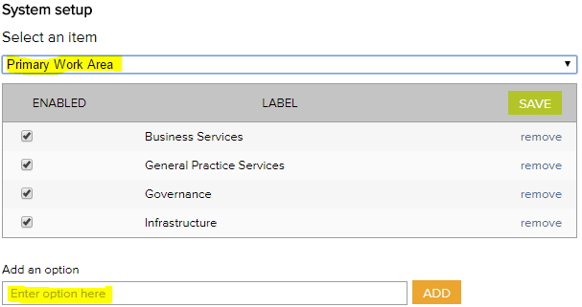
- To add new primary work area categories and type into the option field.
- Click add and click save.
- To remove primary work area categories that you don’t want, click remove and click save. (Note: Once an option has been used in a register item in the system the option can only be disabled and cannot be removed)
- Select secondary work area from the system setup menu.
If a new primary category is created LOGIQC will automatically create a duplicate secondary menu label with the word ‘all’ appended. This option can be removed after other secondary options are added to the category. LOGIQC requires a minimum of one secondary menu option for each primary option.
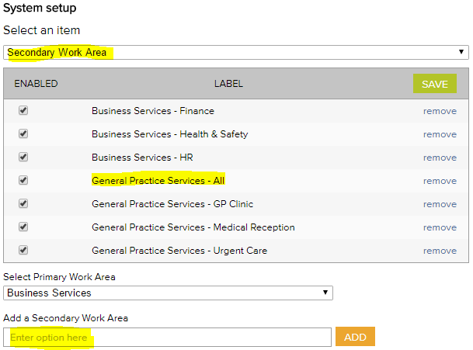
- To add new secondary work areas, select the related primary work area and type into the option field.
- Click add and click save.
- To remove secondary work area categories that you don’t want, click remove and click save. (Note: Once an option has been used in a register item in the system the option can only be disabled and cannot be removed)

System menu examples

Contact Register
The contact type menu is used when adding a business contact to the contacts register. It allows for the contact to be coded to a category. Reports can be generated based on the selections in this menu.
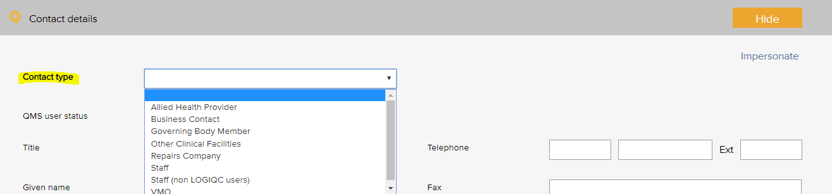
Contact type - Examples
Accident and emergency service | PHO
Assisted communication services | RNZCGP
DHB | Staff
General practice | Supplier - education and training
Government agency | Supplier - it and support
Hospital | Supplier - maintenance and trades
Interpreter services | Supplier - medical equipment
Locum | Supplier - medical supplies
Maori health provider | Supplier - office materials
Medical doctor | Supplier - waste management
Mental health provider

Document Register
The document category menu is used when adding a document to the documents register. It allows for the document to be coded to a category. Reports can be generated based on the selections in this menu.
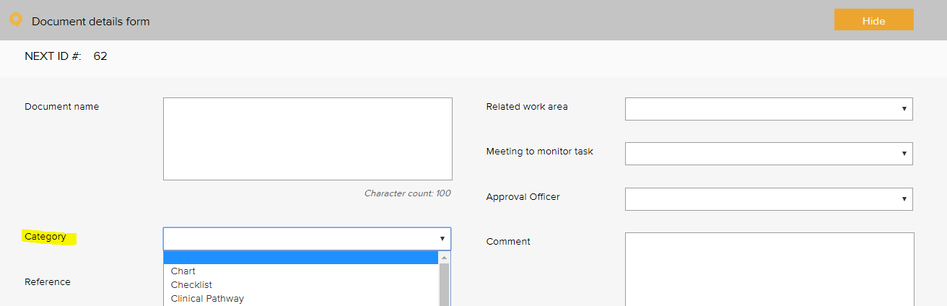
Document category - Examples
Audit tool | Policy and procedure
Brochure | Position description
Checklist | Poster
Diagram | Questionnaire
Form | Register
Information resource | Safety Data Sheet
Legislation | Signage
Logo | Standard / guideline
Plan | Template

Feedback Register

Feedback Type
The feedback type menu is used when reporting feedback in the feedback register. It allows for the feedback or complaint to be coded to a category. Reports can be generated based on the selections in this menu.
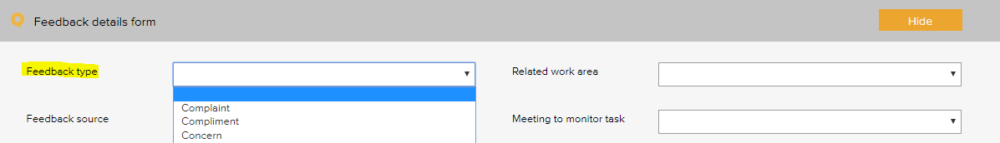
Feedback type - Examples
Complaint
Compliment
Concern
Feedback
Issue

Feedback Source
The feedback source menu is used when reporting feedback in the feedback register. It allows for the source of the feedback or complaint to be selected. Reports can be generated based on the selections in this menu.
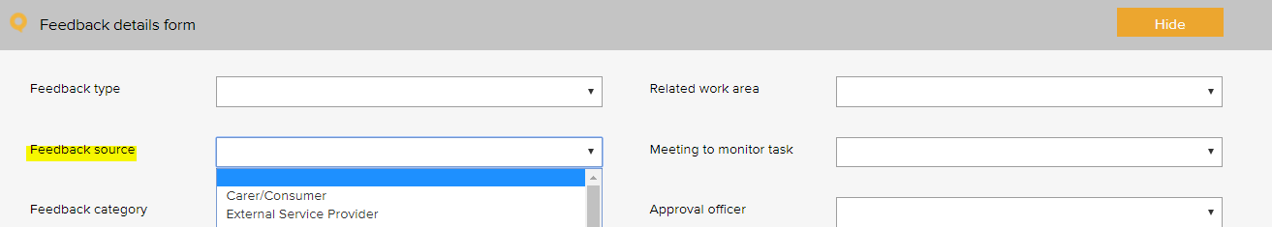

Feedback source - Examples
DHB | Pharmacy
External service provider | PHO
Family or whanau | Staff
Health and disability | Supplier
Ministry of health | Visiting practitioner
Patient

Feedback Category
The feedback category menu is used when reporting feedback in the feedback register. It allows for the feedback or complaint to be coded to a category. Reports can be generated based on the selections in this menu.
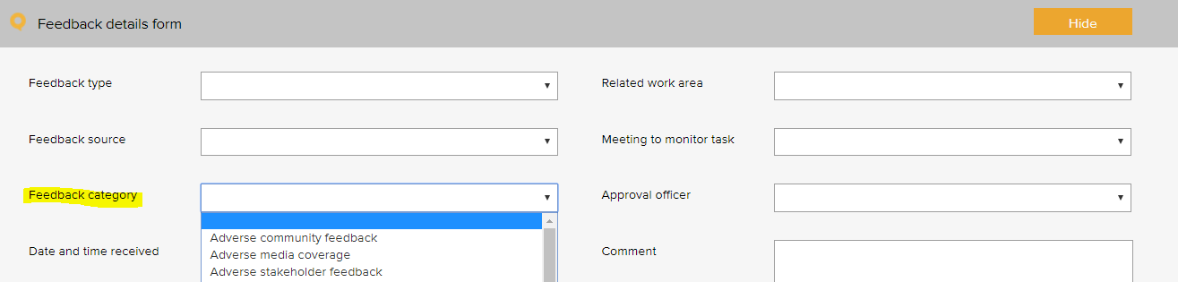

Feedback category - Examples
Adverse community feedback | Concern with clinical care
Adverse media coverage | Concern with clinical information provided
Adverse stakeholder feedback | Concern with practice performance
Concern about confidentiality / privacy | Pleased with access
Concern about cost of service | Pleased with confidentiality / privacy
Concern about cultural sensitivity / competence | Pleased with cultural competence
Concern about customer service | Pleased with customer service
Concern about medication management | Pleased with facilities and amenities
Concern about practice facilities | Pleased with practice performance
Concern about practice responsiveness | Pleased with practice responsiveness
Concern about referral process | Pleased with services provided
Concern about staff courtesy | Praise of staff
Concern with access to services

Improvement Register
The source of issue menu is used when recording an improvement or non-conformance in the improvement register. It allows for the source of the issue to be recorded. Reports can be generated based on the selections in this menu.
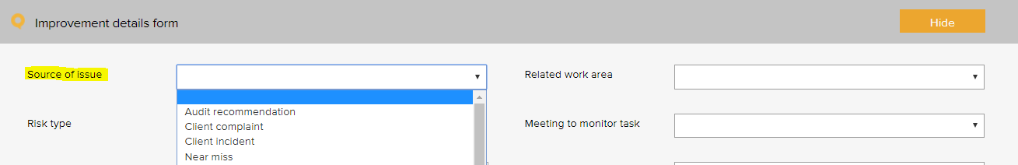
Improvement source - Examples
Arising from - adverse event | Arising from - near miss
Arising from - audit - patient record review | Arising from - pharmacist feedback
Arising from - audit - patient screen and recall | Arising from - staff survey
Arising from - audit recommendation | Suggestion - manager
Arising from - complaint | Suggestion - other service provider
Arising from - feedback | Suggestion - staff
Arising from - health and safety accident | Suggestion - stakeholder
Arising from - incident | Suggestion - team meeting
Arising from - medication management | Suggestion - visiting practicing

Incident Register
The incident type menu is used when reporting an incident in the incident register. It allows for the incident to be coded to a category. Reports can be generated based on the selections in this menu.
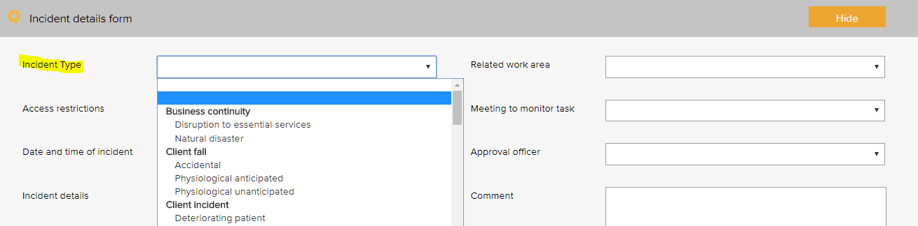
The following example is based on the WHO Conceptual Framework for the International Classification for Patient Safety which provides a categorization of patient safety information using standardized sets of concepts with agreed definitions, preferred terms, and the relationships between them based on an explicit domain ontology. It is designed to facilitate the description, comparison, measurement, monitoring, analysis and interpretation of information to improve patient care, and for epidemiological and health policy planning purposes.
This framework is referred to in the New Zealand Health and Disability Services – National Reportable Events Policy 2012 and has been used as a basis for determining reportable events codes referred to in the Policy.
Incident Type - Examples adapted from the WHO Conceptual Framework for the International Classification for Patient Safety
Primary incident type | Secondary incident type
Clinic administration incident | Appointment
 | Consent
 | Discharge
 | Handover
 | Patient identification
 | Referral / consultation
 | Registration enrolment
 | Response to emergency
 | Task allocation
 | Transfer of care
 | Waiting time
Clinical process / procedure incident | Care / management
 | Diagnosis / assessment
 | Procedure / treatment / intervention
 | Screening
 | Specimens collection
 | Test results
 | Tests investigations
Cold Chain incident | Cold chain breach
Cold Chain incident | Cold chain excursion
Cold Chain incident | Cold chain failure
Documentation incident | Care plan
 | Clinical assessments
 | Medical certificates
 | Medical records / consultation notes
 | Orders / requests
 | Referrals
 | Reports / results / images
Infection control incident | Breach of infection control
 | Clean wound infection
 | Contaminant spill
 | Needle stick injury
Medication incident | Administering
 | Monitoring
 | Prescribing
 | Storage
 | Supply / ordering
IV fluid incident | Administering
 | Setup
Oxygen incident | Administering
 | Storage
Medical device equipment incident | Breakage
 | Malfunction
Staff behaviour incident | Bullying
 | Discrimination / prejudice
 | Disrespectful
 | Harassment
 | Intended self-harm / suicide
 | Noncompliant
 | Physical assault
 | Sexual assault
 | Substance use /abuse
 | Threat to personal safety
 | Verbal aggression
Patient behaviour incident | Bullying
 | Discrimination / prejudice
 | Disrespectful
 | Harassment
 | Intended self-harm / suicide
 | Noncompliant
 | Physical assault
 | Sexual assault
 | Substance use / abuse
 | Threat to personal safety
 | Verbal aggression
Patient accident | Chemical burn
 | Electrical burn
 | Exposure to electricity
 | Skin Abrasion
Patient fall | Collapse
 | Slip
 | Trip / stumble
Building incident | Damaged
Fixture incident | Damaged
 | Faulty
Organisational management incident | Human resource
 | Lack of protocols / policy / procedure / guideline
 | Service availability
 | Staff availability

Additional incidents types, beyond patient safety:
Primary incident type | Secondary incident type
Business continuity issue | Loss of service power
 | Loss of service telecommunications
 | Loss of service water
 | Natural disaster
Contract incident | Breach of contract
Finance incident | Bad debt
 | Fraud
 | Inaccurate accounting and / or reporting
 | Inadequate insurance
 | Inadequate liability insurance (directors and public liability)
 | Loss of funding
 | Missed billing
 | Missed payment obligation
 | Theft
Hazard | Biological
 | Chemical
 | Ergonomic
 | Physical
 | Psychological
 | Safety
Staff training incident | Inadequate supervision
 | Inadequate training
ICT incident | Backup systems failure
 | Computer / systems breakdown
 | Inappropriate use of technology / internet
 | Intrusion / virus
 | Loss of IT data
 | Unauthorised file deletion
Legal incident | Cease and desist notice
 | Legal penalty
 | Litigation claim - non-staff
Inventory incident | Critical item out of stock
 | Expired medical product
 | Inadequate stock
Reputation incident | Adverse publicity
Security incident | Privacy breach
 | Security breach
 | Trespassing
 | Unauthorised access or release of patient information
 | Unauthorised access or release of corporate information
Health and safety | Electrical safety
 | Fire and emergency
 | Manual handling
 | Near miss
Vehicle incident | Accident
 | Damage
 | Theft

Meeting Register
The select a meeting menu is used when scheduling a meeting in the meeting register. It controls the meetings that users can add to the system. A selection from this list must be made when adding an item to any register.
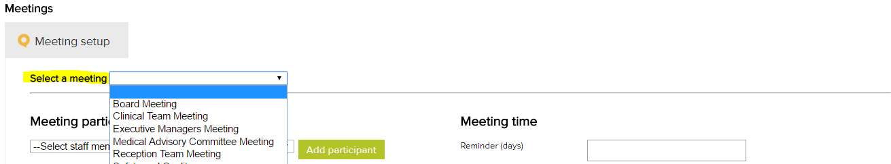
Meeting types - Examples
Admin Meeting
Clinical Team Meeting
Doctors’ Meeting
Management Meeting
Nurse Meeting
Staff Meeting

Positions
The position menu appears when setting up staff contacts in the contacts register. A single unique position title should be created for every user of the system. If there are multiple positions with the same title, each position should be numbered to remain unique e.g. Receptionist 1, Receptionist 2 etc. Tasks in the system are assigned to positions.
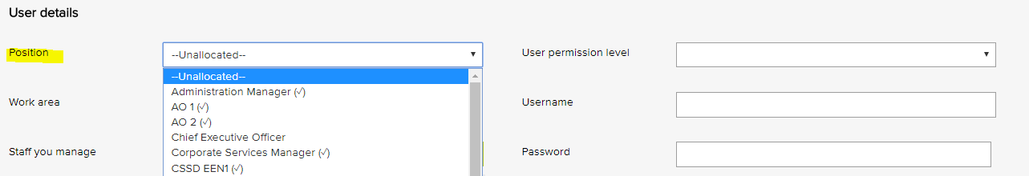
Position titles - Examples
Accounts Manager
General Practitioner 1
General Practitioner 2
Health and Safety Coordinator
Medical Receptionist 1
Medical Receptionist 2
Medical Receptionist 3
Practice Manager
Practice Nurse 1
Practice Nurse 2

Records Register
The category menu is used when adding a record to the records register. It allows for the record to be coded to a category. The menu must also be used when adding a record to a task in the system. Reports can be generated based on the selections in this menu.
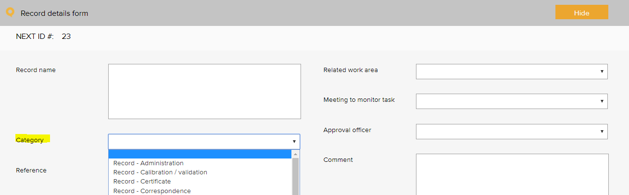
Quality records category - Examples
Record - calibration / validation | Record - staff confidentiality
Record - certificate | Record - staff recruitment
Record - correspondence | Record - sterilisation
Record - CPD | Record - training
Record - email | Report - audit
Record - finance | Report - evaluation
Record - HR | Report - financial
Record - incident | Report - legal advice
Record - licence / credentialing | Report - maintenance
Record - meeting agenda | Report - management
Record - meeting minutes | Report - national health data
Record - photograph | Report - progress
Record - quote | Report - referee
Record - service notification | Report - staff review

Risk Register

Risk Assessment
The risk level and management requirement settings are displayed when rating a risk in the system. Reports can be generated based on the selections in this menu. There are four possible levels of risk in the LOGIQC assessment matrix. Each of these levels can be given a name such as SAC 4, SAC 3, Extreme, High etc. Each risk level can also be given a related ‘management requirement’, eg. rules for how that level of risk should be managed.
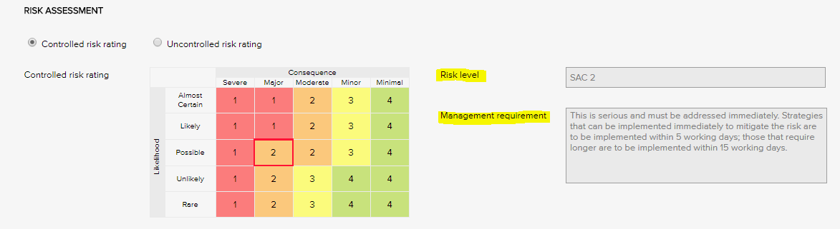

Risk Levels and related Management Requirement - Examples
SAC 1 | This is serious and must be addressed immediately. Strategies that can be implemented immediately to mitigate the risk are to be implemented within same or next working day; those requiring longer are to be implemented within 5 - 10 working days.
SAC 2 | This is serious and must be addressed immediately. Strategies that can be implemented immediately to mitigate the risk are to be implemented within 5 working days; those that require longer are to be implemented within 15 working days.
SAC 3 | Manage by specific monitoring or auditing procedures
SAC 4 | Manage by routine procedures.

Risk Treatment Options
The risk treatment option menu is used when adding a mitigation action to the risk register. It allows for the action to be categorised against a risk treatment strategy.
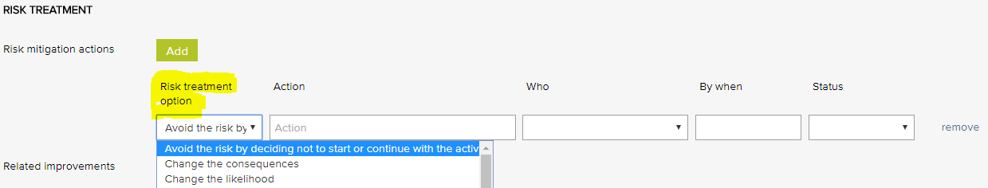
Risk treatment options - Examples
Avoid the risk by deciding not to start or continue with the activity | Minimise the hazard
Take or increase the risk in order to pursue an opportunity | Remove the risk source
Change the consequences | Retain the risk by informed decision
Change the likelihood | Share the risk with another party or parties
Eliminate the hazard

Risk Dimensions
The risk dimension menu is used when adding a risk to the risk register. It allows for the identified risk to be coded to a high level dimension. Reports can be generated based on the selections in this menu.
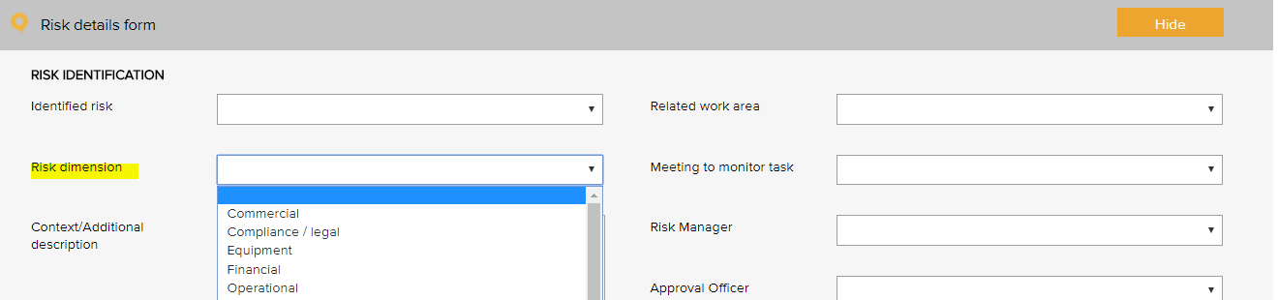
Risk Dimensions | Definition
Commercial | This category includes the risks associated with market placement, business growth, diversification and commercial success. This relates to the commercial viability of a product or service, and extends through establishment to retention and then growth of a customer base.
Compliance / legal | This category includes compliance with legal requirements such as legislation, regulations, standards, codes of practice and contractual requirements. This category also extends to compliance with additional ‘rules’ such as policies, procedures or expectations, which may be set by contracts, customers or the social environment.
Equipment | This extends to the equipment utilised for the operations and conduct of the business. It includes the general operations of the equipment, maintenance, appropriateness, depreciation, safety and upgrade.
Financial | This category includes cash flow, budgetary requirements, tax obligations, creditor and debtor management, remuneration and other general account management concerns.
Organisational | This relates to the internal requirements of a business, extending to the cultural, structural and people issues associated with the effective operation of the business.
Operational | This covers the planning, operational activities, resources (including people) and support required within the operations of a business that result in the successful development and delivery of a product or service.
Project | This includes the management of equipment, finances, resources, technology, timeframes and people associated with the management projects. It extends to internal operational projects, projects relating to business development, and external projects such as those undertaken for clients.
Reputation | This entails the threat to the reputation of the business due to the conduct of the entity as a whole, the viability of product or service, or the conduct of employees or other individuals associated with the business.
Safety | This category includes the safety of everyone associated with the business. This extends from individual safety, to workplace safety, public safety and to the safety and appropriateness of products or services delivered by the business.
Security | This includes the overall security of the business premises, assets and people, and extends to security of information, intellectual property, and technology.
Service delivery | This relates to the delivery of services, including the quality and appropriateness of service provided, or the manner in which a product is delivered, including customer interaction and after-sales service.
Stakeholder management | This category relates to the management of stakeholders, and includes identifying, establishing and maintaining an appropriate relationship. This includes both internal and external stakeholders.
Strategic | This includes the planning, scoping and resourcing requirements for the establishment, sustaining and/or growth of the business.
Technology | This includes the implementation, management, maintenance and upgrades associated with technology. This extends to recognising the need for and the cost benefit associated with technology as part of a business development strategy.

Risk category and risk name
The identified risk menu is used when adding a risk to the risk register. It presents a list of risks that can be added to the risk register. Reports can be generated based on the selections in this menu.
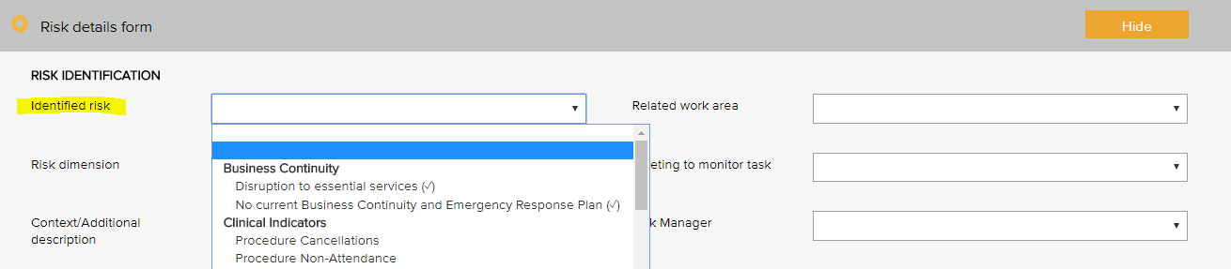

Risk category and risk name
The following risks have been setup in ProCare Practices LOGIQC QMS, by way of example or some of the risks relating to health and safety management.
Risk category | Risk name
Health and safety mismanagement | Assault and injury
Health and safety mismanagement | Bullying and harassment
Health and safety mismanagement | Injury
Health and safety mismanagement | Lack of knowledge of health and safety
Health and safety mismanagement | Lack of personal security
Health and safety mismanagement | Motor vehicle accident
Health and safety mismanagement | Occupational Discomfort Pain and Injury
Health and safety mismanagement | Occupational fatigue
Health and safety mismanagement | Occupational health - environmental
Health and safety mismanagement | Slips, trips and falls
Health and safety mismanagement | Work related stress

Other examples that Practices may consider including on their Risk Register.
Risk category | Risk name
Business continuity | Disruption to essential services
Patient safety | Breach with clinical procedures / standards
 | Clinical incident
 | Currency of professional registration / credentialing
 | Infection control management
 | Medication mismanagement
 | Patient safety
 | Patient fall
Financial | Cash / fund management shortfall
 | Changes in government policy
 | Competitive market
 | Non-compliance with financial management procedures
 | Reduction in or limited enrolled population
Human resource / personnel | Cross cultural conflict
 | Industrial Action
 | Lack / insufficient skills or training
 | Lack of workforce strategy
 | Non-compliance with HR procedures
Inventory | Inventory mismanagement
 | Problems with external contractors
Legal | Legislative / regulatory / contractual breaches
Management | Assets mismanagement
 | Equipment mismanagement
 | Hazard mismanagement
 | Information mismanagement
 | Organisational culture not aligned to organisational values
 | Property mismanagement
Reputation and image | Adverse media coverage
 | Loss or injury to reputation
 | Patient complaint
Security | Security breach
Technological | Breach of data security and backup
 | Failure of IT hardware and network management
 | Loss of productivity due to staff IT competencies
 | Not maximising the potential benefits of digital technologies

Linkages between the Risk Module and the Feedback and Incident Registers
When the Risk Module is activated in the LOGIQC QMS, incident types and feedback categories can be linked to one or more identified risks. When an incident or feedback that is linked to a risk is reported, it will inherit the risk rating assigned to the risk that it is linked to. Where an incident type or feedback category has been linked to multiple risks, it will be assigned the risk that has the highest risk rating amongst those risks that it has been linked to. In the event that there is more than one risk at the highest risk rating, LOGIQC will assign the risk in alphabetical order from those at the highest level.

Site Information
The site information settings controls certain automatic behaviours such as the number of days allowed to respond to a task and the frequency of sending automatic reminders.
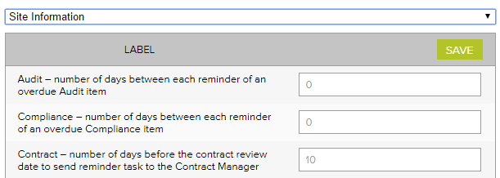

Site information - Examples
Label | No of days
Accreditation – number of days between each reminder of an open accreditation plan action | 14
Accreditation – number of days between each reminder of an overdue Accreditation item | 14
Accreditation – number of days the Approval Officer and the Quality Manager has to complete their tasks | 60
Audit – number of days between each reminder of an overdue audit item | 7
Compliance – number of days between each reminder of an overdue Compliance item | 5
Contract – number of days before the contract review date to send reminder task to the Contract manager | 14
Contract - number of days between each reminder of an overdue Contract item | 7
Contract – number of days the Approval Officer and the Contracts manager has to complete their tasks | 14
Document – number of days before the document review date to send reminder task to the Approval officer | 14
Document – number of days between each reminder of an overdue document item | 7
Document – number of days the Approval Officer has to complete the Approval task | 14
Feedback – number of days between each reminder of an overdue Feedback item | 3
Feedback – number of days the Approval Officer has to complete the Approve for Action task | 3
Improvement - number of days between each reminder of an overdue Improvement item | 14
Improvement – number of days the Approval Officer has to complete the Approve for Action task | 30
Incident - number of days between each reminder of an overdue Incident item | 3
Incident - number of days the Approval Officer has to complete the Approve for Action task | 3
Licensing - number of days between each reminder of an overdue licensing item | 3
Record - number of days between each reminder of an overdue Record item | 7
Repair - number of days between each reminder of an overdue Repair item | 5
Repair - number of days the Approval Officer has to complete the Approve for Action task | 7
Risk - number of days between each reminder of an open mitigation item | 14
Risk - number of days between each reminder of an overdue Risk item | 7
Risk – number of days the Approval Officer and the Risk Manager has to complete their tasks | 30
Supplier – number of days before the supplier review date to send reminder task to the Approval officer | 14
Supplier - number of days between each reminder of an overdue Supplier item | 7
Supplier – number of days the Approval Officer has to complete the Approval task | 14
Training – number of days between each reminder of an overdue Training item | 7

System Settings

Disable auto timeout
The default settings in your LOGIQC QMS are set to disable auto timeout. This means that once logged in, your session will remain open for 12 hours before ‘timing out’ and requiring you to log in again. If you want to decrease this time to 70 minutes, simply un-check the setting.

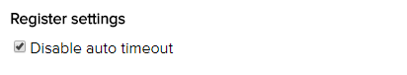

Work Areas
This list appears when adding an item to any register. It is the list of functional work areas in the organisation (eg HR Administration, GP Services, etc) that tasks and issues can be assigned to. All Registers allow for sorting, filtering and printing of reports based on “work areas”.
Primary work area | Secondary work area
Management services | Administration
 | Finance
 | Health and safety
 | HR
 | Information technology
 | Quality and risk
Governance | Management
Infrastructure and facilities | Asset
 | Car park
 | Consult room
 | Equipment
 | Property
 | Security
 | Vehicles
 | Waiting room
Primary care services | Cold chain
 | GP care
 | Infection control
 | Medical reception
 | Minor surgery
 | Nursing care
 | Primary care - all
 | Urgent care

Additional registers

Accreditation Register
The accreditation business system is used to group ‘accreditation actions required’ into higher order categories in the accreditation action plan and excel export. This way the individual tasks added can be categories.
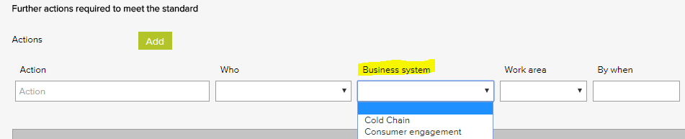
Accreditation business system - Examples
Accountability and reporting | Infection control
Cold chain | Internal communication
Consumer engagement | Management - clinical
Equipment - medical | Management - corporate
Equipment - non-medical | Training - induction
Governance - clinical | Training - mandatory
Governance - corporate

Compliance Register
The Source of requirement menu is used when scheduling a compliance task. It allows for the task to be coded to the entity or regulation that stipulates that the task should be carried out. Reports can be generated based on the selections in this menu.
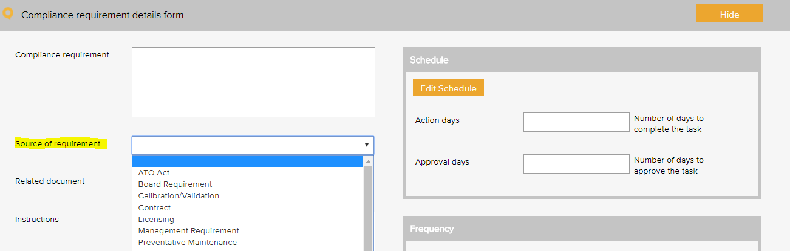
Compliance source document category - Examples
Calibration / validation
Code of Rights 1996
Electrical (Safety) Regulations 2000
Employment Act
Health and Safety at Work Act 2015
Health Information Privacy Code 1994
Medicines Act 1981
NZ Prescription Service
NZ Tax Law
Privacy Act 1993
Privacy Policy
RNZCGP Aiming for Excellence Standard
RNZCGP Foundation Standard
The Treaty of Waitangi principles
Work Safe NZ Act

Contract Register
The contract category menu is used when adding a contract to the contracts register. It allows for the contract to be coded to a category. Reports can be generated based on the selections in this menu.
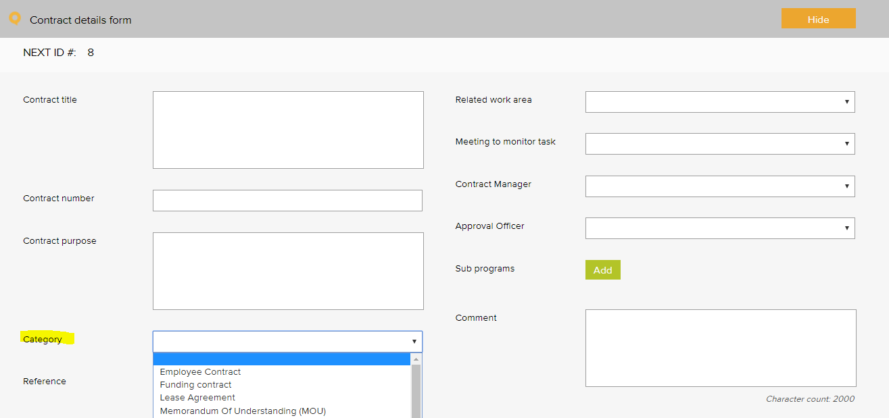
Contract category - Examples
Contracted provider agreement | Memorandum of Understanding (MOU)
Employee contract | Partnership agreement
Insurance policy | Supplier agreement
Lease agreement | Warranty agreement
Maintenance agreement

Suppliers Register
The Assessment criteria menu is displayed as checkboxes when adding and reviewing a supplier in the supplier register. It controls the criteria used for assessing suppliers.
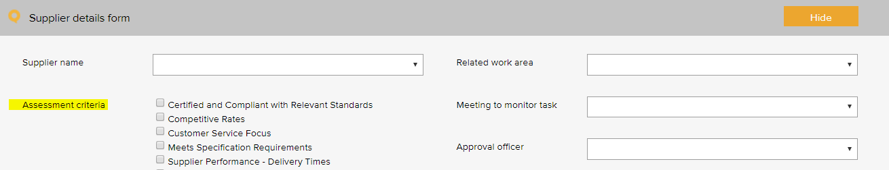
Supplier assessment criteria - Examples
Certified and compliant with relevant standards | NZBN verified
Competitive rates | Supplier performance - delivery times
Customer service focus | Supplier performance - processing of orders
Meets specification requirements | Supplier performance - returns and back orders

License Register
The pre-set licence options menu is used when scheduling a licensing task in the licensing register. It allows for the task to be coded to a category. Reports can be generated based on the selections in this menu.
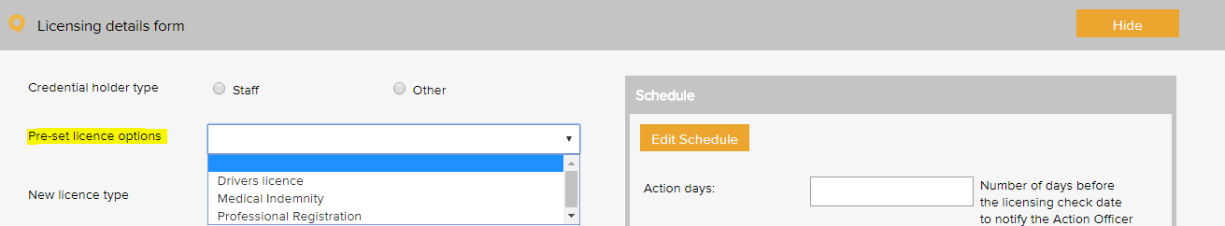
License type - Examples
Annual practicing certificate (APC)
Driver’s licence
Indemnity insurance - medical
Indemnity insurance - nurse
Police vetting check (VCA)

Training Register
The pre-set training options menu is used when scheduling a training task in the training register. It allows for the task to be coded to a category. Reports can be generated based on the selections in this menu.
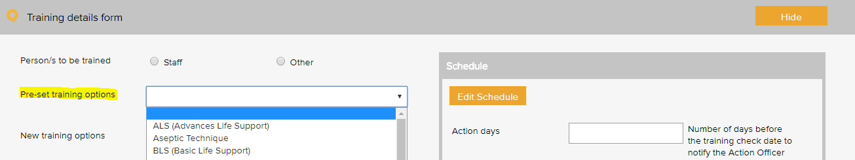
Mandatory training types - Examples
Code of Health & Disability Services Consumers’ Rights 1996 - L1 & L2
Cultural Competency and Cultural Safety
Infection Control - L1
Privacy Act 1993 & the Health Information Privacy Code 1994 - L1 & L2
The Treaty of Waitangi principles - L1 & L2
Triage Procedures - L1 & L2

Training type examples to meet foundation requirements
Adverse reactions to medicines and immunisation reporting requirements
Importance of correct pronunciation of te reo Māori patient names.
Principle of Right 10 of the Code
Process for the collection, use, storage, disposal and disclosure of individual patient information
Repeat prescribing procedures
Role and responsibilities of Health and Safety Coordinator
Screening and Recall Policy
Tracking potentially significant investigations and urgent referrals.

Training type examples to meet advanced requirements
Business structure and contractual requirements
Controlled Drug Register - process for recording transactions; controlled drug process; stores and monitoring of drugs
Electronic clinical decision support tools
Electronic transfer of records
Medicine Reconciliation requirements
Opportunistic Screening
Patient Portal System
Shared Care Planning process

Training type examples to meet aspirational requirements
How information is shared electronically with other providers
Medicines Act 1981
NZ Prescription Service

WHO Conceptual Framework for the International Classification for Patient Safety Version 1.1 Final Technical Report January 2009
International Classification for Patient Safety Statement of Purpose - http://www.who.int/patientsafety/taxonomy/ICPS_Statement_of_Purpose.pdf
Health Quality and Safety Commission New Zealand, New Zealand Health and Disability Services – National Reportable Events Policy 2012, p.10
Definition: Cold Chain incident types as provided by ProCare Cold chain breach: is an event which has led to the vaccines being stored or transported in temperatures outside the required +2˚C to +8˚C range, but the potency/stability of the vaccines has not been compromised. Cold chain excursion: is an event which has led to the vaccines being stored or transported in temperatures outside the required +2⁰C to +8⁰C range and as a result vaccines are compromised and need to be returned for destruction. Cold chain failure: is an event in which vaccines involved in a cold chain excursion are administered to patients.
Risk management guide for small business, NSW Department of State and Regional Development, www.smallbiz.nsw.gov.au

