EXTERNAL AUDITOR’S MANUAL
Instruction on the LOGIQC Accreditation Module – how to access and view evidence relating to the requirements of Standards.

Support
Auditors can use the following channels to access support from LOGIQC staff:
Email: helpdesk@logiqc.com.au Telephone: AU +617 3216 0335 NZ 0800 002 280

Logging in and navigating to the Accreditation Module

- Type the address provided by the organisation into your browser address bar.  - Type the user name and password supplied by the organisation into the LOGIQC QMS login screen.  - Click Login. | 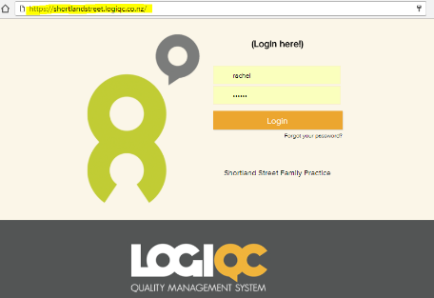
- Click on registers tab and select Accreditation from the dropdown menu | 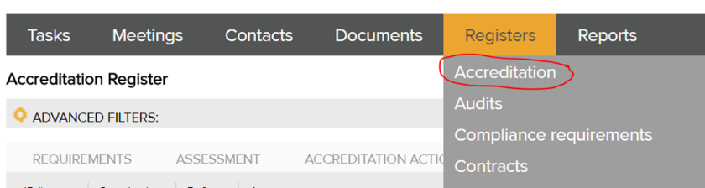
- Click on the Evidence Report tab. The Evidence Report tab will provide an interactive Evidence Report for each of the standard requirements. | 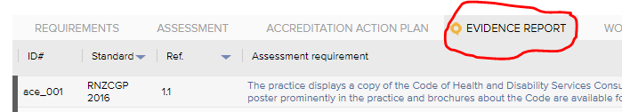
- Click ‘Open’ on the Advanced Filter
- Click the field titled ‘Standard’ and select the Standard you want to review. | 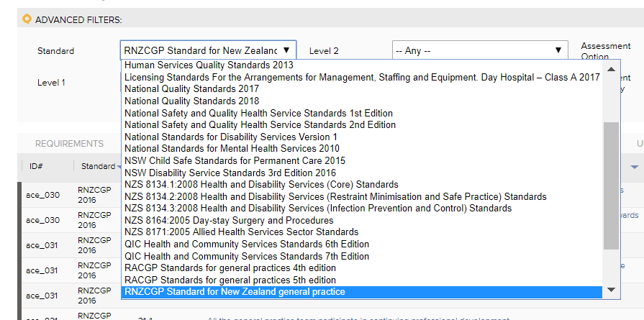
- To view a particular section of the Standard, click on the field titled ‘Level 1’ and select the section of the Standard you want to view.  - To apply these filters click on the ‘apply’ button (on the right hand side of the screen) | 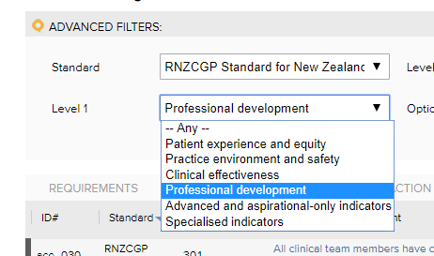

By applying a filter, LOGIQC will display only those criterion that relate to the section selected. In the following example, only those indicators relating to ‘Professional development’ are displayed.
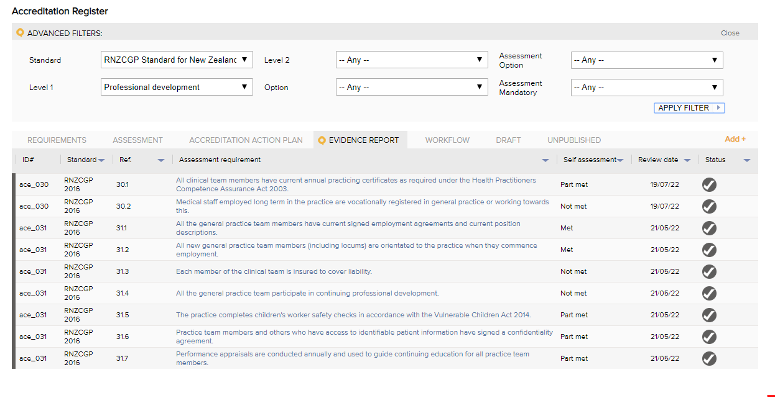
- Click the title of the Indictor to open the Evidence Report for that requirement. E.g. Click on ‘The practice has a policy that describes how the Code is implemented.’ to open Standard QI 3.1A. | 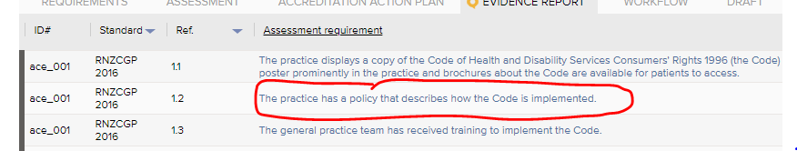
- Select the period you wish to review the organisation’s performance within. | 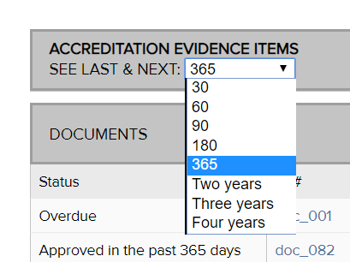  Based on the period selected, the Evidence Report will provide details of the activities that have been undertaken for the period selected and for the same period going forward (see last and next).
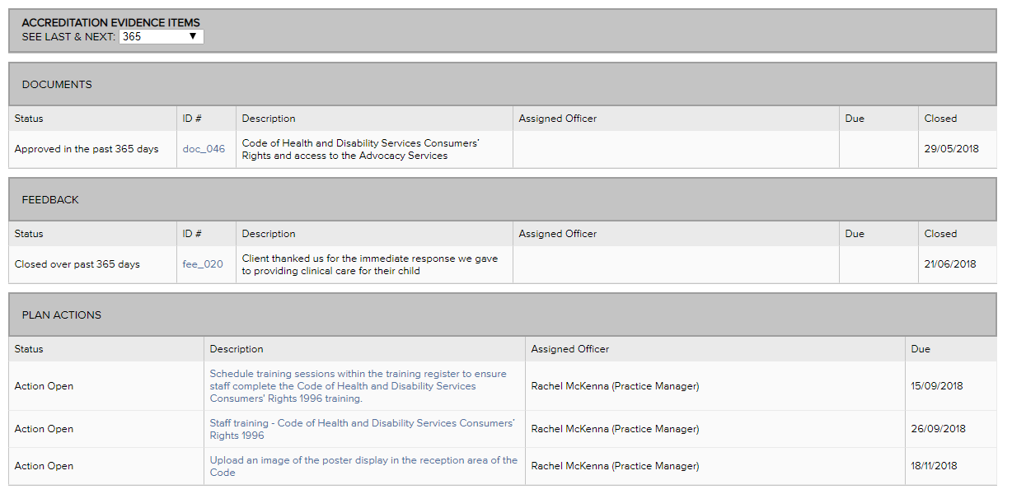
The Evidence Report will provide a link to the range of evidence that the organisation has determined is relevant to demonstrate compliance with the Standard. For example, based on the above example, the Code of Health and Disability has been linked as evidence as well as feedback and the Practice has planned 3 improvement actions.
- Status of the item in the QMS | 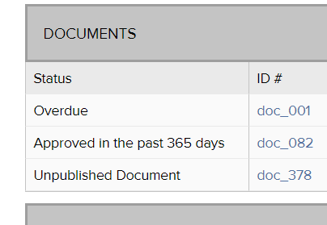  The Evidence Report will provide the status of each task that has been linked to the criterion. For example, ‘closed over past 365 days’; ‘overdue’; ‘missed’, ‘to be done in the next 356 days’.
- Where restricted access has been applied to an item in the QMS, the External Auditor’s access to the item will be restricted. In this instance, it will be noted as ‘confidential’ in the description column. | 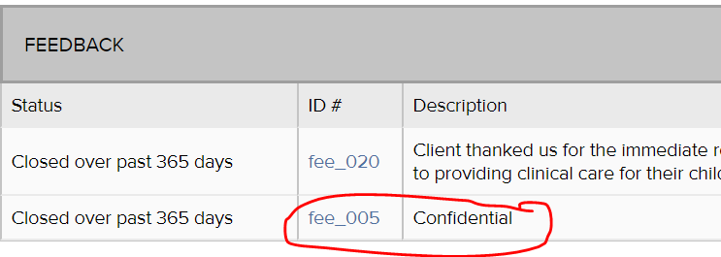  These items may be viewed when the auditor is onsite, where appropriate

How to view the individual quality activity that is referenced in the Accreditation Evidence Report
- Click on the ID# of an individual item reference in the Evidence Report, which take you to the respective Record. For example, in the screen shot below, if you clicked on “aud_027”, which is scheduled to occur on 2/10/18
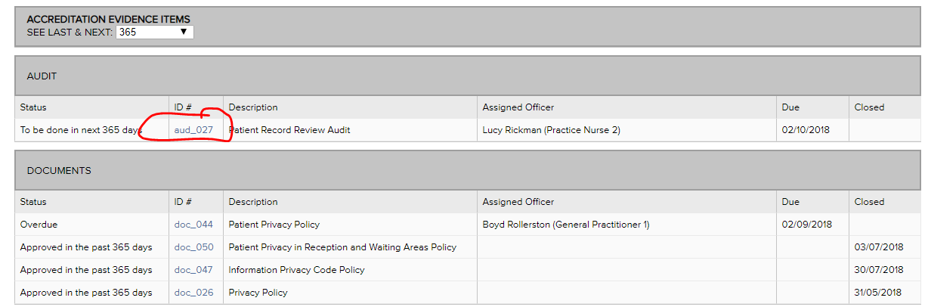
The following screen will appear.
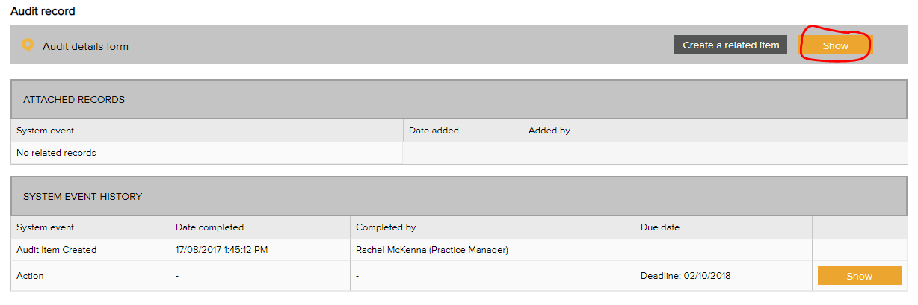
If you then clicked on the “Show” button in the top-right hand side corner, the Details Form for the Audit will appear, which will “show” you the instructions and other details that have been set in LOGIQC QMS to manage this audit task. For instance, see the screen shot below which the instructions for the audit, when the audit is due, who is responsible for conducting the audit, the position accountable, the meeting that will be kept informed of its status, as well as a range of other information.
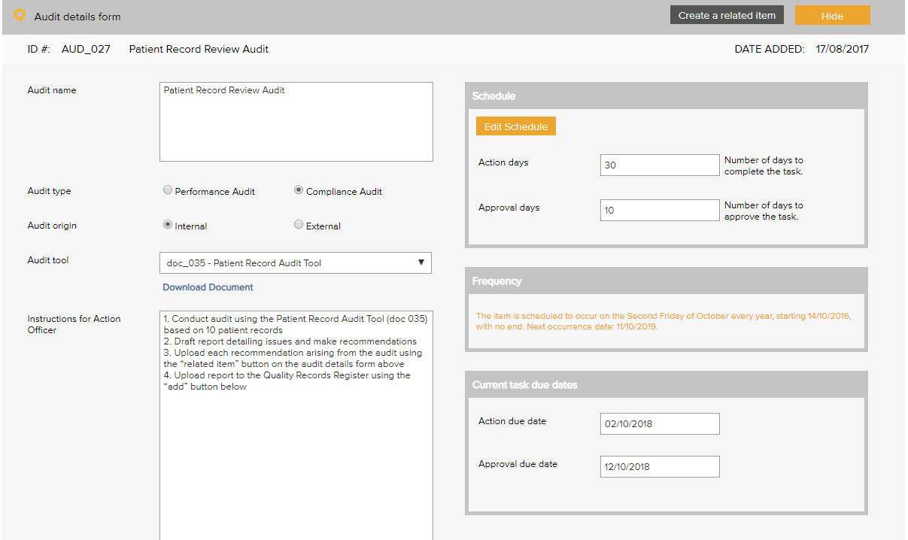
If the task has been completed, click on the title of an Attached Record to open and view related records to the audit tasks, for example, the audit report.
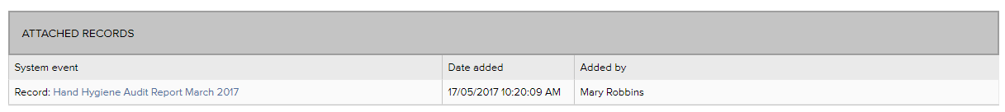
The system event history, will provide details of when the audit was created, actioned, and approved as well as provide links to related improvements that have arisen from the audit. To reveal the full details of any of these processes, click on the “Show” button on the right-hand side of the task forms.
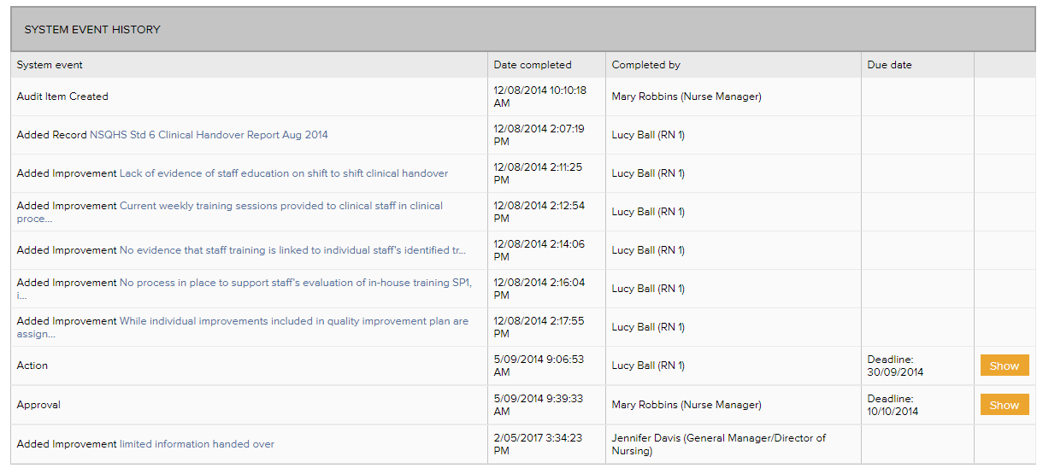
- By clicking on the “Cancel” button on the any form will return to the respective Evidence Report you were originally viewing. Alternatively, you can you the back arrow key on the top left.
How to view items relating to documents, contracts, risks and suppliers.
- Click on the ID# of an individual document to go directly to that item. E.g. Click on “doc_058” to open and view that document.
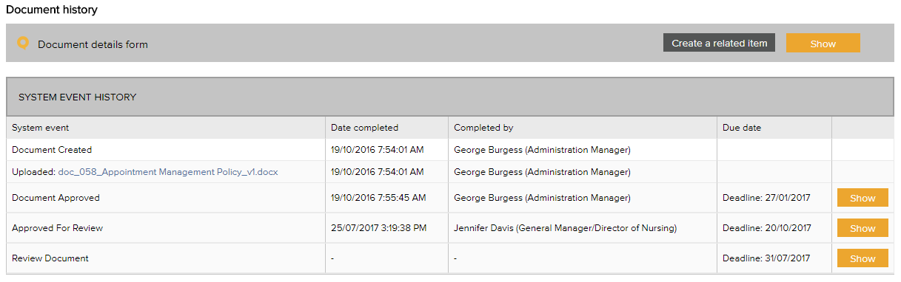
To view the details form for that item, which will summarise the document, author, review date, version number and more, click on the “Show” button in the top-right hand side corner next to the “create a related item” button.
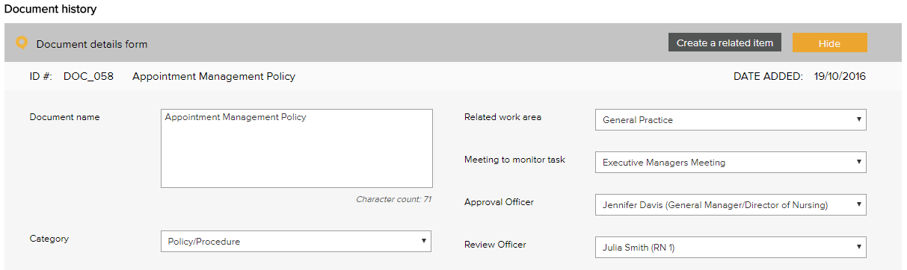
Click on the word “Current Document” at the bottom of the details form to view the current published version of the document.
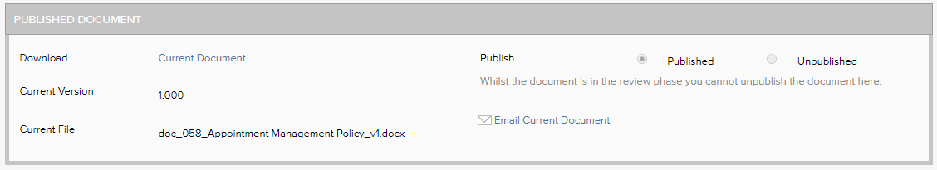
In the system event history, you will be able to view when the document was created and any related review or approval tasks. To reveal the full details of the review or approval, click on the “Show” button on the right-hand side of the task forms.
- Click the “Cancel” button on the details form, or on any of the task forms to return to the Evidence Report.

