External Assessors Manual - How to access evidence in the LOGIQC QMS for Practices with the Accreditation Module

Designed for the CORNERSTONE® accreditation and Foundation certification process.

Support
Assessors can use the following channels to access support from LOGIQC staff:
Email: helpdesk@logiqc.com.au Telephone: 0800 002 280 (AEST 9am – 5pm)

Contents
Background 3
Process 3
Roles as responsibilities 3
What practices need to do 4
What assessors need to do 5
Searching for certain criteria 6
Searching for annual program indicators 6
Attachment A – Assessor Access Form 7

Background
LOGIQC QMS is a cloud-based management system specifically designed to support practices to manage quality, safety and risk and to meet accreditation requirements. LOGIQC QMS comprises a range of registers where documents are stored, tasks are scheduled and issues are reported.
For practices using LOGIQC QMS, much of the evidence required to support their CORNERSTONE® accreditation and Foundation certification will already be in their LOGIQC QMS.
The RNZCGP is aware that users of LOGIQC QMS may simply provide the unique LOGIQC ID# for evidence when completing the QA2QI online tool and that the practice will provide a LOGIQC login to the Assessors, either College (CORNERSTONE) or PHO assigned (Foundation) so the evidence can be examined. This means that evidence already uploaded to the practice’s LOGIQC QMS does not have to be re-uploaded to the QA2QI.
Note: Practices are advised that LOGIQC QMS does not replace the College’s QA2QI self-assessment tool, it simply becomes a source of where evidence of compliance is located.

Process
The following diagram outlines the steps for using LOGIQC QMS with the QA2QI online tool:
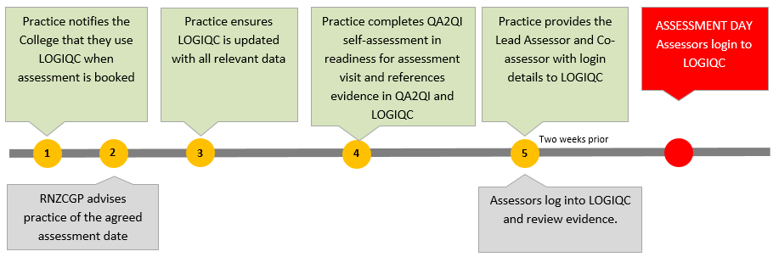

Roles as responsibilities
Practices | The practice must enter the relevant LOGIQC ID number in the evidence field of the QA2QI tool for each item of evidence presented.
Assessor | Review evidence provided by the practice by accessing their LOGIQC QMS where appropriate references have been provided.
LOGIQC staff | Provide a free user account for assessors to use to access the practice’s LOGIQC QMS.  Provide online and telephone support to practices and assessors in relation to accessing evidence in the LOGIQC QMS.

What practices need to do
If practices want to refer the assessor to evidence held in the LOGIQC QMS, they will reference the evidence in the Evidence section of QA2QI.
The example below illustrates how the practice might respond to Indicator 7.1 in the QA2QI online tool by describing what’s in place to comply and listing the relevant LOGIQC ID#.
Indicator 7 24-hour health care is accessible to the practice population
Number | Criterion | Evidence may include | Self-Assessment | Evidence
7.1 | The practice makes provision for 24-hour health care. | - Poster/signage  - Patient information website brochure, pamphlet  - Contract with after-hours provided | We have a pamphlet for patients and a contract with an after-hours provider. | LOGIQC Doc 004  LOGIQC Con 023
Practice enters ID# to reference evidence in their LOGIQC QMS

Each item in LOGIQC QMS (eg. document, audit, incident, training certificate, risk, check etc) has a unique alpha numeric identifier. For example, a complaint management policy held in LOGIQC’s document register may have an ID# of “doc_024”, this means that document number 24 on their Document Register will be the policy and future versions of this document will still be doc_24 but simply a newer version.
In addition to documents such as policies and procedures, assessors will be able to access a wide range of evidentiary information in a practice’s LOGIQC QMS (depending on the registers and modules that the practice has activated in their system. Types of evidence LOGIQC can hold:
Register or Module name | ID# prefix | Evidence that may be available
Document register | doc | Version controlled policies, procedures, forms, templates and other digital resources
Contract register | con | Supplier contracts, funding agreements, staff employment contracts and MOU’s
Records register | rec | Training and credentialing certificates and audit reports
Audit register | aud | Completed and scheduled audits, associated reports and links to quality improvements
Compliance register | com | Completed recurring tasks and checks and associated documentation
Training register | tra | Completed and scheduled staff training and links to certificates
Licencing register | lic | Completed and scheduled credential checks and links to certificates
Incidents register | inc | Reported incidents and details of the outcome
Feedback register | fee | Reported feedback and complaints and details of the outcome
Improvement register | imp | Quality improvements and issues arising from audits
Repairs register | rep | Reported issues with equipment and facilities
Accreditation module | acc | Links to evidence of compliance categorised against indicators and criterion
Risk module | rsk | Identified clinical and health and safety risks and information about how they are managed

What assessors need to do
- Log into the practice’s LOGIQC QMS system using the link and access details supplied by the practice
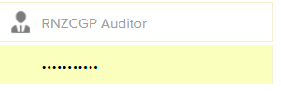
- Select Registers/Accreditation
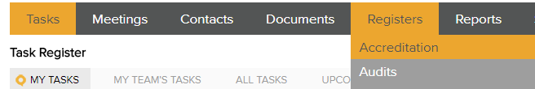
- Select the Indicator to review and a screen will open showing a summary of the criterion and the evidence. Each item in the evidence list is an active hyperlink that will open the individual item.
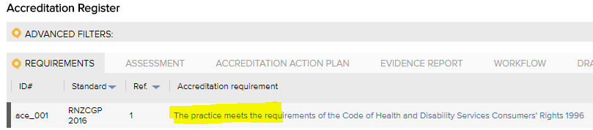
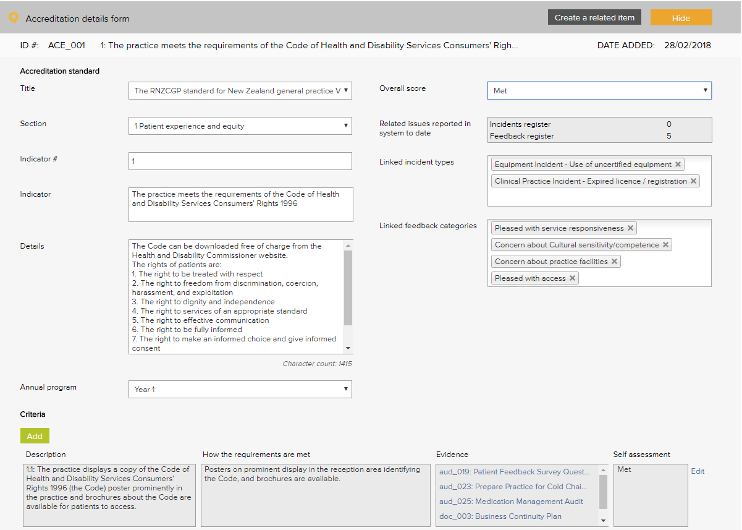

Searching for certain criteria
- Select Registers/Accreditation
- Select the Assessment tab
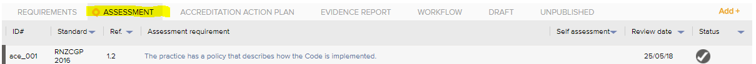
- Click on Advanced Filters, select the search parameters, and select Apply Filter
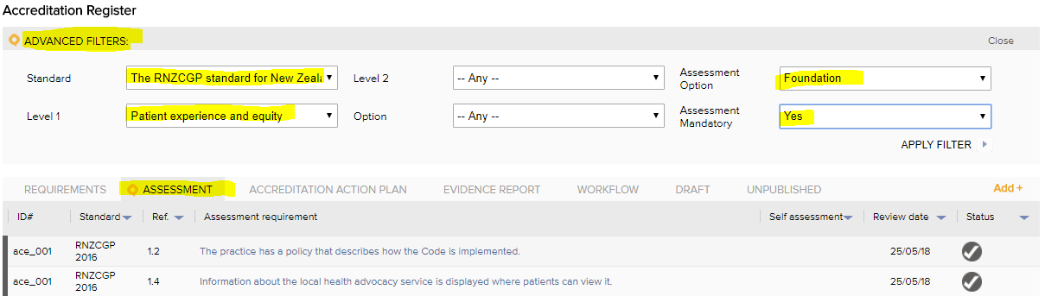

Searching for annual program indicators
- Click on the Requirements tab and then Advanced Filters. Select the year in the Option, and select Apply Filter
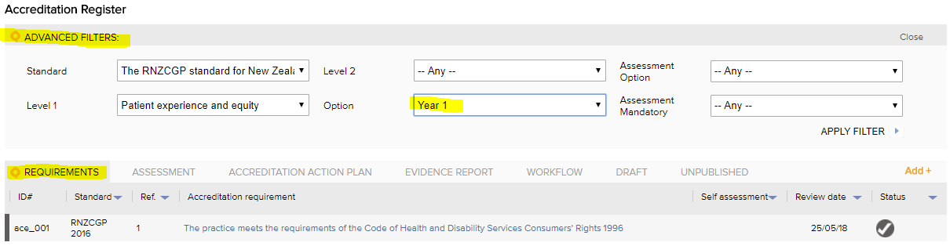

Attachment A – Assessor Access Form
Practices should provide the information set out below to the College and/or the Assessor to grant access to their LOGIQC QMS.
LOGIQC Quality Management System – Assessor Access Form
<Practice name> authorises the Assessors listed below permission to log in to its LOGIQC Quality Management System for the sole purpose of reviewing evidence in relation to compliance with the RNZCGP Aiming for Excellence standard for New Zealand general practice.
Practice name:
LOGIQC URL: | Eg: https://xxx.logiqc.co.nz
Practice contact person:
Practice contact person phone:
Assessor username:
Assessor password:
Date access is provided:
Date access is terminated:

