External Assessors Manual - How to access evidence in the LOGIQC QMS for Practices without the Accreditation Module

Designed for the CORNERSTONE® accreditation and Foundation certification process.

Support
Assessors and practices can use the following channels to access support from LOGIQC staff:
Email: helpdesk@logiqc.com.au Telephone: 0800 002 280

Contents
Background 3
Process 3
Roles as responsibilities 3
What practices need to do 4
What assessors need to do 4
Types of evidence LOGIQC can hold 5
Logging in and navigating to a register 6
Reviewing evidence of policies and procedures 7
Reviewing evidence of audits, training certificates, and staff credentialing 8
Reviewing evidence of quality improvements 9
Reviewing incident reports 10
Reviewing feedback and complaints 11

Background
LOGIQC QMS is a cloud-based management system specifically designed to support practices to manage quality, safety and risk and to meet accreditation requirements. LOGIQC QMS comprises a range of registers where documents are stored, tasks are scheduled and issues are reported.
For practices using LOGIQC QMS, much of the evidence required to support their CORNERSTONE® accreditation and Foundation certification will already be in their LOGIQC QMS.
The RNZCGP is aware that users of LOGIQC QMS may simply provide the unique LOGIQC ID# for evidence when completing the QA2QI online tool and that the practice will provide a LOGIQC login to the Assessors, either College (CORNERSTONE) or PHO assigned (Foundation) so the evidence can be examined. This means that evidence already uploaded to the practice’s LOGIQC QMS does not have to be re-uploaded to the QA2QI.
Note: Practices are advised that LOGIQC QMS does not replace the College’s QA2QI self-assessment tool, it simply becomes a source of where evidence of compliance is located.

Process
The following diagram outlines the steps for using LOGIQC QMS with the QA2QI online tool:
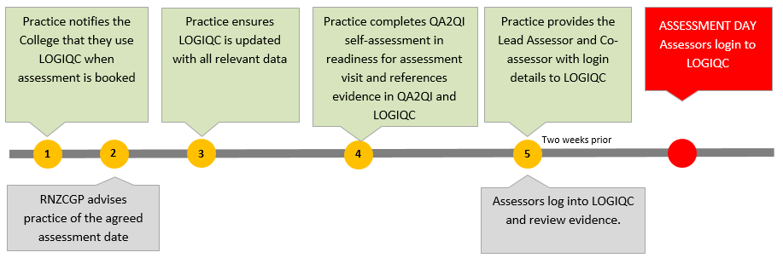

Roles as responsibilities
Practices | The practice must enter the relevant LOGIQC ID number in the evidence field of the QA2QI tool for each item of evidence presented.
Assessor | Review evidence provided by the practice by accessing their LOGIQC QMS where appropriate references have been provided.
LOGIQC staff | Provide a free user account for assessors to use to access the practice’s LOGIQC QMS.  Provide online and telephone support to practices and assessors in relation to accessing evidence in the LOGIQC QMS.

What practices need to do
If practices want to refer the assessor to evidence held in the LOGIQC QMS, they will enter the relevant ID# in the Evidence section of QA2QI.
Each item in LOGIQC QMS (eg. document, audit, incident, training certificate, risk, check etc) has a unique alpha numeric identifier. For example, a complaint management policy held in LOGIQC’s document register may have an ID# of 012. This identifier is permanently assigned to the item and will not change over time or be removed from the system. This means assessors can re-verify evidence if needed months or years after the audit.
The example below illustrates how the practice might respond to Indicator 7.1 in the QA2QI online tool by describing what’s in place to comply and listing the relevant LOGIQC ID#.
Indicator 7 24-hour health care is accessible to the practice population
Number | Criterion | Evidence may include | Self-Assessment | Evidence
7.1 | The practice makes provision for 24-hour health care. | - Poster/signage (including information on front door) and:  - Patient information website brochure, pamphlet.  - Contract with after-hours provided (if applicable); and  - Memorandum of understanding with alternate provider (if applicable). | We have a pamphlet for patients and a contract with an after-hours provider. | LOGIQC Doc 004  LOGIQC Con 023
Practice enters ID# to reference evidence in their LOGIQC QMS

What assessors need to do
Assessors log into the practice’s LOGIQC QMS system using the link and access details supplied in the ‘Assessor Access Form’ (Attachment A). | 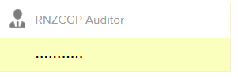
Using the ID number provided by the practice in the evidence section of QA2QI the assessor will search and view the evidence. | 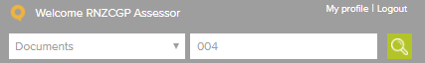
Assessors click on file to open the evidence.  The Assessors will also be able to easily cite an item’s history such as when an action was completed (eg. when a document was last reviewed or when an audit was completed). | 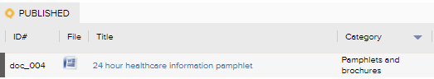

Types of evidence LOGIQC can hold
In addition to documents such as policies and procedures, assessors will be able to access a wide range of evidentiary information in a practice’s LOGIQC QMS:
Register name | ID# prefix | Evidence that may be available
Document register | doc | Version controlled policies, procedures, forms, templates and other digital resources
Contract register | con | Existing supplier contracts, funding agreements, staff employment contracts and MOU’s
Records register | rec | Training and credentialing certificates and audit reports
Audit register | aud | Completed and scheduled audits, associated reports and links to quality improvements
Compliance register | com | Completed recurring tasks and checks and associated documentation
Training register | tra | Completed and scheduled staff training and links to certificates
Licencing register | lic | Completed and scheduled credential checks and links to certificates
Incidents register | inc | Reported incidents and details of the outcome
Feedback register | fee | Reported feedback and complaints and details of the outcome
Improvement register | imp | Quality improvement suggestions, issues arising from audits and details of the changes implemented
Repairs register | rep | Reported issues with equipment and facilities
Accreditation register | acc | Links to evidence of compliance categorised against indicators and criterion of the Aiming for Excellence standard
Risk register | rsk | Descriptions of clinical and health and safety risks identified in the practice and information about how the risks are managed

Examples:
- If a practice refers to “doc_024”, this means that document number 24 on their LOGIQC QMS Document Register will be the documented evidence of compliance eg a policy or procedure. Future versions of this document will still be doc_24 but simply a newer version.
- If a practice refers to “inc_56”, this means that incident number 56 on their LOGIQC QMS Incident Register will display the details of an incident that was reported, how it was managed and what the outcome was.

Logging in and navigating to a register

- Type the address provide by the practice into your browser address bar.  - Type the user name and password supplied by the practice into the LOGIQC QMS login screen.  - Click Login. | 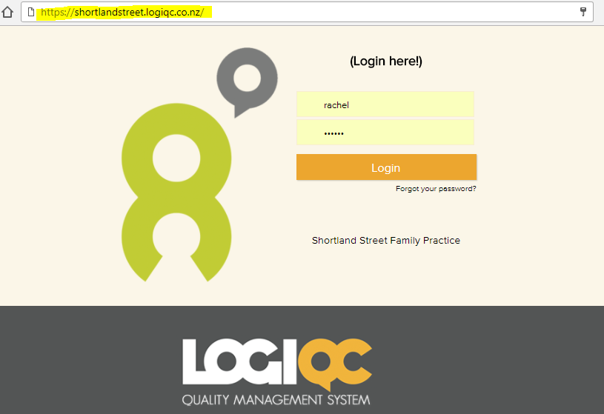
- Click on the Registers button and select the relevant register. For example, if the practice has referred to ‘doc_23’ you will select Documents from the menu to go to the Document Register. | 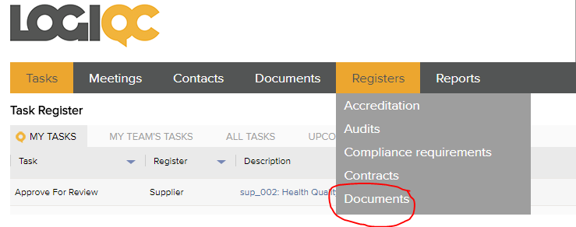
Result  The practice’s Document Register containing all practice policies and procedures is now presented and can be searched. | 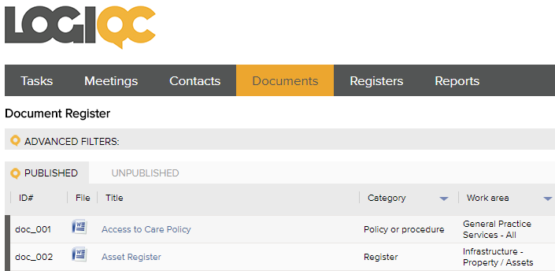

Reviewing evidence of policies and procedures
Scenario: the practice has referred to doc_024 (document number 24).
- Click on the Registers button and select Documents from the menu. | 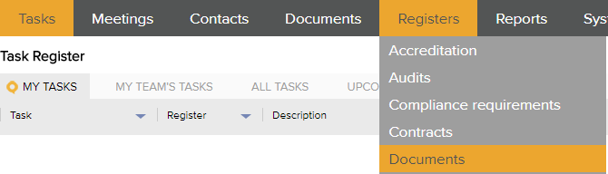
- Enter the document number provided in the search field and press enter or click the green search icon. | 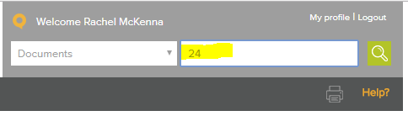
- Document 24 will be presented (along with any other document with ‘24’ in the title or keywords field)  Click on the document icon in the File column to open the document. | 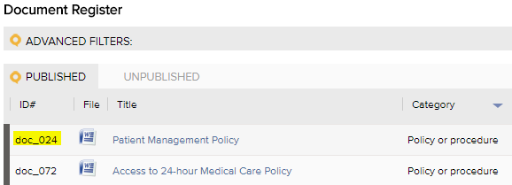

Reviewing evidence of audits, training certificates, and staff credentialing

- Click on the Registers button and select records from the menu. | 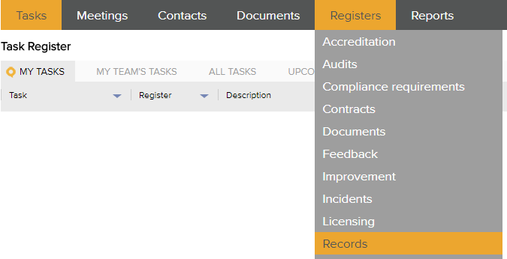
- Click on the Attachments Tab | 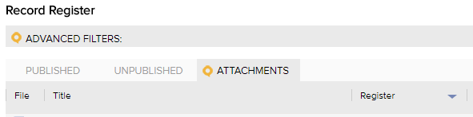
- Enter the ID provided by the practice. For example, if the practice referred to aud_002 (Audit number 2), enter ‘002’ in the search field and press enter or click the green search icon. | 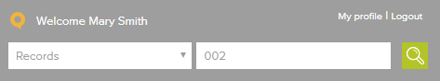
- Click on the document icon in the File column to open the documented evidence. | 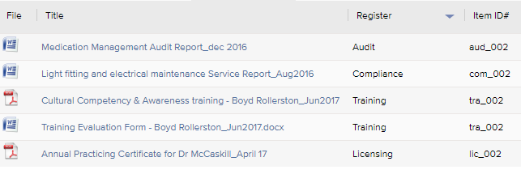
Tip  If the practice provides a generic record number ie rec_001, click on the Published tab and search for 001. | 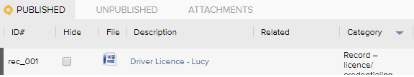

Reviewing evidence of quality improvements
Scenario: the practice has referred to imp_07 (Improvement number 7).
- Click on the Registers button and select Improvements from the menu. | 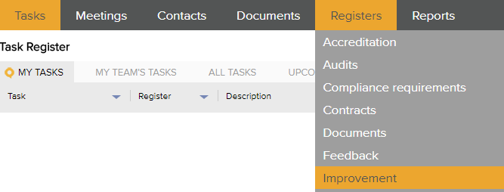
- Click on the All Tab | 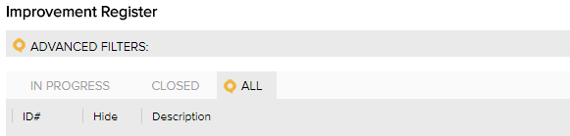
- Enter the improvement number provided by the practice (eg. imp_007) in the search field and press enter or click the green search icon. | 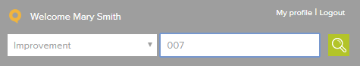
- Click on the description link to open the quality improvement. | 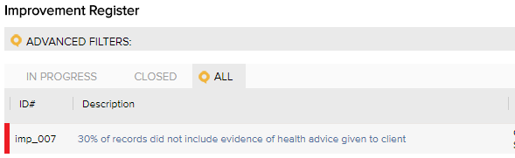
Tip  Scroll to the bottom of the quality improvement and click on ‘Show’ to see the full details of the action taken by the practice. | 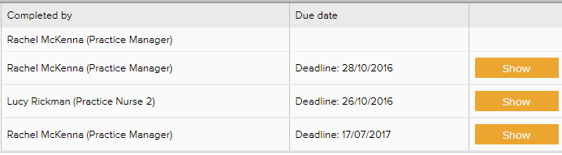

Reviewing incident reports
Scenario: the practice has referred to inc_03 (Incident number 3).
- Click on the Registers button and select Incidents from the menu. | 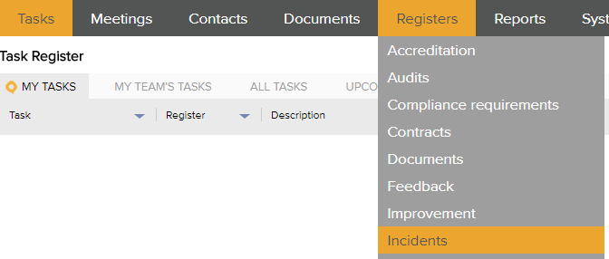
- Click on the All Tab | 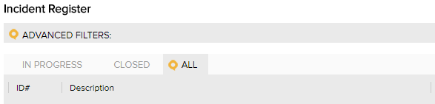
- Enter the incident number provided by the practice (eg. inc_003) in the search field and press enter or click the green search icon. | 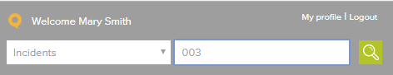
- Click on the description link to open the incident report. | 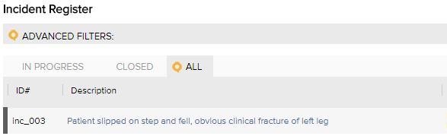
Tip
Scroll to the bottom of the incident report and click on ‘Show’ to see the full details of the action taken by the practice.

Reviewing feedback and complaints
Scenario: the practice has referred to fee_06 (Feedback number 6).
- Click on the Registers button and select Feedback from the menu. | 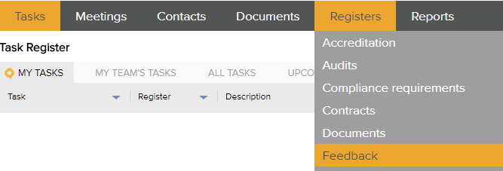
- Click on the All Tab | 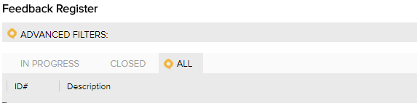
- Enter the feedback number provided by the practice (eg. fee_006) in the search field and press enter or click the green search icon. | 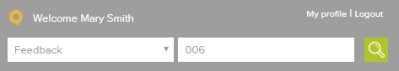
- Click on the description link to open the feedback report. | 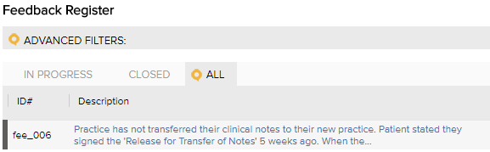
Tip
Scroll to the bottom of the feedback report and click on ‘Show’ to see the full details of the action taken by the practice.

Attachment A – Assessor Access Form



<Practice name> authorises the Assessors listed below permission to log in to its LOGIQC Quality Management System for the sole purpose of reviewing evidence in relation to compliance with the RNZCGP Aiming for Excellence standard for New Zealand general practice.
Practice name:
LOGIQC URL: | Eg: https://xxx.logiqc.co.nz
Practice contact person:
Practice contact person phone:
Assessor username:
Assessor password:
Date access is provided:
Date access is terminated:

