LOGIQC QMS SETUP GUIDE – General Practice NZ
This guide supports the set-up of the LOGIQC Quality Management System menus for New Zealand GP Practices in accordance with the requirements of Aiming for Excellence, the RNZCGP standard for New Zealand general practice for Foundation and CORNERSTONE practices (Version 1.0 – July 2016) and the Royal New Zealand College of Urgent Care for the Urgent Care Standard 2015.
Contents

Customising menus 3
System menu types 3
Editing single level menu options 4
Editing double level menu options 5
System menu examples 6
Accreditation Register 6
Compliance Register 7
Contact Register 8
Contract Register 9
Document Register 10
Feedback Register 11
Feedback Type 11
Feedback Source 11
Feedback Category 12
Improvement Register 13
Incident Register 14
License Register 19
Meeting Register 20
Positions 20
Records Register 21
Risk Register 22
Risk Assessment 22
Risk Dimensions 23
Risk Treatment Options 24
Risk Category and Risk Name 25
Linkages between the Risk Module and the Feedback and Incident Registers 26
Site Information 27
Suppliers Register 28
System Settings 28
Training Register 29
Work Areas 31

Customising menus

System menu types
There are two main types of menus in LOGIQC: single level menus and double level menus. Most menus are single level. The double level menus are work area, incident type and identified risk.

Single level menu example | Double level menu example
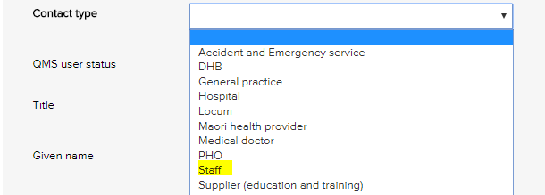 | 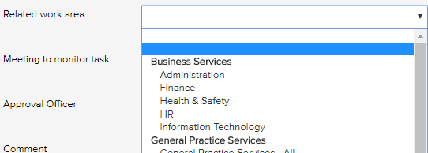
Single level menus  Accreditation assessment  Compliance source document  Contact type  Contract category  Document category  Feedback category  Feedback source  Feedback type  Improvement source  Licensing type  Meetings *  Positions *  Records category  Risk dimension  Risk treatment information  Supplier assessment criteria  Training type  * The content in these menus can be edited. | Double level menus  Primary + secondary incident type  Primary + secondary work area  Risk category + risk name

Editing single level menu options
These instructions use the contact type menu as an example.
- Log-in as administrator and select system setup in the system settings menu.
- From the system setup menu, select the menu to edit.
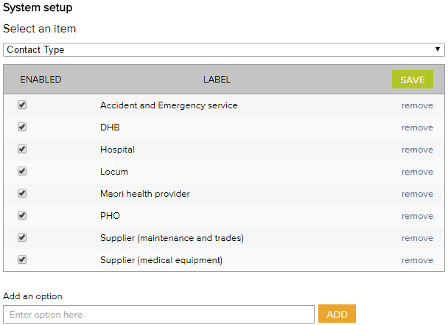
- Enter the new menu option into the add an option field.
- Click add and click save.
- To remove menu options, click remove and click save. (Note: Once an option has been used in a register item in the system the option can only be disabled and cannot be removed)

Editing double level menu options
These instructions use the work area menu as an example.
- Log - in with the Administrator password and select system setup in the system settings menu.
- From the system setup menu, select primary work area from the menu. From this screen, you can customise the menu to your organisation by adding and removing menu options.
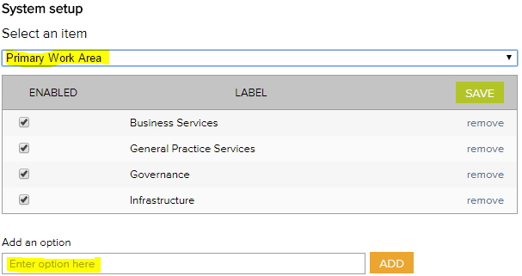
- To add new primary work area categories and type into the option field.
- Click add and click save.
- To remove primary work area categories that you don’t want, click remove and click save. (Note: Once an option has been used in a register item in the system the option can only be disabled and cannot be removed)
- Select secondary work area from the system setup menu.
If a new primary category is created LOGIQC will automatically create a duplicate secondary menu label with the word ‘all’ appended. This option can be removed after other secondary options are added to the category. LOGIQC requires a minimum of one secondary menu option for each primary option.
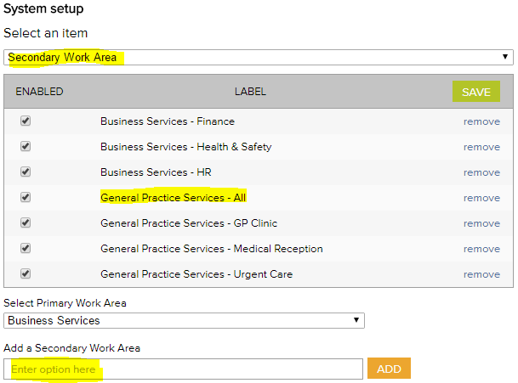
- To add new secondary work areas, select the related primary work area and type into the option field.
- Click add and click save.
- To remove secondary work area categories that you don’t want, click remove and click save. (Note: Once an option has been used in a register item in the system the option can only be disabled and cannot be removed)

System menu examples

Accreditation Register
The accreditation business system is used to group ‘accreditation actions required’ into higher order categories in the accreditation action plan and excel export. This way the individual tasks added can be categories.
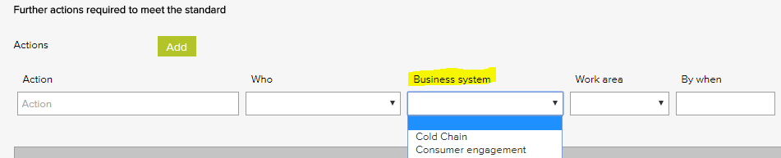

Accreditation business system – General Examples
Accountability and reporting
Cold chain
Consumer engagement
Equipment - medical
Equipment - non-medical
Governance - clinical
Governance - corporate
Infection prevention and control
Internal communication
Management - clinical
Management - corporate
Training - induction
Training - mandatory

Compliance Register
The Source of requirement menu is used when scheduling a compliance task. It allows for the task to be coded to the entity or regulation that stipulates that the task should be carried out. Reports can be generated based on the selections in this menu.
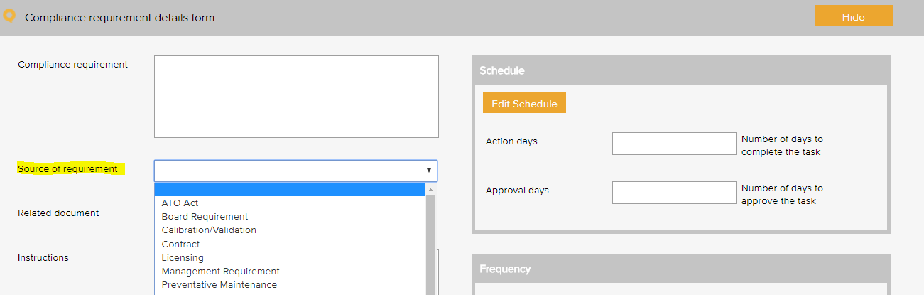

Compliance source document category – General Examples based on the RNZCGP Standards
AS / NZS4815:2006 Standard | NZ Prescription Service
Code of Rights 1996 | NZ Tax Law
Electrical (Safety) Regulations 2000 | Privacy Act 1993
Employment Relations Act 2000 | Privacy Policy
Health and Safety at Work Act 2015 | RNZCGP Aiming for Excellence Standard
Health Information Privacy Code 1994 | RNZCGP Foundation Standard
Health Records NZS 8153:2002 | Treaty of Waitangi
Medicines Act 1981 | Work Safe NZ Act

Compliance source document category – RNZCUC Examples
Accident Compensation Corporation (ACC) | Health Information Privacy Code 1994
Code of Health and Disability Services Consumers’ Rights (the Code) | Privacy Act 1993
NZS 8151:2004 Accident and Medical Clinic Standard | Treaty of Waitangi
Centre for Adverse Reactions Monitoring (CARM) | Australasian College for Emergency Medicine (ACEM) triage scale
Royal New Zealand College of Urgent Care | Health and Safety in Employment Act 1992
New Zealand Nursing Council guidelines | New Zealand Fire Service

Contact Register
The contact type menu is used when adding a business contact to the contacts register. It allows for the contact to be coded to a category. Reports can be generated based on the selections in this menu.
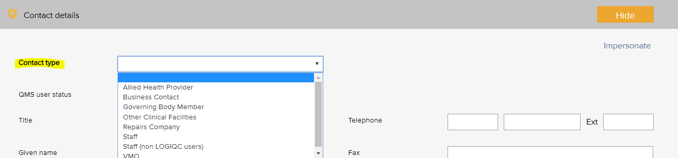

Contact type – General Examples based on the RNZCGP Standards
Accident and emergency service | Midwife
Agency - government | Nurse - other
Agency - locum | Nurse - practice
Agency - other | Nurse - practitioner
DHB | PHO
Doctor - GP | LOGIQC user
Doctor - locum | Supplier - education and training
Doctor - specialist | Supplier - ICT and support
General practice / medical centre | Supplier - maintenance and trades
Hospital | Supplier - medical equipment
Interpreter / assisted communication services | Supplier - medical supplies
Maori health provider | Supplier - office supplies
Mental health provider | Supplier - waste management

Contact type – RNZCUC Examples
Agencies | Podiatry
Dentist | Radiology
Government and community | Social welfare
Health advocates | Tertiary referral centres - hospitals
Laboratory | Tertiary referral centres - outpatient clinics
Pharmacy | Translation services
Physiotherapy

Contract Register
The contract category menu is used when adding a contract to the contracts register. It allows for the contract to be coded to a category. Reports can be generated based on the selections in this menu.
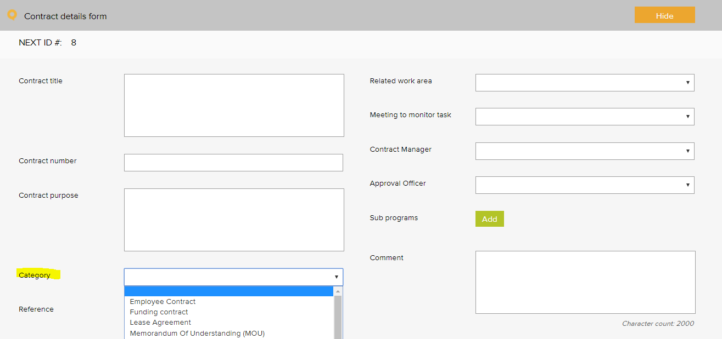

Contract category - General Examples based on RNZCGP Standards
Contracted provider agreement | Memorandum of Understanding (MOU)
Employee contract | Partnership agreement
Insurance policy | Supplier agreement
Lease agreement | Warranty agreement
Maintenance agreement

Document Register
The document category menu is used when adding a document to the documents register. It allows for the document to be coded to a category. Reports can be generated based on the selections in this menu.
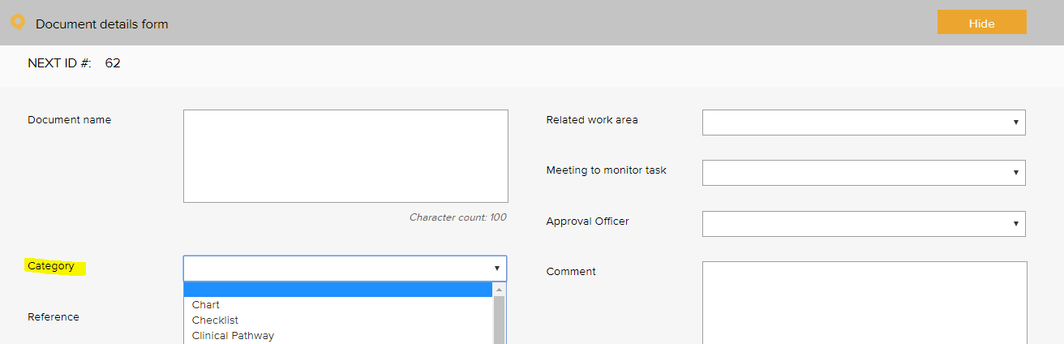

Document category – General Examples based on the RNZCGP Standards
Advanced form | Management plan
Audit tool | Policy and procedure
Brochure / pamphlet | Position description
Checklist | Poster
Diagram / chart | Questionnaire / survey
Flowchart | Resource
Form | Safety data sheet
Guideline | Signage
Instruction | Standard
Legislation | Template
Logo

Feedback Register

Feedback Type
The feedback type menu is used when reporting feedback in the feedback register. It allows for the feedback or complaint to be coded to a category. Reports can be generated based on the selections in this menu.
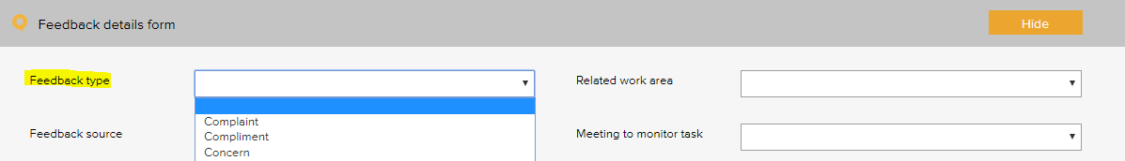

Feedback type - General Examples based on the RNZCGP Standards
Complaint
Compliment
Enquiry
Feedback

Feedback Source
The feedback source menu is used when reporting feedback in the feedback register. It allows for the source of the feedback or complaint to be selected. Reports can be generated based on the selections in this menu.
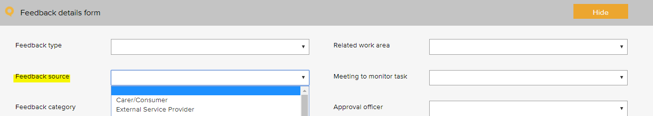

Feedback source – General Examples based on the RNZCGP Standards
After hours service provider | Ministry of health
Caregiver | Patient
DHB | Pharmacy
External health service provider | PHO
Family / whanau | Supplier
Health and disability | Visiting practitioner
Laboratory

Feedback Category
The feedback category menu is used when reporting feedback in the feedback register. It allows for the feedback or complaint to be coded to a category. Reports can be generated based on the selections in this menu.
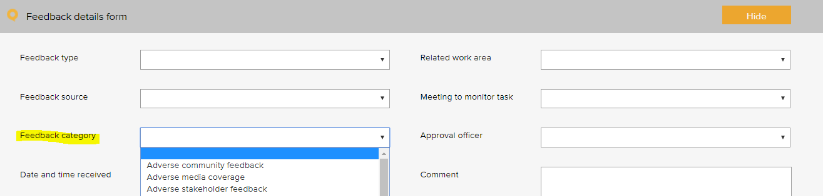

Feedback category - General Examples based on the RNZCGP Standards
Adverse community feedback | Concern about staff courtesy
Adverse media coverage | Concern about waiting time for appointment
Adverse stakeholder feedback | Concern about waiting time in Practice
Concern about access to services provided | Pleased with access to services provided
Concern about clinical care | Pleased with confidentiality / privacy
Concern about clinical information provided | Pleased with continuity of care
Concern about confidentiality / privacy | Pleased with cost of service
Concern about continuity of care | Pleased with cultural competence
Concern about cost of service | Pleased with customer service
Concern about cultural sensitivity / competence | Pleased with disabled access
Concern about customer service | Pleased with facilities and amenities
Concern about disabled access | Pleased with locum
Concern about GP availability | Pleased with media coverage
Concern about locum | Pleased with opening hours
Concern about medication management | Pleased with palliative care
Concern about opening hours | Pleased with practice performance
Concern about palliative care | Pleased with practice responsiveness
Concern about practice facilities | Pleased with services provided
Concern about practice performance | Pleased with weekend service
Concern about practice responsiveness | Praise of staff
Concern about referral process

Improvement Register
The source of issue menu is used when recording an improvement or non - conformance in the improvement register. It allows for the source of the issue to be recorded. Reports can be generated based on the selections in this menu.
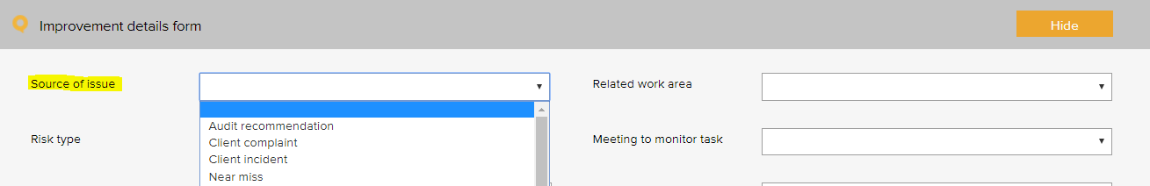

Improvement source – General Examples based on the RNZCGP Standards
Arising from a complaint | Arising from feedback - pharmacist
Arising from a near miss | Suggestion - consultant
Arising from a survey - patient | Suggestion - family / whanau
Arising from a survey - staff | Suggestion - manager
Arising from an adverse event | Suggestion - other health service provider
Arising from an audit - patient record review | Suggestion - patient / caregiver
Arising from an audit - patient screen and recall | Suggestion - PHO
Arising from an audit recommendation | Suggestion - staff
Arising from an incident - health and safety | Suggestion - stakeholder
Arising from an incident - medication mismanagement | Suggestion - supplier
Arising from an incident - other | Suggestion - team meeting
Arising from feedback - other | Suggestion - visiting practitioner

Improvement source – RNZCUC Example
Arising from fire evacuation drills

Incident Register
The incident type menu is used when reporting an incident in the incident register. It allows for the incident to be coded to a category. Reports can be generated based on the selections in this menu.
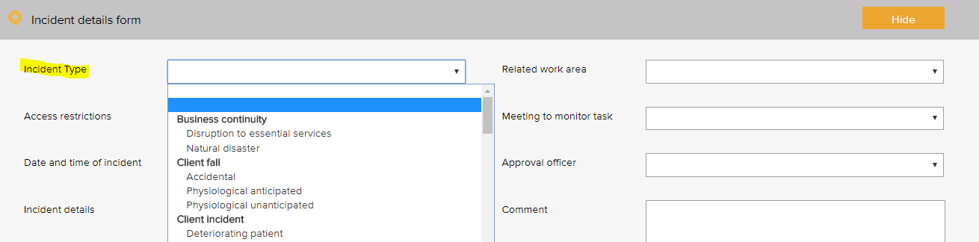
The following example is based on the WHO Conceptual Framework for the International Classification for Patient Safety which provides a categorization of patient safety information using standardized sets of concepts with agreed definitions, preferred terms, and the relationships between them based on an explicit domain ontology. It is designed to facilitate the description, comparison, measurement, monitoring, analysis and interpretation of information to improve patient care, and for epidemiological and health policy planning purposes.
This framework is referred to in the New Zealand Health and Disability Services – National Reportable Events Policy 2012 and has been used as a basis for determining reportable events codes referred to in the Policy.
Incident type – General Examples
Primary incident type | Secondary incident type
Building incident | Damaged
Building incident | Not maintained
Clinic administration incident | Appointment
 | Consent
 | ECDS Tools
 | Enrolment
 | Funding
 | Healthlink
 | Hospital discharge
 | Internal communication
 | Patient Identification
 | Patient portal / SEHR / CWS
 | PMS
 | Referral / consultation
 | Response to emergency
 | Task allocation
 | Transfer of care
 | Waiting time
Clinical documentation incident | Care plan
Clinical documentation incident | Discharge summary
Clinical documentation incident | Medical certificates
Clinical documentation incident | Medical records / consultation notes
Clinical documentation incident | Orders / requests
Clinical documentation incident | Referrals
Clinical documentation incident | Reports / results / images
Clinical process / procedure incident | Diagnosis / assessment
 | General care / management
 | Procedure / treatment / intervention
 | Recall
 | Screening
 | Specimens / results
 | Tests / investigations
Fixture incident | Damaged
Fixture incident | Faulty
Fixture incident | Not maintained
Healthcare associated infection incident | Clean wound infection
 | Infection incident
HR / organisational management incident | Inadequate supervision
HR / organisational management incident | Inadequate training
HR / organisational management incident | Lack of protocols / policy / procedure / guideline
HR / organisational management incident | Personnel grievance
HR / organisational management incident | Service availability
HR / organisational management incident | Staff availability
IV fluid incident | Administering
 | Setup
Medication incident | Administering
Medication incident | Monitoring
Medication incident | Prescribing
Medication incident | Storage
Medication incident | Supply / ordering
Medication incident | Un-reconciled controlled drug register
Medical device equipment incident | Device / equipment
Medical device equipment incident | Sterilisation
Oxygen incident | Administering
 | Storage
Patient accident | Exposure to electricity
Patient accident | Poisoning by chemical or other substance
Patient behaviour incident | Bullying
Patient behaviour incident | Discrimination / prejudice
Patient behaviour incident | Disrespectful
Patient behaviour incident | Harassment
Patient behaviour incident | Intended self-harm / suicide
Patient behaviour incident | Noncompliant
Patient behaviour incident | Physical assault
Patient behaviour incident | Sexual assault
Patient behaviour incident | Substance use / abuse
Patient behaviour incident | Threat to personal safety
Patient behaviour incident | Verbal aggression
Patient fall | Collapse
Patient fall | Loss of balance
Patient fall | Slip / trip / stumble
Staff behaviour incident | Bullying
 | Discrimination / prejudice
 | Disrespectful
 | Harassment
 | Intended self-harm / suicide
 | Noncompliant
 | Physical assault
 | Sexual assault
 | Substance use /abuse
 | Threat to personal safety
 | Verbal aggression

Additional incidents types, beyond patient safety:
Primary incident type | Secondary incident type
Business continuity issue | Loss of connectivity
Business continuity issue | Loss of service power
Business continuity issue | Loss of service telecommunications
Business continuity issue | Loss of service water
Business continuity issue | Natural disaster
Cold chain incident | Cold chain breach
Cold chain incident | Cold chain excursion
Cold chain incident | Cold chain failure
Contract incident | Breach of contract
 | Unsigned contract
Finance incident | Bad debt
 | Financial penalty
 | Fraud / theft
 | Inaccurate accounting and / or reporting
 | Inadequate insurance
 | Inadequate liability insurance (directors and public liability)
 | Missed billing
 | Missed payment obligation
Hazard | Biological
 | Chemical
 | Ergonomic
 | Falls hazard
 | Physical
 | Psychological
 | Safety
Health and safety | Electrical safety
Health and safety | Fire and emergency
Health and safety | Manual handling
Health and safety | Near miss
Infection prevention and control | Compromised packaging
Infection prevention and control | Contamination of a sterile field
Infection prevention and control | Contamination of instruments
Infection prevention and control | Endophthalmitis
Infection prevention and control | Hand hygiene
Infection prevention and control | HepB
Infection prevention and control | MRSA
ICT incident | Backup systems failure
 | Computer / systems breakdown
 | Inappropriate use of technology / internet
 | Intrusion / virus
 | Loss of IT data
 | Unauthorised file deletion
Inventory incident | Critical item out of stock
Inventory incident | Expired medical product
Inventory incident | Inadequate stock
Legal incident | Breach of trespass order
 | Document fraud by patient / caregiver
 | Legal penalty / restriction
 | Litigation claim - non-staff
Privacy incident | Privacy breach
Privacy incident | Unauthorised access or release of patient information
Privacy incident | Unauthorised access or release of practice information
Privacy incident | Unauthorised access or release of staff information
Reputation incident | Adverse publicity
Security incident | Break-in
 | Security breach
 | Trespassing
Vehicle incident | Accident
 | Damage
 | Misuse
 | Theft

License Register
The pre-set licence options menu is used when scheduling a licensing task in the licensing register. It allows for the task to be coded to a category. Reports can be generated based on the selections in this menu.
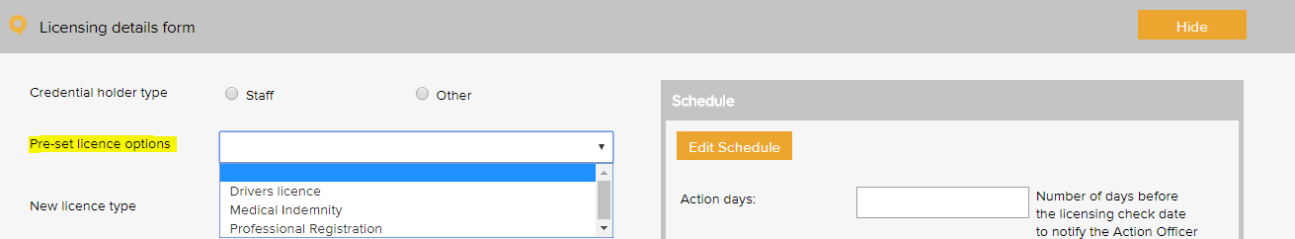

License type – General exampled based on RNZCGP Standards
APC provider number
Credentialing requirements
Criminal record check
Driver’s licence - C
Healthcare provider identifier
Medical indemnity
Medicare council number
Vaccination requirement
Vulnerable children check
Waste handling
Work Visa

License type – RNZCUC Examples
ACLS
New Zealand Annual Practising Certificate
ACLS Certification
APC
Medical indemnity

Meeting Register
The select a meeting menu is used when scheduling a meeting in the meeting register. It controls the meetings that users can add to the system. A selection from this list must be made when adding an item to any register.
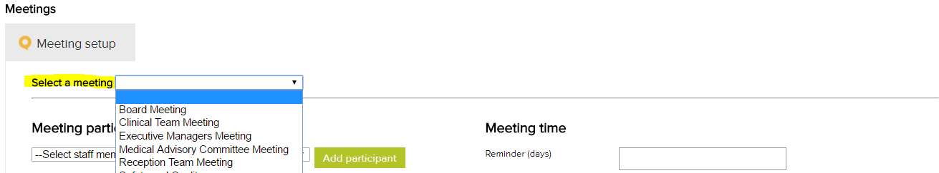
Meeting Types – General exampled based on RNZCGP Standards
Admin Meeting
Clinical Team Meeting
Doctors’ Meeting
Management Meeting
Nurse Meeting
Staff Meeting
Team Leader Meeting

Positions
The position menu appears when setting up staff contacts in the contacts register. A single unique position title should be created for every user of the system. If there are multiple positions with the same title, each position should be numbered to remain unique e.g. Receptionist 1, Receptionist 2 etc. Tasks in the system are assigned to positions.
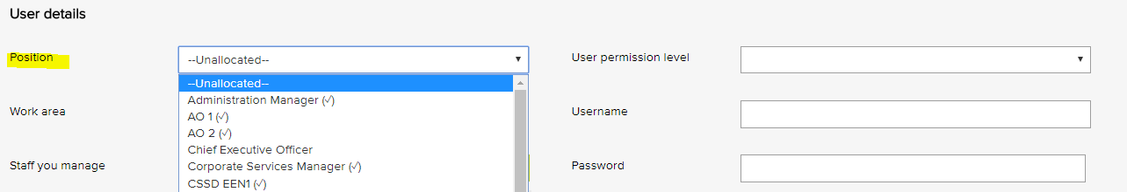
Position titles – General exampled based on RNZCGP Standards
Finance Manager
General Practitioner
General Practitioner 1
General Practitioner 2
Healthcare Assistant 1
Medical Receptionist 1
Medical Receptionist 2
Nurse Practitioner 1
Physician Assistant 1
Practice Manager
Practice Nurse 1

Records Register
The category menu is used when adding a record to the records register. It allows for the record to be coded to a category. The menu must also be used when adding a record to a task in the system. Reports can be generated based on the selections in this menu.
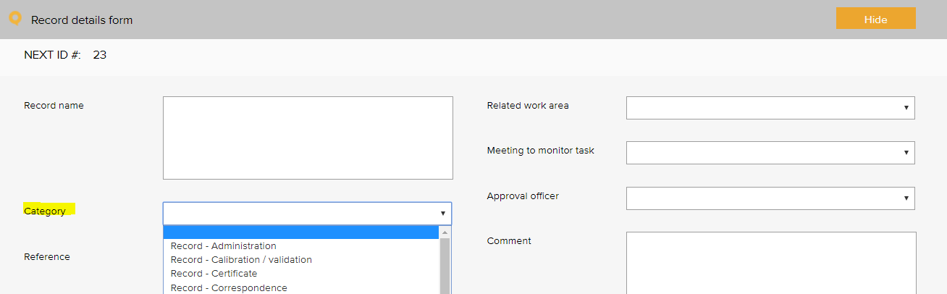
Records category – General exampled based on RNZCGP Standards
Record - administration | Record - training code of rights
Record - APC | Record - training CPR
Record - calibration / validation | Record - training cultural competency
Record - certificate | Record - training diabetes Level 7
Record - correspondence | Record - training infection control
Record - CPD | Record - training other
Record - credentialing | Record - training privacy
Record - driver licence | Record - training TOW
Record - email | Record - training vaccinator’s certificate
Record - finance | Report - audit
Record - HR | Report - data analysis
Record - incident | Report - evaluation
Record - meeting agenda | Report - financial
Record - meeting minutes | Report - legal advice
Record - photograph | Report - maintenance
Record - police check | Report - management
Record - quote | Report - national health data
Record - service notification | Report - performance appraisal
Record - staff confidentiality | Report - progress
Record - staff recruitment | Report - quality achievement
Record - sterilisation | Report - referee

Risk Register

Risk Assessment
The risk level and management requirement settings are displayed when rating a risk in the system. Reports can be generated based on the selections in this menu. There are four possible levels of risk in the LOGIQC assessment matrix. Each of these levels can be given a name such as SAC 1, SAC 2, SAC 3 and SAC 4. Each risk level can also be given a related ‘management requirement’, eg. rules for how that level of risk should be managed.
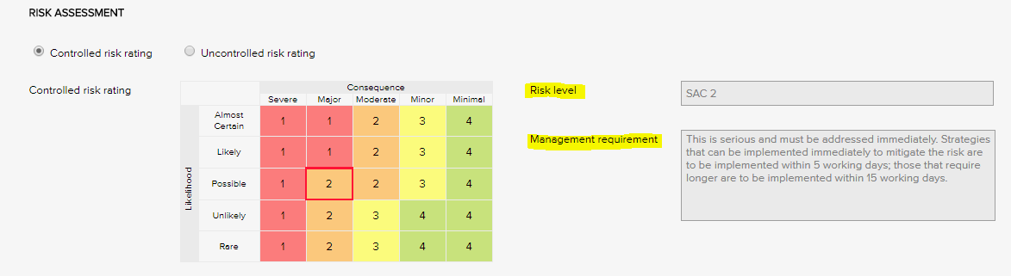

Risk Levels and related Management Requirement - Examples based on the Health Quality and Safety Commission New Zealand risk matrix
SAC 1 | - Complete REB Part 1 and send to HQSC within 15WD  - Formal review using RCA methodology / London Protocol  - Complete REB Part 2 and send to HQSC within 70WD
SAC 2 | - Complete REB Part 1 and send to HQSC within 15WD  - Formal review using RCA methodology / London Protocol  - Complete REB Part 2 and send to HQSC within 70WD
SAC 3 | - Review of incident within 30WD  - May complete REB Part 1 and Part 2 and send to HQSC if considered relevant eg. Health sector issue or learning
SAC 4 | - Review of incident within 30WD  - May complete REB Part 1 and Part 2 and send to HQSC if considered relevant eg. Health sector issue or learning

Risk Levels and related Management Requirement - Examples
SAC 1 | This is serious and must be addressed immediately. Strategies that can be implemented immediately to mitigate the risk are to be implemented within same or next working day; those requiring longer are to be implemented within 5 - 10 working days.
SAC 2 | This is serious and must be addressed immediately. Strategies that can be implemented immediately to mitigate the risk are to be implemented within 5 working days; those that require longer are to be implemented within 15 working days.
SAC 3 | Manage by specific monitoring or auditing procedures
SAC 4 | Manage by routine procedures.

Risk Dimensions
The risk dimension menu is used when adding a risk to the risk register. It allows for the identified risk to be coded to a high level dimension. Reports can be generated based on the selections in this menu.
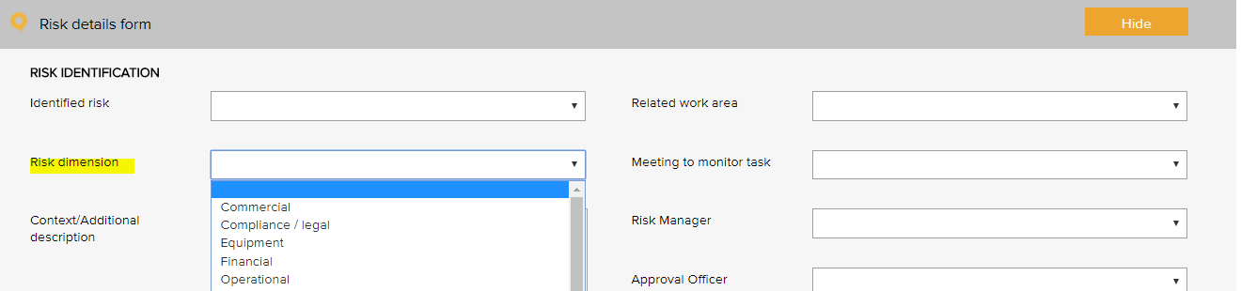
Risk Dimensions | Definition
Commercial | This category includes the risks associated with market placement, business growth, diversification and commercial success. This relates to the commercial viability of a product or service, and extends through establishment to retention and then growth of a customer base.
Compliance / legal | This category includes compliance with legal requirements such as legislation, regulations, standards, codes of practice and contractual requirements. This category also extends to compliance with additional ‘rules’ such as policies, procedures or expectations, which may be set by contracts, customers or the social environment.
Equipment | This extends to the equipment utilised for the operations and conduct of the business. It includes the general operations of the equipment, maintenance, appropriateness, depreciation, safety and upgrade.
Financial | This category includes cash flow, budgetary requirements, tax obligations, creditor and debtor management, remuneration and other general account management concerns.
Organisational | This relates to the internal requirements of a business, extending to the cultural, structural and people issues associated with the effective operation of the business.
Operational | This covers the planning, operational activities, resources (including people) and support required within the operations of a business that result in the successful development and delivery of a product or service.
Project | This includes the management of equipment, finances, resources, technology, timeframes and people associated with the management projects. It extends to internal operational projects, projects relating to business development, and external projects such as those undertaken for clients/patients.
Reputation | This entails the threat to the reputation of the business due to the conduct of the entity as a whole, the viability of product or service, or the conduct of employees or other individuals associated with the business.
Safety | This category includes the safety of everyone associated with the business. This extends from individual safety, to workplace safety, public safety and to the safety and appropriateness of products or services delivered by the business.
Security | This includes the overall security of the business premises, assets and people, and extends to security of information, intellectual property, and technology.
Service delivery | This relates to the delivery of services, including the quality and appropriateness of service provided, or the manner in which a product is delivered, including customer interaction and after-sales service.
Stakeholder management | This category relates to the management of stakeholders, and includes identifying, establishing and maintaining an appropriate relationship. This includes both internal and external stakeholders.
Strategic | This includes the planning, scoping and resourcing requirements for the establishment, sustaining and/or growth of the business.
Technology | This includes the implementation, management, maintenance and upgrades associated with technology. This extends to recognising the need for and the cost benefit associated with technology as part of a business development strategy.

Risk dimensions – RNZCUC Examples
Organisational
Financial
Occupational
Service delivery

Risk Treatment Options
The risk treatment option menu is used when adding a mitigation action to the risk register. It allows for the action to be categorised against a risk treatment strategy.
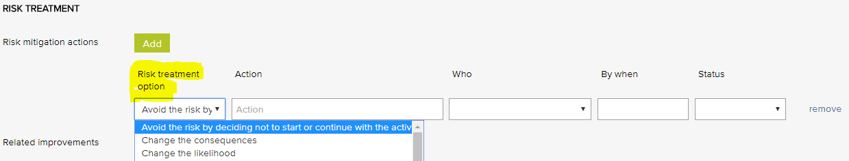

Risk treatment options - General Examples based on the RNZCGP Standards
Avoid the risk by deciding not to start or continue with the activity
Change the consequences
Change the likelihood
Eliminate the hazard
Isolate the hazard
Minimise the hazard
Remove the risk source
Retain the risk by informed decision
Share the risk with another party or parties
Take or increase the risk in order to pursue an opportunity

Risk Category and Risk Name
The identified risk menu is used when adding a risk to the risk register. It presents a list of risks that can be added to the risk register. Reports can be generated based on the selections in this menu.
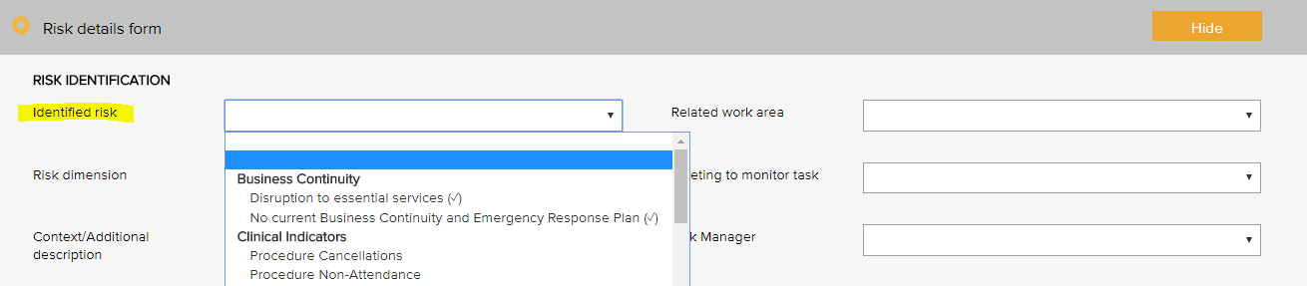
Risk Category | Risk Name
Business continuity | Disruption to essential services
 | Workforce sustainability
Collaborative partnerships | Breakdown in relationship with suppliers / stakeholders
Patient safety | Clinical incident
 | Cold chain breach
 | Currency of professional registration / credentialing
 | Currency of staff immunisation
 | Falls prevention and harm minimisation
 | Infection control breach
 | Medication mismanagement
 | Non-compliance with clinical procedures / standards
 | Patient complaint
 | Patient safety
Financial | Cash / fund management shortfall
 | Competitors
 | Financial literacy
 | Non-compliance with financial management procedures
 | Over-reliance on a small number of customers / suppliers
Human resource / personnel | Cross cultural conflict
Human resource / personnel | Industrial action
Human resource / personnel | Lack / insufficient skills, training to complete job duties
Human resource / personnel | Non-compliance with HR procedures
Human resource / personnel | Over-reliance on a small number of staff or key staff
Human resource / personnel | Problems with outside contractors
Inventory | Inventory mismanagement
Legal | Legislative / regulatory / contractual breach
Management | Assets mismanagement
 | Equipment mismanagement
 | Hazard mismanagement
 | Health and safety mismanagement
 | Information mismanagement
 | Patient transport mismanagement
 | Project goals and objectives not met
 | Property mismanagement
 | Vehicle mismanagement
Operations and assets | Non-compliance with operational procedures
 | Planning and scheduling conflicts
Policy and political | Changes in government
 | Organisational culture not aligned to organisational values
 | Legislative risk
Reputation and image | Adverse media coverage
 | Loss or injury to reputation
 | Reduction or loss of community connectedness
Security | Security breach
Student / registrar placement | Non-compliance with student / registrar placement procedures
Technological | Breach of data security and backup
 | Failure of IT hardware and network management
 | Loss of productivity due to staff IT competencies
 | Not maximising the potential benefits of digital technologies

Linkages between the Risk Module and the Feedback and Incident Registers
When the Risk Module is activated in the LOGIQC QMS, incident types and feedback categories can be linked to one or more identified risks. When an incident or feedback that is linked to a risk is reported, it will inherit the risk rating assigned to the risk that it is linked to. Where an incident type or feedback category has been linked to multiple risks, it will be assigned the risk that has the highest risk rating amongst those risks that it has been linked to. In the event that there is more than one risk at the highest risk rating, LOGIQC will assign the risk in alphabetical order from those at the highest level.

Site Information
The site information settings controls certain automatic behaviours such as the number of days allowed to respond to a task and the frequency of sending automatic reminders.

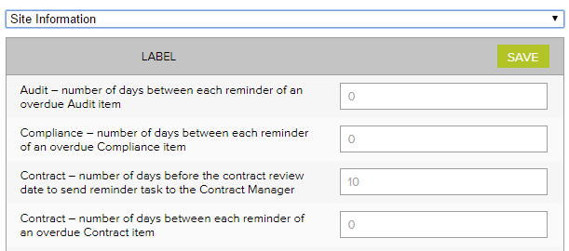
Site information - Examples
Label | No of days
Accreditation – number of days between each reminder of an open accreditation plan action | 14
Accreditation – number of days between each reminder of an overdue Accreditation item | 14
Accreditation – number of days the Approval Officer and the Quality Manager has to complete their tasks | 60
Audit – number of days between each reminder of an overdue audit item | 7
Compliance – number of days between each reminder of an overdue Compliance item | 7
Contract – number of days before the contract review date to send reminder task to the Contract manager | 14
Contract - number of days between each reminder of an overdue Contract item | 7
Contract – number of days the Approval Officer and the Contracts manager has to complete their tasks | 14
Document – number of days before the document review date to send reminder task to the Approval officer | 14
Document – number of days between each reminder of an overdue document item | 7
Document – number of days the Approval Officer has to complete the Approval task | 14
Feedback – number of days between each reminder of an overdue Feedback item | 3
Feedback – number of days the Approval Officer has to complete the Approve for Action task | 3
Improvement - number of days between each reminder of an overdue Improvement item | 14
Improvement – number of days the Approval Officer has to complete the Approve for Action task | 30
Incident - number of days between each reminder of an overdue Incident item | 3
Incident - number of days the Approval Officer has to complete the Approve for Action task | 3
Licensing - number of days between each reminder of an overdue licensing item | 3
Record - number of days between each reminder of an overdue Record item | 14
Repair - number of days between each reminder of an overdue Repair item | 7
Repair - number of days the Approval Officer has to complete the Approve for Action task | 3
Risk - number of days between each reminder of an open mitigation item | 14
Risk - number of days between each reminder of an overdue Risk item | 7
Risk – number of days the Approval Officer and the Risk Manager has to complete their tasks | 60
Supplier – number of days before the supplier review date to send reminder task to the Approval officer | 14
Supplier - number of days between each reminder of an overdue Supplier item | 7
Supplier – number of days the Approval Officer has to complete the Approval task | 14
Training – number of days between each reminder of an overdue Training item | 7

Suppliers Register
The Assessment criteria menu is displayed as checkboxes when adding and reviewing a supplier in the supplier register. It controls the criteria used for assessing suppliers.
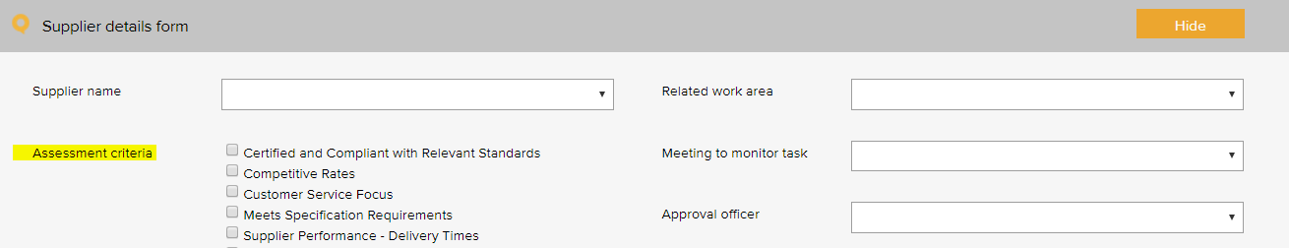

Supplier assessment criteria - General Examples based on the RNZCGP Standards
Certified and compliant with relevant standards
Competitive rates
Customer service focus
Meets specification requirements
NZBN verified
Supplier performance - delivery times
Supplier performance - processing of orders
Supplier performance - returns and back orders

System Settings

Disable auto timeout
The default settings in your LOGIQC QMS are set to disable auto timeout. This means that once logged in, your session will remain open for 12 hours before ‘timing out’ and requiring you to log in again. If you want to decrease this time to 70 minutes, simply un-check the setting.

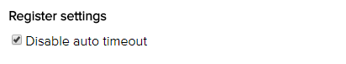

Training Register
The pre - set training options menu is used when scheduling a training task in the training register. It allows for the task to be coded to a category. Reports can be generated based on the selections in this menu.
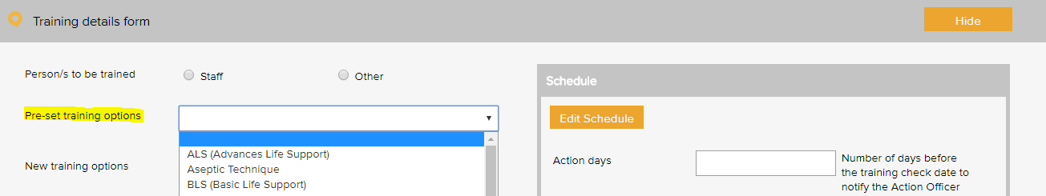

Mandatory training types – General Examples based on the RNZCGP Standards
Code of Health & Disability Services Consumers’ Rights 1996 - L1 & L2
Privacy Act 1993 & the Health Information Privacy Code 1994 - L1 & L2
The Treaty of Waitangi principles - L1 & L2
Cultural Competency and Cultural Safety
Infection Control - L1
Triage Procedures - L1 & L2
CPR Certification and record of current CPR certificates
CPR expiry date recorded
Staff Induction - Medicine Reconciliation

Training type examples to meet RNZCGP foundation requirements
Adverse reactions to medicines and immunisation reporting requirements
Importance of correct pronunciation of te reo Māori patient names
Principle of Right 10 of the Code
Process to manage individual patient information
Repeat prescribing procedures
Role and responsibilities of Health and Safety Coordinator
Screening and Recall Policy
Tracking potentially significant investigations and urgent referrals

Training type examples to meet RNZCGP advanced requirements
Business structure and contractual requirements
Controlled Drug Register - process for management of drugs
Electronic clinical decision support tools
Electronic transfer of records
Medicine Reconciliation requirements
Opportunistic Screening
Patient Portal System
Shared Care Planning process

Training type examples to meet RNZCGP aspirational requirements
How information is shared electronically with other providers
Medicines Act 1981
NZ Prescription Service

Training type – RNZCUC Examples
Code of Health and Disability Services Consumers’ Rights (the Code)
Complaints management process
The Treaty of Waitangi
Advanced cardiac life support certification
Burns management
Closed reduction
Cultural safety
ECG interpretation
First Aid
Implementation of the Code of Health and Disability Services Consumers’ Rights (the Code)
Infection control practices for sterilization and disinfection
IV cannulation
New procedures and equipment
Plastering
Procedural sedation, if applicable
Slit lamp use
Triage procedures
Use of the Slit Lamp
Wound care
X-ray interpretation

Work Areas
This list appears when adding an item to any register. It is the list of functional work areas in the organisation (eg HR Administration, Clinic, Programs, etc) that tasks and issues can be assigned to. All Registers allow for sorting, filtering and printing of reports based on “work areas”.
Primary work area | Secondary work area
Management services | Administration
 | Finance
 | Health and safety
 | HR
 | Information communication technology
 | Quality and risk
Governance | Clinical governance
 | Corporate governance
 | Practice management
Infrastructure and facilities | Asset
 | Car park
 | Consult room
 | Equipment - clinical
 | Equipment - other
 | Grounds
 | Outreach location
 | Practice entrance
 | Reception area
 | Security
 | Specialist room
 | Treatment room
 | Vehicle
 | Waiting room
Primary care services | After hours care
 | All
 | Allied health care
 | Cold chain
 | GP care
 | Infection prevention and control
 | Nursing care
 | Reception
 | Urgent care

WHO Conceptual Framework for the International Classification for Patient Safety Version 1.1 Final Technical Report January 2009
International Classification for Patient Safety Statement of Purpose - http://www.who.int/patientsafety/taxonomy/ICPS_Statement_of_Purpose.pdf
Health Quality and Safety Commission New Zealand, New Zealand Health and Disability Services – National Reportable Events Policy 2012, p.10
There are 3 types of events that need separate reports: Cold chain breach: an event which has led to the vaccines being stored or transported in temperatures outside the required +2˚C to +8˚C range, but the potency/stability of the vaccines has not been compromised. Cold chain excursion: an event which has led to the vaccines being stored or transported in temperatures outside the required +2⁰C to +8⁰C range and as a result, vaccines are compromised and need to be returned for destruction. Cold chain failure: an event in which vaccines involved in a cold chain excursion are administered to patients
Risk management guide for small business, NSW Department of State and Regional Development, www.smallbiz.nsw.gov.au

