LOGIQC QMS SETUP GUIDE - DAY HOSPITALS NZ
This guide supports the set-up of the LOGIQC Quality Management System menus for New Zealand Day Hospitals in accordance with the requirements of the following standards: Australian Council on Healthcare Standards EQuiP6; NZS 8151:2004 Accident and Medical Clinic Standard; NZS 8164:2005 Day-stay Surgery and Procedures; NZS 8134:2008 Health, Diability; Reproductive Technology Accreditation Committee (RTAC) 2017 and EQuIP6 Day Procedure Centres Standards.
Contents
Customising menus 3
System menu types 3
Editing single level menu options 4
Editing double level menu options 5
System menu examples 6
Accreditation Register 6
Compliance Register 7
Contact Register 11
Contract Register 13
Document Register 14
Feedback Register 16
Feedback Type 16
Feedback Source 17
Feedback Category 18
Improvement Register 20
Incident Register 21
License Register 30
Meeting Register 31
Positions 31
Records Register 32
Risk Register 35
Risk Assessment 35
Risk Treatment Options 35
Risk Dimensions 36
Risk Category and Risk Name 37
Site Information 40
Suppliers Register 41
System Settings 41
Training Register 42
Work Areas 45

Customising menus

System menu types
There are two main types of menus in LOGIQC: single level menus and double level menus. Most menus are single level. The double level menus are work area, incident type and identified risk.

Single level menu example | Double level menu example
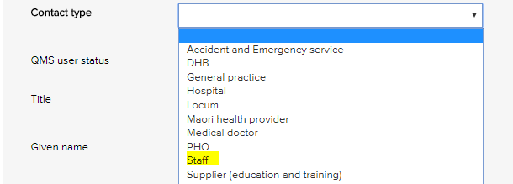 | 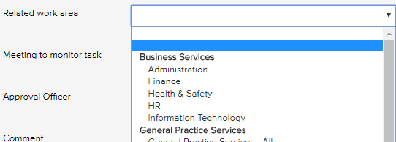
Single level menus  Accreditation assessment  Compliance source document  Contact type  Contract category  Document category  Feedback category  Feedback source  Feedback type  Improvement source  Licensing type  Meetings *  Positions *  Records category  Risk dimension  Risk treatment information  Supplier assessment criteria  Training type  * The content in these menus can be edited. | Double level menus  Primary + secondary incident type  Primary + secondary work area  Risk category + risk name

Editing single level menu options
These instructions use the contact type menu as an example.
- Log-in as administrator and select system setup in the system settings menu.
- From the system setup menu, select the menu to edit.
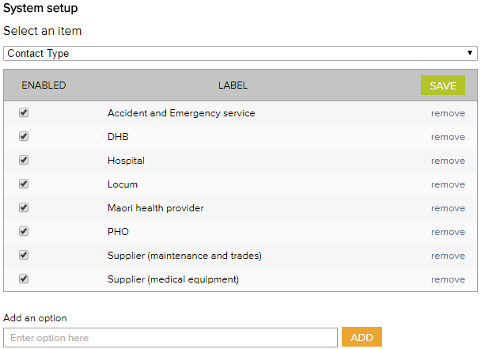
- Enter the new menu option into the add an option field.
- Click add and click save.
- To remove menu options, click remove and click save. (Note: Once an option has been used in a register item in the system the option can only be disabled and cannot be removed)

Editing double level menu options
These instructions use the work area menu as an example.
- Log-in with the Administrator password and select system setup in the system settings menu.
- From the system setup menu, select primary work area from the menu. From this screen, you can customise the menu to your organisation by adding and removing menu options.
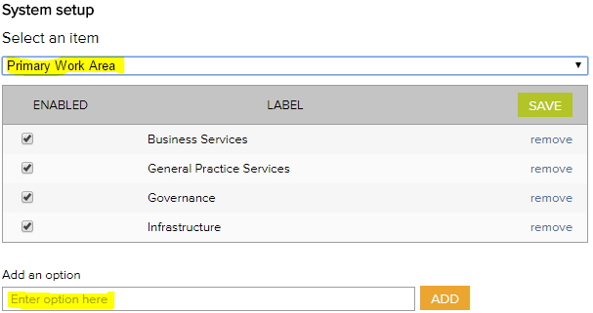
- To add new primary work area categories and type into the option field.
- Click add and click save.
- To remove primary work area categories that you don’t want, click remove and click save. (Note: Once an option has been used in a register item in the system the option can only be disabled and cannot be removed)
- Select secondary work area from the system setup menu.
If a new primary category is created LOGIQC will automatically create a duplicate secondary menu label with the word ‘all’ appended. This option can be removed after other secondary options are added to the category. LOGIQC requires a minimum of one secondary menu option for each primary option.
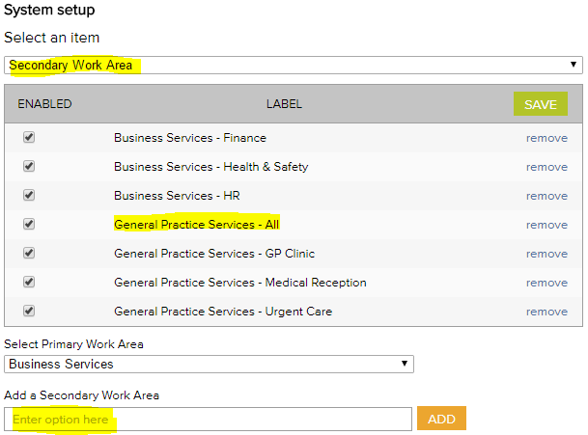
- To add new secondary work areas, select the related primary work area and type into the option field.
- Click add and click save.
- To remove secondary work area categories that you don’t want, click remove and click save. (Note: Once an option has been used in a register item in the system the option can only be disabled and cannot be removed)

System menu examples

Accreditation Register
The accreditation business system is used to group ‘accreditation actions required’ into higher order categories in the accreditation action plan and excel export. This way the individual tasks added can be categories.
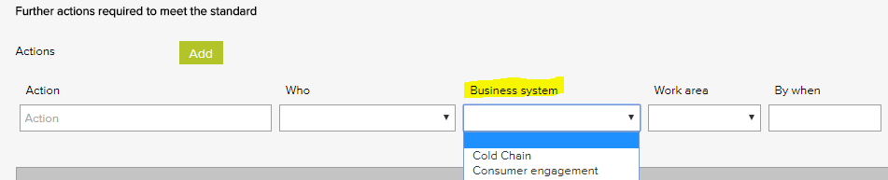
Accreditation business system – General Examples
Accountability and reporting
Cold chain
Consumer engagement
Equipment - medical
Equipment - non-medical
Governance - clinical
Governance - corporate
Infection prevention and control
Internal communication
Management - clinical
Management - corporate
Training - induction
Training - mandatory

Compliance Register
The Source of requirement menu is used when scheduling a compliance task. It allows for the task to be coded to the entity or regulation that stipulates that the task should be carried out. Reports can be generated based on the selections in this menu.
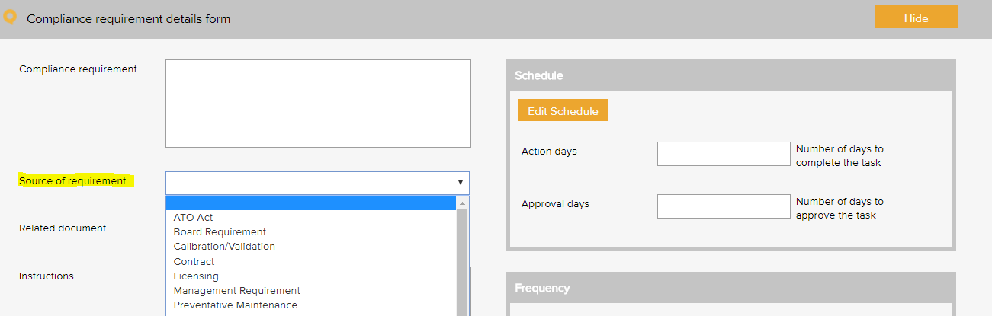

Compliance source document category – General Examples
Antibiotic guidelines
AS 31000 Risk management: principles and guidelines
Assets management
Australia New Zealand Therapeutic Products Agency (ANZTPA)
By-laws
Cleaning schedule
Employee Assistance Program
ICT preventive maintenance
Legislative requirement
Management requirement
Manufacturer's instruction
Policy and Procedures
Regulation

Compliance source document category – 8164 Examples
Advertising Standards Authority
AS/NZS 1336-1997 Recommended practices for occupational eye-protection;
AS/NZS 1337.5:2004 Eye-protectors for adjustment work on lasers and laser systems (laser adjustment eye-protectors).
AS/NZS 2211 .1:2004 Equipment classification, requirements and user's guides;
AS/NZS 2500:2004 Guide to the safe use of electricity in patient care
AS/NZS 3003.1:2003 Electrical installations
AS/NZS 35.51 :2004 Technical management programs for medical devices
AS/NZS 3760:2003 In-service safety inspection and testing of electrical equipment
AS/NZS 4146:2000 Laundry practice
Body Protected Areas, as specified in AS/NZS 3003:2003 Electrical installations
Centre for Adverse Reactions Monitoring (CARM)
Code of Health and Disability Services Consumers' Rights
Complaints Board
Fair Trading Act 1986
Health and Safety at Work Act 2015
Health and Disability Commissioner Act 1994
Health Information Privacy Code 1994
Health Practitioners Competence Assurance Act 2003
Medicines Act 1981
NZS 8142:2000 Infection controls
NZS 8153 Health records
Occupational safety and health requirements
Privacy Act 1993
The Smoke-free Environments Act 1990
Treaty of Waitangi

Compliance source document category – EquIP6 Examples
Assets management
Australian Incident Monitoring System (AIMS)
Cleaning schedule
Criteria of Appropriateness of Blood Transfusions (NHMRC guidelines)
Employee Assistance Program
ICT preventive maintenance
Incident Information Management System (IIMS)
Legislative requirement
Medical Advisory Council (MAC)
Policy and Procedures

Compliance source document category – 8134 Examples
AS 2828
AS 8153
AS NZS 2500
AS NZS 3003
AS NZS 3551
AS NZS 4146
Australasian Health Facility Guidelines (HCAMC)
Births, Deaths and Marriages Registration Act
Charitable Trusts Act
Companies Act
Coroners Act
Crimes Act
Criminal Justice Act
Fire Safety and Evacuation of Buildings Regulations
Food Act
Food and nutrition guidelines (MOH)
Guidelines on the administration of ECT (Clinical Memorandum '12) RANZC of Psychiatrists
Hazardous Substances and New Organisms Act
Health (Retention of Health Information) Act
Health Act
Health and Disability Services (Safety) Act
Health and Safety in Employment Act
Health Information Privacy Code 1994
Human Rights Act
Incorporated Societies Act
Laundry Guidelines for rest homes and small hospitals (MOH)
Medicines Act and Regulations
Mental Health (Compulsory Assessment and Treatment) (MA (CAT)) Act
Mental Health Act
NZ 3003.1
NZ 4303
NZ 8134.3
NZ Bill of Rights Act
NZ Building Code
NZ Disability Strategy
NZ Health Information Service (NZHIS)
NZ Medicines and Medical Devices Safety Authority
NZ Public Health and Disability Act
NZ Transport Agency (NZTA) rules and regulations
NZS 4121
Privacy Act 1993
Professional practice / legislation requirements
Reporting requirements of the NZ Fire Service
Resource Management Act

Compliance source document category – 8151 Examples
AS/NZS 3003:2003 Electrical installations
AS/NZS 3551: 1996 Technical management programs for medical devices
AS/NZS 3551: 1996 Technical management programs for medical devices
AS/NZS 4815:200 1 Office-based health-care facilities not involved in complex patient procedures and processes
Australasian College for Emergency Medicine (ACEM) triage scale
Cold chain standards for vaccine storage
Fire and Local Body Regulations
Guidelines/standards for disposal of sharps and contaminated waste management
Health [Retention of Health Information] Regulations 1996
Health Information Privacy Code 1994
Manchester Triage Scale or similar
Misuse of Drugs Regulations (1977)
NZS 3003.1 :2003 Electrical installations
NZS 4121:2001 Design for access and mobility: buildings and associated facilities
NZS 8142:2000 Infection control
Occupational Safety and Health requirements
Smoke-free Environments Act 1990
Privacy Act 1993
SAA/SNZ HB 221:2003 Business continuity management
SAA/SNZ HB 228:2001 Guidelines for managing risk in the healthcare sector
The Code of Health and Disability Services Consumers' Rights, Right 10

Compliance source document category – RTAC 2017 Examples
ANZ Assisted Reproduction Database (ANZARD) custodian
Certification body requirements
College / council requirements regarding Annual Practising Certificates (APC)
Commerce Commission New Zealand
Donor and surrogacy legislation
Manufacturer's instructions
NATA Medical Testing Field Application Document
New Zealand Consumer Law
NHMRC Ethical Guidelines on the use of ART in clinical practice
Preventive maintenance
RTAC Code of Practice

Contact Register
The contact type menu is used when adding a business contact to the contacts register. It allows for the contact to be coded to a category. Reports can be generated based on the selections in this menu.
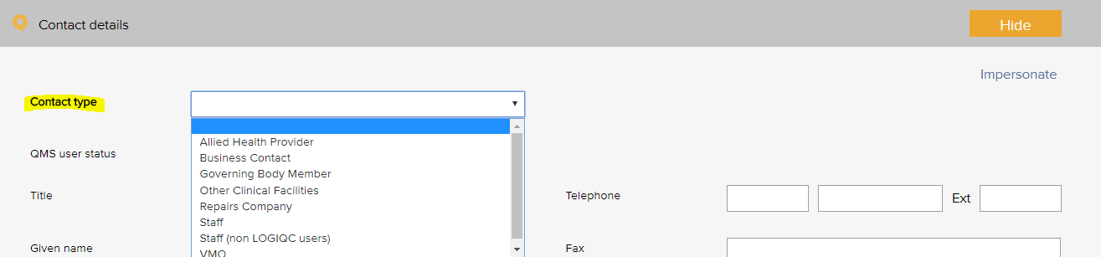

Contact type – General Examples
Advocacy and support services | Supplier - education and training
Agency staff | Supplier - hospital environment and cleaning
Business contact | Supplier - IT and support
General practitioner | Supplier - maintenance
Government agency | Supplier - medical equipment
Industry body | Supplier - medical gases
Interpreter services | Supplier - medical supplies
Medical practitioner - anaesthetist | Supplier - office
Medical practitioner - surgeon | Supplier - waste management
Staff | Visiting medical officer - surgical assistant
Standards agency

Contact type – 8164 Examples
Clinical service | Support service
Community agency

Contact type – 8134 Examples
Accommodation support services | Non-Government Organisations
Allied Health Specialists | Other government agencies
Community recreation providers | Pacific providers
General practitioner | Parenting support services
Income benefit services | Specialist therapy services
Interpreter services | Specialists and acute services
Media organisation | Vocational providers

Contact type – 8151 Examples
Clinical service | General Practitioner
Clinical support service | Health provider
Community agencies | Primary Care Provider
Disability provider

Contract Register
The contract category menu is used when adding a contract to the contracts register. It allows for the contract to be coded to a category. Reports can be generated based on the selections in this menu.
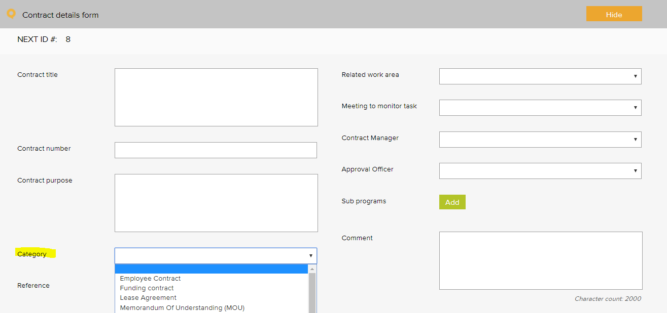

Contract category – General Examples
Confidentiality agreement | Non-disclosure agreement
Contractor agreement | Partnership agreement
Employee agreement | Position description
External provider agreement | Rental agreement
Funding agreement | Service level agreement (SLA)
Health insurance contract | Service Provider Contract
Insurance policy | Supplier agreement
Lease agreement | Warranty agreement
Memorandum of understanding (MOU) | Workforce contract

Contract category – EQuIP6 Examples
Agreement | Interpreter services
Community partnership | Service Provider Contract
External provider agreement

Contract category – RTAC 2017 Examples
Deed of Agreement | Service agreement
Insurance policy

Document Register
The document category menu is used when adding a document to the documents register. It allows for the document to be coded to a category. Reports can be generated based on the selections in this menu.
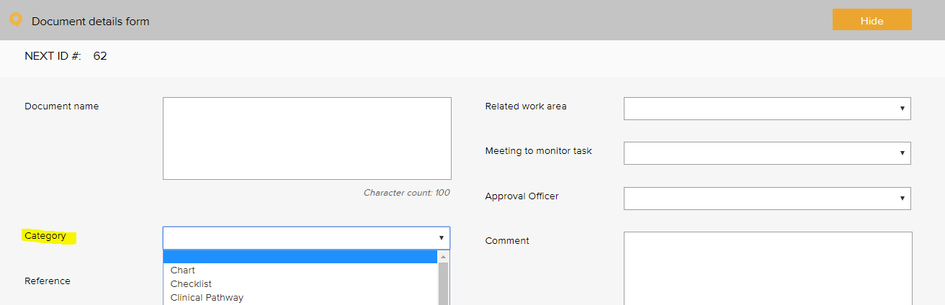

Document category – General Examples
Assessment protocol | Logo
Audit tool | Manufacturer instruction manual
Brochure, information sheet | Map
Bylaws | Patient information
Chart | Plan
Charter | Policy / procedure / guideline
Checklist | Position description
Clinical pathway | Profile
Clinical preference sheet | Reference resource material / tool
Communication material | Reference text
Competency assessment tool | Register
Diagram | Resource material
Education material | Safety data sheet
Flowchart | Schedule
Form | Sign sheet
Framework | Signage
Guideline | Standard
Index | Template
Information resource | Terms of reference
Instrument | Tool
Legislation | Work instruction
List

Document category – EQuIP6 Examples
Assessment protocol | Patient information
Assessment tool | Plan
Audit Tool | Policy / procedure / guideline
Chart | Position description
Clinical pathway | Profile
Form | Reference resource material / tool
Framework | Register
Guideline | Safety data sheet
Index | Schedule
Information resource | Signage
Instrument | Standard
Legislation | Template
Map | Terms of reference

Document category – 8151 Examples
Clinical guideline and procedure | Signage
Code | Standard

Document category – RTAC 2017 Examples
Bulletin | Patient information

Document category – EQuIP6 DPC Examples
Code of practice

Feedback Register

Feedback Type
The feedback type menu is used when reporting feedback in the feedback register. It allows for the feedback or complaint to be coded to a category. Reports can be generated based on the selections in this menu.
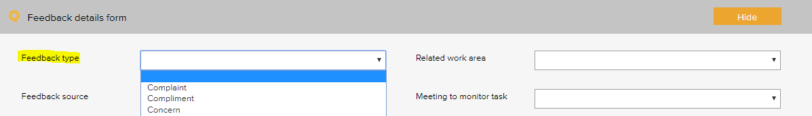

Feedback type – General Examples
Complaint
Compliment
Issue of concern
Praise of staff
Suggestion for improvement

Feedback Source
The feedback source menu is used when reporting feedback in the feedback register. It allows for the source of the feedback or complaint to be selected. Reports can be generated based on the selections in this menu.
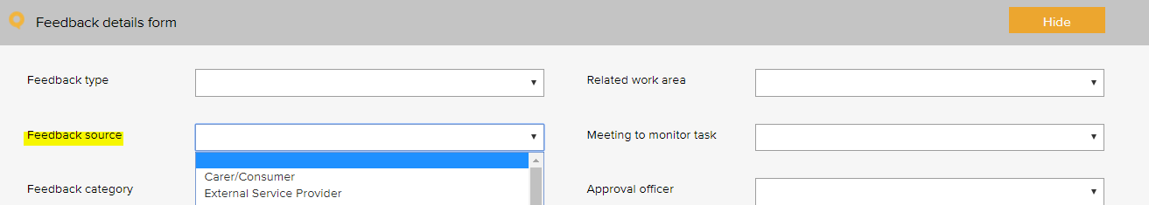

Feedback source - General Examples
Carer or family member | Government agency
Consumer / patient | Health professional
Consumer representative | Referral organisation
External service provider | Referral physician
General practitioner

Feedback source – EQuIP6 Examples
Consumer / patient | Health professional
Consumer representative | Referral organisation
General Practitioner | Referral physician

Feedback source – 8151 Examples
Clinical service | Family / whanau
Clinical support service | General Practitioner
Community agencies | Health provider
Consumer | Primary Care Provider
Disability provider

Feedback Category
The feedback category menu is used when reporting feedback in the feedback register. It allows for the feedback or complaint to be coded to a category. Reports can be generated based on the selections in this menu.
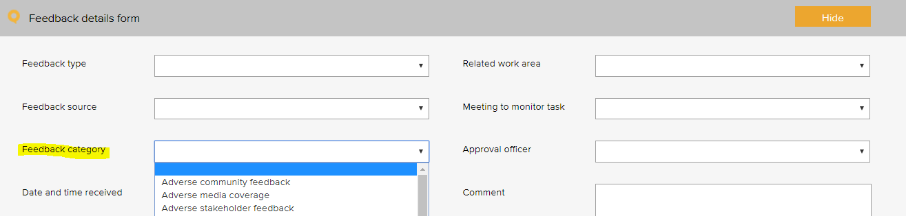

Feedback Category - General Examples
Adverse community feedback | Issue with internal temperature
Adverse media coverage | Issue with medication
Adverse stakeholder feedback | Issue with open disclosure support services
Issue with post-discharge | Issue with outcomes of clinical care
Issue with access to services | Issue with overall effectiveness of care
Issue with accessing data from earlier admissions | Issue with processes of engagement and support provided
Issue with admission process | Issue with referral practices
Issue with arrangements for ongoing care | Issue with service facilities
Issue with clinical care | Issue with service performance
Issue with clinical handover | Issue with service responsiveness
Issue with communication | Issue with staff courtesy
Issue with confidentiality / privacy | Issue with waiting time
Issue with consent - financial | Issue with where care is provided
Issue with consent - materials used to obtain informed consent | Pleased with access
Issue with consent - process | Pleased with anaesthetist
Issue with consumer education | Pleased with confidentiality / privacy
Issue with consumer rep role | Pleased with consumer education
Issue with coordinated care | Pleased with cultural sensitivity
Issue with cost of service | Pleased with customer service
Issue with cultural sensitivity | Pleased with facilities and amenities
Issue with discharge summary | Pleased with medical provider
Issue with governance | Pleased with performance
Issue with individual care episode | Pleased with service responsiveness
Issue with information - clinical | Pleased with services provided
Issue with information - non-clinical | Pleased with staff
Issue with information material | Pleased with surgeon

Feedback category - 8164 Example
Issue with cultural safety

Feedback category – EQuIP6 Examples
Issue post-discharge | Issue with individual care episode
Issue with accessing data from earlier admissions | Issue with open disclosure support services
Issue with admission process | Issue with outcomes of clinical care
Issue with arrangements for ongoing care | Issue with overall effectiveness of care
Issue with consent | Issue with where care is provided
Issue with consumer rep role | Issue with consumer education
Issue with coordinated care | Pleased with consumer education
Issue with discharge summary

Feedback category – 8134 Examples
Issue with access to spiritual care | Pleased with access to spiritual care
Issue with appropriate access to services | Pleased with appropriate access to services
Issue with consumers' right to cultural values and beliefs | Pleased with consumers' right to cultural values and beliefs
Issue with interaction with service provider | Pleased with interaction with service provider
Issue with rights to personal independence | Pleased with service delivery
Issue with service delivery | Pleased with service response to consumers' rights to cultural and spiritual beliefs
Issue with service response to consumers' rights to cultural and spiritual beliefs | Pleased with service responsiveness
Issue with service responsiveness | Pleased with staff courtesy
Issue with staff courtesy

Feedback category – 8151 Examples
Issue with complaint management process | Issue with triage process
Issue with confidentiality / privacy | Issue with waiting time
Issue with consumer rights | Please with parking available for consumers
Issue with cultural and individual values | Please with service responsiveness
Issue with how consumer feedback was responded to | Pleased with consumer rights
Issue with information provided relating to clinical results | Pleased with cultural and individual values
Issue with information provided to GP / PCP | Pleased with how consumer feedback was responded to
Issue with information relating to diagnosis | Pleased with information provided to GP / PCP
Issue with parking available for consumers | Pleased with the complaint management process
Issue with service signage | Pleased with time to access the service

Feedback category – EQuIP6 DPC Examples
Issue with environment | Issue with transfer of care
Pleased with environment | Issue with clinical handover
Issue with post-discharge | Issue with open disclosure support services
Pleased with post-discharge | Pleased with open disclosure support services
Issue with discharge

Improvement Register
The source of issue menu is used when recording an improvement or non-conformance in the improvement register. It allows for the source of the issue to be recorded. Reports can be generated based on the selections in this menu.
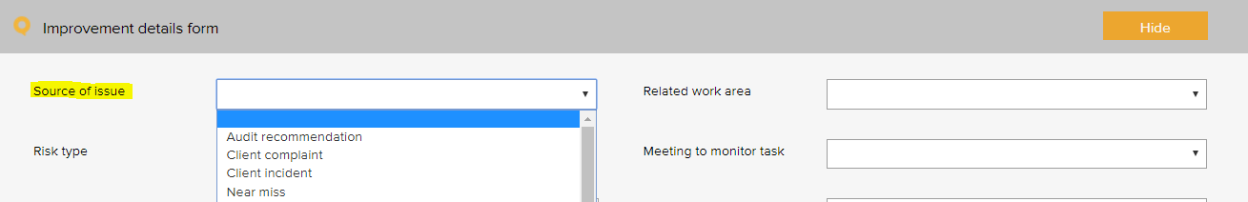

Improvement source – General Examples
Arising from - audit | Arising from - health and safety incident
Arising from - breakdown in service | Suggestion - manager
Arising from - complaint | Suggestion - other service provider
Arising from - emergency | Suggestion - staff
Arising from - feedback | Suggestion - staff member
Arising from - near miss | Suggestion - stakeholder
Arising from - non-patient incident | Suggestion - team meeting
Arising from - patient incident | Suggestion - visiting practitioner

Incident Register
The incident type menu is used when reporting an incident in the incident register. It allows for the incident to be coded to a category. Reports can be generated based on the selections in this menu.
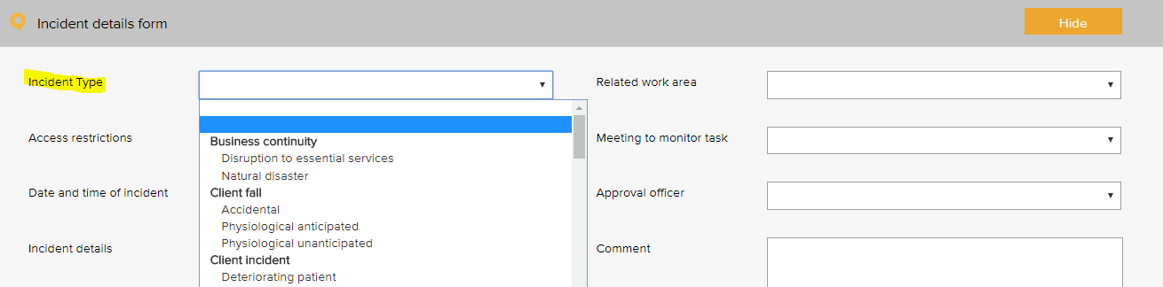
The following example is based on the WHO Conceptual Framework for the International Classification for Patient Safety which provides a categorization of patient safety information using standardized sets of concepts with agreed definitions, preferred terms, and the relationships between them based on an explicit domain ontology. It is designed to facilitate the description, comparison, measurement, monitoring, analysis and interpretation of information to improve patient care, and for epidemiological and health policy planning purposes.

Incident type - Examples
Primary incident type | Secondary incident type
Clinic administration incident | Advanced health directive
 | Allocation of Medical Record Number
 | Appointment
 | Consent - financial
 | Consent - non-financial
 | Discharge
 | Handover
 | Patient identification
 | Referral / consultation
 | Response to emergency
 | Task allocation
 | Transfer of care
 | Waiting time
Clinical process / procedure incident | Adverse event
 | Cancellation after admission
 | Deviation from protocol / procedure / guideline
 | Diagnosis / assessment
 | General care / management
 | Infectious status
 | Lack of protocols / policy / procedure / guideline
 | Misidentification
 | Near miss
 | Patient deterioration due to poor nutrition
 | Patient / procedure mismatching
 | Preadmission screening
 | Procedure / treatment / intervention
 | Referral
 | Sentinel event
 | Specimens / results
 | Tests / investigations
 | Transfer
 | Wrong site
Pressure injury | Anaphylaxis
 | Inadequate skin assessment
 | Inadequate use of equipment
 | Prolonged length of time in theatre
Documentation incident | Clinical pathway
 | Discharge summary
 | Double up of medical record number
 | Loss of medical information
 | Loss of medical record
 | Medical certificates
 | Medical records / assessments
 | Medical records / consultation notes
 | Orders / requests
 | Poor record management
 | Referrals
 | Reports / results / images
Healthcare associated infection incident | Antibiotic related issue
 | Infection incident
Medication incident | Administering
 | Adverse drug reaction
 | Breach of authorisation system
 | Breach of policies, procedures and protocols
 | Disposal
 | Information provided to patients and carers
 | Monitoring
 | Prescribing
 | Reporting system
 | Storage
 | Supply and distribution
 | Supply / ordering
 | Temperature sensitivity
 | Un-reconciled controlled drug register
Blood management | Adverse event
 | Inadequate blood handling
 | Mismanagement of blood
 | Transfusion issue
IV fluid incident | Administering
 | Setup
Oxygen incident | Administering
 | Fault
 | Storage
Medical device equipment incident | Failure / breakdown
 | Fault
Inappropriate staff behaviour | Bullying
 | Discrimination / prejudice
 | Disrespectful
 | Harassment
 | Intended self-harm / suicide
 | Noncompliant
 | Physical assault
 | Sexual assault
 | Substance use / abuse
 | Threat to personal safety
 | Verbal aggression
Inappropriate patient behaviour | Bullying
 | Discrimination / prejudice
 | Disrespectful
 | Harassment
 | Intended self-harm / suicide
 | Noncompliant
 | Physical assault
 | Sexual assault
 | Substance use / abuse
 | Threat to personal safety
 | Verbal aggression
Patient accident | Exposure to electricity
 | Poisoning by chemical or other substance
Patient fall | Collapse
 | Loss of balance
 | Slip / trip / stumble
Building incident | Damage
 | Lift failure
Fixture incident | Damaged
 | Faulty

Additional incidents type examples, beyond patient safety:
Primary incident type | Secondary incident type
Business continuity issue | Loss of connectivity
 | Loss of service power
 | Loss of service telecommunications
 | Loss of service water
 | Natural disaster
Cold chain incident | Cold chain breach
 | Cold chain excursion
 | Cold chain failure
Contract incident | Breach of contract
Finance incident | Bad debt
 | Fraud / theft
 | Inaccurate accounting and / or reporting
 | Inadequate insurance
 | Inadequate liability insurance (directors and public liability)
 | Loss of funding
 | Missed billing
 | Missed payment obligation
Hazard | Biological
 | Chemical
 | Environmental hazard
 | Ergonomic
 | Falls hazard
 | Physical
 | Psychological
 | Safety
Infection prevention and control | Compromised packaging
 | Contamination of a sterile field
 | Contamination of instruments
 | Endophthalmitis
 | Hand hygiene
 | HepB
 | MRSA
Staff training incident | Inadequate supervision
 | Inadequate training
 | Incompetent
ICT incident | Backup systems failure
 | Computer / systems breakdown
 | Inappropriate use of technology / internet
 | Intrusion / virus
 | Loss of IT data
 | Unauthorised file deletion
Legal incident | Cease and desist notice
 | Legal penalty
 | Litigation claim - non-staff
Inventory incident | Critical item out of stock
 | Expired medical product
 | Inadequate stock
Privacy incident | Privacy breach
 | Unauthorised access or release of patient information
Reputation incident | Adverse publicity
Security Incident | Security breach
 | Trespassing
 | Unauthorised access or release of corporate information
Health and safety | Electrical safety
 | Fire and emergency
 | Manual handling
 | Near miss
Vehicle incident | Accident
 | Damage
 | Theft
Environment | Status
 | Un-cleanliness

If your organisation is participating in the ACHS Clinical Indicator Program, you can also use the Incident Register to track occurrences of these Indicators. Following is list of the ACHS Clinical Indicators, some of which may be applicable to your day hospital.
Incident Type – Australian Council on Healthcare Standards) (ACHS) Clinical Indicators
Primary incident type | Secondary incident type
ACHS - Procedure Non-Attendance | Booked patients who fail to arrive
ACHS - Procedure Cancellations | Cancellation after arrival due to pre-existing medical condition
 | Cancellation after arrival due to an acute medical condition
 | Cancellation after arrival due to admin / organisational reasons
ACHS - Unplanned Return to the Operating Theatre | Unplanned return to the operating room on same day as initial procedure
ACHS - Unplanned Transfer / Admission | Unplanned transfer or overnight admission related to procedure
 | Unplanned transfer or overnight admission related to ongoing mgmt.
ACHS - Discharge | Unplanned delayed discharge for clinical reasons >1hr beyond expected
 | Unplanned delayed discharge non-clinical reasons >1hr beyond expected
ACHS - Medication Errors | Medication errors – adverse event requiring intervention
ACHS - Central Line-Associated Blood Stream Infections | Haematology Unit-related CI-CLABSI
ACHS - Central Line-Associated Blood Stream Infections | Haematology Unit-related PI-CLABSI
 | Oncology Unit-related CI-CLABSI
 | Oncology Unit-related PI-CLABSI
 | OPIV Unit-related CI-CLABSI
 | OPIV Unit-related PI-CLABSI
ACHS - Haemodialysis-Associated Bloodstream Infection Surveillance | Haemodialysis – AV-fistula access-associated BSI
 | Haemodialysis – synthetic graft access-associated BSI
 | Haemodialysis – native vessel graft access-associated BSI
 | Haemodialysis – CI non-cuffed line access-associated BSI
 | Haemodialysis – CI cuffed line access-associated BSI
ACHS - Healthcare Associated MRSA Morbidity | Non ICU associated new MRSA inpatient HAIs in a sterile site
ACHS - Healthcare Associated MRSA Morbidity | Non ICU associated new MRSA inpatient HAIs in a non-sterile site
ACHS - Occupational Exposures to Blood and/or Body Fluids | Reported parenteral exposures sustained by staff
ACHS - Occupational Exposures to Blood and/or Body Fluids | Reported non-parenteral exposures sustained by staff
ACHS - Pre-Anaesthesia Period | Pre-anaesthesia consultation completed by anaesthetist
ACHS - Patient Recovery Period | Unplanned stay in recovery room >2 hrs for medical reasons
ACHS - Cataract Surgery | Cataract surgery readmission within 28 days
 | Cataract surgery readmission within 28 days due to endophthalmitis
 | Cataract surgery unplanned overnight admission
 | Cataract surgery – anterior vitrectomy
ACHS - Failure to reach Caecum | Failure to reach caecum due to inadequate bowel preparation
 | Failure to reach caecum due to diseased colon
 | Failure to reach caecum due to instrument failure
 | Failure to reach caecum due for any other reason
ACHS - Adverse outcome – Colonoscopy / Polypectomy | Treatment for possible perforation post-polypectomy
ACHS - Adverse outcome – Colonoscopy / Polypectomy | Treatment for possible perforation not related to polypectomy
 | Post-polypectomy haemorrhage
ACHS - Oesophageal Dilation - Perforation | Oesophageal dilatation – possible perforation
ACHS - Aspiration following GI Endoscopy | Aspiration following endoscopy

Additional Incident Types
The following incident types have been identified in the Standards but have not been specifically added to your system. Some may be similar to those which have been added. If you want to add these to your system, there are several options: you can add it or replace it with a similar one that has been added, add as a new “Primary incident”, or add as an “Secondary Incident”.

Incident type – 8164 Examples
Primary incident type | Secondary incident type
Clinic administration | Decline of entry
Medication Incident | Allergy
Infection prevention and control | Notifiable diseases

Incident type – EQuIP6 Examples
Primary incident type | Secondary incident type
Blood Management | Adverse event
Staff behaviour | Bullying or harassment
Healthcare associated infection | Infection incident
Staff behaviour | Inappropriate behaviour
Clinical process / procedure | Patient deterioration due to poor nutrition

Incident type – 8134 Examples
Primary incident type | Secondary incident type
Consumer | Abuse
 | Neglect
Security | Open disclosure
Waste Management | Animal waste
 | Biological waste
 | Chemical waste
 | Cytotoxic waste
 | Hazardous waste
 | Human tissue waste
 | Laboratory waste
 | Pharmaceutical waste
 | Radioactivity / radioactive waste
 | Sharps
Staff behaviour | Discrimination
Hazard | Spills of biological material
Hazard | Hazardous waste
Infection prevention and control | Needle stick injuries
Infection prevention and control | Contamination

Incident type – 8151 Examples
(generally encompassed in the range of incident types, not added as individual incident types)
Primary incident type | Secondary incident type
Infection prevention and control | Adverse clinical event
Infection prevention and control | Infection

Incident type – RTAC 2017 Examples
Primary incident type | Secondary incident type
Infection transmission risk | Infection between patients and donors and staff handling their biological material
Infection transmission risk | Infection between donors of reproductive tissues and recipients or surrogate
Infection transmission risk | Infection between partners in sero-discordant couples
Infection transmission risk | Infection between patients and donors
Notifiable adverse event | Recommended that notifiable incident types are listed as secondary incident types under this primary.

License Register
The pre-set licence options menu is used when scheduling a licensing task in the licensing register. It allows for the task to be coded to a category. Reports can be generated based on the selections in this menu.
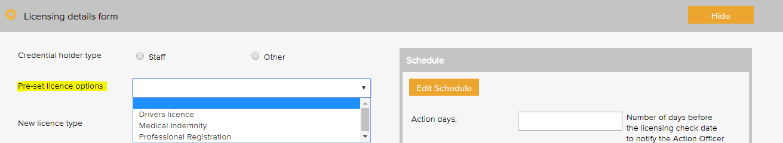

License type – General Examples
APC provider number | Medicare council number
Credentialing requirements | Vaccination requirements
Criminal record check | Vulnerable children check
Driver’s licence - C | Waste handling
Healthcare provider identifier | Work Visa
Medical indemnity

License type – 8164 Examples
New Zealand Resuscitation Council Level 5 or equivalent | Required service provider vaccination

License type – EQuIP6 Examples
APC Provider number | Waste Handling

License type – 8134 Examples
Credentialing of service providers | Practice registration / certificate renewal
Police checks | Privileging of service providers

License type – 8151 Examples
Advanced Cardiac Life Support Level 6 | Advanced cardiopulmonary resuscitation (CPR)
Advanced Cardiac Life Support Level 7 | Advanced Paediatric Life Support (APLS)

License type – RTAC 2017 Examples
Certificate of Reproductive Endocrinology and Infertility (CREI) | Royal Australian and New Zealand College of Obstetricians and Gynaecologists (RANZCOG)
Fellowship of the FRANZCOG | Royal Australian College of Physicians (RACP)
Full membership of the Australian and New Zealand Infertility Counsellors Association (ANZICA) | Specialist gynaecologist
Professional registration

Meeting Register
The select a meeting menu is used when scheduling a meeting in the meeting register. It controls the meetings that users can add to the system. A selection from this list must be made when adding an item to any register.
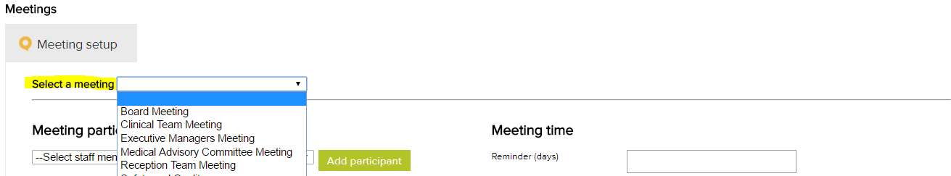

Meeting type - Examples
Clinical and Corporate Governance
Clinical Staff Meeting
Consumer Focus Group Committee
Executive Management Committee
Medical Advisory Committee
Quality and Safety Committee
Staff Meeting - All

Positions
The position menu appears when setting up staff contacts in the contacts register. A single unique position title should be created for every user of the system. If there are multiple positions with the same title, each position should be numbered to remain unique e.g. Receptionist 1, Receptionist 2 etc. Tasks in the system are assigned to positions.
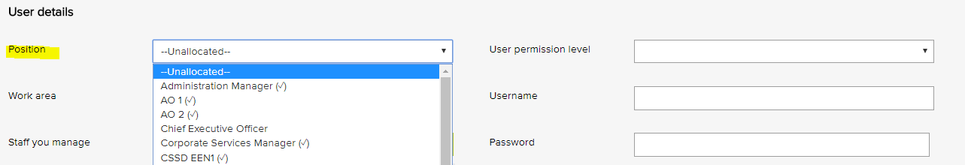

Position titles - Examples
Chief Executive Officer
Clinical Manager
Health and Safety Officer
Quality Manager
Registered Nurse 1
Registered Nurse 2

Records Register
The category menu is used when adding a record to the records register. It allows for the record to be coded to a category. The menu must also be used when adding a record to a task in the system. Reports can be generated based on the selections in this menu.
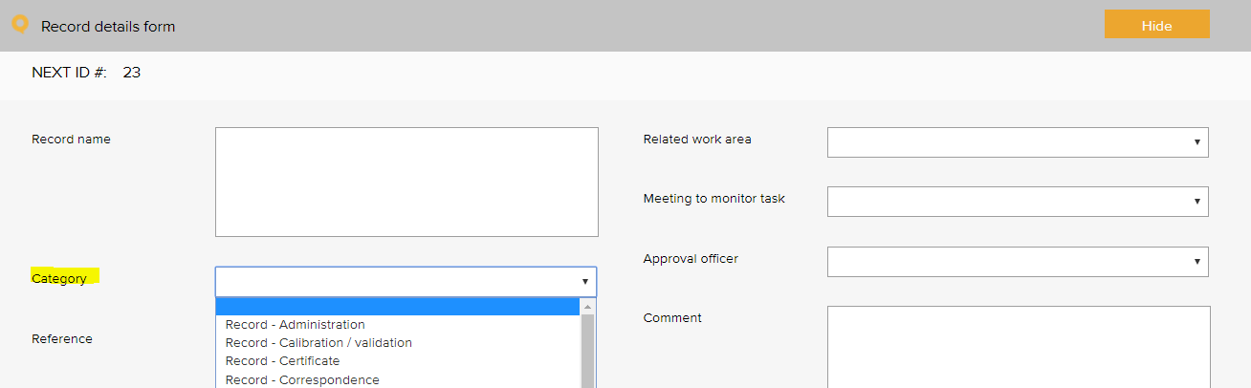

Records category – General Examples
Certificate - education and training | Record - staff immunisation
Certificate - indemnity insurance | Record - staff recruitment
Certificate - laser use licence | Record - staff support
Certificate - professional registration | Record - staff vaccination
Certificate - orientation | Record - task sheet
Certificate - other | Record - tender document
Record - administration | Record - thermostat mixing valve
Record - advertising | Record - training
Record - antimicrobial consumption | Record - waste management
Record - antimicrobial stewardship | Register - assets
Record - audit information requirements / request | Register - education and training attendance
Record - blood and blood products | Register - orientation attendance
Record - calibration / validation | Report - annual report
Record - cleaning | Report - audit
Record - committee papers | Report - benchmarking report
Record - communication to workforce | Report - board
Record - community meeting | Report - budget
Record - community participation | Report - clinical indicator report
Record - consultation | Report - clinician key performance indicators
Record - consumer involvement | Report - clinician's scope of practice
Record - consumer involvement in governance activity | Report - compliance
Record - consumer representation | Report - consumer focus groups
Record - consumer training | Report - data
Record - correspondence - external | Report - data systems and surveillance
Record - correspondence - internal | Report - training evaluation
Record - credentialing | Record – thermostat mixing value
Record - credentialing - insurance authority | Report - equipment maintenance
Record - credentialing - renewal declaration | Report - essential services
Record - data security | Report - evaluation
Record - data validation | Report - external report
Record - discard rates of blood products | Report - falls prevention
Record - email | Report - financial
Record - ethical approval | Report - haemovigilance
Record - feedback to consumers and carers | Report - hospital licensing / reporting
Record - finance | Report - inspection
Record - focus group | Report - legal advice
Record - human resource | Report - maintenance
Record - incident | Report - management
Record - legislation update | Report - medication safety alerts
Record - licence renewal | Report - microbiology
Record - maintenance | Report - mortality review
Record - media release | Report - performance
Record - meeting agenda | Report - progress
Record - meeting member contact details | Report - referee
Record - meeting minutes | Report - research
Record - meetings task sheet | Report - review
Record - memo | Report - review of deaths and cardiac arrests
Record - newsletter | Report - risk assessment
Record - newspaper articles | Report - safety and quality indicators and data
Record - observer’s registration | Report - serious transfusion incident report (stir)
Record - open disclosure | Report - service notification
Record - orientation attendance | Report - staff consultation
Record - patient feedback | Report - staff performance review report
Record - photograph | Report - transfusion
Record - planning | Report - trend
Record - publication | Sign sheet - emergency trolley
Record - quote | Sign sheet - fridge temperatures
Record - related / supporting documentation | Sign sheet - key register
Record - roster | Sign sheet - miscellaneous
Record - safety and quality performance | Sign sheet - oxygen and suction
Record - staff confidentiality | Sign sheet - pathology collection
Record - staff development plan | Sign sheet - visitors log

Records category – EQuIP6 Examples
Record - administration | Record - staff support
Record - advertising | Record - staff vaccination
Record - cleaning | Record - tender document
Record - community participation | Record - training
Record - consultation | Record - waste management
Record - consumer involvement | Report - annual report
Record - data security | Report - audit
Record - data validation | Report - budget
Record - ethical approval | Report - clinical indicator report
Record - license renewal | Report - compliance
Record - maintenance | Report - essential services
Record - media release | Report - evaluation
Record - meeting agenda | Report - inspection
Record - meeting minutes | Report - management
Record - newsletter | Report - performance
Record - orientation attendance | Report - progress
Record - publication | Report - research
Record - roster | Report - review
Record - staff development plan | Report - staff consultation
Record - staff immunisation | Report - staff performance review report

Records category – RTAC 2017 Example
HR - professional registration

Risk Register

Risk Assessment
The risk level and management requirement settings are displayed when rating a risk in the system. Reports can be generated based on the selections in this menu. There are four possible levels of risk in the LOGIQC assessment matrix. Each of these levels can be given a name such as SAC 4, SAC 3, Extreme, High etc. Each risk level can also be given a related ‘management requirement’, eg. rules for how that level of risk should be managed.
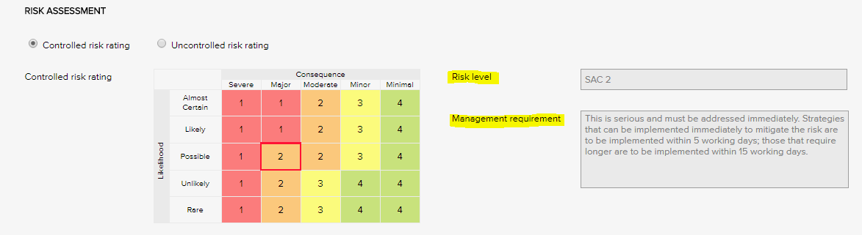
Risk Levels and related Management Requirements - Examples
SAC 1 | This is serious and must be addressed immediately. Strategies that can be implemented immediately to mitigate the risk are to be implemented within same or next working day; those requiring longer are to be implemented within 5 - 10 working days.
SAC 2 | This is serious and must be addressed immediately. Strategies that can be implemented immediately to mitigate the risk are to be implemented within 5 working days; those that require longer are to be implemented within 15 working days.
SAC 3 | Manage by specific monitoring or auditing procedures
SAC 4 | Manage by routine procedures.

Risk Treatment Options
The risk treatment option menu is used when adding a mitigation action to the risk register. It allows for the action to be categorised against a risk treatment strategy.
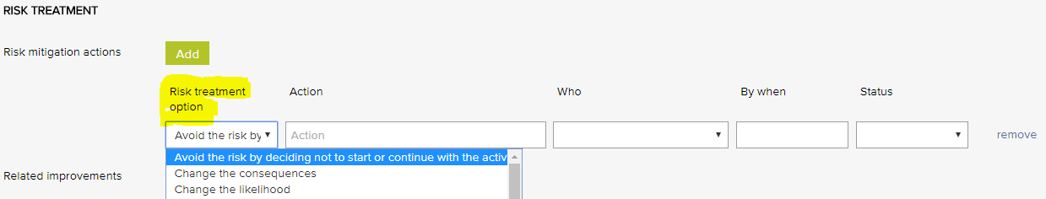

Risk treatment options - Examples
Avoid the risk by deciding not to start or continue with the activity | Isolate the hazard
Take or increase the risk in order to pursue an opportunity | Minimise the hazard
Change the consequences | Remove the risk source
Change the likelihood | Retain the risk by informed decision
Eliminate the hazard | Share the risk with another party or parties

Risk Dimensions
The risk dimension menu is used when adding a risk to the risk register. It allows for the identified risk to be coded to a high level dimension. Reports can be generated based on the selections in this menu.
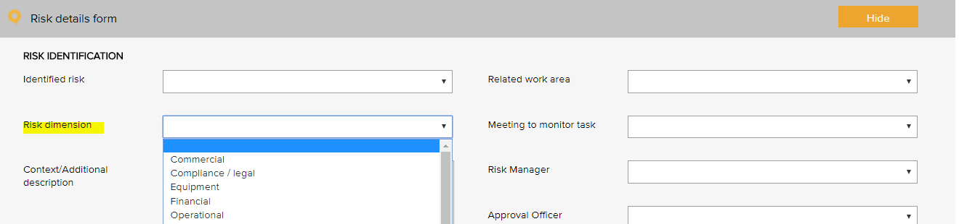
Risk dimensions - Examples
Risk Dimensions | Definition
Commercial | This category includes the risks associated with market placement, business growth, diversification and commercial success. This relates to the commercial viability of a product or service, and extends through establishment to retention and then growth of a customer base.
Compliance / legal | This category includes compliance with legal requirements such as legislation, regulations, standards, codes of practice and contractual requirements. This category also extends to compliance with additional ‘rules’ such as policies, procedures or expectations, which may be set by contracts, customers or the social environment.
Equipment | This extends to the equipment utilised for the operations and conduct of the business. It includes the general operations of the equipment, maintenance, appropriateness, depreciation, safety and upgrade.
Financial | This category includes cash flow, budgetary requirements, tax obligations, creditor and debtor management, remuneration and other general account management concerns.
Organisational | This relates to the internal requirements of a business, extending to the cultural, structural and people issues associated with the effective operation of the business.
Operational | This covers the planning, operational activities, resources (including people) and support required within the operations of a business that result in the successful development and delivery of a product or service.
Project | This includes the management of equipment, finances, resources, technology, timeframes and people associated with the management projects. It extends to internal operational projects, projects relating to business development, and external projects such as those undertaken for patients.
Reputation | This entails the threat to the reputation of the business due to the conduct of the entity as a whole, the viability of product or service, or the conduct of employees or other individuals associated with the business.
Safety | This category includes the safety of everyone associated with the business. This extends from individual safety, to workplace safety, public safety and to the safety and appropriateness of products or services delivered by the business.
Security | This includes the overall security of the business premises, assets and people, and extends to security of information, intellectual property, and technology.
Service delivery | This relates to the delivery of services, including the quality and appropriateness of service provided, or the manner in which a product is delivered, including customer interaction and after-sales service.
Stakeholder management | This category relates to the management of stakeholders, and includes identifying, establishing and maintaining an appropriate relationship. This includes both internal and external stakeholders.
Strategic | This includes the planning, scoping and resourcing requirements for the establishment, sustaining and/or growth of the business.
Technology | This includes the implementation, management, maintenance and upgrades associated with technology. This extends to recognising the need for and the cost benefit associated with technology as part of a business development strategy.

Risk Category and Risk Name
The identified risk menu is used when adding a risk to the risk register. It presents a list of risks that can be added to the risk register. Reports can be generated based on the selections in this menu.
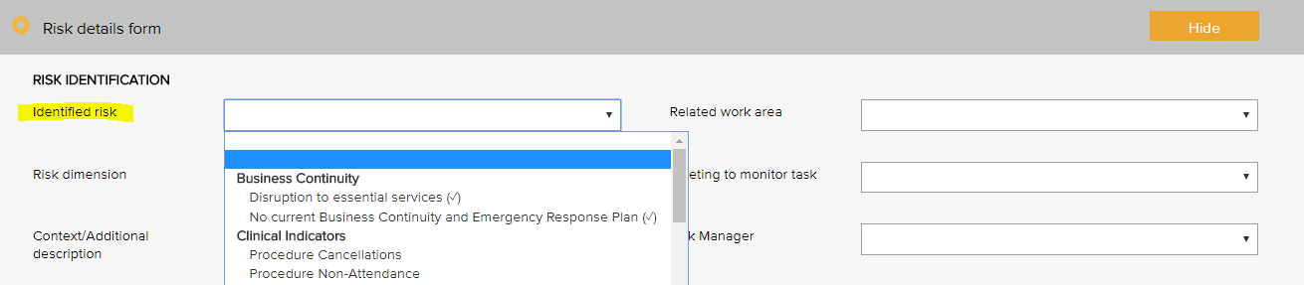

Risk Category | Risk Name
Business continuity | Disruption to essential services
 | Workforce sustainability
Collaborative partnerships | Breakdown in relationship with suppliers / stakeholders
Patient safety | Clinical incident
 | Cold chain breach
 | Currency of professional registration / credentialing
 | Currency of staff immunisation
 | Falls prevention and harm minimisation
 | Infection control breach
 | Medication mismanagement
 | Non-compliance with clinical procedures / standards
 | Patient complaint
 | Patient safety
Financial | Cash / fund management shortfall
 | Competitors
 | Financial literacy
 | Non-compliance with financial management procedures
 | Over-reliance on a small number of customers / suppliers
Human resource / personnel | Cross cultural conflict
Human resource / personnel | Industrial action
Human resource / personnel | Lack / insufficient skills, training to complete job duties
Human resource / personnel | Non-compliance with HR procedures
Human resource / personnel | Over-reliance on a small number of staff or key staff
Human resource / personnel | Problems with outside contractors
Inventory | Inventory mismanagement
Legal | Legislative / regulatory / contractual breach
Management | Assets mismanagement
 | Equipment mismanagement
 | Hazard mismanagement
 | Health and safety mismanagement
 | Information mismanagement
 | Patient transport mismanagement
 | Project goals and objectives not met
 | Property mismanagement
 | Vehicle mismanagement
Operations and assets | Non-compliance with operational procedures
 | Planning and scheduling conflicts
Policy and political | Changes in government
 | Organisational culture not aligned to organisational values
 | Legislative risk
Reputation and image | Adverse media coverage
 | Loss or injury to reputation
 | Reduction or loss of community connectedness
Security | Security breach
Student / registrar placement | Non-compliance with student / registrar placement procedures
Technological | Breach of data security and backup
 | Failure of IT hardware and network management
 | Loss of productivity due to staff IT competencies
 | Not maximising the potential benefits of digital technologies

Linkages between the Risk Module and the Feedback and Incident Registers
When the Risk Module is activated in the LOGIQC QMS, incident types and feedback categories can be linked to one or more identified risks. When an incident or feedback that is linked to a risk is reported, it will inherit the risk rating assigned to the risk that it is linked to. Where an incident type or feedback category has been linked to multiple risks, it will be assigned the risk that has the highest risk rating amongst those risks that it has been linked to. In the event that there is more than one risk at the highest risk rating, LOGIQC will assign the risk in alphabetical order from those at the highest level.

Additional Risk Categories
The Standards referred to the following risks, however, they have not been added to example risks which have been setup in your system, as some may be similar to those that have already been added, or they have been added as “incident” types which are linked to risks. Refer to the Table above, for a list of the Risk Categories and Risk Names that have been added to your system. And refer to the Incident type examples provided in an earlier Table. If you would like to add those additional risks, you can either replace those that have already been setup in your system or add as a new risk. You also have the option, of adding these as an “Incident Type” and then linking the incident type to an identified risk.

Additional Risk Categories - RTAC 2017 Examples
Donation of gametes or embryos
Emergency equipment and supply management
Statutory storage periods
Infection prevention and control
Infection risks between donors of reproductive tissues and recipients or surrogate
Record keeping
Reporting requirements
Surrogacy

Additional Identified Risks – 8134 Examples
Business continuity and recovery planning
Contractual
HRM and recruitment
Information management
Legal compliance
Natural disaster and emergency (internal and external)
OHS
Service environment

Additional Identified Risks – 8134 Examples - Reducing the risk of potential harm occurring to consumers as a result of:
Ability to perform activities of daily living
Clinical risk
Cultural values and beliefs not being met
Current health or disability status
Disturbing behaviour
Exit, discharge and transfer
Exposure to infection
Harm by / to others
Impaired capacity to make decisions
Mortality data
Outdated calibration of equipment
Support and/or diagnostic treatment regimes

Additional Identified Risks – 8134 Examples - Minimalizing the potential harm to occur through:
Informed consent
Multidisciplinary team input
Providing relevant information to family / whanau
Specific risk assessment tools

Site Information
The site information settings controls certain automatic behaviours such as the number of days allowed to respond to a task and the frequency of sending automatic reminders.

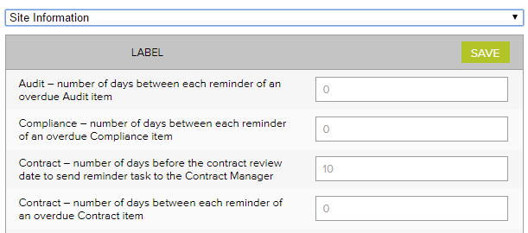
Site information - Examples
Label | No of days
Accreditation - number of days between each reminder of an open accreditation plan action | 14
Accreditation - number of days between each reminder of an overdue Accreditation item | 14
Accreditation - number of days the Approval Officer and the Quality Manager has to complete their tasks | 60
Audit - number of days between each reminder of an overdue audit item | 7
Compliance - number of days between each reminder of an overdue Compliance item | 7
Contract - number of days before the contract review date to send reminder task to the Contract manager | 14
Contract - number of days between each reminder of an overdue Contract item | 7
Contract - number of days the Approval Officer and the Contracts manager has to complete their tasks | 14
Document - number of days before the document review date to send reminder task to the Approval officer | 14
Document - number of days between each reminder of an overdue document item | 7
Document - number of days the Approval Officer has to complete the Approval task | 14
Feedback - number of days between each reminder of an overdue Feedback item | 3
Feedback - number of days the Approval Officer has to complete the Approve for Action task | 3
Improvement - number of days between each reminder of an overdue Improvement item | 14
Improvement - number of days the Approval Officer has to complete the Approve for Action task | 30
Incident - number of days between each reminder of an overdue Incident item | 3
Incident - number of days the Approval Officer has to complete the Approve for Action task | 3
Licensing - number of days between each reminder of an overdue licensing item | 3
Record - number of days between each reminder of an overdue Record item | 14
Repair - number of days between each reminder of an overdue Repair item | 7
Repair - number of days the Approval Officer has to complete the Approve for Action task | 3
Risk - number of days between each reminder of an open mitigation item | 14
Risk - number of days between each reminder of an overdue Risk item | 7
Risk - number of days the Approval Officer and the Risk Manager has to complete their tasks | 60
Supplier - number of days before the supplier review date to send reminder task to the Approval officer | 14
Supplier - number of days between each reminder of an overdue Supplier item | 7
Supplier - number of days the Approval Officer has to complete the Approval task | 14
Training - number of days between each reminder of an overdue Training item | 7

Suppliers Register
The Assessment criteria menu is displayed as checkboxes when adding and reviewing a supplier in the supplier register. It controls the criteria used for assessing suppliers.
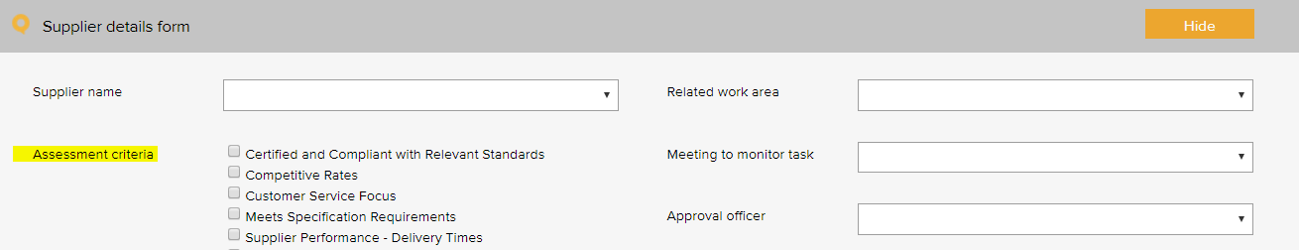

Supplier assessment criteria – General Examples
Certified and compliant with relevant standards
Competitive rates
Customer service focus
Meets specification requirements
NZBN verified
Supplier performance - delivery times
Supplier performance - processing of orders
Supplier performance - returns and back orders
Supplier performance - engagement
Supplier performance - value adding

Supplier assessment criteria – RTAC 2017 Examples
Registered the NHMRC Australian Human Ethics Committee or New Zealand equivalent

System Settings

Disable auto timeout
The default settings in your LOGIQC QMS are set to disable auto timeout. This means that once logged in, your session will remain open for 12 hours before ‘timing out’ and requiring you to log in again. If you want to decrease this time to 70 minutes, simply un-check the setting.



Training Register
The pre-set training options menu is used when scheduling a training task in the training register. It allows for the task to be coded to a category. Reports can be generated based on the selections in this menu.
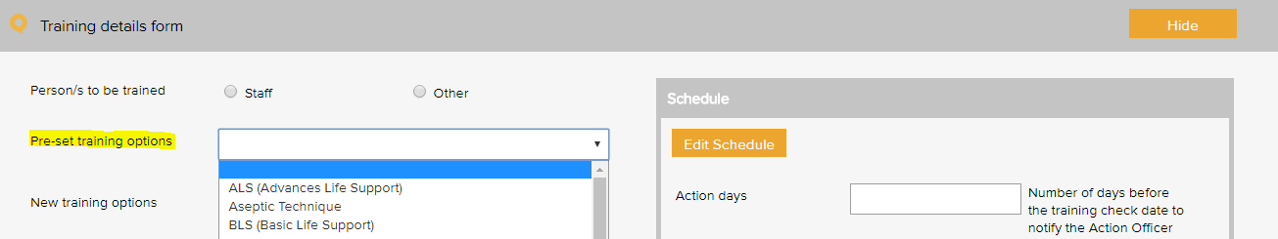

Training type – General Examples
ALS (Advanced Life Support) | ICT and appropriate use of personal devices
BLS (Basic Life Support) | Incident management and reporting
Budget management | Information management
Bullying and harassment | Informed consent
Charter of Consumer / Patient Rights and Responsibilities | Manual handling
Code of conduct | Open disclosure
Competency assessment | Orientation
Complaints Handling | Patient privacy and confidentiality
Conflict Resolution | Position responsibilities
Continuous Improvement | Quality management system training
Corporate Records Management | Recruitment and selection
CPR training | Risk management
Cultural awareness | Safe food handling
Emergency procedures | Security and access
Fire training | Staff rights and responsibilities
Grievance resolution and/or behavioural management | Use of email and information technology
Hand Hygiene | Violent incident response
Hazard reporting | Waste handling
Health Records Management | Waste stream management
Human resource management | WHS
Induction

Additional occupation specific training
Advanced care directives | Investigating clinical incidents
Adverse drug reaction documentation and reporting | Medication authorisation system
Antimicrobial stewardship | Medication management system
Aseptic technique | Medication safety on-line training modules
Blood and blood products - adverse reactions | Patient identification and management protocols
Blood management | Personal protective equipment
Clinical Deterioration | Prescription and clinical administration of blood and risk assessment
Clinical Protocols | Pressure injury prevention and management
Clinical services, procedures and technologies | Pressure injury reporting systems
Complaints management system | Protocols for clinical handover
Decontamination of reusable instruments and devices | Safety and quality - general
Disposal of unused, unwanted or expired medications | Safety and quality - patient care
Escalating care | Skin Integrity
Falls prevention and management | Standard precautions
Identification and matching procedures | Transmission-based precautions
Identification of at-risk patients | Use of invasive devices
Individual performance review | Workforce orientation
Infection prevention and control

Training type – 8164 Examples
As required by the Health Practitioners Competence Assurance Act | New Zealand Resuscitation Council Level 5 or equivalent
Blood and body fluid exposure management | Practice in relation to single-use items
Cleaning, disinfection and sterilization practices | Prudent antimicrobial prescribing
Code of Health and Disability Services Consumers' Rights (the Code) | Standard precautions
Cultural Safety | Surveillance and outbreak management
Hand hygiene and cough etiquette | Transmission based precautions
Management of waste and hazardous substances | Treaty of Waitangi
Medication management

Training type – EQuIP6 Examples
Blood management | ICT and appropriate use of personal devices
Charter of Consumer / Patient Rights and Responsibilities | Incident management and reporting
Protocols for clinical handover | Information Management
Clinical Deterioration | Informed Consent
Clinical Protocols | Open Disclosure
Competency assessments | Orientation
Complaints Handling | Position responsibilities
Conflict Resolution | Recruitment and Selection
Continuous Improvement | Risk management
Corporate Records Management | Safe food handling
Identification and matching procedures | Skin integrity
CPR training | Staff Rights and Responsibilities
Cultural Awareness | Open Disclosure
Fire training | Violent Incident Response
Grievance resolution and/or behavioural management | Waste Handling
Hand Hygiene | Waste Stream Management
Health Records Management

Training type – 8134 Examples
Driver safety | Management of waste and hazardous substances

Training type – RTAC 2017 Examples
ART treatment requirements | Hand hygiene
CME points | Staff induction
Continuing education

Work Areas
This list appears when adding an item to any register. It is the list of functional work areas in the organisation (eg HR Administration, Clinic, Programs, etc) that tasks and issues can be assigned to. All Registers allow for sorting, filtering and printing of reports based on “work areas”.
Work area - Examples
Primary work area | Secondary work area
Corporate services | Administration
 | Finance
 | Human Resource
 | Infection prevention and control
 | Information Communications Technology
 | Marketing and promotion
 | Quality and risk
 | Work health and safety
Governance | Board
 | Clinical governance
 | Corporate governance
 | Management
Infrastructure and facilities | Building
 | Car park
 | Equipment
 | Grounds
 | Lifts
 | Property
 | Security
Patient services | Pre-admission
Patient services | Admission
Patient services | CSSD
 | Discharge
 | Operative
 | Pre-operative
 | Recovery
Environmental services | Cleaning
 | Laundry
 | Medical gases
 | Medical plumbing
 | Waste
 | Water

WHO Conceptual Framework for the International Classification for Patient Safety Version 1.1 Final Technical Report January 2009
International Classification for Patient Safety Statement of Purpose - http://www.who.int/patientsafety/taxonomy/ICPS_Statement_of_Purpose.pdf
There are 3 types of events that need separate reports: Cold chain breach: an event which has led to the vaccines being stored or transported in temperatures outside the required +2˚C to +8˚C range, but the potency/stability of the vaccines has not been compromised. Cold chain excursion: an event which has led to the vaccines being stored or transported in temperatures outside the required +2⁰C to +8⁰C range and as a result, vaccines are compromised and need to be returned for destruction. Cold chain failure: an event in which vaccines involved in a cold chain excursion are administered to patients
Risk management guide for small business, NSW Department of State and Regional Development, www.smallbiz.nsw.gov.au

