LOGIQC BUILD INSTRUCTIONS

This workbook supports the build of the LOGIQC Quality Management System

Contents
Introduction 4
LOGIQC implementation process 4
LOGIQC implementation support resources 4
Checklist for completing the LOGIQC Build process 5
Customise the system 6
System settings 6
Add system users 7
How to add a system user 7
Add business contacts 9
Business contacts 9
How to add a business contact 9
Schedule meetings 11
Meetings register 11
How to schedule meetings 11
Add documents 13
Document register 13
Workflow 13
How to add a document 13
Add suppliers 15
Supplier register 15
Workflow 15
How to add a supplier 15
Add contracts 17
Contracts register 17
Workflow 17
How to add a contract 17
Schedule audits 20
Audit register 20
Workflow 20
How to schedule an audit 20
Schedule compliance requirements 23
Compliance register 23
Workflow 23
How to schedule compliance task 24
Schedule license checks 26
License register 26
Workflow 26
How to schedule license checks 26
Schedule training tasks 29
Training register 29
Workflow 29
How to schedule training tasks 29
Add records 32
Records register 32
Workflow 32
How to add a record 32

Introduction
This workbook is designed as a step-by-step guide to the set-up of the LOGIQC Quality Management System (QMS).
This workbook focusses on the ‘build’ of your system and complements the additional training resources available on the LOGIQC helpdesk.
Once the LOGIQC Build phase is completed, you will progress on to the LOGIQC Train resources.

LOGIQC implementation process
LOGIQC implementation comprises two main phases – LOGIQC Build and LOGIQC Train.
LOGIQC Build involves setting up the core parts of the system required for staff to start using the system. LOGIQC Train involves general user training and accessing and using the system.
LOGIQC BUILD |  | LOGIQC TRAIN
GO LIVE

LOGIQC implementation support resources
The LOGIQC helpdesk includes a range of help articles and instructional videos. Go to http://support.logiqc.com.au to search for the available support resources or lodge a support ticket with our helpdesk staff.

Checklist for completing the LOGIQC Build process
Step |  |  |  | Actions | Status
One | Customise the system  (refer to LOGIQC Set-up Guide) | Review system settings and customise the drop-down menus to suit the organisation |  |  | ☐
o | Add and upload items to LOGIQC | Add system users  Add business contacts  Schedule meetings  Review document footer format and add documents  Add suppliers  Add contracts |  |  | ☐  ☐  ☐  ☐  ☐  ☐
Three | Schedule tasks in LOGIQC | Schedule audit tasks  Schedule compliance tasks  Schedule licensing requirements  Schedule mandatory training items  Add records relating to quality, safety, and risk |  |  | ☐  ☐  ☐  ☐  ☐
Four | Review and customise the reporting registers  (refer to LOGIQC Set-up Guide) | Review incident primary and secondary incident options  Review feedback type, feedback source and feedback categories  Review improvement source options  Develop reporting pathways for use in LOGIQC |  |  | ☐  ☐  ☐  ☐
Five | Build the risk register and accreditation register  (refer to Risk and Accreditation Build Workbooks) | Review risk setup menu options, add risks and hazards and link related items  Review accreditation standard details forms and link related items |  |  | ☐  ☐
OGIQC Train workbook
Six | User training  (refer to LOGIQC Train Workbook) | Learn how to suggest improvements and non-conformances  Learn how to find and manage contacts, documents, and records.  Learn how to complete audit and compliance tasks and action licensing tasks. |  |  | ☐  ☐  ☐
GO LIVE | Promote system across the organisation | Advise all staff that as of the go-live date documents are to be found on the LOGIQC QMS. |  |  | ☐

Customise the system

System settings
The system settings allow the administrator to customise the LOGIQC QMS to suit your organisation. Only the Administrator can access the System settings menu.
Each of the drop-down menu’s should be updated to suit your organisation prior to using the system. Refer to the setup guide for instructions on how to update the system setting options and suggested examples of drop-down menus developed.
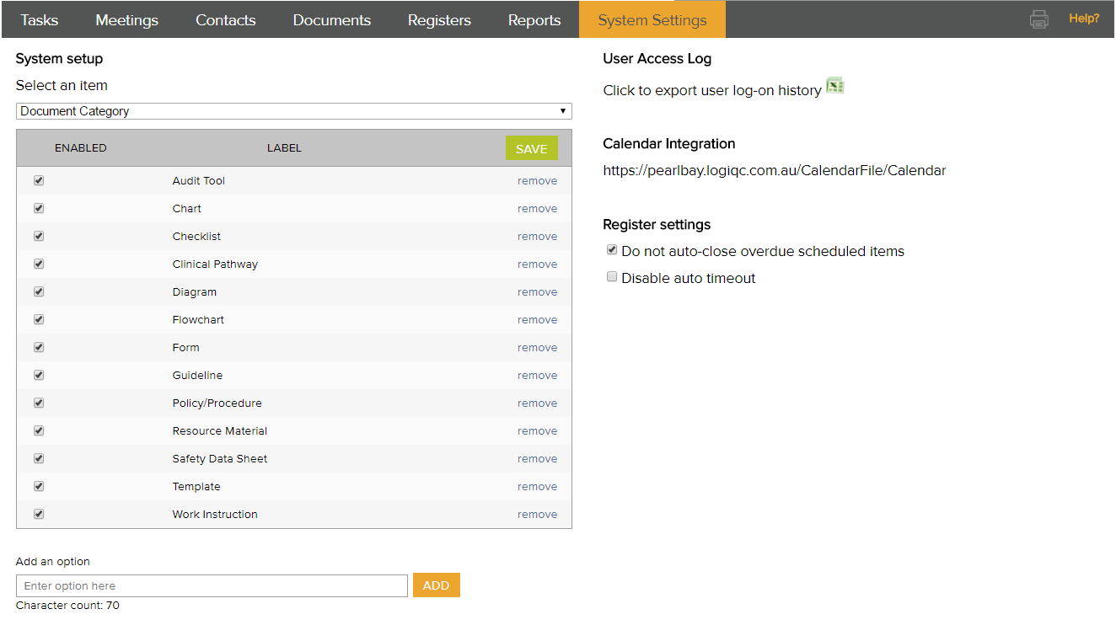

Add system users
User profiles are required so that users can log into LOGIQC. The staff contacts tab displays all system users who can access the system. Note: people must be entered as staff contacts to be able to log into the system.
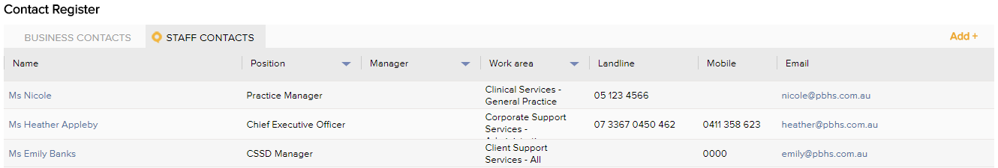

A system user is always displayed with their name and position title. Position titles must be unique even if there are multiple positions with the same title. This is because tasks in LOGIQC are assigned to the position, not the person. When creating multiple positions of the same name, make them unique eg Nurse 1, Nurse 2 etc. To setup the position title menu refer to the system setup guide for examples and instructions.

How to add a system user

- Log in as administrator
- Click on contacts and click add
- Select the staff option in the contact type menu

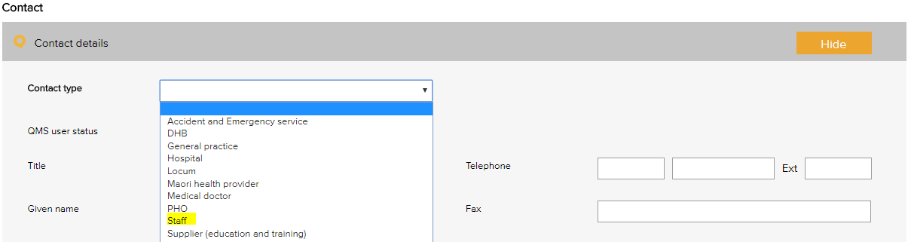
- Complete the contacts details form referring to the instructions for each field below:
 | Select active to enable the user to log in. When a user leaves the organisation, their status should be set to inactive.
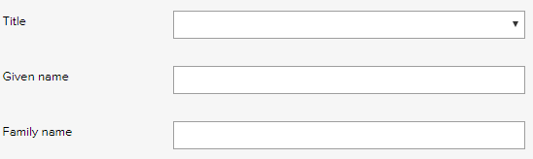 | Select the person’s preferred title and enter their family and given name.
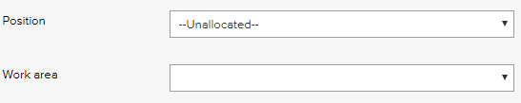 | Select the position title of the staff member. A user must have a position to receive tasks.  Select the work area and position relevant to the person.
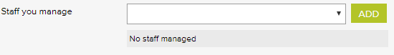 | Select the name of each staff member who reports to this position and click add.
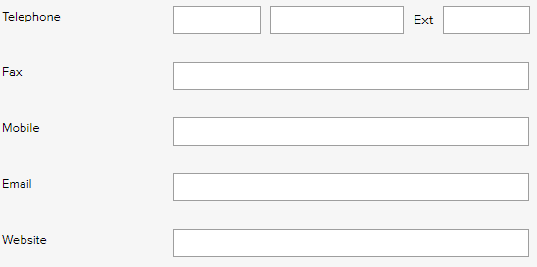 | Enter the contact details for the staff member. All users can see these details. Required fields are:  Telephone OR mobile number  Email
 | Specify the user’s system permissions. (see appendix or search on permissions in helpdesk)
 | Enter a username for logging on to the system eg firstname.lastname. It may be useful to use the same naming convention as the user network login account.
 | Enter the user password for logging in. Each user can reset their own password by clicking My profile after logging in. Tip: Passwords are case sensitive.
- Click Save.

Add business contacts

Business contacts
The business contacts tab displays corporate contacts, contractors, suppliers and stakeholders. When adding these contacts, you will select a category from the contact type menu.
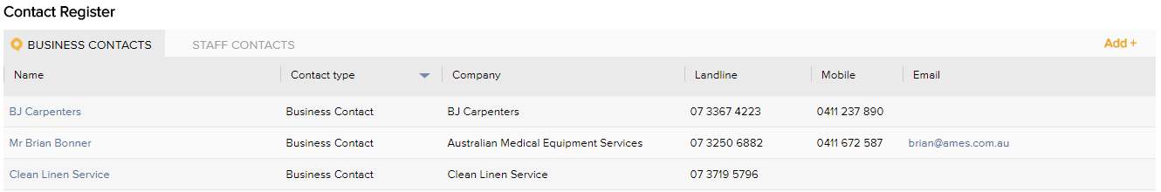
This list of contacts can be a useful central phone directory for all users to access. Note: If the contracts or supplier registers are activated in your system, the relevant parties must be entered as business contacts.

How to add a business contact

- Log in as yourself (your permission level must be creator or higher to add business contacts)
- Click on contacts and click add
- Select the relevant option in the contact type menu
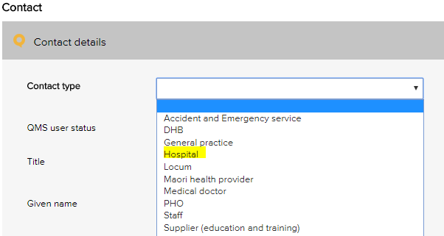
- Complete the relevant fields on the information form and click save. Tip: Not all fields have to be completed. To see which fields are required, click save before entering any data.
 | Select active to see the contact in the system.
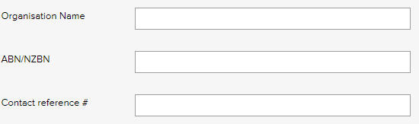 | Enter the organisation name. If the contact is not a company, simply enter their full name in this field.
 | These fields are optional. The ABN/NZBN is the business number of the company. The contact reference field could hold a doctor’s provider number for example.
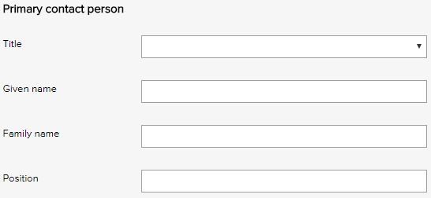 | Enter the details of the organisational contact. These fields are optional
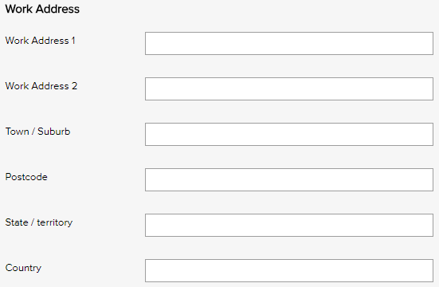 | Enter the contact’s physical address.
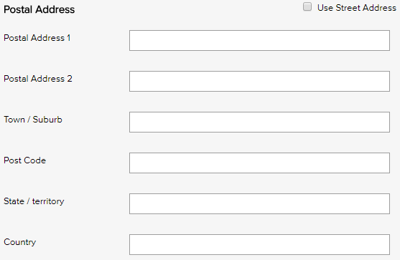 | Enter the contact’s postal address. Use the checkbox to automatically complete these fields if the postal address is the same as the work address.
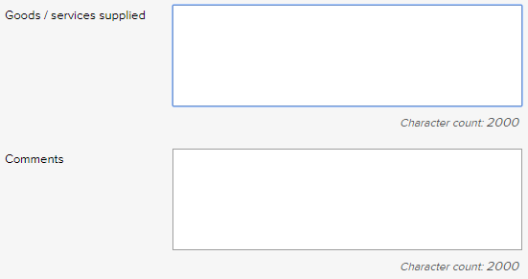 | These fields are optional. If the contact is a supplier, we recommend that you briefly describe the goods or services purchased from them because this information will display in the suppliers register. For example, ‘Provides medical consumables’.
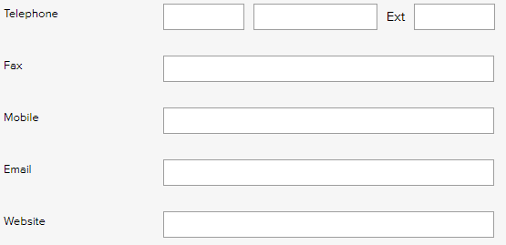 | Complete the contact details for the contact.

Schedule meetings

Meetings register
Meetings are recurring team meetings whose accountabilities include monitoring the status of actions in LOGIQC. The meetings register sends email and task reminders to participants to attend team meetings and provides a report that is automatically populated with all tasks and issues that have been reported in LOGIQC and assigned to the meeting.
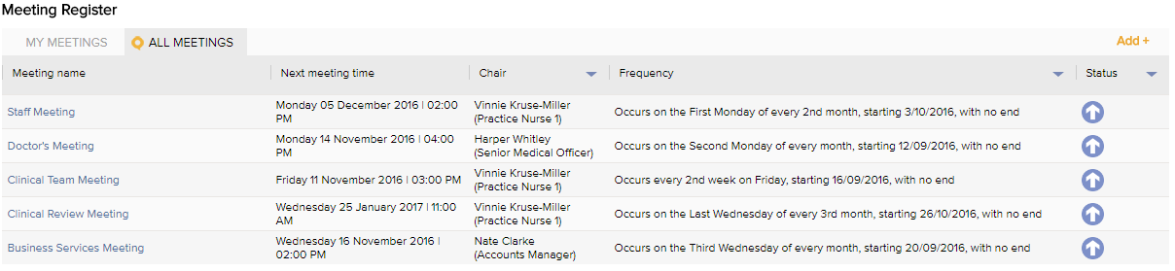
A selection from this list must be made when adding an item to any register. This allows you to automatically generate an agenda in LOGIQC that lists only the items relevant to a particular work group or team. To schedule a meeting in LOGIQC, the meeting name must be entered as a menu option in system setup (refer to setup guide).

How to schedule meetings
- Click on meetings and click add (all users with permission levels of creator of higher can schedule meetings).
- Complete the required fields.
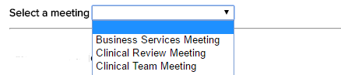 |  | Use the select a meeting menu to select a meeting from the list (Meeting options are set by the administrator in system setup).
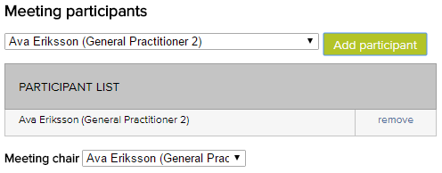 |  | Select a meeting participant and click add participant. Only system users can be participants in meetings.  Select the chair of the meeting from the meeting chair list.
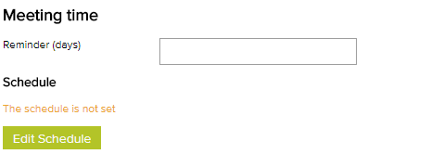 |  | In the reminder (days) field set how many days prior to the meeting the participants should receive a task and email reminder to attend the meeting.
 |  | Click edit schedule and complete the fields to program the meeting time and recurrence pattern
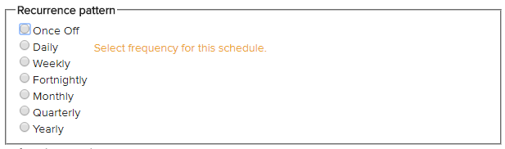 |  | Select the frequency of the meeting. Tip - to program a six-monthly meeting select monthly and then specify every 6 months.
 |  | This is the start time of the meeting. Eg. for a 1pm meeting enter either 1:00pm or the 24-hour format 13:00
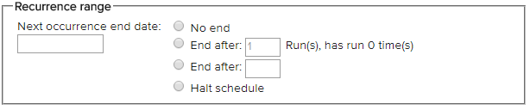 | The next occurrence end date is the date of the next meeting.  No end means LOGIQC will continue to generate meetings until halted  End after (x) runs means meetings will stop being generated after the specified number of meetings have occurred  End after (date) means meetings will stop being generated after the specified date  Halt schedule: This should be selected when you want to terminate an existing meeting. It means that no further meetings will be generated after the current one is completed.
- Click OK and save.

Add documents

Document register
The document register is a central library of key documents that have been approved for use in the organisation, such as policies, procedures, templates and forms.
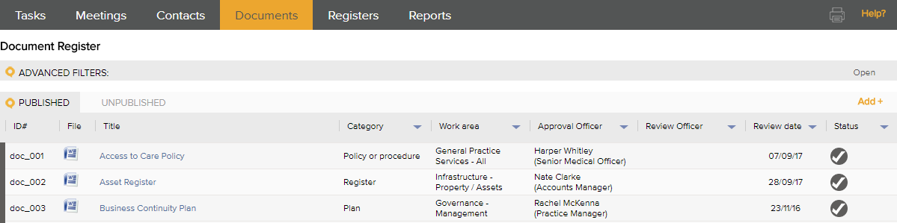

Workflow
The LOGIQC workflow dictates how and when a document moves from person to person once a document is added to the system.
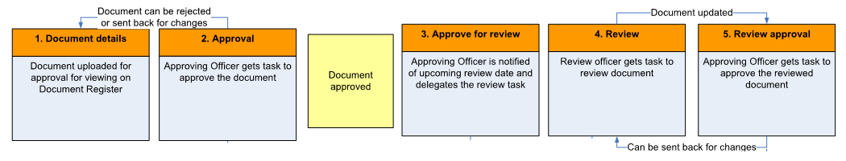

How to add a document
- Log-in under your own user profile.
- Click on documents.
- Click add.
- Complete the required fields.
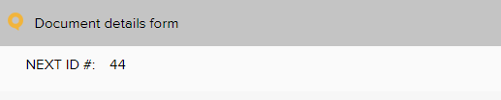 | The document ID# is system generated. It shows the document number that QC will assign to the document. This number should also be added to the footer of the document to ensure good document control when a document is printed out.
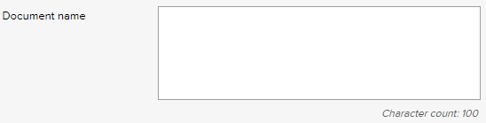 | Enter a brief title for the document. This is the title that staff will see on the register so the title should be short and descriptive
 | Select the most relevant category for the document. The options can be controlled by your System Administrator.
 | Enter the standard criterion number relating to the document. This will allow for documents to be found based on the clause number in the standard by using the keyword search function.
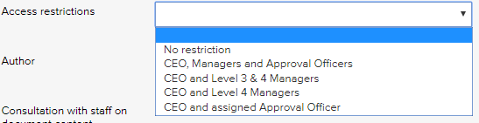 | Selecting a restriction level will mean that only users with those permission levels can see the record.  To see the permission levels assigned to users, go to contacts/staff contacts and click export.
 | We recommend the name of the authoring organisation is entered eg. name of your practice.
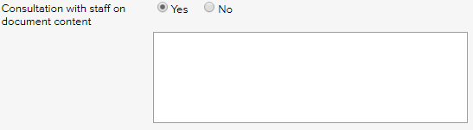 | Select yes, if applicable, and note brief details of any consultation with relevant staff.
 | Enter a date for when the document should be reviewed. As a rule of thumb documents that are critical, used often and tend to change should be reviewed at least every six months. Documents that don’t tend to change often could be reviewed at 12 or 24 month intervals.
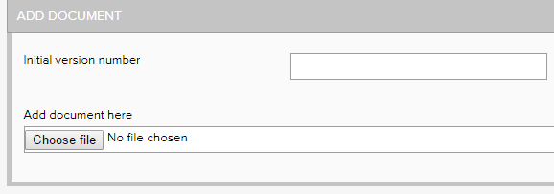 | Enter the current version number of the document. This number will be automatically incremented when new versions are approved and cannot be changed. The field only accepts a single numeral eg. 1  Click the browse/choose button and select and upload the document to LOGIQC.
 | Select the work area of your organisation that the document most relates to. The options can be controlled by your System Administrator.
 | Select the staff team responsible for monitoring the review of the document.
 | Select the staff member to approve the document. Only people with the relevant system permissions levels are able to approve documents.
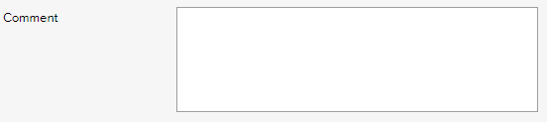 | Enter any comment relevant to this document. This field is optional.
- Click save.

Add suppliers

Supplier register
The supplier register is a central library of critical suppliers that have been approved for use in the organisation.
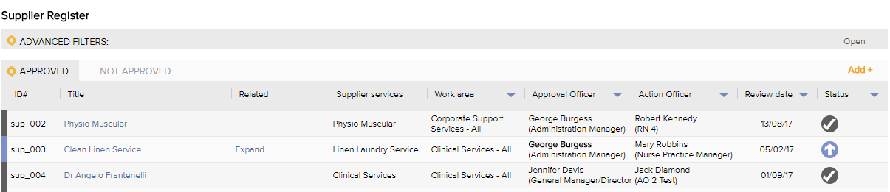

Workflow
The LOGIQC workflow dictates how and when a supplier moves from person to person once a supplier is added to the system.
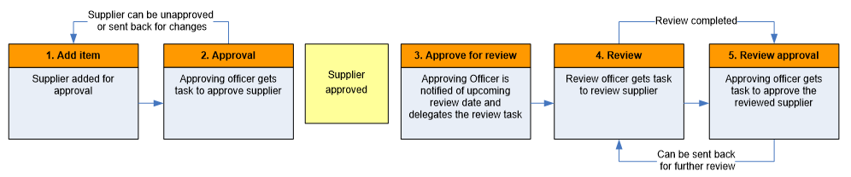

How to add a supplier
- Click on suppliers.
- Click add.
- Complete the required fields.
 | Select the supplier name to add to the supplier register. Note: This drop-down menu is pre-populated by the contacts entered in the contact register.
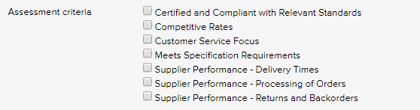 | Select the box where a supplier meets the criterion. These criteria are set in the system setup module by the system administrator.
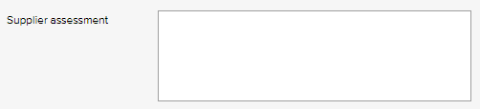 | Provide a summary of the assessment done on the supplier.
 | Enter a date for when the supplier should be reviewed and reassessed.
 | Select the work area of your organisation that the supplier most relates to. The options can be controlled by your System Administrator.
 | Select the staff team responsible for monitoring the review of the supplier.
 | Select the staff member to approve the supplier. Only people with the relevant system permissions levels can approve suppliers.
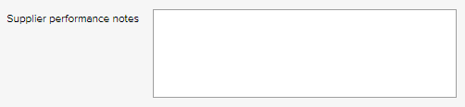 | Enter any anecdotal comments over the course of time about the supplier. Where the supplier has been in breach a formal non-conformance report should be raised by creating a related improvement. This field is optional.
- Click save.

Add contracts

Contracts register
The contracts register is a central library for contracts and agreements such as funding agreements and contracts with subcontractors. Compliance tasks, such as reports, can also be created and linked to the contract.
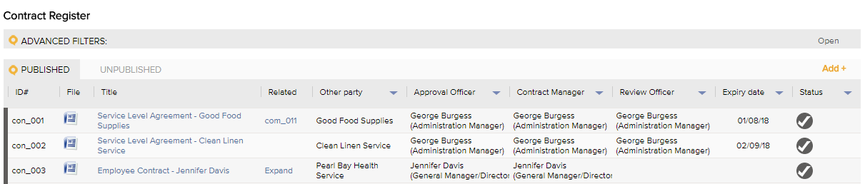

Workflow
The LOGIQC workflow dictates how and when a contract moves from person to person once a contract is added to the system.
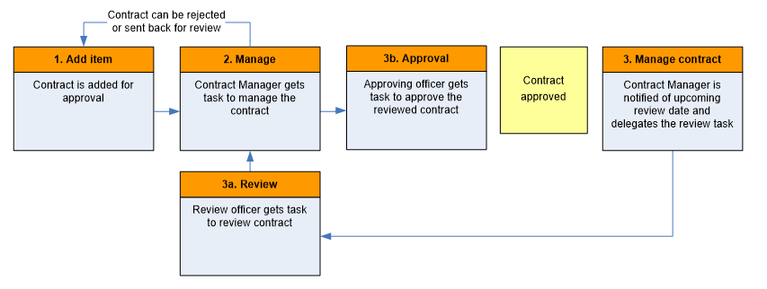

How to add a contract
- Click on contracts.
- Click add.
- Complete the required fields.
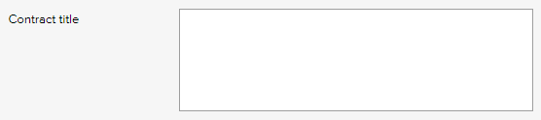 | Enter a brief title for the contract. This is the title that staff will see on the register so the title should be short and descriptive.
 | Enter internal contract number/ID (LOGIQC will also allocate a Contract ID#)
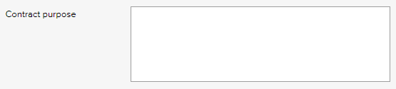 | Enter a brief description of what the contract is for.
 | Select the most relevant category for the contract.
 | This field can be used for a reference number relating to the contract.
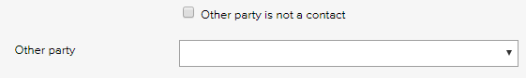 | Select the other party to the contract from the Contacts register or click the box enter the other party.
 | Enter the total value of the contract
Selecting a restriction level will mean that only users with those permission levels can see the contract.
To see the permission levels assigned to users, go to contacts/staff contacts and click export.
 | We recommend the name of the authoring organisation is entered eg. name of your practice.
 | Enter the date the contract commenced.
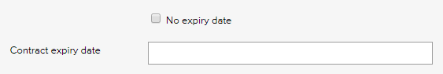 | Enter the date the contract will expire. If the contract does not have an expiry date, click the box.
 | Enter the date the contract should be reviewed. LOGIQC will automatically notify the Contract Manager that the contract is approaching expiry, (reminder days can be set in System Setup).
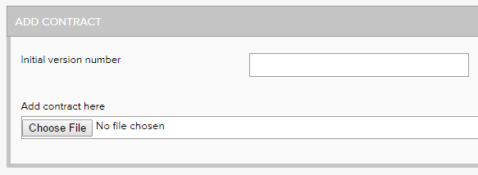 | Enter the current version number of the contract. This number will be automatically incremented when new versions are approved and cannot be changed. The field only accepts a single numeral eg. 1  Click the browse/choose button and select and upload the contract to LOGIQC.
 | Select the work area of your organisation that the contract most relates to. The options can be controlled by your System Administrator.
 | Select the staff team responsible for monitoring the review of the contract.
 | Select the staff member to manage the contract. Only people with the relevant system permissions are able to approve contracts.
 | Select the staff member to approve the contract. Only people with the relevant system permissions are able to approve contracts.
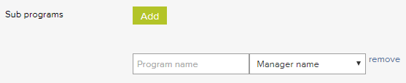 | Click the Add button to list sub programs to the contract. Enter the program name and select a manager from the drop-down list. You can add multiple sub programs by clicking the add button again. This field is optional.
 | Enter any comment relevant to this document that would be useful for the system to record. This field is optional.
- Click save.

Schedule audits

Audit register
The audit register is a schedule of internal and external audits, checks/surveys or evaluations that generates reminders to carry out audits, provides access to instructions on how to complete audits and allows for the audit results to be captured.
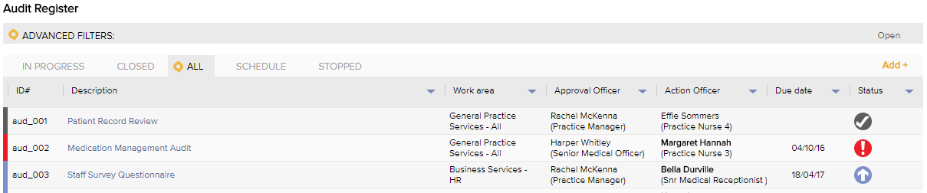

Workflow
The LOGIQC workflow dictates how and when an audit moves from person to person once an audit has been scheduled in the system.
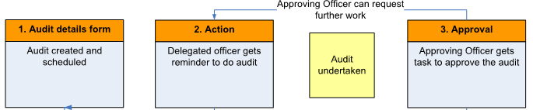

How to schedule an audit
- Click on registers and select audit.
- Click add.
- Complete the required fields.
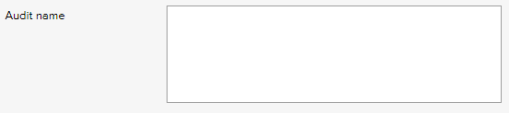 | Enter the title of the audit.
 | Select the type of audit to be conducted. Examples of performance audits include: program or service delivery evaluations and the effectiveness of improvements. Examples of compliance audits include: WHS audit or internal financial controls audit.
 | Select if the audit is being conducted internally (by staff) or by an external entity.
 | If the audit tool has been uploaded as a template to the document register, select the document from this list. A hyperlink to the audit tool will then be provided on the action form for with the task to carry out the audit.
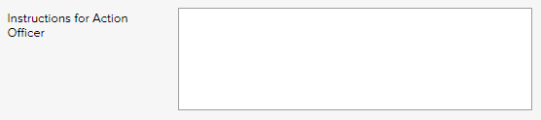 | Enter the instructions for the action officer relating to how to carry out the audit. It is recommended that the instructions include: 1) details of how the audit should be conducted; 2) requirement to upload the audit report to the Quality Records register; and 3) create related improvements using the Related item feature.
 | Select the staff member to carry out the audit. This can be yourself.
 | Select the staff member who has the authority to approve the audit once complete. Only people with approving officer system permission levels are able to approve items.
 | Select the work area that the audit most relates to.
 | Select the staff team responsible for monitoring the audit.
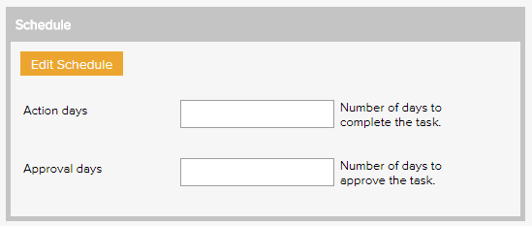 | Enter the number of days the action officer will need to conduct the audit. This will determine how many days before the deadline the action officer will receive the task reminder.  Enter the number of days the Approving Officer needs to check that the audit has been completed satisfactorily.  Click on edit schedule.
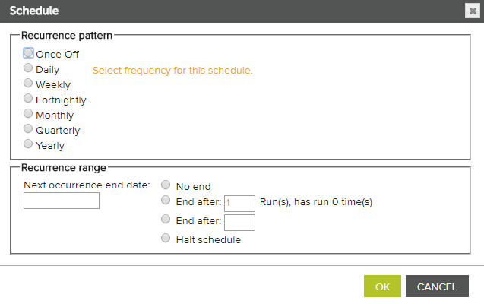 | Select the relevant recurrence pattern. Tip: for a 6-monthly audit, select monthly and enter ‘6’ for every six months.
 | In ‘next occurrence end date’ select the date that the first audit should be approved by. Tip: It should be the same as the date set in the recurrence pattern.
Example
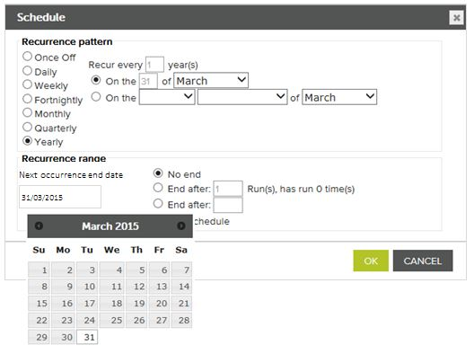 | In this example, the deadline for the approval Officer to sign off on the audit would be 31 March every year starting in 2015.
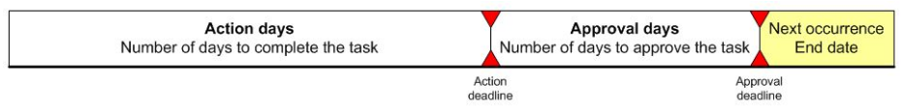
- Click save.

Schedule compliance requirements

Compliance register
The compliance register can be used to schedule tasks relating to legal obligations and corporate governance, operational policies and procedures, asset maintenance, and business planning. Ensuring that compliance requirements are monitored and completed within the required timeframe helps to minimise risk to the organisation.
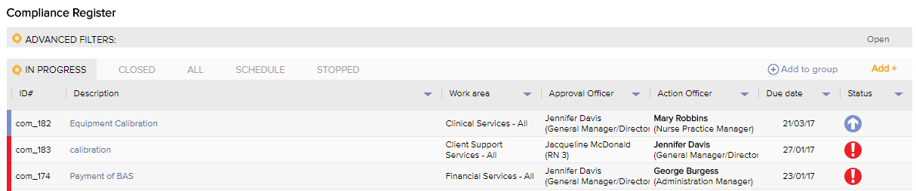

Workflow
The LOGIQC workflow dictates how and when a compliance task moves from person to person once a compliance task has been scheduled in the system.
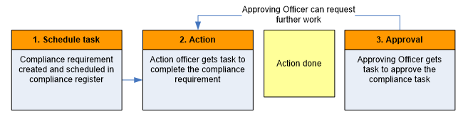

How to schedule compliance task
- Click on registers and select Compliance requirements.
- Click add.
- Complete the required fields.
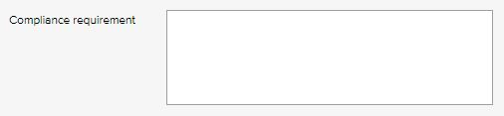 | Enter the title of the compliance requirement.
 | Select the source of the compliance requirement to be scheduled.
 | If a related document to the compliance schedule has been uploaded to the document register, select the document from the list. A hyperlink to the related document will then be provided on the action form for with the task to carry out the compliance task.
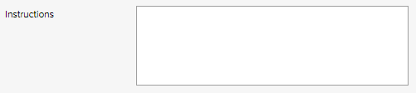 | Enter the instructions for the action officer relating to how to carry out the compliance task. It is recommended that the instructions include: 1) details of the compliance task to be completed; and 2) requirement to upload evidence as an attached record.
 | Select the staff member to carry out the compliance task. You can select multiple action officers to create a group of compliance tasks.
 | Select the staff member who has the authority to approve the compliance task once complete. Only people with approving officer system permission levels can approve items.
 | Select the work area that the compliance task most relates to.
 | Select the staff team responsible for monitoring the compliance task.
Enter the number of days the action officer will need to conduct the compliance task. This will determine how many days before the deadline the action officer will receive the task reminder.
Enter the number of days the Approving Officer needs to check that the compliance task has been completed satisfactorily.

Click on edit schedule.
 | Select the relevant recurrence pattern. Tip: for a 6-monthly compliance task, select monthly and enter ‘6’ for every six months.
 | In ‘next occurrence end date’ select the date that the first compliance task should be approved by. Tip: It should be the same as the date set in the recurrence pattern.
Example
 | In this example, the deadline for the approval Officer to sign off on the compliance task would be 31 March every year starting in 2015.
- Click save.

Schedule license checks

License register
The licensing register can be used to schedule tasks relating to staff and supplier/contractor's licenses, credentials and other registrations that need to be periodically checked for legal and other reasons. Managing licensing is a central part of effective compliance management.
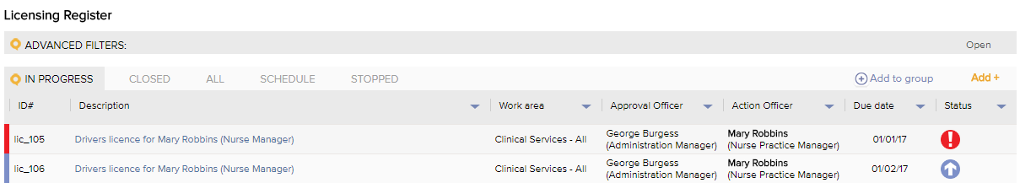

Workflow
The LOGIQC workflow dictates how and when a license task moves from person to person once a license task has been scheduled in the system.
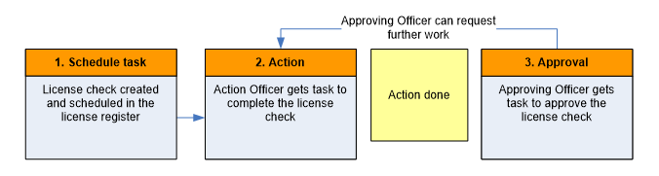

How to schedule license checks
- Click on registers and select License register.
- Click add.
- Complete the required fields.
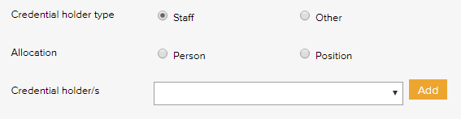 | Licensing can be scheduled for staff (users in the Staff Contacts tab in Contacts) or business contacts (individuals and companies in the Business Contacts tab in Contacts) or business contacts.
If ‘staff’ is selected above, the Allocation option will display.

Allocate licensing item to a person or position
Position: Selecting ‘position’ means that the licensing task will apply to whoever is in the position.
Person: Selecting ‘person’ means that when a person moves to another position their licensing task will go with them.

Note: when a user is made inactive by the system administrator, future tasks allocated to ‘person’ will be terminated
Select the name and click add.

Create a group licensing item
If you select and add more than one name for the licensing event, LOGIQC will create a set of licensing tasks for different people with the details specified in the initial form. All fields (with the exception of meeting, approval officer, and work area) will be linked on these items. This means, for example, that if you change the licence check due date or instructions on one item it will change on all linked items.
 | If the credential holder is not the Action Officer check this box and select who will be the action officer.
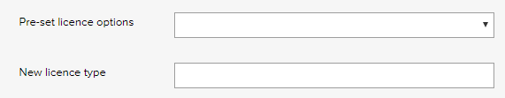 | Complete only one of these two fields.  Pre-set license options:  Select the name of the licence/credential check from the list. If the item you require is not is the drop down menu you can enter the name of the requirement in the New event name field. The items in the drop down menu are set by your system administrator.  New licence type:  If the training type is not in the Pre-set training options, the title can be added here
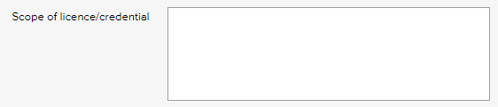 | Enter the scope of the licence/credential for the individual.
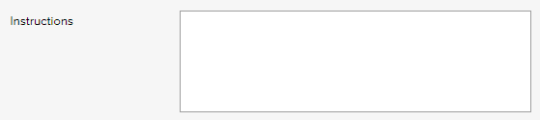 | List the instructions for what the person should do at the time of completing the task eg. submit/upload certificate. See sample instructions in the resources sections of this helpdesk.
 | Select the work area of the licensing most relates to.
 | Select the staff team meeting that is responsible for ensuring the task gets done.
 | Select the staff member has the authority to approve the task once complete. Only people with approving officer system permissions are able to approve items.
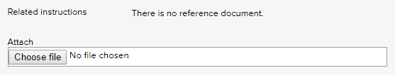 | Click ‘Choose file’ to upload documentation that relates to the licensing task. This field is optional.
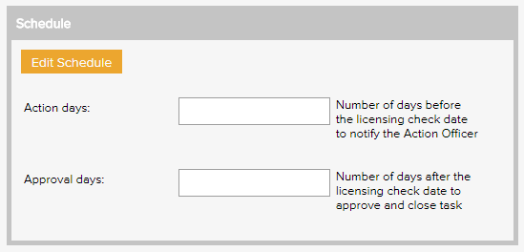 | Enter the number of days before the event that the system send a reminder to the action officer.  Enter the number of days after the licensing check that the Approving Officer has to approve and close the item.  Click on edit schedule.
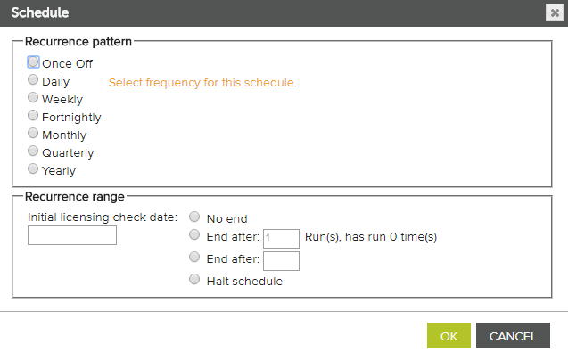 | Select the relevant recurrence pattern. Tip: for a 6-monthly license check, select monthly and enter ‘6’ for every six months.
In ‘initial licensing check date’ select the date that the first license task should be actioned by.

Tip: It should be the same as the date set in the recurrence pattern.
Example
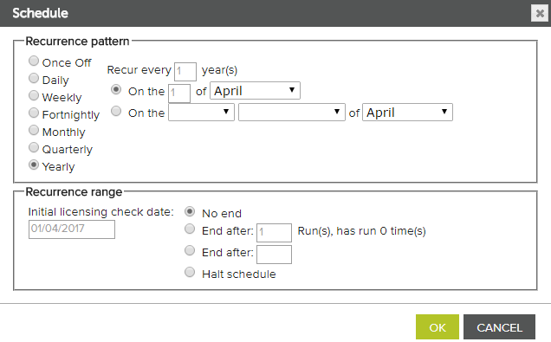 | In this example, the deadline for the action officer to complete their license task would be 1 April every year starting in 2017.  No end: Means the item will continue to recur.  End after (number): Means the item will stop being scheduled after the set number have happened.  End after (date): Means the item will continue to be scheduled until the set date.  Halt schedule: Selecting this will mean that no further items will be scheduled after the current one is completed.
- Click save.

Schedule training tasks

Training register
The training register can be used to schedule tasks relating to mandatory training, legal obligations and professional development. Managing mandatory training is a central part of effective compliance management.
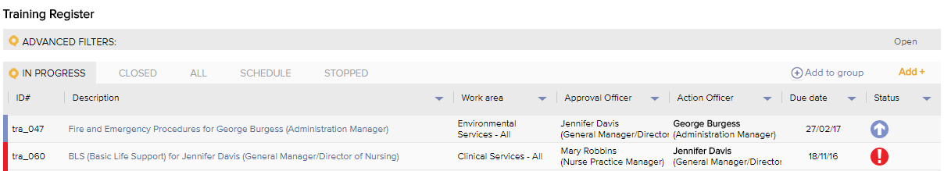

Workflow
The LOGIQC workflow dictates how and when a training task moves from person to person once a training task has been scheduled in the system.
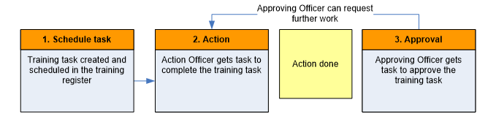

How to schedule training tasks
- Click on registers and select Training.
- Click add.
- Complete the required fields.
 | Training can be scheduled for staff (users in the Staff Contacts tab in Contacts) or business contacts (individuals and companies in the Business Contacts tab in Contacts) or business contacts.
If ‘staff’ is selected above, the Allocation option will display.

Allocate training item to a person or position
Position: Selecting ‘position’ means that the training task will apply to whoever is in the position.
Person: Selecting ‘person’ means that when a person moves to another position their training task will go with them.

Note: when a user is made inactive by the system administrator, future tasks allocated to ‘person’ will be terminated
Select the name and click add.

Create a group training item
If you select and add more than one name for the training event, LOGIQC will create a set of training tasks for different people with the details specified in the initial form. All fields (with the exception of meeting, approval officer, and work area) will be linked on these items. This means, for example, that if you change the training due date or instructions on one item it will change on all linked items.
 | If the training participant is not the Action Officer check this box and select who will be the action officer.
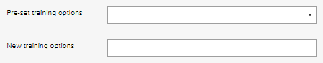 | Complete only one of these two fields.  Pre-set training options:  Select the name of the training event from the list. If the item you require is not is the drop down menu you can enter the name of the requirement in the New event name field. The items in the drop down menu are set by your system administrator.  New training options:  If the training type is not in the Pre-set training options, the title can be added here
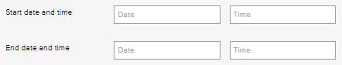 | If the details of the training event are known, they can be noted here. This field can be updated or completed at any time in the future prior to the event being closed off.
 | List the instructions for what the person should do at the time eg. attend/book training, send certificate to HR. See sample instructions in the resources sections of this helpdesk.
 | Select the work area of the training task most relates to.
 | Select the staff team meeting that is responsible for ensuring the task gets done.
 | Select the staff member has the authority to approve the task once complete. Only people with approving officer system permissions are able to approve items.
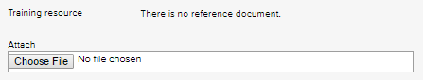 | Click ‘Choose file’ to upload a training resource that relates to the training task. This field is optional.
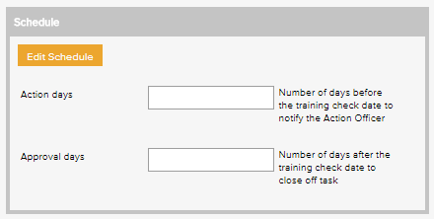 | Enter the number of days before the training event that the system send a reminder to the action officer.  Enter the number of days after the training event that the Approving Officer has to approve and close the item.  Click on edit schedule.
 | Select the relevant recurrence pattern. Tip: for a 6-monthly training check, select monthly and enter ‘6’ for every six months.
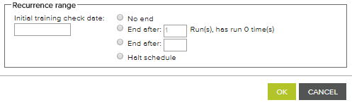 | In ‘initial training check date’ select the date that the first training task should be actioned by.  Tip: It should be the same as the date set in the recurrence pattern.
Example
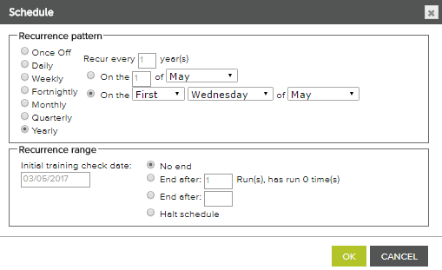 | In this example, the deadline for the action officer to complete their training task would be the first Wednesday of May of every year starting in 2017.  No end: Means the item will continue to recur.  End after (number): Means the item will stop being scheduled after the set number have happened.  End after (date): Means the item will continue to be scheduled until the set date.  Halt schedule: Selecting this will mean that no further items will be scheduled after the current one is completed.
- Click save.

Add records

Records register
The records register is a central library for evidentiary records of activity related to compliance obligations resulting from legislation and standards.
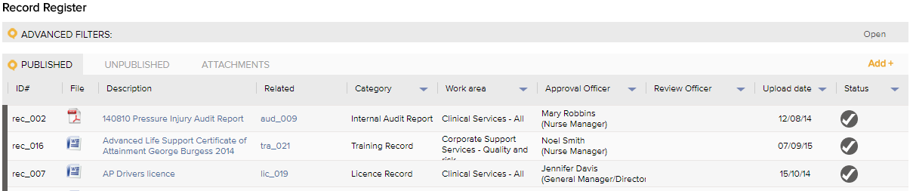

Workflow
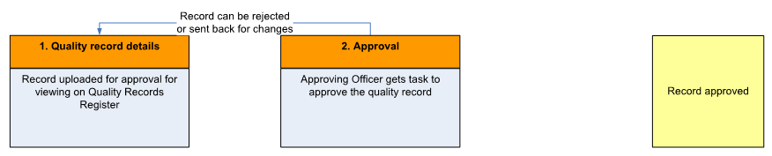
The LOGIQC workflow dictates how and when a record moves from person to person once a record is added to the system.

How to add a record
- Click on the registers menu and select records.
- Click add
- Complete the required fields.
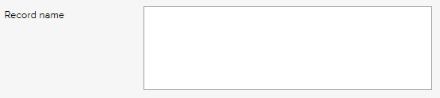 | Enter a brief title for the record. This is the title that staff will see on the register so the title should be short and descriptive.
 | Select the most relevant category for the record. Refer to setup guide to modify dropdown menus.
 | Enter a keyword or number relating to the record. This field is optional but it supports very powerful keyword searches because it’s linked to the search field.
 | We recommend the name of the authoring organisation is entered.
Selecting a restriction level will mean that only users with those permission levels can see the record.
To see the permission levels assigned to users, go to contacts/staff contacts and click export.
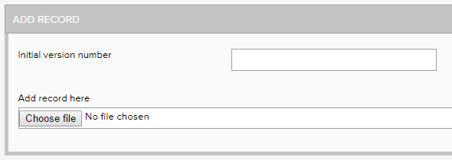 | Enter the current version number of the record. This number will be automatically incremented when new versions are approved and cannot be changed. The field only accepts a single numeral eg. 1  Click the browse/choose button and select and upload the record to LOGIQC.
 | Select the work area of your organisation that the record most relates to. The options can be controlled by your System Administrator.
 | Select the staff team responsible for the record.
 | Select the staff member to approve the document. Only people with the relevant system permissions levels are able to approve records.
 | Enter any comment relevant to this record. This field is optional.
- Click Save.

