LOGIQC CLIENT PORTAL QUICK START GUIDE
Welcome to the LOGIQC Client Portal powered by monday.com. This guide will assist you navigate around the portal, view and manage the progress of your implementation, track the delivery of any additional products and services, access resources and communicate with our Customer Success Team.

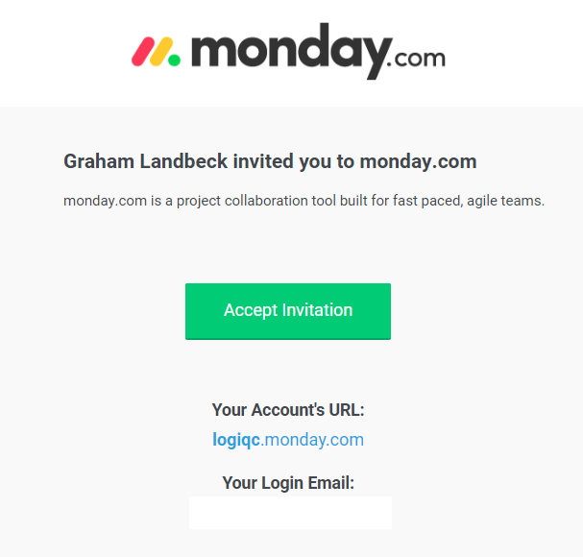  Invitation email | Shortly you will be receiving an email from monday.com to sign into your client portal board.  Is this a legitimate email? Yes, it is.  The email is not generated by your LOGIQC Customer Journey Specialist. It is an automated email sent out by the monday.com platform, inviting you to log in to your personalised client portal.  The invitation will look something like the email invitation on the left.  Your login email will be the email account you received the invitation through.
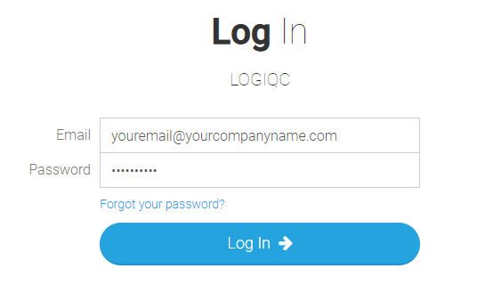  Logging into your portal | Once you create your user account, which is a username, your email address and a password, you are ready to log in and start using your portal.  If you ever forget your password, click on the ‘Forgot your password?’ link and monday.com will email you a new link to reset your password.

Lets take a closer look
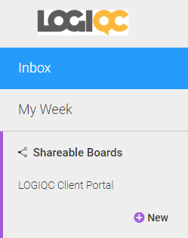  Portal menus | Once you log in to your portal, you will see on the top left hand side of your portal the following menus:  - Inbox – Where all communication within the board resides. No more searching through endless emails. All your communication is contained within the portal. This is the default view when you log in to your portal.  - My Week – A weekly view of all your due tasks (Refer to - Status, Due Dates & Timelines for more information)  - Shareable Boards – Your portal is listed here. Clicking on the portal name will display your portal in the main window of the platform.  Click on each menu to view
When you select your portal, the portal will be displayed as per the image below.
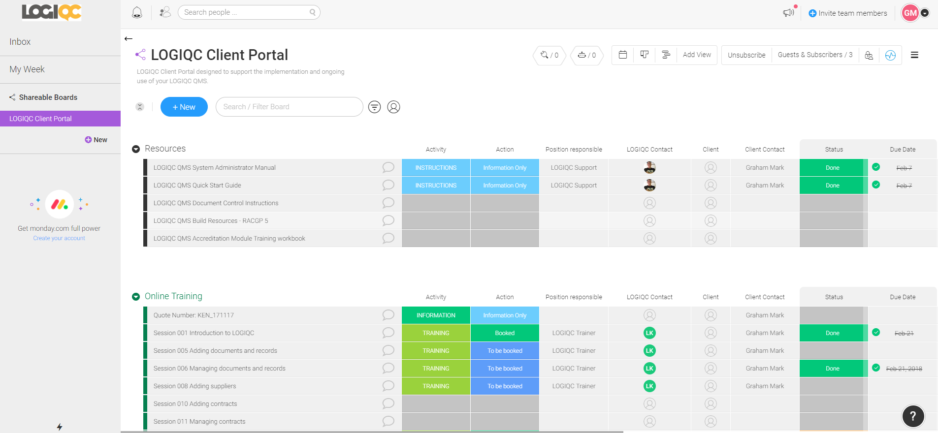
Your LOGIQC Client portal

Users of your portal
Once you have selected your portal to view, you will see additional menu items along the top of your portal window. There is a menu item called ‘Guests & Subscribers’ This displays all the users who have been added to your portal.
Portal menu items
There are two types of users:
- Subscribers – These are your LOGIQC contacts. Subscribers have administration rights over the board.
- Guests – This is you and your team. The board resides internally at LOGIQC on the monday.com platform. Key members within your team have been added to the portal as ‘guests’ to be able to view your project plan and contribute to any of the phases your team will be responsible for completing, as part of your implementation. Only LOGIQC can add and remove users.
Below is an example of portal membership. On the left are LOGIQC Customer Journey Enthusiasts who will be responsible for assiting you with the implementation of your LOGIQC QMS platform. On the right will be you and any other team members within your organisation who require access to the portal.
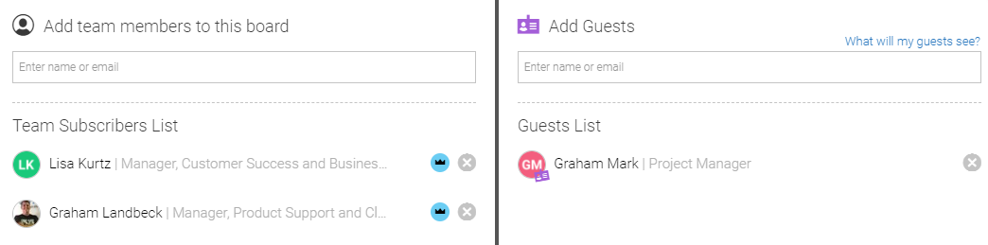
Portal users

My Profile

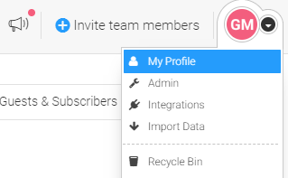  My Profile | Your profile information is located at the top right hand side of the portal window.  You can update your profile by clicking on the arrow beside your profile name and selecting ‘My Profile’ from the drop down menu.  This is where you can update your details, add a profile picture and update your password.  The profile drop down menu also contains the ‘Logout’ function.  
Groups
Your portal displays all the relevant implementation stages, resources, additional products and services which are split into groups. This is the work that both you and the LOGIQC team will perform to support and strengthen your QMS.
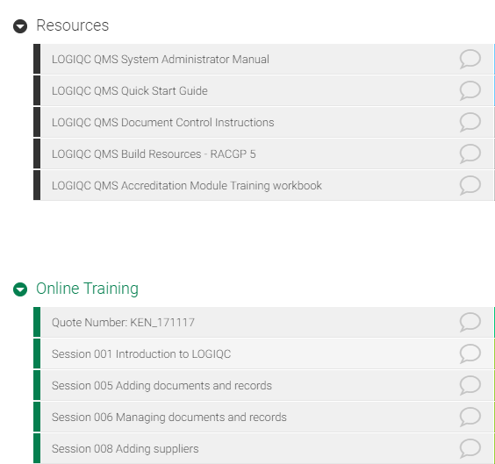
Groups
Pulses
Within each group are rows, known as pulses. A pulse is a single line of work within a group requiring action by a person. These pulses are assigned either to you and your team or assigned to a LOGIQC team member to complete.
A pulse
Assignees
Each pulse within each group will be assigned to a user to complete. In your portal, you will see 2 user columns. One is the LOGIQC contact and one is ‘Client’. Pulses assigned to ‘Client’ is the work you will be assigned to complete as part of your implementation.
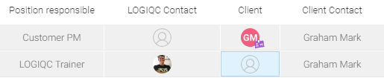
Portal Contacts – LOGIQC & Client contacts
User permissions within your portal
Any work assigned to a LOGIQC contact is locked to external users as this is internal work LOGIQC must perform on your behalf as part of your implementation.
Any work assigned to the ‘Client’ column is available to be edited. You can add comments, change the status, set due dates and download any content that has been attached to your pulse.
Action and Activity columns
Each pulse within your portal will contain an Activity and an Action column
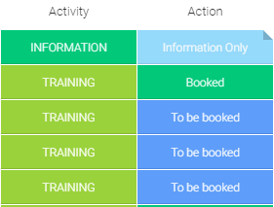  Activity & Action column | The Activity column will already be populated in your portal by LOGIQC, however any pulses assigned to you can be edited.  The Action column will be blank and is updated as activities progress.
To update an Activity or Action status, simply click on the cell and select the appropriate Activity or Action relevant to the description of the pulse.
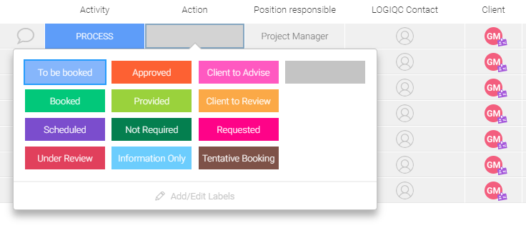
Update or change a status

If you try to change a pulse you are not assigned to you, will see the following comment.
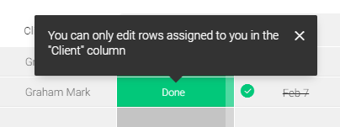
Example of user permissions on your portal

Status, Due Dates and Timelines
Each pulse has a ‘Status’ column and a ‘Due Date’ column. There is also an additional ‘Timeline’ column which can be used to monitor work that may take a specific length of time to complete.
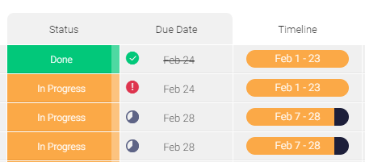
Status - Due Date – Timeline columns
These columns are used to monitor the progress of the implementation. LOGIQC will use this information to ensure we meet our agreed deadlines. You can use these columns to set your own deadlines and due dates to monitor your teams progress.
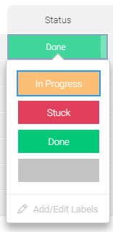  Change status | There are 3 ‘Status’ fields  - In Progress – Work that has commenced  - Stuck – Work has halted and is waiting for another activity to be completed before it can continue  - Done – The work has finished.  To change the status on your assigned pulses, click on the cell and select the appropriate status.

To set a due date, click on the Due Date cell and select a date.
 | Once a due date has been set the clock icon will slowly countdown each day until the due date has been reached.
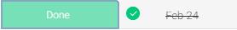 | Once a pulse status has been changed to ‘Done’, the date is ticked off.
Using the Timeline
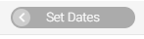 | If you wish to use the timeline feature, click on the left-hand side of the cell on the arrow to set the start date. The calendar will open, and you can select the start and end dates.
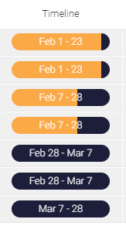 | Once your dates have been filled out, your timeline status will look like this  The Timeline feature is an optional extra you can make use of to monitor your progress.
PLEASE NOTE: It is highly recommended you set due dates on all pulses assigned to you. This will enable you to make use of the ‘My Week’ function within your portal as explained previously in ‘Navigating around your portal’.
My Week will only work if there is a ‘Status’ and a ‘Due Date’ set against the pulse.

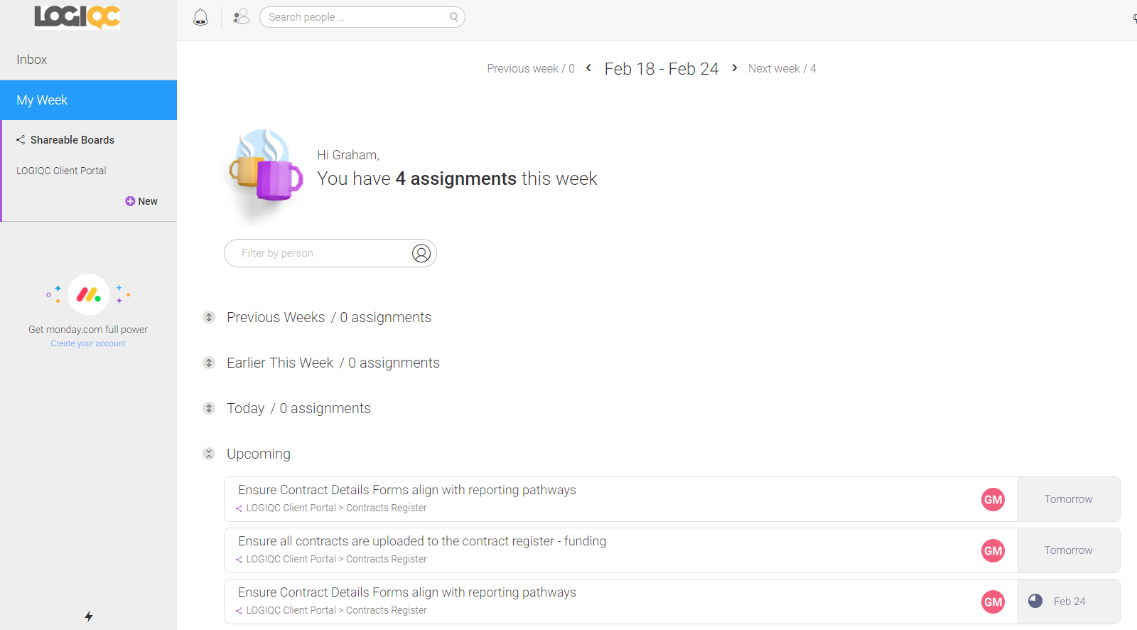
‘My week’ view
Accessing resources in a pulse
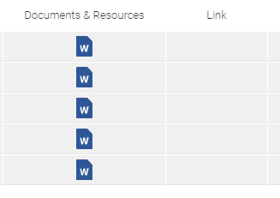  Documents & Resources and Links | The LOGIQC team will add documents and resources and in some cases hyperlinks to some of the pulses on your portal.  You access these resources by clicking on them. Documents will download to your computer and links will open a second window in your browser, so you don’t lose access to your client portal page.  You won’t be able to access documents or open links that are in pulses you are not assigned to. Trouble-shooting tip: When you first log in to your portal there may be a delay of up to 1 business day while we assign you to the relevant pulses.
Communicating within the portal
You can add a comment to each pulse by clicking on the balloon icon located in the description field of the pulse. This is how you provide status updates on the progress of the pulse or communicate with your LOGIQC contact or other users of the portal.
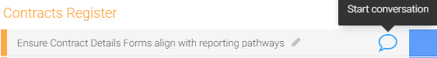
Add a comment
The portal supports the @mention function, so any user who has been added to the portal can communicate directly with other users of the portal. Below is an example of the @mention function being used to let Lisa know the work on the selected pulse has been completed.

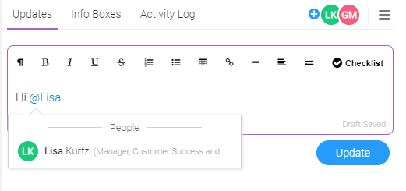
Using the @mention function

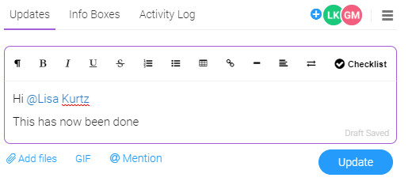
Adding a comment to the pulse

This will appear in Lisa’s ‘In Box’ as an update. Lisa will also receive a notification from the portal advising her that this pulse has been updated.

Notifications
Anytime there is a change to one of your assigned pulses, you will receive a notification. To view this notification, click on the bell icon, located at the top left of your portal window.
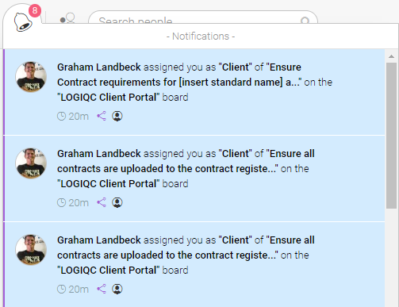
Notifications

Using filters
Your portal can sometimes be a little overwhelming with all the groups and pulses, so if you want to filter on one person’s work here are some filtering options. Filters are located at the top of your client portal window.
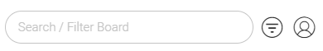
Filtering options

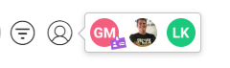  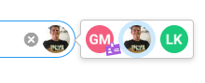 | Filter by person  - Click on the person icon  - Select the person you wish to filter on and only their work will be displayed.  - Click on the ‘X’ to remove the filtered result.
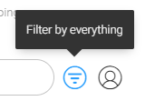 | Filter by everything  - Select the ‘Filter by everything’ icon  - A table showing all the groups, pulses, status columns etc will be displayed  - Select the information you want to filter on and the result will be displayed.  - Select ‘Clear’ to clear the filtered result.
Other Features built into the Client Portal
LOGIQC uses monday.com to power your portal. This guide is not intended to be a monday.com user guide, but rather a guide to assist you navigate around the key features of your Client Portal that have been specifically customised for you.
There are many other features available within the monday.com platform that this guide intentionally does not cover and are not supported by LOGIQC.

