LOGIQC QUICK START GUIDE

Log in
- Open your Internet browser (eg. Google Chrome) and go to https://(2020.logiqc.com.au)
(Note: using ‘www’ in the address will take you to the wrong page)
- Enter your user name and password, and click log in. If you’ve forgotten your password, click on Forgot your password? enter your username, tick the 'I'm not a robot' box and then click on 'Send link' and a reset password will be sent to your email address. (Note: if you can't remember your username, select 'Contact the LOGIQC help desk'.)
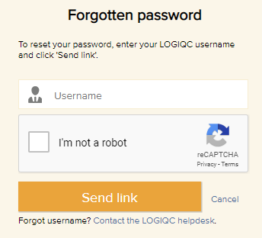
Click to update your password
Click to go to document library
Click to check meetings
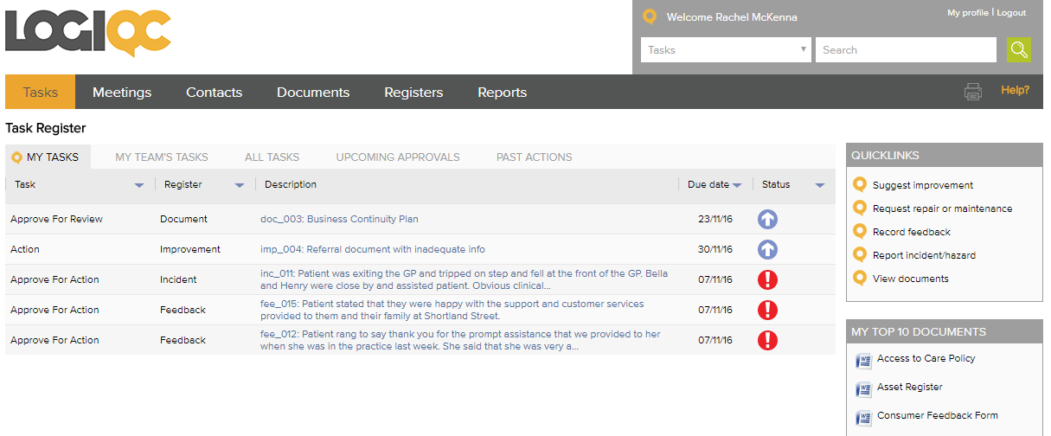
Click to open frequently viewed documents
Click to go to task
Click to access Helpdesk
Click to report an issue

Updating your password
- After logging in, click on the My profile (top-right of screen) to open your profile.
- Go to the Password field, type your new password and click Save.

LOGIQC Help Desk
Click Help? (top-right of screen) to access Helpdesk.
- The Help Desk contains several knowledge-based articles that can provide you with useful information about your query.
- The Help Desk also provides you with access to the Learning Centre, here you have an option to access self-passed learning with Introductory, Intermediate and Advanced Workshops relating to Governance, Management and Reporting in the QMS.
- Further to the self passed learning there is also a train the trainer option that will skill key staff within your organisation the skills to support other staff through their learning journey.
- Click Support (bottom of screen) to submit a support request ticket to the LOGIQC helpdesk staff

Report an event (eg incident, complaint, feedback, improvement)
- Click on the relevant Quicklink option.
- Complete the form shown and click Save. A task to respond to the issue will be sent to the person you selected as approval officer.

Get a document
- Click on Documents.
- To search for a document, type the name of the document in the search field (part word is OK) and hit enter or click the green magnifying glass.
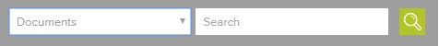
- Click on the file icon to open the document
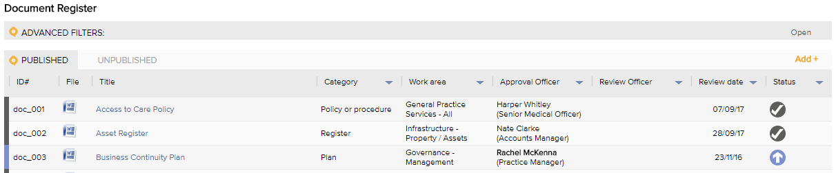

Complete a Task
If you have a task you will receive an email and a task will be listed in My tasks when you log in.
- Click on the link in the Description column to open your tasks and review your options and instructions.
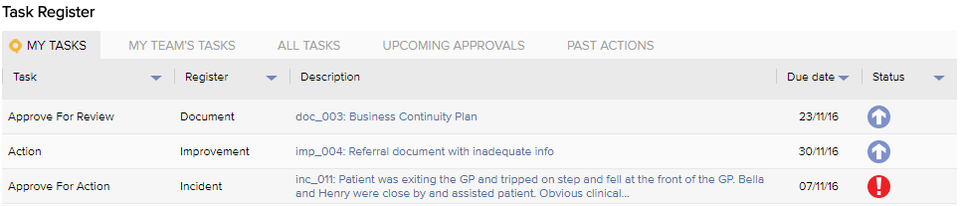
Attach a record to the task (Optional).
- Click add to reveal the upload fields.
- Type a description of the record name and, if the record needs to be confidential, select an access restriction level.
- Select the most relevant record category for the record
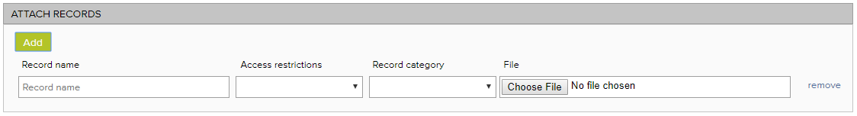
- Click choose file and locate the record. When you task is saved, the record will be uploaded into LOGIQC.

LOGIQC workflows
LOGIQC comprises four workflows that act as built-in business rules about how to manage the business processes:
Workflow 1: Documents and Suppliers

Workflow 2: Contracts, Risks and Accreditation Standards
Workflow 3: Audit, Compliance, Training and Licensing
Workflow 4: Incidents, Feedback, Repairs and Improvements

