REPORTING REGISTERS: INCIDENTS, FEEDBACK, REPAIRS AND IMPROVEMENTS TRAINING WORKBOOK

This workbook supports the training and use on how to use each of the four reporting registers in the LOGIQC QMS to report an event and how the workflow relating to the reporting registers supports managers to manage adverse events within requried timeframes.

Contents page

1. Introduction 3
2. About the LOGIQC QMS 4
3. The purpose and scope of the reporting registers 5
4. LOGIQC reporting register workflow 6
5. How to navigate within the reporting registers 7
6. Incident Register 8
7. Feedback Register 16
8. Repair Register 24
9. Improvement Register 31

Introduction
This training workshop has been designed to provide instruction on how to use the reporting registers in the LOGIQC Quality Management System:
- Incident
- Feedback
- Repair
- Improvement
  - Learning outcomes:
- Understanding of purpose and scope of the incident, feedback, repairs and improvement registers
- Reporting registers workflow
- How to navigate within the reporting registers
- Reporting events and occurrences
- Managing and responding to event and occurrences
- Closing a reported event

  - Related documents and resources
- Reporting Pathways for the reporting registers

About the LOGIQC QMS
LOGIQC QMS is a cloud-based software platform for healthcare and related organisations to manage safety, quality and risk. LOGIQC QMS is specifically designed to meet accreditation requirements against most quality and clinical standards. LOGIQC QMS can be configured with the specific registers and modules you need to strengthen corporate and clinical governance.
LOGIQC QMS was released in 2010 and has now been implemented in more than 150 healthcare organisations and related NGO’s across Australia and New Zealand. LOGIQC QMS has been proven in the field to be compliant with the requirements of international standards for quality and risk management such as ISO 9001 and ISO 31000.
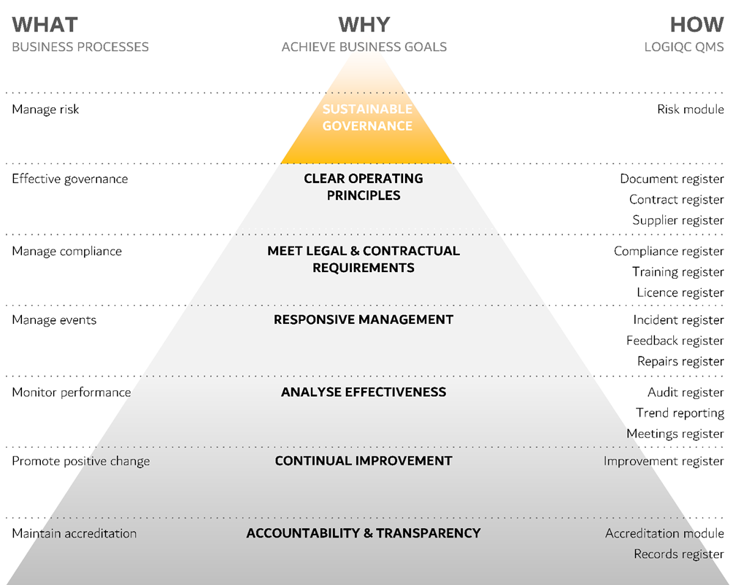

The purpose and scope of the reporting registers
These registers support:
- Real time reporting to enable staff to easily contribute to a safe environment for staff, clients and others.
- Immediate communication and notification to management of an event which may have the potential to impact on safety and quality of health care
- Open communication to all levels of staff of the safety of the environment and areas which may impact on the safety of health care
- Consistent recording and categorisation of the range and type of events that occur
- Integration between adverse events and risk management
- Management of corrective action
- Monitoring of the management of events
- Trend analysis of the type of events occurring in order to identify emerging issues, real or potential
- Integration between adverse events and continuous improvement to avoid or reduce the chance of same or similar event occurring again in the future
- Paperless reporting of incidents, feedback and complaints

LOGIQC reporting register workflow
There are four registers in the LOGIQC QMS which support reporting of an event
- Incident
- Feedback
- Repair
- Improvement
The diagram bellow outlines the workflow for all four LOGIQC QMS Reporting Registers. The workflow supports the following four discreet processes:
Process 1 Reporting of the event, which includes categorisation of the event based on the pre-set options. In reporting an event, a manager is selected to be the Approving Officer.
Process 2 The selected Approval Officer is notified of the reported event via an automatic email generated by LOGIQC. The assigned Approval Officer, is tasked with determine what action, if any is required to manage the consequences of the event. Where action is required, the Approval Officer is required to provide instructions for the action to be taken, select the Action Officer, nominate the timeframe in which the action is to be completed.
Process 3 The selected Action Officer is notified of the requirement to undertake the action via an automatic email generated by LOGIQC. Following action taken, the assigned Action Officer, is required to record details of all action taken. Where action is taken over a period of time, LOGIQC allows for progress notes to be recorded. Evidence to verify action taken can be added to the Action Officer’s form.
Process 4 Following the completion of the required action, the selected Approval Officer is tasked with determining whether all action required to be taken. Where further action is required, the Approval Officer has the option to repeat the process as outlined in 2.
Where all required action has been taken the Approval Officer has the option to close off the task.
Workflow 4: Incidents, Feedback, Repairs and Improvements

How to navigate within the reporting registers
  - Reporting register tabs
To access the registers, you will need to select one of the reporting registers from the registers heading.
There are 3 ‘tabs’ along the top of the reporting registers
- The In Progress tab displays the reported items currently active with a task assigned to the action or approval officer.
- The Closed tab displays past items that have been reported and closed off as completed and managed.
- The All tab displays both items currently in progress and the past, closed items.

  - Navigating through the reporting registers
The search bar allows the user to search for reported items based on the description of the item or the ID#.
The items in the register view are displayed in numerical order based on the ID# of item. The column titles allow the user to click on the title of the column to sort the content in alphabetical or numerical order based on that column. E.g. Click on the “Description” title in the second column to sort the items in alphabetical order. Clicking again will reverse the sort order.
The column filters are displayed as small blue triangles on the left hand-side of some of the register columns and enable the user to select options from that column to be filtered. E.g. Click on the blue triangle in the “work area” column to select one or more options from the list, then click apply.
The advanced filters option sit above the reporting registers and can be used to apply a range of filters to enable different views or ad-hoc reports based on data within the details forms of the items. These will be different depending on what register you are viewing. Click on the word “Advanced filters” to display the advanced filter options. Use the drop-down menus to select one or more filters then click apply.
E.g. Advanced Filters in the Incident Register:
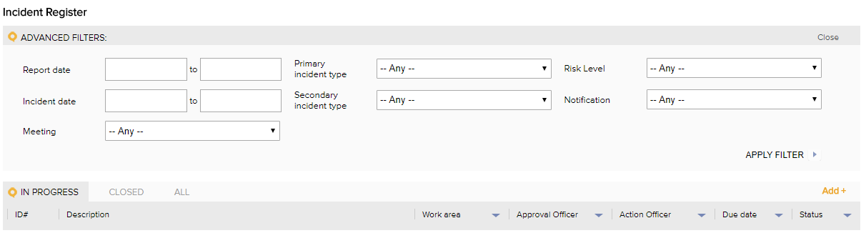

Incident Register
  - Purpose and Scope of Incident Register
The LOGIQC Incident Register helps you to ensure that adverse events are reported and managed in accordance with operational and statutory requirements. All organisations have a duty of care to ensure employees, clients and any other person who may be affected by the organisation's services, remain safe both in terms of the health care provided and in terms of the environment in which care is provided.
The Incident Register enables:
- All staff access to simple and quick incident reporting through one-click from any device
- Real time reporting
- Restricted viewing access to the incident reports and attached records, where appropriate
- Single location for all related records eg photos, report etc.
- Immediate notification to management following reporting of an incident
- Management to delegate required action with instructions and specified timeframes, where required
- Management to monitor action taken
- Documentation that verifies the evidence of action taken to be held with the incident report
- Built in search filters and trend reporting for high level analysis of what’s happening in your business
  - Incident Register Workflow

How to report an incident
Instructions to report an incident in the LOGIQC QMS:
      - Log-in under your own user profile.
      - Click on "report incident/hazard" in the Quicklinks box in your Task Register Screen
      - Complete the required fields as follows:
 | Select the type of incident that is most relevant to the item being reported.
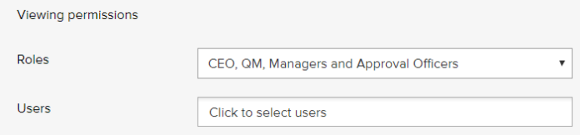 | Set the viewing permission to ‘All users’ unless the incident should be confidential. Where restricted access is required, select the appropriate viewing permissions. The most restricted access level is: ‘CEO, QM, Assigned Approval Officer’.
 | Specify the date and time of the incident.
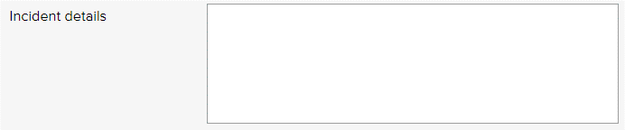 | Enter a summary to describe the nature and details of the incident. Note a full account of the incident can be attached as a record using the ‘Add’ button below.
 | If applicable, enter a reference number associated with client or patient related to the incident (optional).
 | Specify if an injury was sustained from the incident.
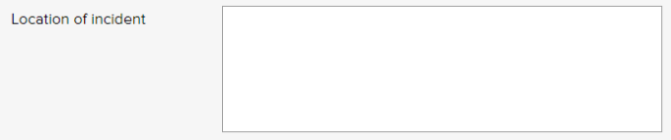 | Specify and detail the location of where the incident occurred.
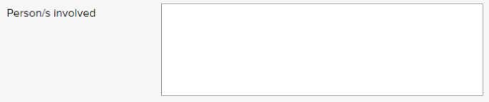 | List all people involved in or who were a witness to the incident. Include the name and position title, where appropriate.
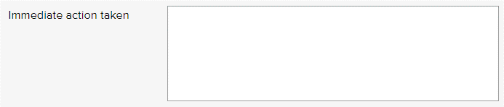 | Describe the immediate action/s that have taken place to manage the incident. If no action has been taken state ‘no immediate action taken’.
 | Select the work area of your organisation that the incident most relates to.
 | Select the meeting that either needs to be kept informed of incident or the meeting that has oversight for ensuring the incident is responded to and managed. In instances, where this is not one and the same meeting, the organisation will need to determine which of the two assumes priority: communication or oversight.
 | Select a staff member who is required to manage this type of incident.
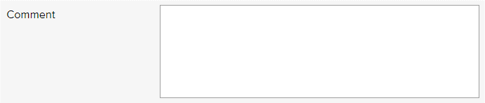 | Enter any additional relevant comments (optional).
 | Select individual staff members, including managers who are required to be informed when this type of incident has occurred. Upon the Form being ‘saved’ notification of the event will be sent via an automatic email generated by LOGIQC. Note: access to the incident report will be restricted based on the ‘viewing permission’ selected.
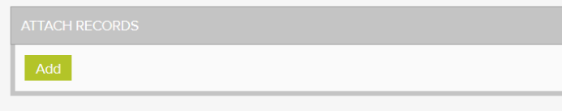 | Click 'Add' to attach related records, e.g. photos or any other records relevant to the incident.
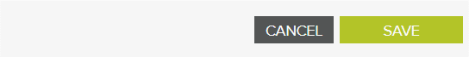 | Click save to add the reported event to the Incident Register, which will activate the 2nd process in the Incident Workflow.

  - Complete “Approve for Action” Task for Incident
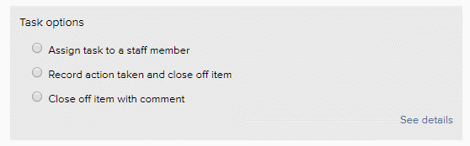 | Where action is required to be taken in response to the reported incident, select the 1st option and complete the ‘required’ fields:  - instructions as to what action is to be taken  - select who is to take the action  - timeframe in which the action is be completed  Where all action required to be taken has already been taken, select the 2nd option and complete the ‘required’ fields:  - record what further action has been taken that is not already noted on the Incident Details Form  - press ‘save’ which will close the incident report in LOGIQC.  Where no further action has been taken or is required to be taken, select the 3rd option and complete the ‘required’ fields:  - make a comment  - press ‘save’ which will close the incident report in LOGIQC.
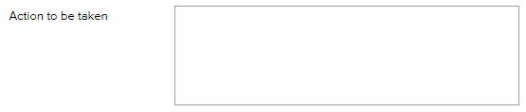 | Where action is required to be taken, document the instructions.
 | Select whether this is a notifiable incident or not. The organisation should determine the definition or types of incidents that are ‘notifiable’.
 | Where action is required to be taken, select the staff member who is required to undertake the action.
 | Where action is required to be taken, specify the timeframe in which the action is to be completed within.
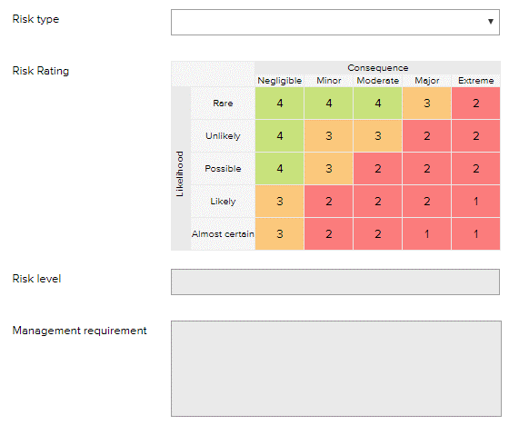 | Where the incident relates to a Risk type, select the relevant Risk type the incident relates to.  Note:  - Where the incident type has been linked to a Risk type on the Risk Register, LOGIQC will automatically link the respective Risk type and will assign the risk rating that has been assign to that Risk type.  - The Approving Officer can override the automatic Risk type that has been assigned by LOGIQC, which may be necessary as the nature of the incident may be more relevant to another Risk type.  Details of ‘Management Requirement’ will be automatically populated by LOGIQC, based on the information recorded in ‘system settings’.
Click save to submit the completed “Approve for Action” form.
Where option 1 has been selected, LOGIQC will activate the 3rd process in the Incident Workflow.
Where option 2 or 3 has been selected, LOGIQC will close the Incident Report in LOGIQC, and move the Incident Report to both the “Closed” and “All” tabs in the Incident Register.

  - Complete “Action” Task for Incident
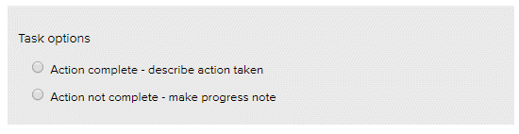 | Where all action required to be taken has been taken, select the 1st option and complete the ‘required’ fields:  - record details of action taken  - add comment (optional)  - attach verifying evidence of action taken  - press ‘save’ and LOGIQC will send the incident report to the assigned Approval Officer who has responsibility to assess the action taken based on what was required and to determine, if any further action is required.  Where only a part of the action required to be taken has been taken, select the 2nd option and complete the ‘required’ fields:  - record details of action taken  - press ‘save’ and the task will remain with the Action Officer, until Option 1 has been selected.
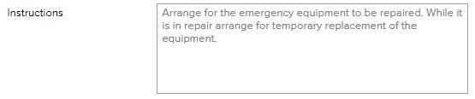 | These are the instructions which the assigned Approval Officer has requested in response to the incident.
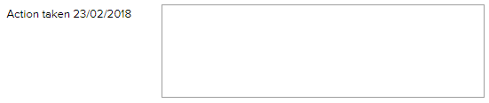 | Record in this field details of all action taken giving consideration to legislative requirements in relation to record keeping. For example, it may be required that full details of action taken is kept by the organisation.
 | Press ‘add progress note’ when you want to add further details of action taken. LOGIQC will record the date and time the additional notes were added. You can add as many additional notes as required, until all action has been taken.
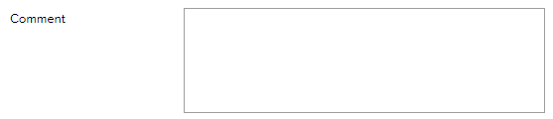 | Add additional comments (optional).
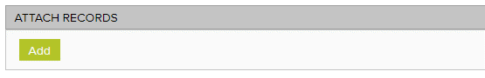 | Click 'Add' to attach related records, e.g. correspondence, report etc. relevant to any action taken in response to the incident.
 | Click save, which will activate the 3rd process in the Incident Workflow.

  - Complete “Approval” Task for Incident
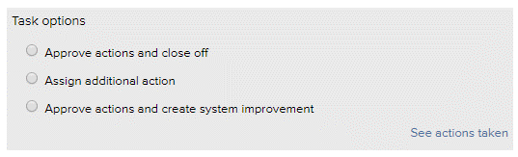 | Where action required to be taken in response to the reported incident has been completed, select the 1st option and select save.  Where additional action is required to be taken, select the 2nd option and complete the ‘required’ fields:  - instructions as to what further action is to be taken  - select who is to take the further action  - timeframe in which the further action is be completed  Where no further action needs to be taken and there is the opportunity to implement a system improvement select the 3rd option and LOGIQC will:  - generate an improvement form  - link the improvement to the incident so that a record is kept that the improvement was generated from an incident.  - Refer to the instructions on how to complete the improvement form.
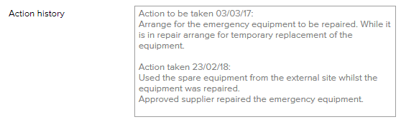 | This field provides details of what action has been taken that was recorded by the Action Officer on the ‘Action Details Form’.
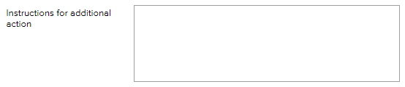 | Where further action is required to be taken, document the instructions for the further action to be taken.
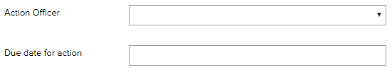 | Where further action is required to be taken, select the staff member who is required to undertake the action and specify the timeframe in which the action is to be completed within.
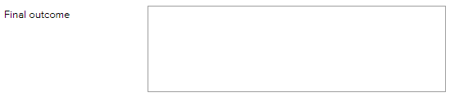 | When closing off the incident, the Approval Officer can record details of the final outcome in responding to and managing the incident (optional).
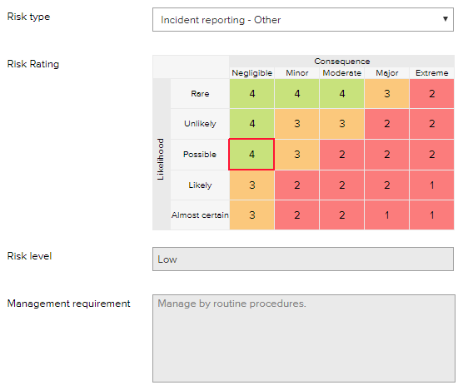 | The Approval Form, provides a further opportunity to link the incident type to a Risk type, or to change the Risk type that may have been set previously by the Approval Officer or by LOGIQC. Refer to the earlier instructions in relation to the Risk Rating, Risk level and Management requirement.
Where option 1 or 3 has been selected, LOGIQC will close the Incident Report in LOGIQC, and move the Incident Report to both the “Closed” and “All” tabs in the Incident Register.
Where option 2 has been selected, LOGIQC will activate the 3rd process in the Incident Workflow.

Feedback Register
  - Purpose and Scope of Feedback Register
The feedback register helps to ensure client feedback and complaints are reported and managed effectively in accordance with operational requirements. An organisation striving for excellence will provide high levels of customer service including being responsive to feedback and focussed on how it’s managed.
- All staff access to simple and quick complaints and client feedback reporting through one-click reporting from any device
- Real time reporting
- Restricted viewing access to the feedback reports and attached records, where appropriate
- Single location for all related records eg letter of complaint, compliment note, etc.
- Immediate notification to management following reporting of feedback
- Management to delegate required action with instructions and specified timeframes, where required
- Management to monitor action taken
- Documentation that verifies the evidence of action taken to be held with the feedback report
- Built in search filters and trend reporting for high level analysis of what’s happening in your business

  - Feedback Register Workflow

  - How to report Feedback or Complaints
Instructions to report feedback in the LOGIQC QMS:
      - Log-in under your own user profile.
      - Click on "record feedback" in the Quicklinks box in your Task Register Screen
      - Complete the required fields as follows:
 | Select the type of feedback being reported from the drop-down menu.
 | Select the source that best describes where the feedback came from. This menu can be edited by the System Administrator in system setup.
 | Select the feedback category that is most relevant to the feedback received.
 | Specify the date and time that the feedback was received.
 | Set the viewing permission to ‘All users’ unless the feedback should be confidential. Where restricted access is required, select the appropriate viewing permission level. The most restricted access level is: ‘CEO, QM, and Assigned Approval Officer’.
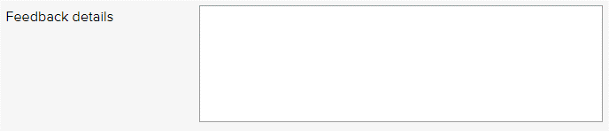 | Enter a summary to describe the nature and details of the feedback receive. Note a full account of the feedback can be attached as a record using the ‘Add’ button below.
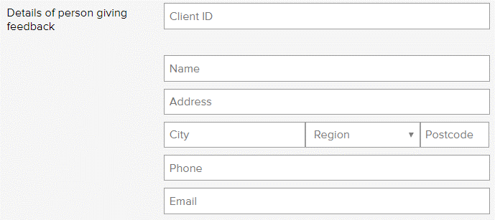 | If applicable, enter a reference number associated with client or patient related to the feedback. Note: This field is optional.  Specify the contact details of the person who gave the feedback, if appropriate.  Note: The name field is required. Insert ‘n/a’ if not applicable.
 | Describe the immediate action/s that have taken place to manage the feedback. If no action has been taken state ‘no immediate action taken’.
 | Select the work area of your organisation the feedback most relates to.
 | Select the meeting that either needs to be kept informed of the feedback or the meeting that has oversight for ensuring the feedback is responded to and managed. In instances, where this is not one and the same meeting, the organisation will need to determine which of the two assumes priority: communication or oversight.
 | Select a staff member who is required to manage this type of feedback.
 | Enter any additional relevant comments (optional).
 | Select individual staff members, including managers who are required to be informed when this type of feedback has been received. Upon the Form being ‘saved’ notification of the feedback will be sent via an automatic email generated by LOGIQC. Note: access to the feedback report will be restricted based on the ‘viewing permission’ selected.
 | Click 'Add' to attach related records, e.g. letter of complaint, complimentary note or any other records relevant to the feedback.
 | Click save to add the reported event to the Feedback Register, which will activate the 2nd process in the Feedback Workflow.

  - Complete “Approve for Action” Task for Feedback
Where action is required to be taken in response to the reported feedback, select the 1st option and complete the ‘required’ fields:
- instructions as to what action is to be taken
- select who is to take the action
- timeframe in which the action is be completed

Where all action required to be taken has already been taken, select the 2nd option and complete the ‘required’ fields:
- record what further action has been taken that is not already noted on the Feedback Details Form
- press ‘save’ which will close the feedback report in LOGIQC.

Where no further action has been taken or is required to be taken, select the 3rd option and complete the ‘required’ fields:
- make a comment
- press ‘save’ which will close the feedback report in LOGIQC.
 | Where action is required to be taken, document the instructions.
 | Where action is required to be taken, select the staff member who is required to undertake the action.
 | Where action is required to be taken, specify the timeframe in which the action is to be completed within.
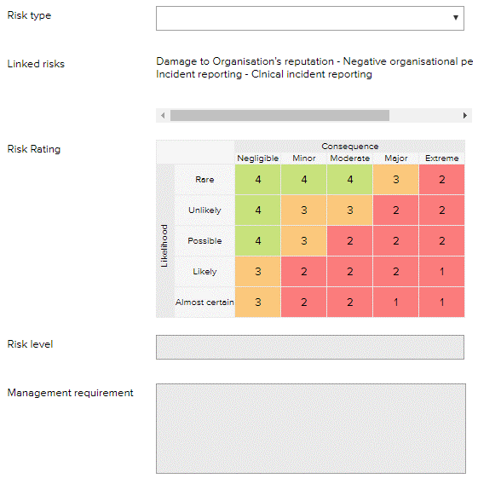 | Where the feedback relates to a Risk type, select the relevant Risk type the feedback relates to.  Note:  - Where the feedback type has been linked to a Risk type on the Risk Register, LOGIQC will automatically link the respective Risk type and will assign the risk rating that has been assign to that Risk type.  - The Approving Officer can override the automatic Risk type that has been assigned by LOGIQC, which may be necessary as the nature of the feedback may be more relevant to another Risk type.  Details of ‘Management Requirement’ will be automatically populated by LOGIQC, based on the information recorded in ‘system settings’.
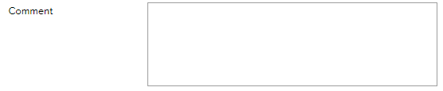 | Only required if the 3rd option has been selected. Otherwise this is an optional field. If required, state why the Feedback Report is being closed eg ‘no action required as the feedback was a compliment’.
Click save to submit the completed “Approve for Action” form.
Where option 1 has been selected, LOGIQC will activate the 3rd process in the Feedback Workflow.
Where option 2 or 3 has been selected, LOGIQC will close the Feedback Report in LOGIQC, and move the Feedback Report to both the “Closed” and “All” tabs in the Feedback Register.

  - Complete “Action” Task for Feedback
Where all action required to be taken has been taken, select the 1st option and complete the ‘required’ fields:
- record details of action taken
- add comment (optional)
- attach verifying evidence of action taken
- press ‘save’ and LOGIQC will send the feedback report to the assigned Approval Officer who has responsibility to assess the action taken based on what was required and to determine, if any further action is required.

Where only a part of the action required to be taken has been taken, select the 2nd option and complete the ‘required’ fields:
- record details of action taken
- press ‘save’ and the task will remain with the Action Officer, until Option 1 has been selected.

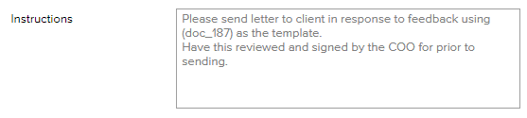 | These are the instructions which the assigned Approval Officer has requested in response to the feedback.
 | Record in this field details of all action taken giving consideration to legislative requirements in relation to record keeping. For example, it may be required that full details of action taken is kept by the organisation.
 | Press ‘add progress note’ when you want to add further details of action taken. LOGIQC will record the date and time the additional notes were added. You can add as many additional notes as required, until all action has been taken.
 | Add additional comments (optional).
 | Click 'Add' to attach related records, e.g. correspondence, report etc. relevant to any action taken in response to the feedback.
 | Click save, which will activate the 3rd process in the Feedback Workflow.

  - Complete “Approval” Task for Feedback
Where action required to be taken in response to the reported feedback has been completed, select the 1st option and select save.

Where additional action is required to be taken, select the 2nd option and complete the ‘required’ fields:
- instructions as to what further action is to be taken
- select who is to take the further action
- timeframe in which the further action is be completed

Where no further action needs to be taken and there is the opportunity to implement a system improvement select the 3rd option and LOGIQC will:
- generate an improvement form
- link the improvement to the feedback so that a record is kept that the improvement was generated from feedback.
- Refer to the instructions on how to complete the improvement form.

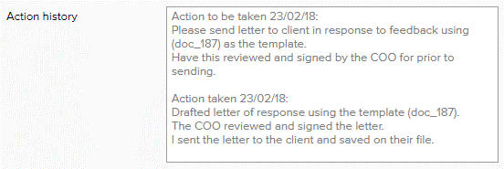 | This field provides details of what action has been taken that was recorded by the Action Officer on the ‘Action Details Form’.
 | Where further action is required to be taken, document the instructions for the further action to be taken.
 | Where further action is required to be taken, select the staff member who is required to undertake the action and specify the timeframe in which the action is to be completed within.
 | When closing off the feedback, the Approval Officer can record details of the final outcome in responding to and managing the feedback (optional).
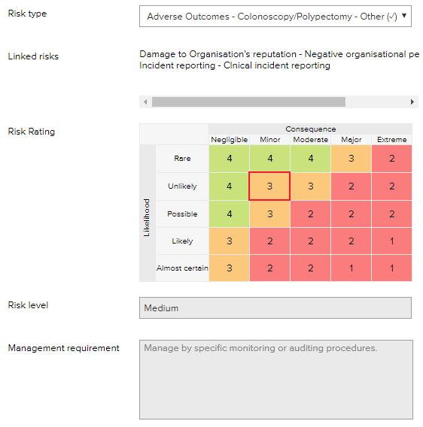 | The Approval Form, provides a further opportunity to link the feedback type to a Risk type, or to change the Risk type that may have been set previously by the Approval Officer or by LOGIQC. Refer to the earlier instructions in relation to the Risk Rating, Risk level and Management requirement.
Where option 1 or 3 has been selected, LOGIQC will close the Feedback Report in LOGIQC, and move the Feedback Report to both the “Closed” and “All” tabs in the Feedback Register.
Where option 2 has been selected, LOGIQC will activate the 3rd process in the Feedback Workflow.

Repair Register
  - Purpose and Scope of Repair Register
The repairs register ensures plant and equipment malfunctions are reported and managed in accordance with operational requirements. Organisations need effective processes for maintaining physical infrastructure to ensure high standards of service delivery and compliance with legal obligations in relation to workplace safety.
The Repair Register enables:
- All staff access to simple and quick reporting on faults with equipment and other assets through one-click from any device
- Real time reporting
- Single location for all related records eg photos, report etc.
- Immediate notification to management following reporting of equipment failure or requesting a repair
- Management to delegate required action with instructions and specified timeframes, where required
- Management to monitor action taken
- Documentation that verifies the evidence of action taken to be held with the requested repair report
- Built in search filters and trend reporting for high level analysis of what’s happening in your business

  - Repair Register Workflow

  - How to report Repairs and Maintenance
Instructions to report a repair in the LOGIQC QMS:
      - Log-in under your own user profile.
      - Click on "report repair or maintenance" in the Quicklinks box in your Task Register Screen
      - Complete the required fields as follows:
 | Briefly describe the item needing repair or maintenance (tip: this field is searchable on the register)
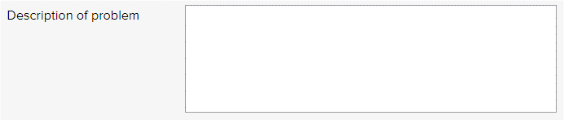 | Enter a summary to describe the nature and details of the repair request. Note a full account of the repair request can be attached as an attached record using the ‘Add’ button below.
 | Specify whether the repair is related to a Risk type that has been identified by the organisation.
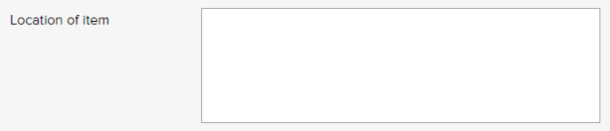 | Specify where the item the repair request relates to is located, eg consultation room 1, sterilisation area, admin office, Vehicle Reg# SYZ 123, etc.
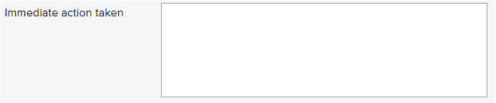 | Describe the immediate action/s that have taken place to manage the repair. If no action has been taken state ‘no immediate action taken’.
 | Select the work area of your organisation that the repair most relates to.
 | Select the meeting that either needs to be kept informed of requested repair or the meeting that has oversight for ensuring the repair is responded to and managed. In instances, where this is not one and the same meeting, the organisation will need to determine which of the two assumes priority: communication or oversight.
 | Select a staff member who is required to manage this type of feedback.
 | Enter any additional relevant comments (optional).
 | Select individual staff members, including managers who are required to be informed when this type of repair has been requested. Upon the Form being ‘saved’ notification of the repair request will be sent via an automatic email generated by LOGIQC. Note: access to the requested repair will be restricted based on the ‘viewing permission’ selected.
 | Click 'Add' to attach related records, e.g. service maintenance report or any other records relevant to the repair.
 | Click save to add the requested repair to the Repair Register, which will activate the 2nd process in the Repair Workflow.

  - Complete “Approve for Action” Task for Repair
Where action is required to be taken in response to the requested repair select the 1st option and complete the ‘required’ fields:
- instructions as to what action is to be taken
- select who is to take the action
- timeframe in which the action is be completed

Where all action required to be taken has already been taken, select the 2nd option and complete the ‘required’ fields:
- record what further action has been taken that is not already noted on the Repairs Details Form
- press ‘save’ which will close the repair report in LOGIQC.

Where no further action has been taken or is required to be taken, select the 3rd option and complete the ‘required’ fields:
- make a comment
- press ‘save’ which will close the repair report in LOGIQC.
Where action is required to be taken, document the instructions.
Where action is required to be taken, select the staff member who is required to undertake the action.
Where action is required to be taken, specify the timeframe in which the action is to be completed within.
Where an external supplier is required to be involved in repairing the equipment, select the ‘yes’ option and LOGIQC will generate an additional field on the Form, requesting the name of the supplier, which can be selected from the drop-down list, which is pointing to the Business Contacts, or these details can be directly entered onto the Form.
Where the repair relates to a Risk type, select the relevant Risk type the repairs relates to.

Details of ‘Management Requirement’ will be automatically populated by LOGIQC, based on the information recorded in ‘system settings’.
Where the repair relates to a Risk type, select the relevant Risk type the repairs relates to.

In selecting a Risk type, if the Risk type has been assigned a risk rating, LOGIQC will automatically assign the same risk rating to the ‘Approve for Action’ form. However, the Approving Officer can override the automatic Risk rating that has been assigned by LOGIQC, which may be necessary as the nature of the repair may have a different risk level.

Details of ‘Management Requirement’ will be automatically populated by LOGIQC, based on the information recorded in ‘system settings’.
Enter any additional relevant comments (optional).
Click save to submit the completed “Approve for Action” form.
Where option 1 has been selected, LOGIQC will activate the 3rd process in the Repairs Workflow.
Where option 2 or 3 has been selected, LOGIQC will close the Repair Report in LOGIQC, and move the Repair Report to both the “Closed” and “All” tabs in the Repairs Register.

  - Complete “Action” Task for Repair
Where all action required to be taken has been taken, select the 1st option and complete the ‘required’ fields:
- record details of action taken
- add comment (optional)
- attach verifying evidence of action taken
- press ‘save’ and LOGIQC will send the repair report to the assigned Approval Officer who has responsibility to assess the action taken based on what was required and to determine, if any further action is required.

Where only a part of the action required to be taken has been taken, select the 2nd option and complete the ‘required’ fields:
- record details of action taken
- press ‘save’ and the task will remain with the Action Officer, until Option 1 has been selected.

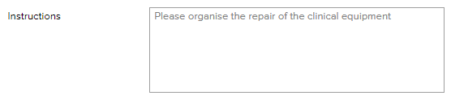 | These are the instructions which the assigned Approval Officer has requested in response to the requested repair.
 | This is the name of the external supplier who is required to be contacted, as per the instructions provided by the assigned Approval Officer. Details of the contact may be found on the Business Contacts Register in LOGIQC.
 | Record in this field details of all action taken giving consideration to legislative requirements in relation to record keeping. For example, it may be required that full details of action taken is kept by the organisation.
 | Press ‘add progress note’ when you want to add further details of action taken. LOGIQC will record the date and time the additional notes were added. You can add as many additional notes as required, until all action has been taken.
 | Add additional comments (optional).
 | Click 'Add' to attach related records, e.g. service maintenance report etc. relevant to any action taken in arranging the repair.
 | Click save, which will activate the 3rd process in the Repairs Workflow.

  - Complete “Approval” Task for Repair
Where action required to be taken in response to the requested repair has been completed, select the 1st option and select save.

Where additional action is required to be taken, select the 2nd option and complete the ‘required’ fields:
- instructions as to what further action is to be taken
- select who is to take the further action
- timeframe in which the further action is be completed

Where no further action needs to be taken and there is the opportunity to implement a system improvement select the 3rd option and LOGIQC will:
- generate an improvement form
- link the improvement to the requested repair so that a record is kept that the improvement was generated from a requested repair.
- Refer to the instructions on how to complete the improvement form.

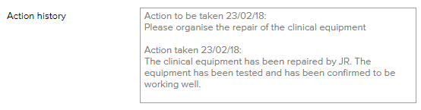 | This field provides details of what action has been taken that was recorded by the Action Officer on the ‘Action Details Form’.
 | Where further action is required to be taken, document the instructions for the further action to be taken.
 | Where action is required to be taken, select the staff member who is required to undertake the action and specify the timeframe in which the action is to be completed within.
 | When closing off the requested repair, the Approval Officer can record details of the final outcome in responding to and managing the repair (optional).
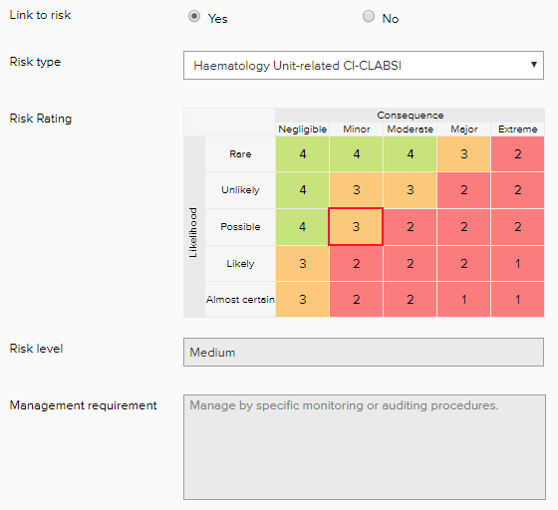 | The Approval Form, provides a further opportunity to link the requested repair to a Risk type, or to change the Risk type that may have been set previously by the Approval Officer. Refer to the earlier instructions in relation to the Risk Rating, Risk level and Management requirement.
Where option 1 or 3 has been selected, LOGIQC will close the Repair Report in LOGIQC, and move the Repair Report to both the “Closed” and “All” tabs in the Repairs Register.
Where option 2 has been selected, LOGIQC will activate the 3rd process in the Repairs Workflow.

Improvement Register
  - Purpose and Scope of Improvement Register
Improvement and innovation are central to an organisation’s ongoing success. The Improvement register promotes a culture of quality improvement and supports the organisation to take action in response to staff suggestions and reported issues relating to service delivery or business processes.
The Improvement Register enables:
- Report issues and suggest improvements or corrective actions through one-click from any device
- One-click reporting from any device
- Real time reporting
- Related records to attached to the reported improvement
- Immediate notification to management following reporting of corrective or preventive action
- Document root cause analysis and actions arising in accordance with ISO 9001 requirements
- Delegation of action with instructions and timeframes specified
- Monitoring of action taken
- Documentation that verifies the evidence of action taken to be held with the improvement report
- Built in search filters and trend reporting for high level analysis of what’s happening in your business.

  - Improvement Register Workflow

  - How to suggest an Improvement
Instructions to report an improvement in the LOGIQC QMS:
      - Log-in under your own user profile.
      - Click on "suggest Improvement" in the Quicklinks box in your Task Register Screen
      - Complete the required fields as follows:
 | Select the option that best matches the source or cause of the issue relating to the improvement.
 | Specify whether the repair is related to a Risk type that has been identified by the organisation.
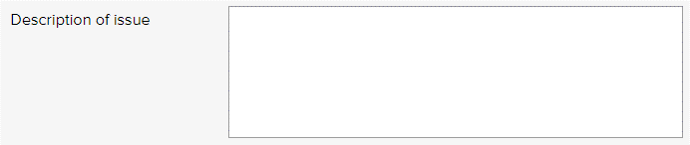 | Describe the issue prompting this improvement suggestion.  Note a full account of the issue can be attached as an attached record using the ‘Add’ button below.
 | Select if the issue was identified internally, eg by staff, or externally, eg auditor. If the origin of the issue is external, LOGIQC will generate a further field requesting the name of the person or company who has made the suggestion.
Select if the issue is a non-conformance. A non-conformance refers to something that does not comply with specified procedures, process, or specified requirements when referring to goods or services, provided or contracted.

If the issue is a non-conformance, specify the system that failed, eg ordering procedure, staff induction, ongoing staff training program, formal communication channels, delegations procedures, etc.

Give consideration to why the system failure occurred eg. Staff induction not updated to include requirements relating to new services and programs, internal clinical meetings do not include the full clinical team, etc.

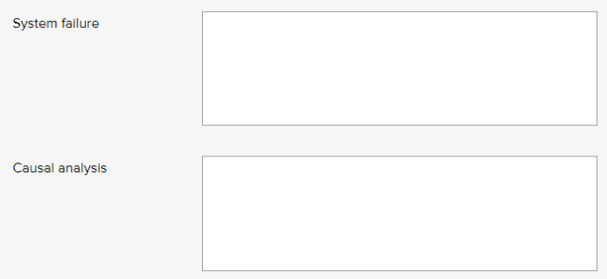
 | Describe the immediate action/s that have taken place in response to the identified issue. If no action has been taken state ‘no immediate action taken’.
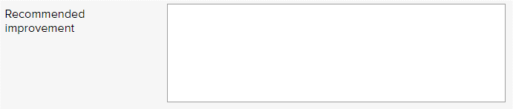 | In response to the identified issue, make a recommendation as to how the issue could be addressed. Note: improvements generally focus on how system or processes can be improved upon. In some instances purchasing additional equipment or personnel may be appropriate, but this improving systems and / or processes need to be considered in the first instance, as these are generally more achievable.
 | Select the work area of the organisation that the improvement most relates to.
 | Select the meeting that either needs to be kept informed of requested improvements or the meeting that has oversight for ensuring the improvement is responded to and managed. In instances, where this is not one and the same meeting, the organisation will need to determine which of the two assumes priority: communication or oversight.
 | Select a staff member who is required to manage this type of improvement.
 | Enter any additional relevant comments (optional).
 | Select individual staff members, including managers who are should be informed of this improvement recommendation. Upon the Form being ‘saved’ notification of the recommended improvement will be sent via an automatic email generated by LOGIQC.
 | Click 'Add' to attach related records, e.g. evaluation reports or any other records relevant to the improvement.
 | Click save to add the reported event to the Improvement Register, which will activate the 2nd process in the Improvement Workflow.

  - Complete “Approve for Action” Task for Improvement
Where action is required to be taken in response to the recommended improvement, select the 1st option and complete the ‘required’ fields:
- instructions as to what action is to be taken
- select who is to take the action
- timeframe in which the action is be completed

Where all action required to be taken has already been taken, select the 2nd option and complete the ‘required’ fields:
- record what further action has been taken that is not already noted on the Improvement Details Form
- press ‘save’ which will close the improvement report in LOGIQC.

Where no further action has been taken or is required to be taken, select the 3rd option and complete the ‘required’ fields:
- make a comment
- press ‘save’ which will close the improvement report in LOGIQC.
 | Where action is required to be taken, document the instructions.
 | Where action is required to be taken, select the staff member who is required to undertake the action.
 | Where action is required to be taken, specify the timeframe in which the action is to be completed within.
 | Select whether the recommended action is corrective or preventive action.
 | Select whether the improvement relates to a Risk type.
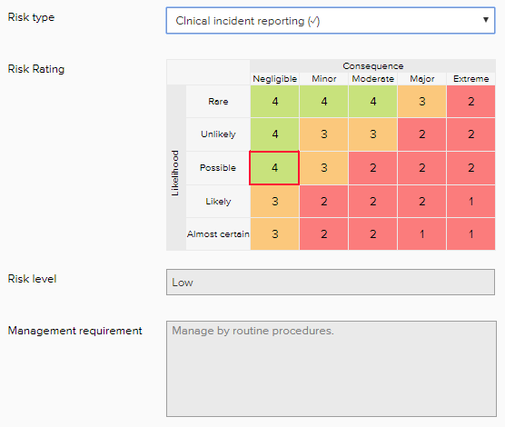 | Where a recommended improvement relates to a Risk type, select the relevant Risk type the improvement relates to.  In selecting a Risk type, if the Risk type has been assigned a risk rating, LOGIQC will automatically assign the same risk rating to the ‘Approve for Action’ form. However, the Approving Officer can override the automatic Risk rating that has been assigned by LOGIQC, which may be necessary as the nature of the repair may have a different risk level.  Details of ‘Management Requirement’ will be automatically populated by LOGIQC, based on the information recorded in ‘system settings’.
 | Add any addition comments (optional).
Click save to submit the completed “Approve for Action” form.
Where option 1 has been selected, LOGIQC will activate the 3rd process in the Improvement Workflow.
Where option 2 or 3 has been selected, LOGIQC will close the Improvement Report in LOGIQC, and move the Improvement Report to both the “Closed” and “All” tabs in the Improvement Register

  - Complete “Action” Task for Improvement
Where all action required to be taken has been taken, select the 1st option and complete the ‘required’ fields:
- record details of action taken
- add comment (optional)
- attach verifying evidence of action taken
- press ‘save’ and LOGIQC will send the improvement report to the assigned Approval Officer who has responsibility to assess the action taken based on what was required and to determine, if any further action is required.

Where only a part of the action required to be taken has been taken, select the 2nd option and complete the ‘required’ fields:
- record details of action taken
- press ‘save’ and the task will remain with the Action Officer, until Option 1 has been selected.

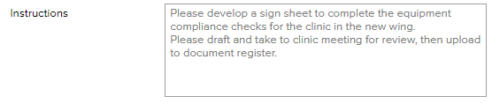 | These are the instructions which the assigned Approval Officer has requested in response to the improvement.
 | This is the name of the external supplier who is required to be contacted, as per the instructions provided by the assigned Approval Officer. Details of the contact may be found on the Business Contacts Register in LOGIQC.
 | Record in this field details of all action taken giving consideration to legislative requirements in relation to record keeping. For example, it may be required that full details of action taken is kept by the organisation.
 | Press ‘add progress note’ when you want to add further details of action taken. LOGIQC will record the date and time the additional notes were added. You can add as many additional notes as required, until all action has been taken.
 | Add additional comments (optional).
 | Click 'Add' to attach related records, e.g. evaluation report etc. relevant to any action taken in response to the improvement.
 | Click save, which will activate the 3rd process in the Improvement Workflow.

  - Complete “Approval” Task for Improvement
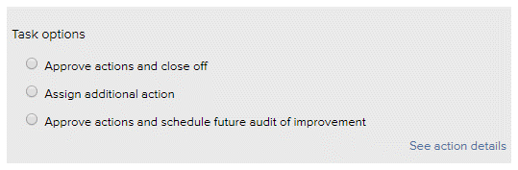 | Where action required to be taken in response to the requested improvement has been completed, select the 1st option and select save.  Where additional action is required to be taken, select the 2nd option and complete the ‘required’ fields:  - instructions as to what further action is to be taken  - select who is to take the further action  - timeframe in which the further action is be completed  Where no further action needs to be taken and you want to schedule an future audit to evaluate whether the action taken to address the original issues has been effective select the 3rd option and LOGIQC will:  - generate an audit form  - link the audit to the improvement so that a record is kept that the audit was generated from an improvement.  - Refer to the instructions on how to schedule an audit.
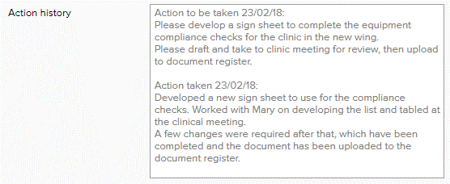 | This field provides details of what action has been taken that was recorded by the Action Officer on the ‘Action Details Form’.
 | Where further action is required to be taken, document the instructions for the further action to be taken.
 | Where action is required to be taken, select the staff member who is required to undertake the action and specify the timeframe in which the action is to be completed within.
 | When closing off the improvement, the Approval Officer can record details of the final outcome in responding to and managing the improvement (optional).
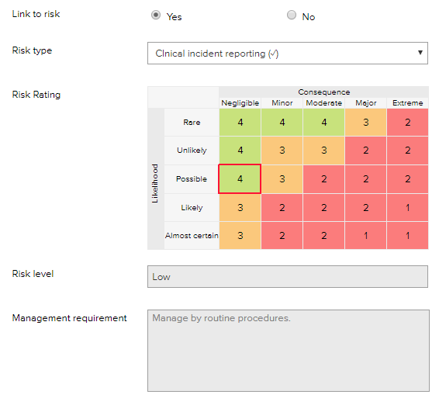 | The Approval Form, provides a further opportunity to link the recommended improvement to a Risk type, or to change the Risk type that may have been set previously by the Approval Officer. Refer to the earlier instructions in relation to the Risk Rating, Risk level and Management requirement.
Where option 1 or 3 has been selected, LOGIQC will close the Improvement Report in LOGIQC, and move the Improvement Report to both the “Closed” and “All” tabs in the Improvement Register.
Where option 2 has been selected, LOGIQC will activate the 3rd process in the Improvement Workflow.

