LOGIQC RISK MODULE TRAINING WORKBOOK

This workbook supports the onboarding and training of the LOGIQC Quality Management System Risk Module.

Contents page

1. Introduction 3
2. The purpose and scope of the Risk Module 3
3. ISO 31000 Risk Management – Principles and Guidelines 4
4. LOGIQC Risk Module – Workflow 5
5. How to navigate within the risk module 6
6. How to complete the Risk Details Form 7
7. Risk Treatment actions 10
8. Risk management plan 12
9. How to review an identified risk 13
10. How to manage the review of an identified risk 14

Introduction
This training workshop has been designed to provide support in the onboarding and training in the use of the LOGIQC Quality Management System Risk Module.
Learning outcomes:
Completion of Risk Details Form
- Understanding of purpose and scope of the Risk Register
- How to describe existing controls in place to managen an identified risk
- How to link relevant items in the QMS that currently control a risk
- How to recommend further risk mitigation action

Managing identified risks
- How to assess the completion of the Risk Details Form
- How to restrict access to a Risk Details Form
- How to manage and approve the Risk Details Form
- How to review the organisation’s exposure to an identified risk
- How to bring an identified risk under review
- How to recommend risk mitigation action and close when completed
- How to generate reports from the Risk Module

Related Documents and Resources
- ISO 31000 Risk Management – Principles and Guidelines
- NSQHS Standards – Risk Management Approach
- LOGIQC QMS Risk module build guide

The purpose and scope of the Risk Module
The Risk Module has been developed in line with the international standard, ISO 31000 Risk Management – Principles and Guidelines and supports an integrated approach to the identification and management of risks.
The scope of the module includes:
- linkages between the Risk Module and ISO 31000
- how to use the Risk Module to:
  - Identify known risks and demonstrate existing controls
  - Rate risks against risk/SAC levels in accordance with external agency requirements
  - Set and track risk treatment and mitigation tasks
  - Track and report on occurrences of risk across the business
- range and scope of reporting from the Risk Module

ISO 31000 Risk Management – Principles and Guidelines
The LOGIQC risk module, which allows for organisational risks to be identified, control measures to be described, and mitigation actions to be documented, has been designed in accordance with ISO 31000 Risk Management – Principles and Guidelines.
The following diagram outlines the risk management process proscribed in ISO 31000.

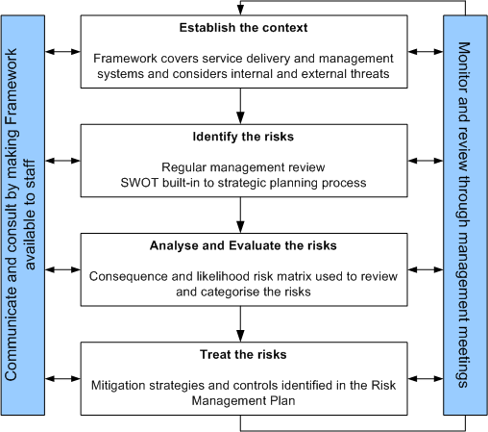

ISO 31000 Risk Management Process
The risk management process is designed to support the following outcomes:
- Better identification of opportunities and threats,
- Prevention of potential risks from being realised and the reduction of the element of chance
- Increased accountability and transparency for decisions
- More effective allocation and use of resources
- Improved incident management and reduction in the cost of risk, including insurance premiums
- Improved stakeholder confidence and trust
- Improved compliance with relevant legislation and accreditation processes
- Proactive rather than reactive management
- Enhanced governance

LOGIQC Risk Module – Workflow
The diagram bellow outlines the workflow of the LOGIQC QMS Risk Module, which involves the following processes:
Process 1 Following the identification of a risk, a full description of the risk is documented on the Risk Details Form (RDF)
Process 2 RDF is sent to the Risk Manager to check that the risk is fully described and controlled
Process 3 If approved by the Risk Manager, the RDF is sent to the Approving Office for sign off
Process 4 When the risk review date or the Risk Occurrence Threshold has been reached, the Risk Manager will be sent a task to review the risk
Process 5 If required, the Risk Manager will push the risk into the “review” phase of the workflow. As part of the review the following processes will be undertaken:
- the frequency of the risk occurring will be reviewed and analysed
- the controls in place to manage the risk will be reviewed to ensure they remain effective and adequate
- mitigation action that was previously identified and tasked to be completed has been completed
- the frequency of the review of the risk is appropriate (Note: 31000 recommends risks are reviewed within a 12-month timeframe)
- the linkages between the risk and the incident and feedback registers is appropriate and comprehensive
- where required, further mitigation action to better control the risk has been identified and added as “risk treatment” tasks
Process 6 Workflow returns to step 2

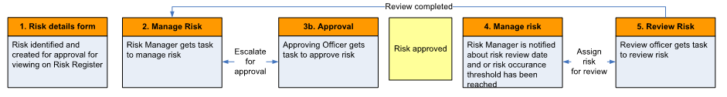

How to navigate within the risk module
  - Risk module Tabs
To access the risk module, you will need to select “risk” from the registers heading.
There are 6 ‘tabs’ along the top of the risk module:
- The Identified Risk tab displays the risks currently identified and approved for monitoring.
- The Closed Risk tab displays risks that have been closed and are no longer current risks to monitor.
- The Risk Mitigation Actions tab displays a current list of actions that are in place to mitigate risks.
- The Risk Management Plan tab displays the actions from other registers that are in place to mitigate the risks.
- The Workflow tab displays the list of risks with information as to where in the workflow the risk is currently in and whom is allocated the task.
- The Draft tab displays the drafted identified risks. These details forms will not generate tasks and are not part of the workflow until they are saved and moved to the Identified risk tab.
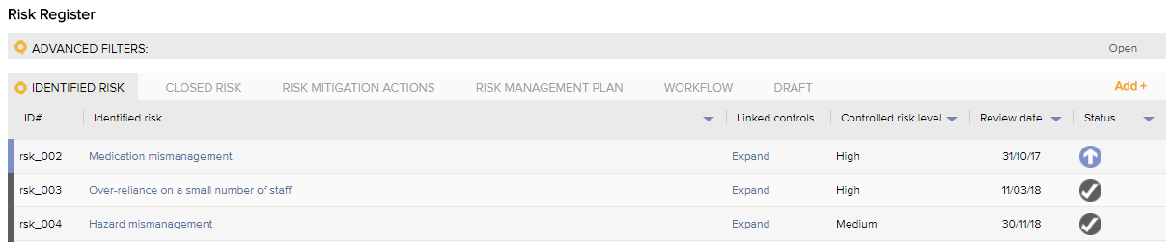

  - Navigating through the risk module
The search bar allows the user to search for risks based on the identified risk name or the ID# of the risk.
The risks in the register view are displayed in numerical order based on the ID# of the risk by default. The column titles allow the user to click on the title of the column to sort the content in alphabetical or numerical order based on that column. E.g. Click on the “Identified risk” title in the second column to sort the risks in alphabetical order. Clicking again will reverse the sort order.
The column filters are displayed as small blue triangles on the left hand-side of some of the register columns and enable the user to select options from that column to be filtered. E.g. Click on the blue triangle in the “Controlled risk level” column to select one or more options from the list, then click apply.
The advanced filters option sits above the risk module and can be used to apply a range of filters to enable different views or ad-hoc reports based on data within the details forms of the risks. E.g. Click on the word “Advanced filters” to display the advanced filter options. Use the drop-down menus to select one or more filters then click apply.
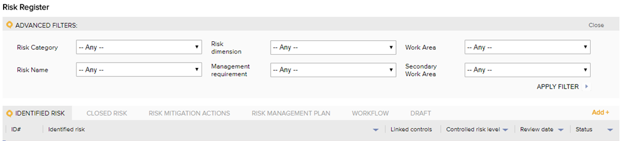

How to complete the Risk Details Form
To assist organisations with the build of their Risk Module, LOGIQC has documented a range of risks that are typical to the healthcare service delivery context. Each risk has been fully described in terms of potential consequences, cause/contributing factors and includes a description of controls that are generally in place as required by industry Standards. For example, required policies and procedures, internal audits, licence and credentialing checks, mandatory training etc, which are typical controls to manage risks.

The content provided in these drafted details forms can be modified to suit your organisations specific operating environment. If there are some that are not applicable to your organisation you can simply delete the details form, similarly if you have additional risk you need to add beyond the examples provided you can add these to your Risk Module.

  - Completing the drafted Risk Details Form
 | Select a risk from the menu. Additional risks can be added by the administrator in system setup.
 | Select a corresponding dimension. This menu can be edited by the administrator in system setup.
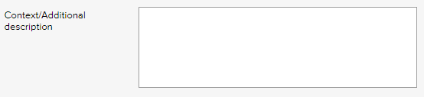 | Provide a detailed description of the actual risk including the context in which it can occur. This is important as it brings clarity to the context and parameters of the risk.
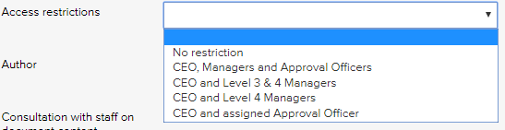 | Selecting a restriction level will mean that only users with those permission levels can see the Risk Details Form on the system. To see the permission levels assigned to users, go to contacts/staff contacts and click export. Enabling access supports transparency and accountability in the management of risks.
 | State the main locations where this risk could occur e.g. clinic, car park, admin etc. or NA.
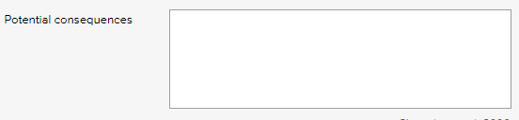 | Describe the consequences to the organisation, if the risk were to occur.
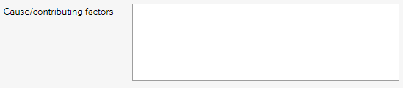 | Describe the cause or contributing factors that would give rise to the risk occurring.
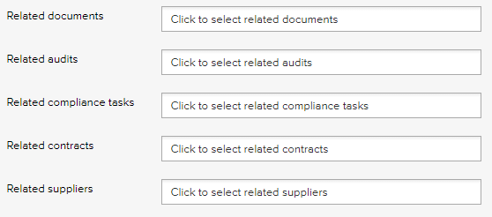 | Items in other LOGIQC registers (if activated in your system) can be linked to the risk as evidence of the controls that are in place to manage or mitigate the risk. Click into each field and select any relevant items.
  - How to complete the risk assessment
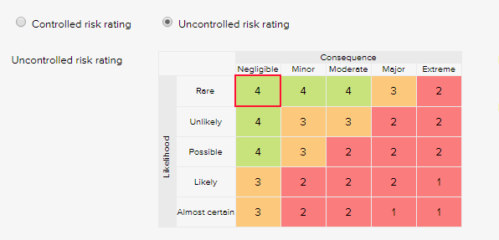 | Each risk is given two ratings:  Uncontrolled risk rating  The uncontrolled risk rating is the rating of the risk without controls (e.g. policies, procedures, staff training etc.). The uncontrolled risk rating represents the “inherent” or “residual” risk to the organisation. The uncontrolled risk rating is equivalent to the natural level of the risk inherent in a process or activity without doing anything to reduce the likelihood or mitigate the severity of the risk occurring. Uncontrolled risks which are assessed as “extreme” or “high” should be closely monitored and have rigorous controls in place.  Controlled risk rating  The controlled risk rating is the rating for the risk after controls are put in place. Where the controlled risk rating remains “extreme” or is only downgraded to a “high”, consideration needs to be given as to what further mitigation action/s need to be taken in order for the risk rating to be downgraded to a “medium” or “low”.
  - How to add risk mitigation actions
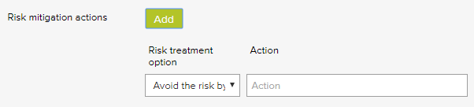 | If further controls or actions are needed to be put in place to manage a risk, e.g. strengthening policies or procedures, delegating responsibility for monitoring, formalising systems or processes, increasing frequency of monitoring or internal audit processes, providing staff with training, the mitigation actions can be entered here.  All mitigation actions will also be automatically listed on the Risk Mitigation Actions tab on the Risk Register, thereby providing a full list of all mitigation actions across all risks.
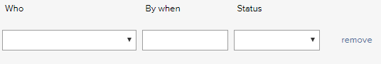
 | If there are items in the Improvement Register that relate to a risk, they can be linked to the risk via this menu. Linking related improvements provides valuable information on what processes or action has been taken in the past to strengthen the controls to mitigate a risk enabling the organisation to assess whether these improvements have been effective.

  - How to schedule the Risk for review
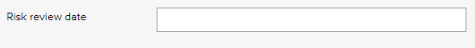 | Date when the risk is to be reviewed. Reviewing a risk enables the organisation to assess to what extent the controls that are in place to mitigate the risk are effective and to identify if the organisation’s exposure to the risk is escalating.  ISO 31000 recommends that risks are reviewed within a 12-month timeframe. Frequency of the review needs to be determined in consideration of each risk’s “controlled” risk rating, with those rated at the “extreme” or “high” being reviewed more frequently.
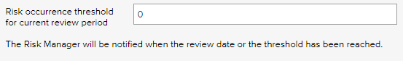 | Risks are multifaceted, that is they can be related to a range of adverse events.  To enable the organisation to monitor its exposure to a risk, adverse events that are likely to be an expression of each risk can be linked to the respective Risk Details Form. For example, needle stick injuries as an incident type can be linked to the risk “infection control mismanagement”.  When setting up the Risk Details Form, all related incident types and feedback categories can be linked to a risk. Further when a non-conformance is reported through the Improvement Register or a request for a repair is reported through the Repair Register, these events can be linked to an identified risk by the Approving Officer, as part of the “Approve for Action” task.  Each time an event is linked to an identified risk, LOGIQC will add the details to the Risk Management Plan. LOGIQC will also keep a count of the number of events that have been linked. When the number exceeds the Risk Occurrence Threshold which has been set on the RDF, LOGIQC will send a task to the risk manager notifying that the risk needs to be reviewed.
 | Select the work area that the risk most relates to.
 | Select the meeting that has responsibility for oversight of the management of the risk.
 | Select the person who has responsibility for managing the risk. The Risk Manager will be notified when the risk is to be reviewed, which could result from the risk review date being reached or when the Risk Occurrence Threshold has been exceeded.
 | Select the person who has the authority to approve that the risk is published to the risk register.
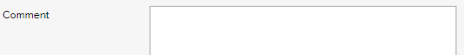 | Enter any comment relevant to the risk. This field is optional.

  - How to save the draft details form
Click “Save as Draft” to save the draft form to continue working on the form. Note: You cannot select any one to manage the risk, enter a review date or add mitigation actions when saving the risk as a draft.
Or
Click “Save” to submit the draft form into the requirements tab and put the details form into the review workflow
Or
Click “Save and Approve” to submit the draft form into the requirements tab approved. This form will come up for review based on the review date.

Risk Treatment actions
The risk treatment section of the Risk Details Form allows a user to identify actions that could be completed to further control and mitigate a risk from occurring or reduce the consequence, if the risk occurred. The risk mitigation actions are added at the bottom of the Risk Details Form.
Examples of risk mitigation actions are:
- Draft a procedure for responding to needle stick injuries
- Provide training to staff on the management of the exposure to blood and other body fluids and the requirement to report all instances on the Incident Register
- Conduct an internal audit of compliance with infection control procedures

When a risk treatment action has been added to a Risk Details Form, LOGIQC will advised the staff member assigned to complete the action will be advised of the task via email. If the risk treatment action has not been signed off as completed by the due date, LOGIQC will send a reminder email, at a frequency set by the Administrator in system setup.

  - How to view risk mitigation actions
The risk mitigation actions are managed at the bottom of the Risk Details Form. All risk mitigation actions will also be automatically listed on the Risk Mitigation Actions tab on the Risk Module. The Risk Mitigation Action Plan will display all mitigation actions relating to each identified risks as well as information about the status, due date and the staff member who is required to undertake the action (action officer).
To view a risk mitigation action, click on the title of the identified risk. This will take you to the respective Risk Details Form that the mitigation action relates to, thereby providing a full context as to why the risk mitigation action is required.

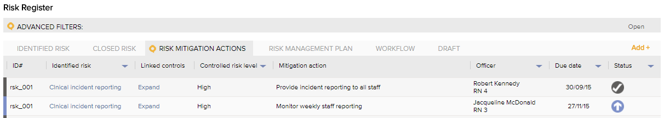

  - How to complete risk mitigation actions
Click on the title of the identified risk the risk mitigation action relates to. The action tasks will display at the bottom of the details form.
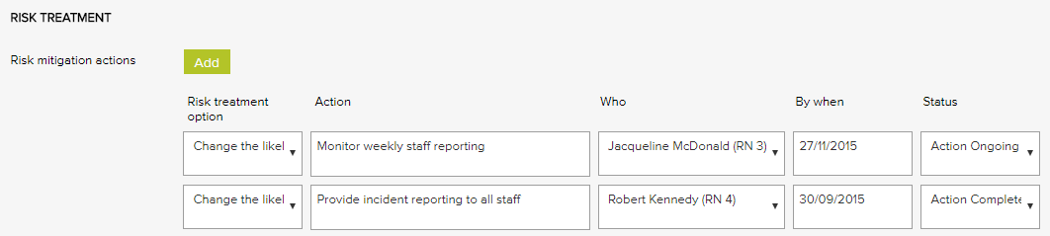
Once the action has been completed, change the status of the task to “Action Completed”, if applicable. Where the evidence of the action taken has been added to the LOGIQC QMS, link the relevant evidence to the controls section of the risk. For example, if the action required a procedure to be added to the Document Register, and this document has been added to the Document Register and has been approved, select the document in the “Document” field.
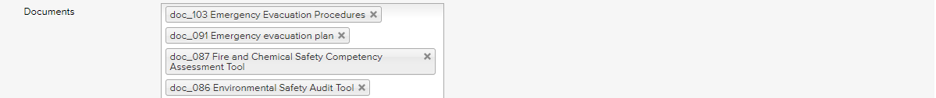

  - How to approve/close a risk mitigation actions
The Risk Manager for each risk is responsible for ensuring all risk mitigation actions associated with the risk/s they are managing have been completed to the satisfaction of the organisation and within required timeframes. Following the completion of risk mitigation action/s they are also responsible for ensuring the description of the risk and the controls that are in place to manage the risk are accurately reflected on the Risk Details Form. While this is also a part of their responsibilities when reviewing the risk, the Risk Details Form, can be updated by the respective risk manager at any time.

Risk management plan
The risk management plan tab will provide an interactive “Risk management report” for each risk, which commences with a description of the controls that are in place to manage the risk.
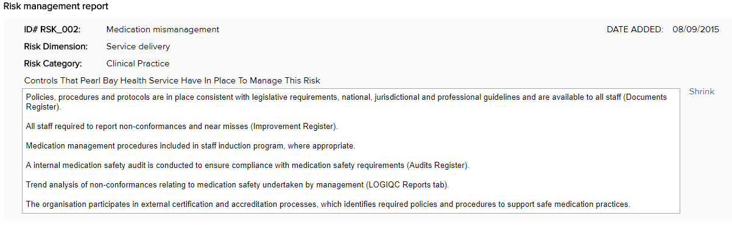
  - How to view the risk management plan
To support the review of a risk, the Risk management report details the status of the controls in place that are linked to the respective risk. In the following example, the “Client Medications Dispensing Audit Template” is currently overdue for review. This may indicate that the audit, which is using this tool, may not be as effective as a control in managing the risks associated with “medication mismanagement”, as the audit tool may not be in line with the organisation’s procedures, which would be the case if the procedures had been updated and the audit tool had not.
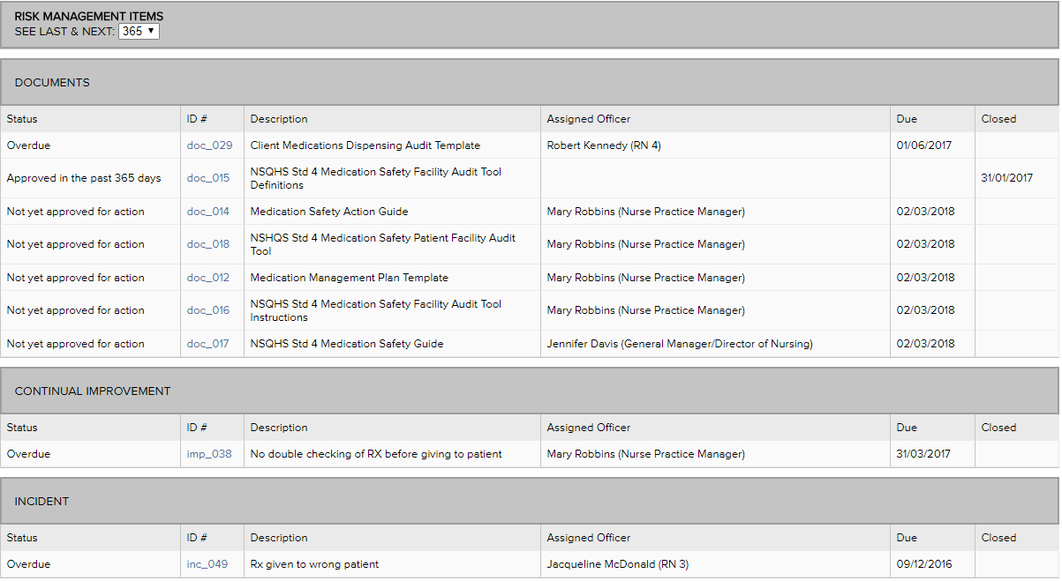

This risk management plan provides details of the status of all items in the QMS that have been linked on the details form. In the following example, information is provided on a task relating to calibrating the equipment and indicates that the latest task was completed, while 3 times the task was missed, and it also scheduled to occur again in the following 365 day period.

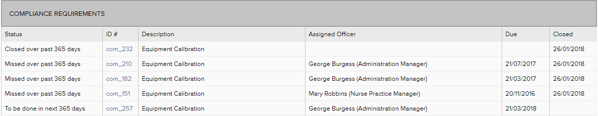

Note: In reviewing the Risk management plan, you have the option to modify the number of days the review relates to, from 30 days to 1 year by adjusting the “See last & next” drop down field.
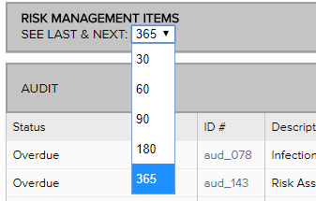

  - How to drill through the risk management plan
To view a particular item on the Risk management plan, click on the ID# hyperlink to go directly to the task. You can then use the “back” button to return to the Risk Mitigation Plan.

How to review an identified risk
In reviewing a risk, the following steps are recommended:
Refer to the Risk management plan
- Assess to what extent the controls in place are effective based on their status
- Where adverse events are listed (incidents, feedback, non-conformances, repairs), open each event to gain an understanding of the organisation’s exposure to the risk
- Review the status of the risk mitigation actions
Based on the information gained through the review of the Risk management plan
- Review the Risk Details Form to ensure the description of the risk is accurate and revise, if required
- Review the controls and link additional controls, if applicable
- Review the linkages with incident types and feedback categories and revise, if required
- Review the controlled risk rating and revise, if required
- Add additional risk treatment actions to better manage or mitigate the risk, if required
- Increase or decrease the Risk Occurrence threshold, as required

How to manage the review of an identified risk
The Risk Manager has responsibility for the overall management of the risk that has been assigned to them. As part of this role the risk manager has the responsibility to ensure:
- the organisation has an accurate understanding of the real and potential exposure to the identified risk
- the risk has been fully described in terms of potential consequences and contributing factors
- appropriate controls are in place to manage or mitigate the risk
- where the “controlled risk” assessment is rated “high” or “extreme” further risk mitigation action will be taken to mitigate the organisation’s exposure to the risk and that risk treatment actions will be treated as a priority
- where further treatment action is required, action has been delegated with clear timeframes for completion
- the organisation’s exposure to the risk is being monitored
- the risk is reviewed at required intervals or upon the Risk Occurrence Threshold being reached
- where the organisation’s exposure to the risk increases, the issue will be escalated to higher management

