The following instructions have been developed to assist LOGIQC QMS Users in the process of creating a new calendar integrated on an into MS Outlook that will display and update with the users scheduled LOGIQC QMS meetings on an iPad or iPhone.
If you require further assistance in integrating your LOGIQC QMS Meetings calendar please don’t hesitate to contact the LOGIQC support team via our online LOGIQC helpdesk or emailing helpdesk@logiqc.com.au

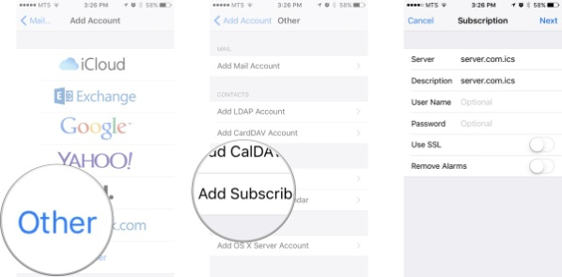
- Launch the Settings app on your iPhone or iPad
- Scroll down and Click Mail, Contacts, Calendars
- Under the Accounts title click Add Account
- Select Other
- Under the Calendars title select Add subscribed Calendar
- The New Internet Calendar Subscription dialog box displays. In the edit box, paste/type your organisations’ LOGIQC URL LOGIQC QMS URL (this is the link to your LOGIQC QMS site) with “/CalendarFile/Calendar” added to the end:

If your LOGIQC QMS URL is: https://example.logiqc.com.au
Add to the end: /CalendarFile/Calendar
This should now read: https://example.logiqc.com.au/CalendarFile/Calendar

- The Security dialogue box displays. Enter your LOGIQC QMS username and password that you use to Log in to your LOGIQC QMS site.
- Click Save.
Your LOGIQC calendar is now integrated with any other calendars you have in the Calendar App on your iPhone / iPad.
- When in the calendar app, by clicking on the ‘calendars’ button you can select and deselect which calendars you would like to view from your phone. Your LOGIQC QMS subscribed calendar will be shown in this list.
This procedure will need to be followed for each iPhone / iPad you wish to have this feature. The new LOGIQC Calendar, once created, will update automatically when changes are made to meeting details in LOGIQC.

