Risk Settings

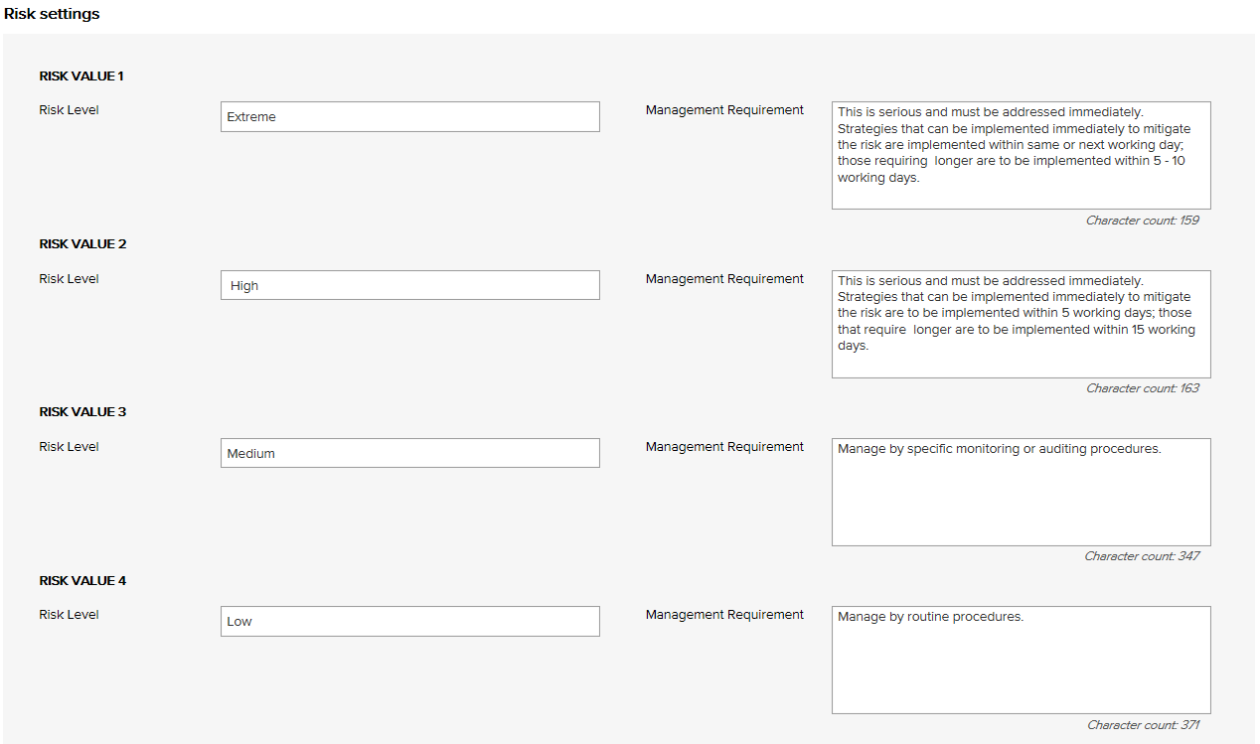

Risk Level | Management Requirement
Extreme | This is serious and must be addressed immediately. Strategies that can be implemented immediately to mitigate the risk are to be implemented within same or next working day; those requiring longer are to be implemented within 5 - 10 working days.
High | This is serious and must be addressed immediately. Strategies that can be implemented immediately to mitigate the risk are to be implemented within 5 working days; those that require longer are to be implemented within 15 working days.
Medium | Manage by specific monitoring or auditing procedures
Low | Manage by routine procedures.

Example of Risk Dimensions

Proposed Primary Risk Categories | Definition
Commercial | This category includes cash flow, budgetary requirements, tax obligations, creditor and debtor management, remuneration and other general account management concerns.
Organisational | This relates to the internal requirements of a business, extending to the cultural, structural and people issues associated with the effective operation of the business.
Compliance / legal | This category includes compliance with legal requirements such as legislation, regulations, standards, codes of practice and contractual requirements. This category also extends to compliance with additional ‘rules’ such as policies, procedures or expectations, which may be set by contracts, customers or the social environment.
Operational | This covers the planning, operational activities, resources (including people) and support required within the operations of a business that result in the successful development and delivery of a product or service.
Financial | This category includes the risks associated with market placement, business growth, diversification and commercial success. This relates to the commercial viability of a product or service, and extends through establishment to retention and then growth of a customer base.
Safety | This category includes the safety of everyone associated with the business. This extends from individual safety, to workplace safety, public safety and to the safety and appropriateness of products or services delivered by the business.
Strategic | This includes the planning, scoping and resourcing requirements for the establishment, sustaining and/or growth of the business.
Equipment | This extends to the equipment utilised for the operations and conduct of the business. It includes the general operations of the equipment, maintenance, appropriateness, depreciation, safety and upgrade.
Security | This includes the overall security of the business premises, assets and people, and extends to security of information, intellectual property, and technology.
Reputation | This entails the threat to the reputation of the business due to the conduct of the entity as a whole, the viability of product or service, or the conduct of employees or other individuals associated with the business.
Service delivery | This relates to the delivery of services, including the quality and appropriateness of service provided, or the manner in which a product is delivered, including customer interaction and after-sales service.
Project | This includes the management of equipment, finances, resources, technology, timeframes and people associated with the management projects. It extends to internal operational projects, projects relating to business development, and external projects such as those undertaken for clients.
Stakeholder management | This category relates to the management of stakeholders, and includes identifying, establishing and maintaining an appropriate relationship. This includes both internal and external stakeholders.
Technology | This includes the implementation, management, maintenance and upgrades associated with technology. This extends to recognising the need for and the cost benefit associated with technology as part of a business development strategy.
ACHS Day Patient Clinical Indicators | Version 5
ACHS Medication Safety Clinical Indicators | Version 3
ACHS Infection Control Clinical Indicators | Version 3.1
ACHS Anaesthesia Clinical Indicators | Version 5.1
ACHS Ophthalmology Clinical Indicators | Version 5
ACHS Gastrointestinal Endoscopy Clinical Indicators | Version 2

Example of Risk Treatment Options

Avoid the risk by deciding not to start or continue with the activity
Change the consequences
Change the likelihood
Eliminate the hazard
Isolate the hazard
Minimise the hazard
Remove the risk source
Retain the risk by informed decision
Share the risk with another party or parties
Take or increase the risk in order to pursue an opportunity

Example of Primary and Secondary Risk Types

ACHS Clinical Indicators / Risks
Primary Risk Category | Secondary Risk Category
Procedure Non-Attendance | Booked patients who fail to arrive
Procedure Cancellations | Cancellation after arrival due to pre-existing medical condition
 | Cancellation after arrival due to an acute medical condition
 | Cancellation after arrival due to admin / organisational reasons
Unplanned Return to the Operating Theatre | Unplanned return to the operating room on same day as initial procedure
Unplanned Transfer / Admission | Unplanned transfer or overnight admission related to procedure
 | Unplanned transfer or overnight admission related to ongoing mgmt.
Discharge | Unplanned delayed discharge for clinical reasons >1hr beyond expected
 | Unplanned delayed discharge non-clinical reasons >1hr beyond expected
Medication Errors | Medication errors – adverse event requiring intervention
Central Line-Associated Blood Stream Infections | Haematology Unit-related CI-CLABSI
 | Haematology Unit-related PI-CLABSI
 | Oncology Unit-related CI-CLABSI
 | Oncology Unit-related PI-CLABSI
 | OPIV Unit-related CI-CLABSI
 | OPIV Unit-related PI-CLABSI
Haemodialysis-Associated Bloodstream Infection Surveillance | Haemodialysis – AV-fistula access-associated BSI
 | Haemodialysis – synthetic graft access-associated BSI
 | Haemodialysis – native vessel graft access-associated BSI
 | Haemodialysis – CI non-cuffed line access-associated BSI
 | Haemodialysis – CI cuffed line access-associated BSI
Healthcare Associated MRSA Morbidity | Non ICU associated new MRSA inpatient HAIs in a sterile site
 | Non ICU associated new MRSA inpatient HAIs in a non-sterile site
Occupational Exposures to Blood and/or Body Fluids | Reported parenteral exposures sustained by staff
 | Reported non-parenteral exposures sustained by staff
Pre-Anaesthesia Period | Pre-anaesthesia consultation completed by anaesthetist
Patient Recovery Period | Unplanned stay in recovery room >2 hrs for medical reasons
Cataract Surgery | Cataract surgery readmission within 28 days
 | Cataract surgery readmission within 28 days due to endophthalmitis
 | Cataract surgery unplanned overnight admission
 | Cataract surgery – anterior vitrectomy
Failure to reach Caecum | Failure to reach caecum due to inadequate bowel preparation
 | Failure to reach caecum due to diseased colon
 | Failure to reach caecum due to instrument failure
 | Failure to reach caecum due for any other reason
Adverse outcome – Colonoscopy / Polypectomy | Treatment for possible perforation post-polypectomy
 | Treatment for possible perforation not related to polypectomy
 | Post-polypectomy haemorrhage
Oesophageal Dilation - Perforation | Oesophageal dilatation – possible perforation
Aspiration following GI Endoscopy | Aspiration following endoscopy

Organisational Risks
Primary Risk Category | Secondary Risk Category
Business Continuity | Cyclone
 | Electrical 'spikes'
 | Epidemic among staff
 | Fire
 | Flooding
 | Industrial accidents
 | Lightning strikes
 | Power cuts
 | Water cuts
 | Computer/systems breakdown
 | Contingency planning/business resumption
Environmental | Community exposure to pollution
 | Staff exposure to long-term hazards and pollution
Financial | Audit risk
 | Bad debts
 | Cash/fund management shortfall
 | Fines/judgment orders
 | Fraud
 | Inaccurate accounting and/or reporting
 | Inadequate costing systems (leading to unsustainable pricing)
 | Inadequate insurance
 | Non-conformance with procedures
 | Over-reliance on a small number of customers/suppliers
 | Poor cash flow
Human Resource/Personnel | Over-reliance on a small number of staff
 | Problems with outside contractors
 | Absenteeism
 | Industrial Action
 | Badly-designed workplaces
 | Claims of sexual harassment
 | Criminal activity
 | Cultural/religious conflicts
 | Language difficulties
 | Loss of key staff
 | Non-conformance with procedures
 | Workplace Health and Safety disputes
 | Unfair dismissals/litigation
 | Lack/insufficient skills, training to complete job duties
 | Theft, misappropriation
Inventory | Obsolescence
 | Stock losses
Legal | Breach of contract
 | Director and officer liability
 | Errors and omissions
 | Limitation of liability
 | Legislative / regulatory breaches
 | Product liability
 | Public liability
 | Statutory breaches
 | Negligence
Management | Client transport management
 | Client management
 | Equipment management
 | Hazard
 | Health service delivery
 | ICT management
 | Infection control breach
 | Medication management
 | Patient fall
 | Property management
 | Security management
 | Vehicle management
 | WHS management
Operations & Assets | Badly-designed products
 | Contaminated or unsafe products
 | Contaminated raw materials
 | Equipment breakdown
 | Inexperienced personnel
 | Planning and scheduling conflicts
 | Poor service leading to angry customers
 | Poorly maintained equipment and/or infrastructure
 | Superseded equipment
 | Supply delays
Policy & Political | Changes in government
 | Community expectations
 | Legislative changes
 | Regulatory environments
 | Reporting and accountability requirements
 | Organisational culture not aligned to organisational values
 | Political environment and issues
 | Changes in government
 | Community expectations change
 | Legislative changes
 | Management activities
Reputations and Image | Reduced or loss of community support/expectations
 | Adverse media coverage
Security | Espionage
 | Arson
 | Attack by persons
 | Sabotage
 | Sabotage/vandalism
 | Security breach
Student education | Student behaviour
 | Injury to students
 | Student safety
 | Inadequate supervision
Technological | Changes in information technology – hardware & software
 | Information security
 | Changes to information technology requirements by the organisation
 | IT systems/processes may be made or become obsolete
 | Implementation of new IT systems/process across the organisation

Risk management guide for small business, NSW Department of State and Regional Development, www.smallbiz.nsw.gov.au

