The following instructions have been developed to assist LOGIQC QMS Users in the process of creating a new calendar integrated into MS Outlook that will display and update with the users scheduled LOGIQC QMS meetings.
If you require further assistance in integrating your LOGIQC QMS Meetings calendar please don’t hesitate to contact the LOGIQC support team via our online LOGIQC helpdesk or emailing helpdesk@logiqc.com.au
Log-in to your LOGIQC QMS:
- Login to LOGIQC and open your user profile
- Click ‘generate’ next to the Private Calendar URL Field
- Copy link
- Click save
Log-into your Outlook on your computer:
- Open Outlook and click into the Calendar
- Click the ‘HOME’ tab at the top of the screen

- Click the ‘Open Calendar’ button at the top of the screen and select ‘From Internet…’ from the drop-down menu.
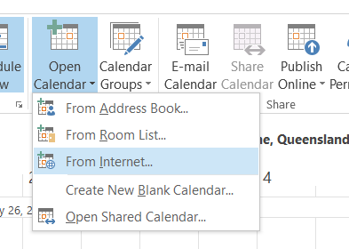

- The New Internet Calendar Subscription dialog box displays. Paste the LOGIQC code into the field and click OK
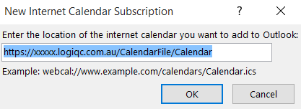

- Microsoft Outlook will ask you to confirm “if you would like to add this internet calendar to Outlook and subscribe to updates?” Click Yes.
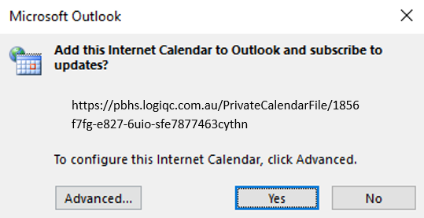
Note: You may receive a request for your credentials. If so, Enter your LOGIQC QMS username and password that you use to Log in to your LOGIQC QMS site.
- The pane on the left side of the screen now lists your LOGIQC Calendar in addition to your Outlook Calendar.
- You can tick the check box next to the title of the LOGIQC calendar in addition to your Outlook Calendar; both calendars are displayed side by side.
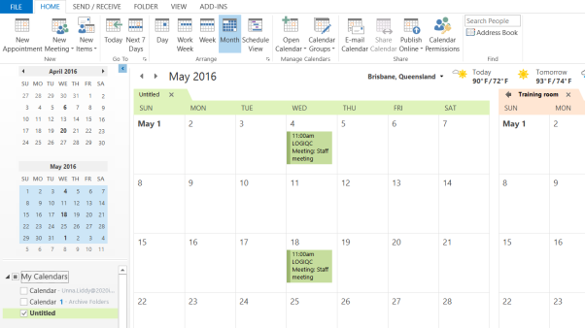

- Right click on this new Calendar, and select ‘Rename Calendar’ from the menu.
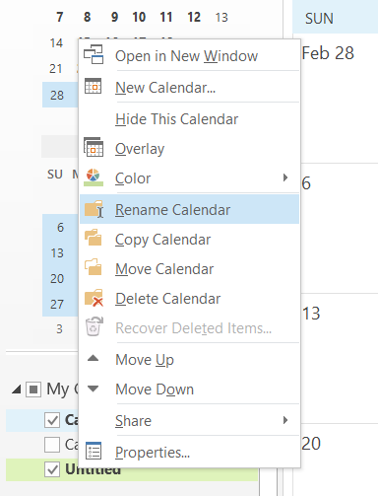

- Enter a title for the calendar for e.g. LOGIQC QMS Calendar
Optional Tip:
- Right click on the new LOGIQC QMS Calendar, and select ‘Overlay’ from the menu.
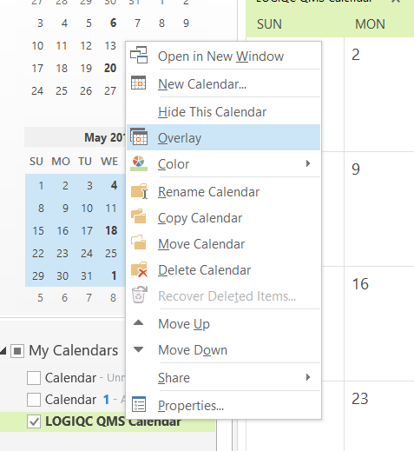

- This will display multiple calendars as one, with the all the calendar items listed
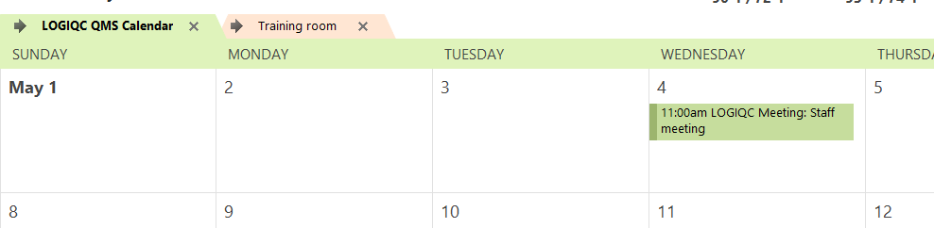
This procedure will need to be followed for each computer you wish to have this feature. The new LOGIQC Calendar, once created, will update automatically when changes are made to meeting details in LOGIQC.

